App Installation Guide
This guide explains how to install KLIN using the Windows setup wizard.
1. Installation Overview
The KLIN setup wizard guides you through five main stages: opening the installer, choosing the destination folder, confirming installation, waiting for the files to install, and finishing the setup. The screenshots in this document match the KLIN Windows installer shown during installation.
2. Requirements
- A Windows computer that can run the KLIN application.
- The KLIN installer file.
- Administrator permission, if Windows requests it during installation.
- Enough disk space in the selected destination folder.
3. Installation Steps
3.1 Open the installer
Run the KLIN setup file. The welcome screen appears. Click Next to continue or click Cancel if you want to exit the setup wizard.
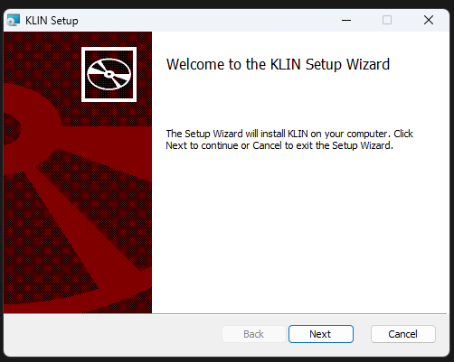
Figure 1. Step 1: Welcome to the setup wizard

3.2 Choose the installation folder
The installer shows the default destination folder, usually C:\Program Files\KLIN\. To use the default folder, click Next. To select a different location, click Change and choose another folder.
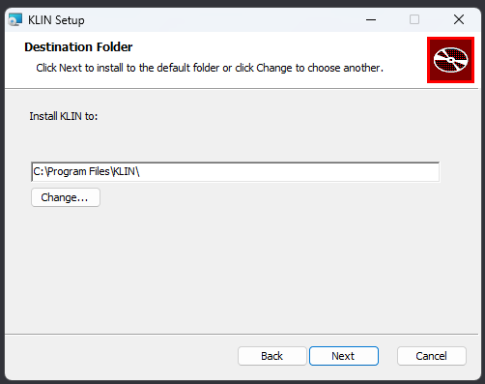
Figure 2. Step 2: Choose the destination folder

3.3 Confirm installation
When the Ready to install KLIN screen appears, review the installation settings. Click Install to begin copying the application files to your computer.
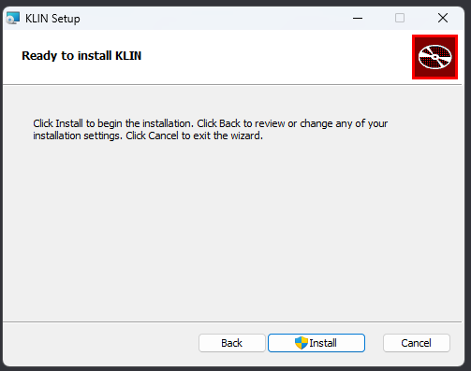
Figure 3. Step 3: Confirm that KLIN is ready to install

3.4 Wait for the installer
The Installing KLIN screen shows the installation status. Wait until the process finishes. Do not close the setup wizard while installation is in progress.
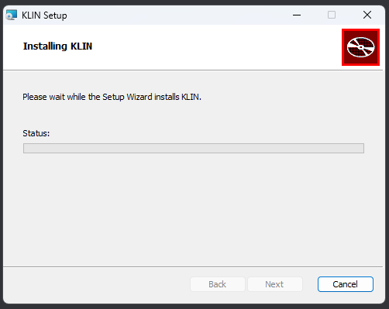
Figure 4. Step 4: Wait for installation to complete

3.5 Complete the setup
When the Completed the KLIN Setup Wizard screen appears, the installation is finished. Keep Launch KLIN checked if you want to open the application immediately, then click Finish.
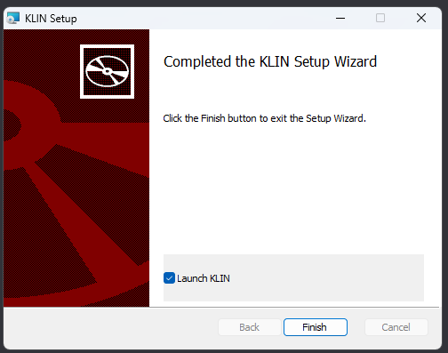
Figure 5. Step 5: Finish the installation
4. After Installation
If Launch KLIN was selected, the application should open automatically after clicking Finish.
If it does not open automatically, search for KLIN from the Windows Start menu and launch it manually.
Check that the application opens correctly before deleting the installer file.
5. Troubleshooting
Issue | Suggested Solution
The installer asks for permission | Click Yes if you trust the KLIN installer and want to continue.
Cannot install to Program Files | Run the installer as administrator or choose another folder using Change.
Installation seems stuck | Wait for a few minutes. If it does not continue, cancel the setup and run the installer again.
KLIN does not launch after Finish | Open KLIN from the Start menu, or restart Windows and try again.

