**HR RECRUITMENT PROCESS AUTOMATION – REQUIREMENT**

Kalpraj Shejwal, August 2025

**Personas**

1. HR Manager

- Goal: Reduce time-to-hire from 30 days to 15 days to fill roles faster.

- Challenge: Manual resume screening takes too long and misses top candidates.

2. Recruiter

- Goal: Identify high-potential candidates quickly for interviews.

- Challenge: No automated way to score resumes based on skills or experience.

3. IT Lead

- Goal: Ensure new tools integrate with existing HR systems like Workday.

- Challenge: Lack of clear requirements for system compatibility.

**Stakeholder Interview Questions**

1. What are the biggest pain points in the current recruitment process?

2. How long does it take to screen resumes, and what delays this step?

3. What metrics are most important for hiring success (e.g., time-to-hire, candidate retention)?

4. Are there manual tasks (e.g., data entry) that could be automated?

5. What tools or systems (e.g., ATS like Workday) do you currently use?

6. How do you prioritize candidates for interviews?

7. What data do you need to track to evaluate recruitment sources?

8. Are there integration issues between job platforms and internal systems?

**User Stories**

1. As an HR Manager, I want automated candidate scoring based on skills so that I can prioritize top candidates and reduce screening time.

2. As a Recruiter, I want a dashboard showing recruitment source performance so that I can focus on sources with high retention rates.

3. As an IT Lead, I want an ATS that integrates with our existing HR system so that data flows seamlessly without manual entry.

4. As an HR Manager, I want email notifications for candidate status updates so that I can keep applicants informed without manual effort.

**SWOT and Gap Analysis**

- **Strengths**:

- Diverse recruitment sources (e.g., LinkedIn, Indeed) attract varied candidates.

- Existing HR system captures basic employee data.

- **Weaknesses**:

- Manual resume screening causes delays and inconsistent candidate selection.

- No centralized dashboard to track recruitment metrics.

- **Opportunities**:

- Automate screening with an ATS to reduce time-to-hire.

- Use data analytics to identify high-performing recruitment sources.

- **Threats**:

- Delays in hiring may lead to losing top candidates to competitors.

- Lack of integration increases manual errors in data entry.

- **Gaps and Recommendations:**

- Gap: No integration between job platforms and HR systems.

- Recommendation: Implement API-based ATS (e.g., Workday) for seamless data flow.

- Gap: Limited visibility into recruitment source performance.

- Recommendation: Build a Power BI dashboard to analyze hire quality and retention.

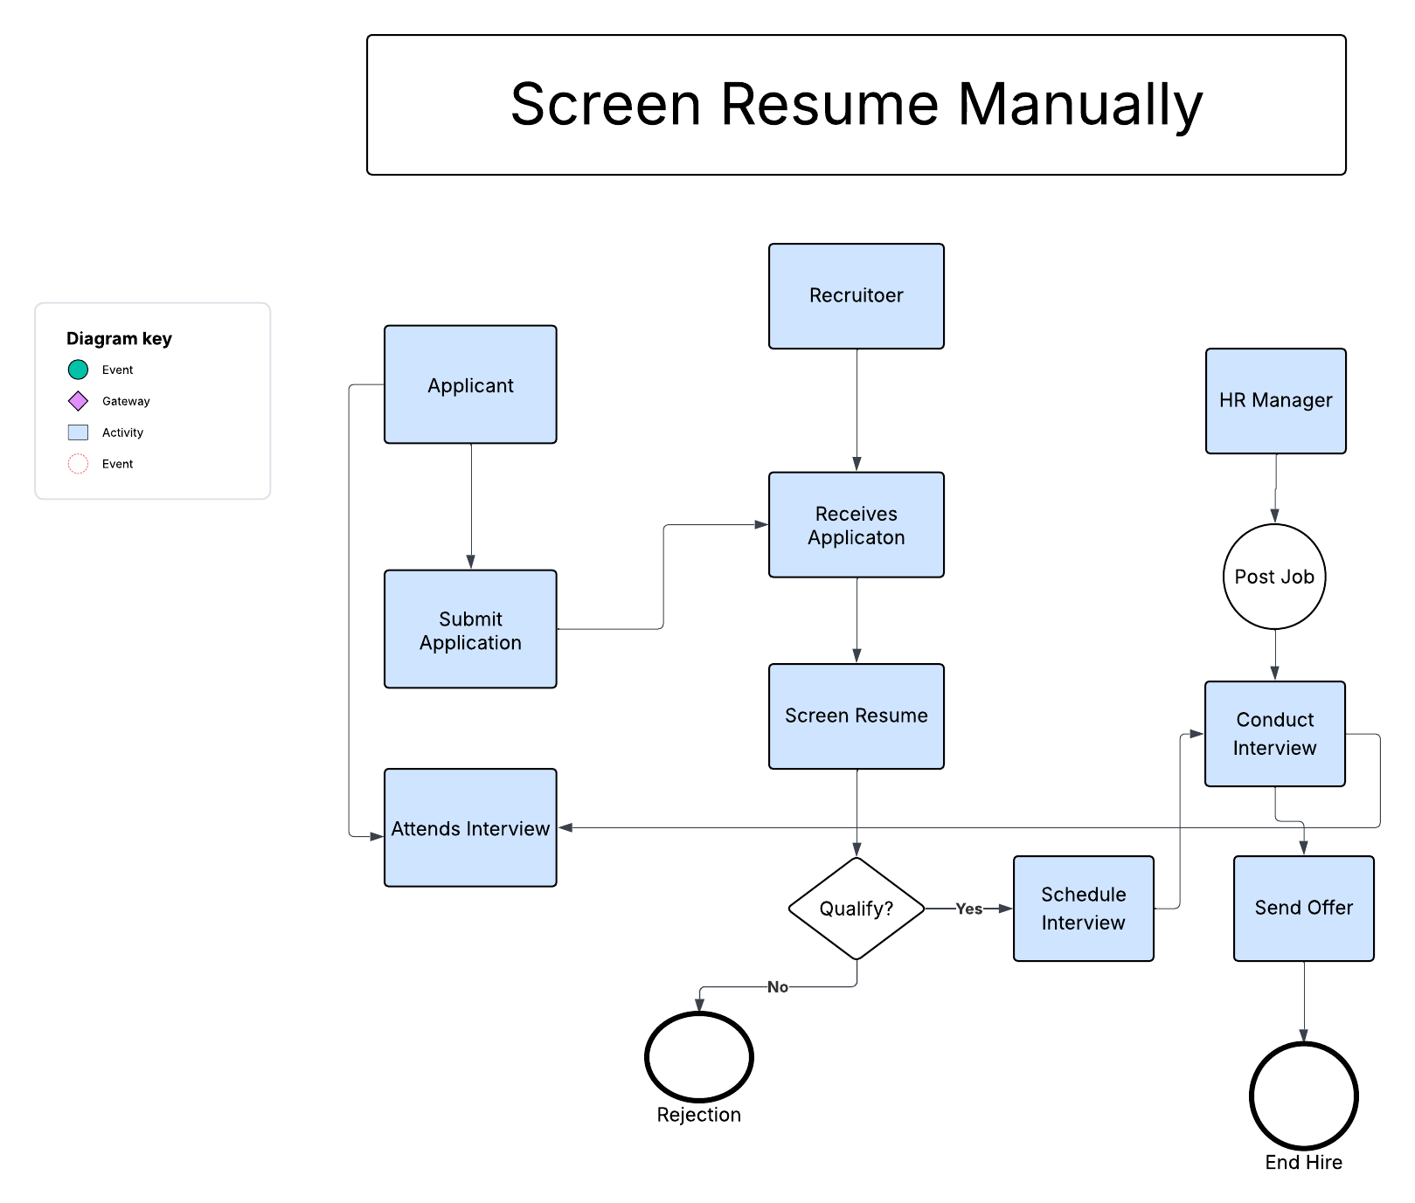This figure represents the resume screening manually which takes a lot of time compare to the ATS screen by using automation.  
It delay the process by 1 day.

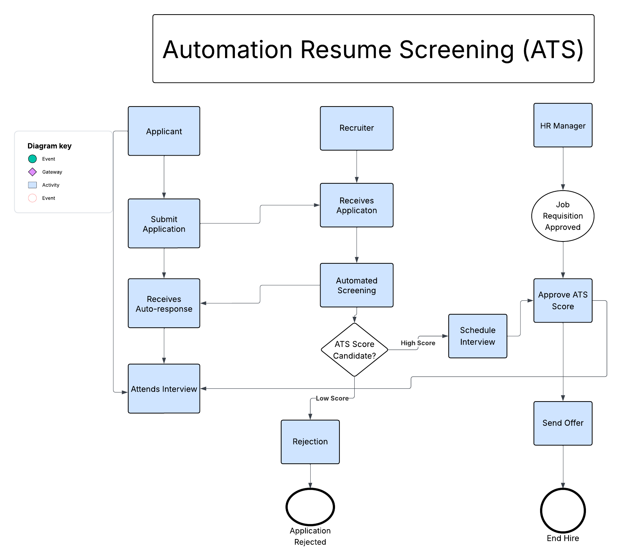This figure or BPMN shows that we have implemented ATS system ie the automation screening of resume which is way faster than manual screening.  
This improves the accuracy and reduces the time.