**HOMEPAGE**

**Overview**

The homepage consists of a slider, ‘who are we’ section, featured games, recent games, and upcoming events.

For more information about the featured games and recent games on the homepage view the ‘games’ section of this document.

Upcoming events will automatically display future events.

**WordPress**

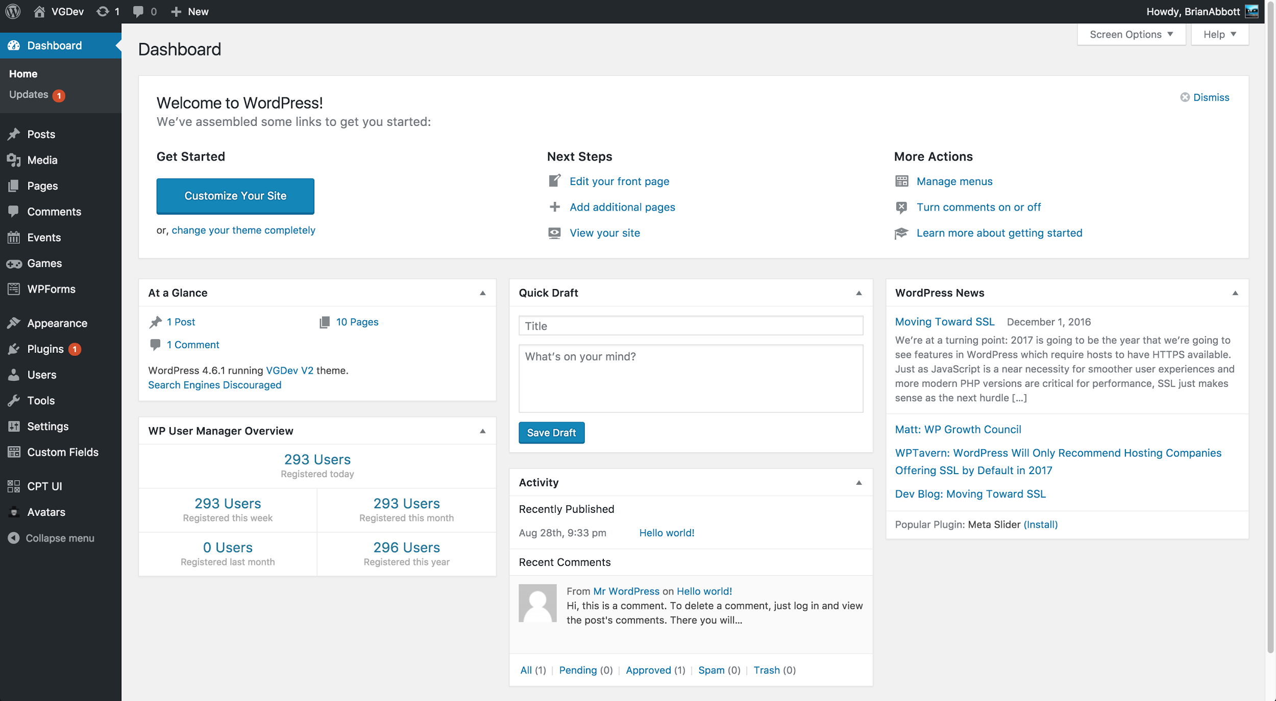

**Edit Homepage**

1. Login to the admin dashboard. (vgdev.org/admin or vgdev.org/wp-admin).
2. Click ‘Pages’ from the menu on the left of the screen.
3. On the list of pages, click ‘home’.
4. Make changes to the large text box near the top of the edit page to edit the ‘who are we’ section of the homepage.
5. Update the ‘homepage slider’ section on this page to update the slider images.
6. Toggle the ‘visible’ checkbox on each slide to determine if it will display
7. If adding a new slide, either add a new background image OR a background color.
8. The slide content is where text can be displaying over the image or background color.
   1. The content should be edited by using the ‘text’ view instead of the ‘visual’ view.

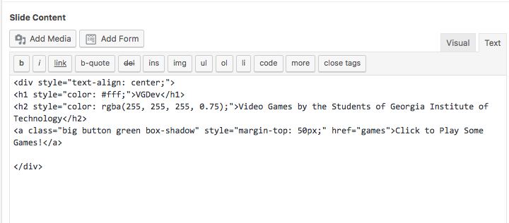

It’s recommended that an administrator with HTML experience modify the slider.

1. After making changes click ‘update’ near the top right of the screen.

**ALL PAGES**

**Edit All Pages**

1. Login to the admin dashboard. (vgdev.org/admin or vgdev.org/wp-admin).
2. Click ‘Pages’ from the menu on the left of the screen.
3. On the list of pages, click the name of the page you want to edit.

In general, all of the pages of the site are edited in a similar way to the homepage. The only difference that there is no section for a slider, but instead just a editor for content.

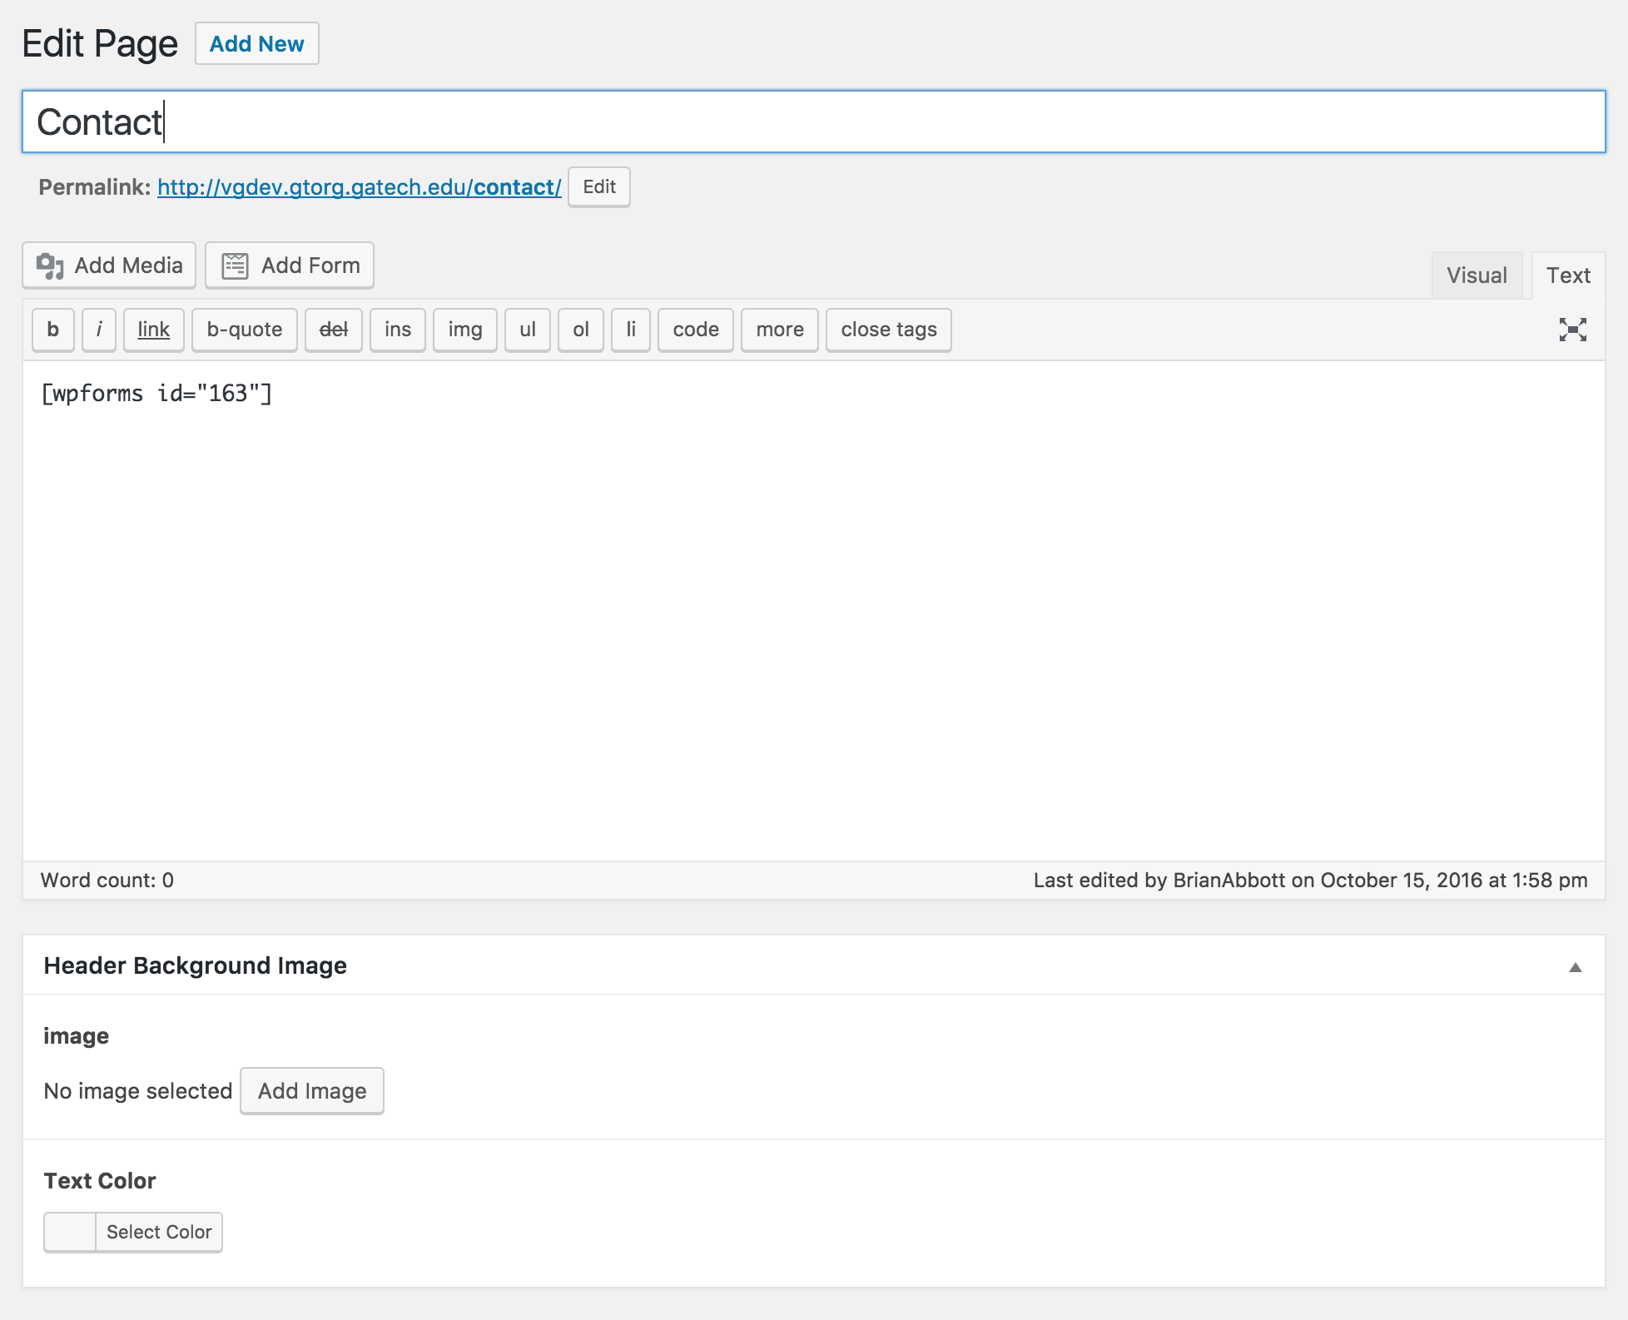

**USERS**

**Overview**

All users on VGDev.org have a profile that contains all their information. Users also have a portfolio with a public URL that can be attached to resumes. The portfolio will display a user's information and will list all the games that have contributed on.

VGDev members must have an account created by a site administrator in order to sign into the site. Regular members of the club should only need to sign into the site if they need to update their own profile.

There are three (3) roles for the site:

* Subscriber - all members who only have access to their profiles
* Editor - members who can add and remove games and users (game managers).
* Administrator - member who can do anything with the site

**Add New User to The Site**

1. Login to the admin dashboard. (vgdev.org/admin).
2. Click ‘Users’ from the menu on the left of the screen.
3. Click ‘Add New’ on the left menu or at the top of the screen.
4. Fill in all information about the user.
   1. When selecting a role refer to the ‘Roles Explained’ section of this document for more information
5. Click ‘Add New User’ at the bottom.
6. The user will receive an email and they will be able to login and set their password.

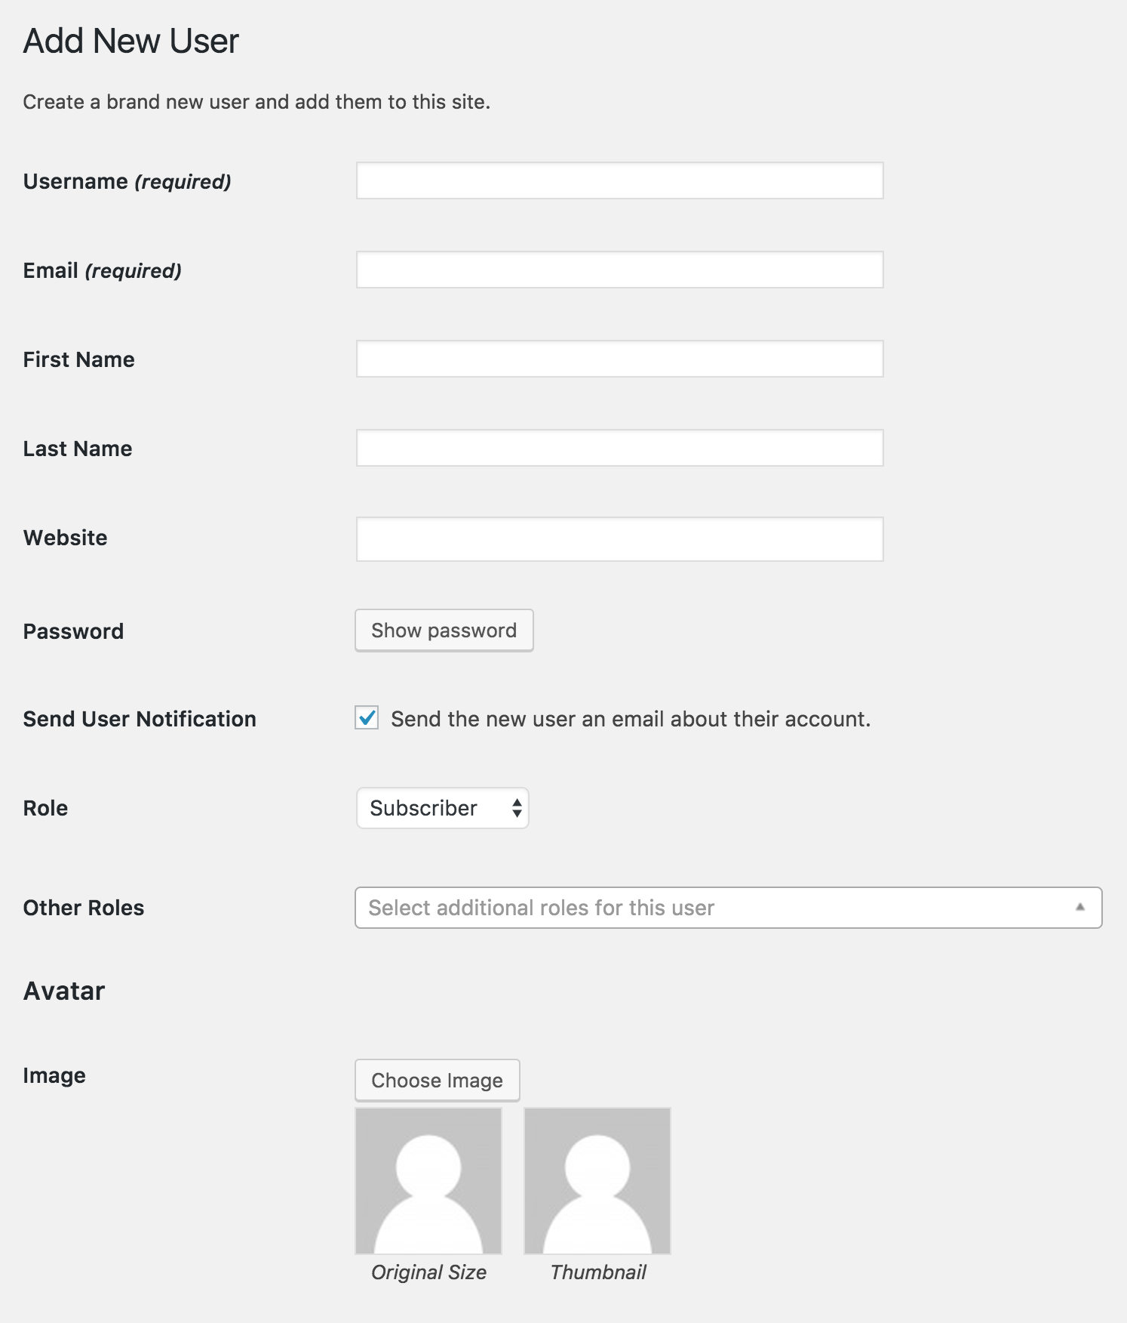

**Add Multiple New Uses to The Site**

1. Login to the admin dashboard. (vgdev.org/admin).
2. Click ‘Tools’ from the menu on the left of the screen.
3. Click ‘Import users from CSV’
4. Make a CSV with AT LEAST the following columns:
   1. Username
   2. Password
   3. NOTE: <https://wordpress.org/plugins/import-users-from-csv-with-meta/> for CSV and plugin information
5. Choose the role you want these users to be (more than likely ‘Subscriber’).
6. Import your CSV file.
7. If there are duplicate emails for multiple users, make sure to make ‘Repeated email in different users’ ‘allowed’.
8. Click ‘Start Importing’ if all the settings are correct/ what is desired.

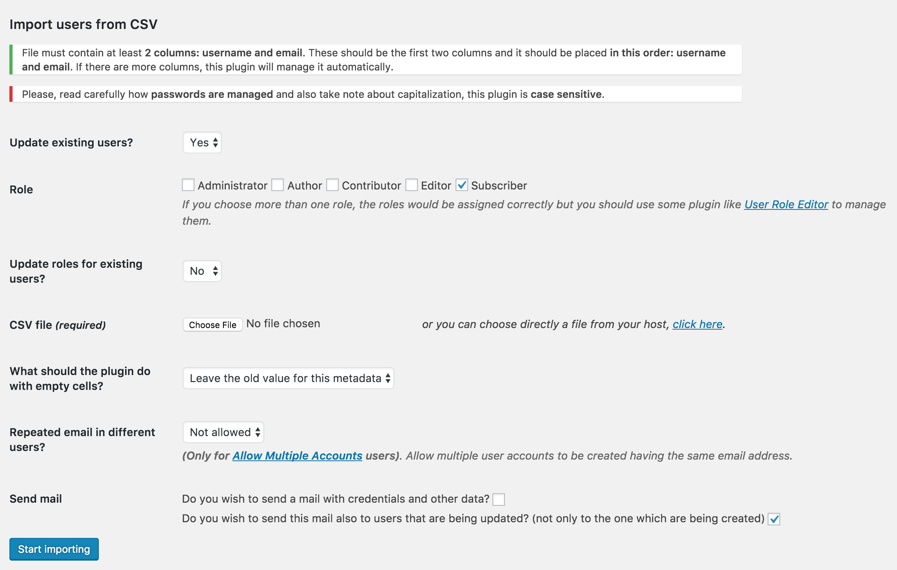

**Roles Explained**

[http://www.wpbeginner.com/beginners-guide/wordpress-user-roles-and-permissions](http://www.wpbeginner.com/beginners-guide/wordpress-user-roles-and-permissions/)

**GAMES**

**Overview**

Games can be viewed from the ‘Games’ page on vgdev.org. Featured games and recent games will appear on the homepage.

From the games page, games can be searched by title, semester, or year. Individual games can be viewed to see more information.

**Add a New Game**

1. Login to the admin dashboard (vgdev.org/admin).
2. Click ‘Games’ from the menu on the left of the screen.
3. Click ‘Add New’ on the left menu or at the top of the screen.
4. Fill out all the information on the screen.
   1. Required field have a red asterisk.
   2. To add contributors, click ‘Add Row’ in the contributor section.
      1. To add more contributor roles see the ‘Add Contributor Roles’ section of this document
   3. To add game images click ‘Add Row’ in the gallery section.
      1. Multiple images can be added at one time by selecting multiple files from your directory at once.
   4. I recommend selecting a hero image after adding images to the gallery. The hero image appears on the games search page.
   5. To feature a game on the homepage select the ‘featured’ checkbox.
5. Click ‘publish’ at the top right of the screen.
6. The game can now be see on the site.

**Add Contributor Roles**

1. Login to the admin dashboard. (vgdev.org/admin).
2. Click ‘Custom Fields’ on the left side of the screen.
3. Click the ‘Contributors’ custom field.
4. Click the ‘Contributor’ label.
5. In the subfields section that appears click on ‘role’.
6. In the ‘choices’ section that appears, new choices can be added.
7. Click ‘update’ in the top right after adding new selections.

**EVENTS**

**Overview**

Events can be viewed from the ‘Events’ page on vgdev.org. Games will be displayed either the ‘upcoming events’ section or the ‘past events’ section based on the date of the event.

**Add a New Event**

1. Login to the admin dashboard (vgdev.org/admin).
2. Click ‘Events’ from the menu on the left of the screen.
3. Click ‘Add New’ on the left menu or at the top of the screen.
4. Fill in the information about the event.
5. Click ‘Publish’ near the top right.

**USEFUL LINKS**

These are links to the plugin documentation/ information and other useful sites in order to help aid anyone either working with or on the site in the future.

Advanced Custom Fields

<https://www.advancedcustomfields.com/>

Advanced Custom Fields User Search Select

<https://support.advancedcustomfields.com/forums/topic/user-field-type-search/>

Allow Multiple Accounts

<https://wordpress.org/plugins/allow-multiple-accounts/>

Custom Post Types UI

<https://wordpress.org/plugins/custom-post-type-ui/>

Import Users from CSV with Meta

<https://wordpress.org/plugins/import-users-from-csv-with-meta/>

User Role Editor

<https://wordpress.org/plugins/user-role-editor/>

WP User Avatar

<https://wordpress.org/plugins/wp-user-avatar/>

WP User Manager

<https://wordpress.org/plugins/wp-user-manager/>

WPForms Lite

<https://wordpress.org/plugins/wpforms-lite/>