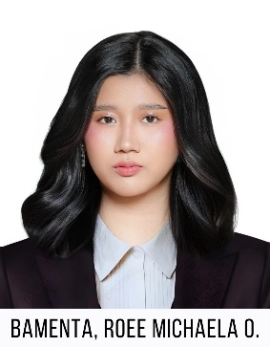
Project Manager
https://noeyes00.github.io/roeemichaela/
ROEE MICHAELA O.
BAMENTA
EXPERIENCE
Lightweight Solutions – Project Manager [Internship]
December 2025 – April 2026
- Create project kick‑offs and manage sign‑offs
- Facilitate client meetings and stakeholder alignment
- Create and manage certificates and agreements
- Present plans, timelines, and deliverables
- Plan scope, schedule, and risks; track progress and report.

MTI, Globe Maritime Training Center – Full Stack Web Developer/Junior Project Manager [Remote]
February 2023 – December 2025
- Planned and oversaw the entire system development process
- Defined and plotted the project timeline and milestones
- Led and participated in system development and implementation
- Gathered and analyzed client requirements
- Coordinated with stakeholders for updates, feedback, and approvals
- Conducted system testing, debugging, and quality assurance
- Ensured the system met performance, security, and usability standards
- Prepared documentation, reports, and user guides

BRENT, Globe Brent Secondary Maritime Academy Inc. – Assistant Web Developer/Project Coordinator [Remote]
October 2021 – January 2023
- Assisted the Main Developer in system development tasks
- Planned and managed the development timeline
- Conducted system testing to ensure functionality and quality
- Coordinated with the client for updates, feedback, and requirements

Bulacan, Philippines
+639760353307
roeemichaelabamenta0416@gmail.com
SKILLS
- Timeline and Milestone Management
- Agile (Scrum) and Waterfall Methodologies
- Stakeholder Communication and Engagement
- Team Leadership and Cross-Functional Collaboration
- Resource Allocation and Capacity Planning
- Requirements Gathering and Analysis
- Process Improvement and Optimization
- Documentation, Reporting, and Project Tracking

TECH STACK
- Languages: HTML, CSS, JavaScript, Python, PHP, Java, C++, C#, SQL/MySQL
- Frameworks & Libraries: React, Node.js, Bootstrap, Firebase
- Developer Tools: Git, VS Code, Sublime Text, Android Studio, Unity
- Design Tools: Figma, Pencil, Adobe Photoshop, Adobe Illustrator, Adobe Premiere, Adobe Animate, Adobe Fresco, Canva
- Project Management & Collaboration Tools: Jira, Monday.com, Trello, Asana, Slack, Microsoft Teams

EDUCATION
Bulacan State University, Bustos – Bachelor of Science in Information Technology with Specialization in Web and Mobile Development – 2026
GPA 1.45
- 2x Dean’s Lister

