How to Connect and Pull from our GitHub Repo – Using **Atom**

*This guide is assuming you already have Atom Installed. No additional Atom Packages are needed for this guide

# Connecting to GitHub

1. Go to our GitHub Repo in a Browser (<https://github.com/NoMagicMike/KSU-PMO-Capstone>)
2. On the right side, click on “Clone or Download”, and hit the copy button to the right

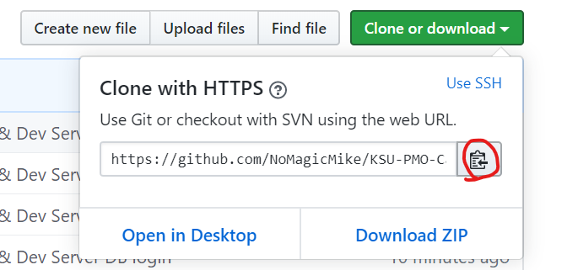

1. Open Atom, and click on Github at the bottom right:

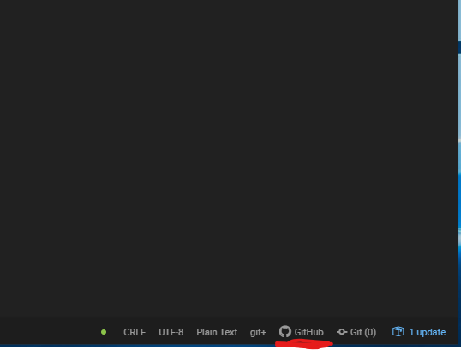

1. Click “Clone an existing Github repository” and enter the URL we copied earlier, then click **Clone**

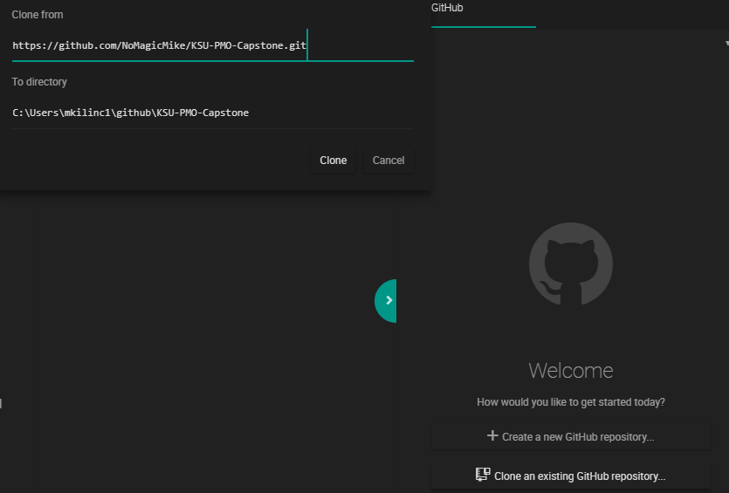

1. GitHub should then ask you to log in, Follow the instructions on the login screen

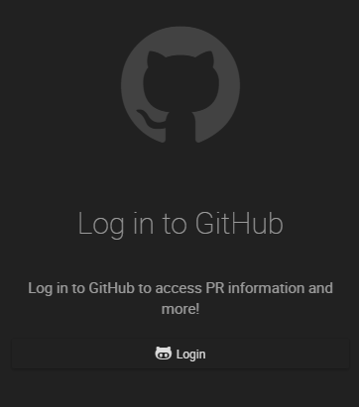

**You are now connected! **Note – It will default to the master Branch. Please do not modify the files.**

# How to Create a New Branch

1. First, find your way to the bottom right of the screen, where you will see a Branch Icon, and the word “master” 
2. Click on “master” and click on “New Branch” …Enter in a new branch name. The branch name should be named after the feature you are adding at that time (for example, “Adding-Logon-Screen). For this example I will use “Adding-Github-Guide”. Enter the name and click “New Branch” again. **Remember, always use a new or existing branch. Use the same branch if you are working on the same feature. NEVER USE MASTER(Unless you are fetching and pulling. Explained later).**



The branch icon at the bottom right should now change to the new name. 

# How to Commit and Push

1. Next to the Github Icon on the bottom right, you will also see an Icon that says “Git”. Click on it to open the Git window
2. The git window will display all your changes as you work. When you are done, hit “Stage All” at the top right

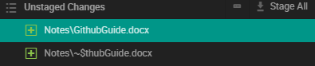

1. Your changes will then move to “Staged”. Here, write a commit message below the changes. Make sure it is relatively descriptive so someone reading can understand what changed.

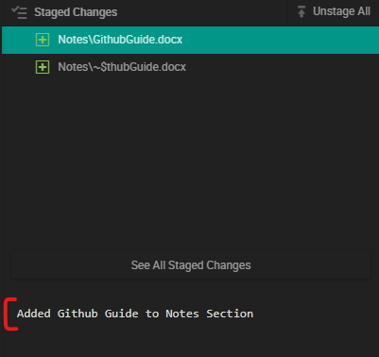

1. Click **Commit to <Branch Name>**

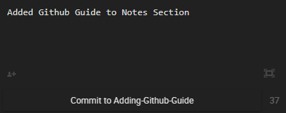

1. You will notice the change log update with your message.



1. We’re not done! Although this is a commit, it is not yet published to github. Click on the “Publish: Icon at the bottom  It will change to “Pushing”, then “Fetch”, once you see “Fetch”, **you have pushed to Github!** We can now see this change on Github.com.



Please note, this change will only appear in the branch you created, until it is merged with the Master.

# How to Fetch and Pull

1. What do we do when someone updates a branch or the master? We’ll need to fetch, and pull. First, under the Git Menu, click on the “Fetch” Icon 
2. If there are changes, it will say “Pull” and the number of changes. I have added a PDF Document from github.com to demonstrate this. . Click on Pull
3. You will then see the changed or added file updated in Atom. It will also show up in the change log to the right.



1. It is important to occasionally pull changes to your branches and master, so you can have the most up to date version of your files.