1.- Go to <https://github.com>

2.- Create new repository **project-demo**

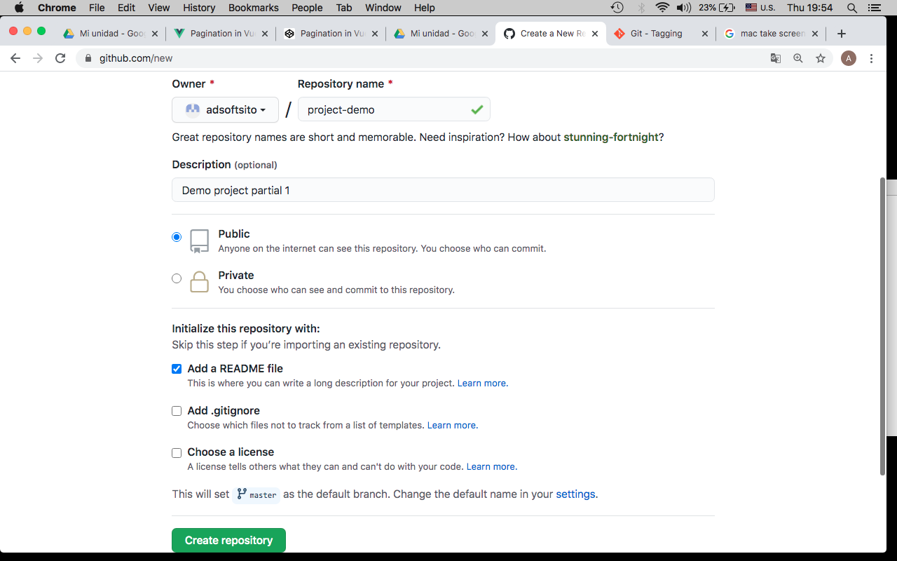

3.- copy url repository

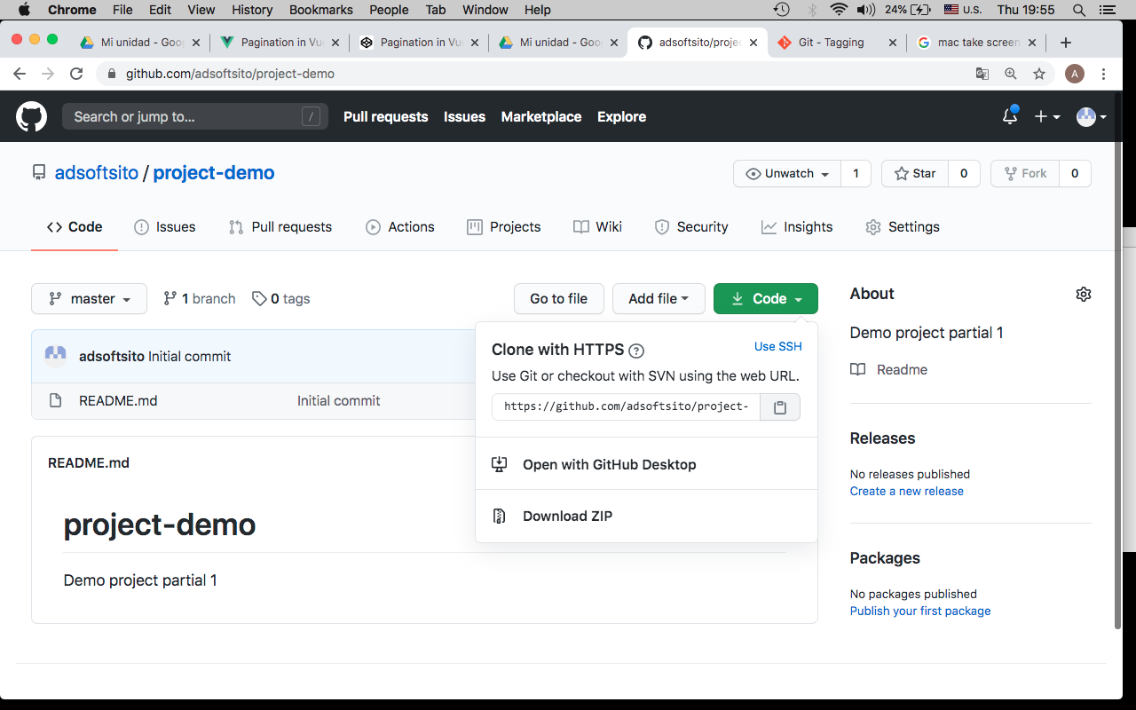

4.- clone repository in wokstation

$ git clone [https://github.com/<gituser>/project-demo.git](https://github.com/%3cgituser%3e/project-demo.git)

5.- change to repo directory

$ cd project-demo

6.- check url repository

$ pwd

$ git remote –v

*origin https://github.com/adsoftsito/project-demo.git (fetch)*

*origin https://github.com/adsoftsito/project-demo.git (push)*

7.- edit README.md, add # v0.1 tag

$ vi README.md

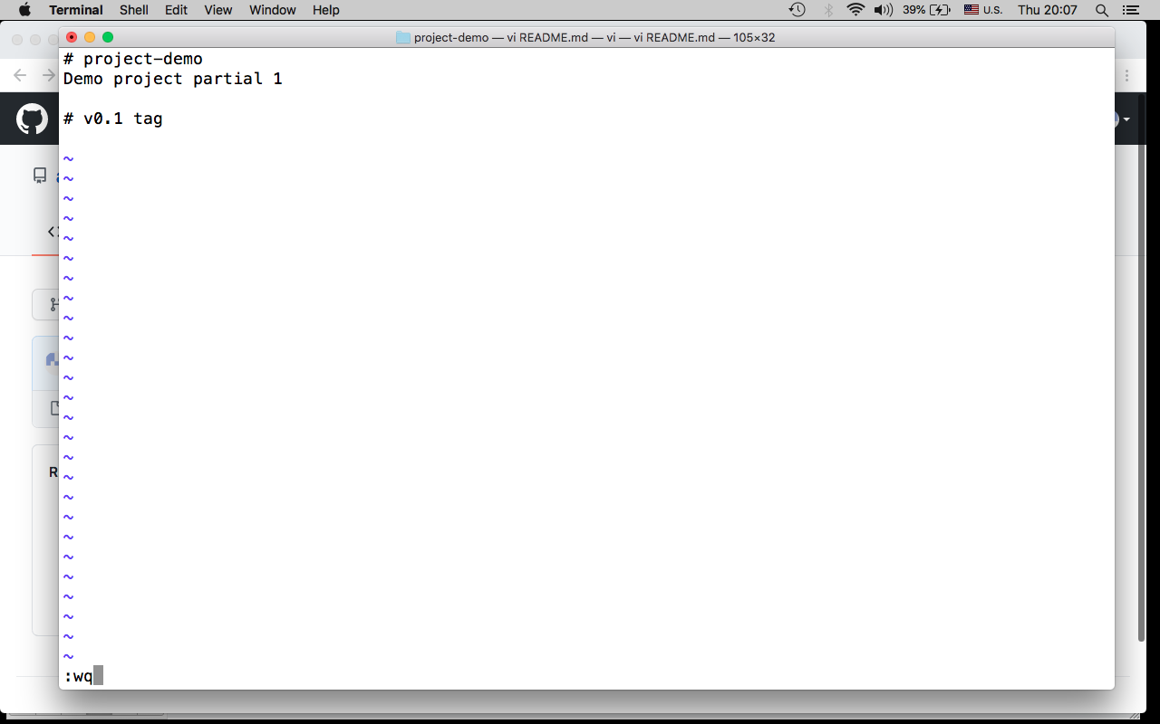

8.- commit, push changes

$ git add .

$ git commit -m "update README with v0.1 tag"

$ git push –u origin master

9.- tag base code with v0.1

*$ git tag -a v0.1 -m "my version 0.1"*

*$ git tag*

*$ git show v0.1*

9.- publish tag

$ git push origin v0.1

10.- create branch develop

$ git branch develop

$ git checkout develop

11.- commit, push changes

$ git add .

$ git commit –m “init develop branch”

$ git push –u origin develop

12.- add team members to repository

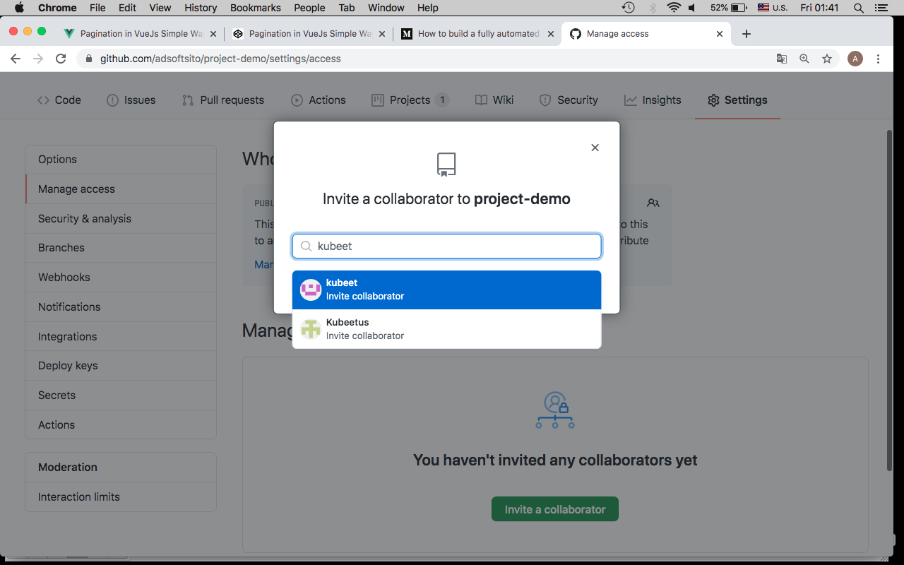

13.- créate Project in github.com, select Automated Kanban Project template.

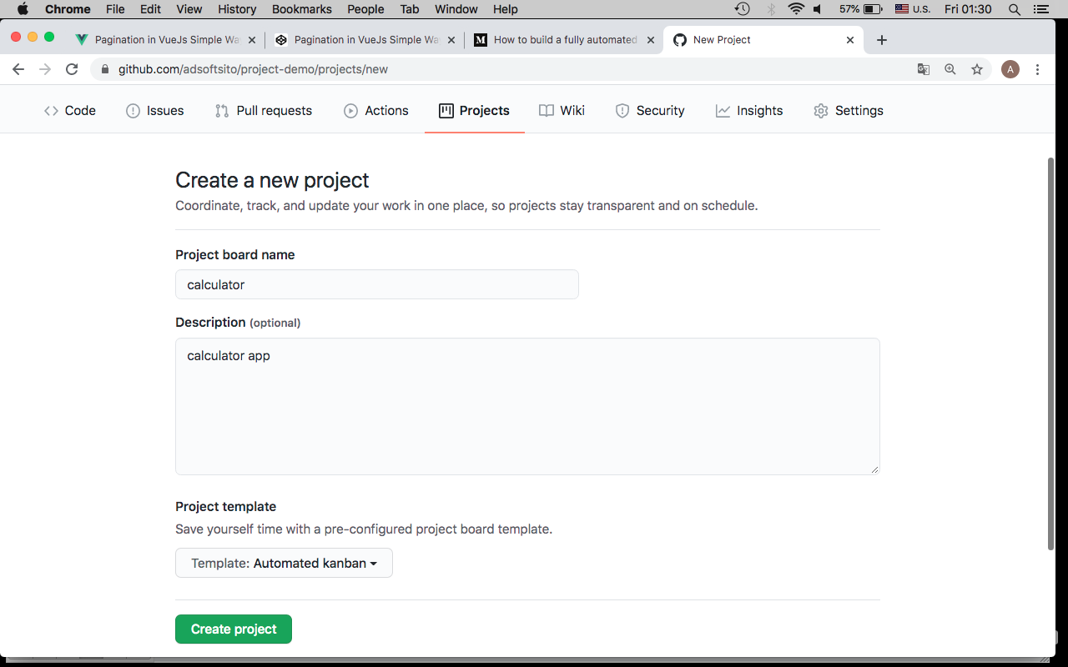

14.- Delete default cards in To do Column

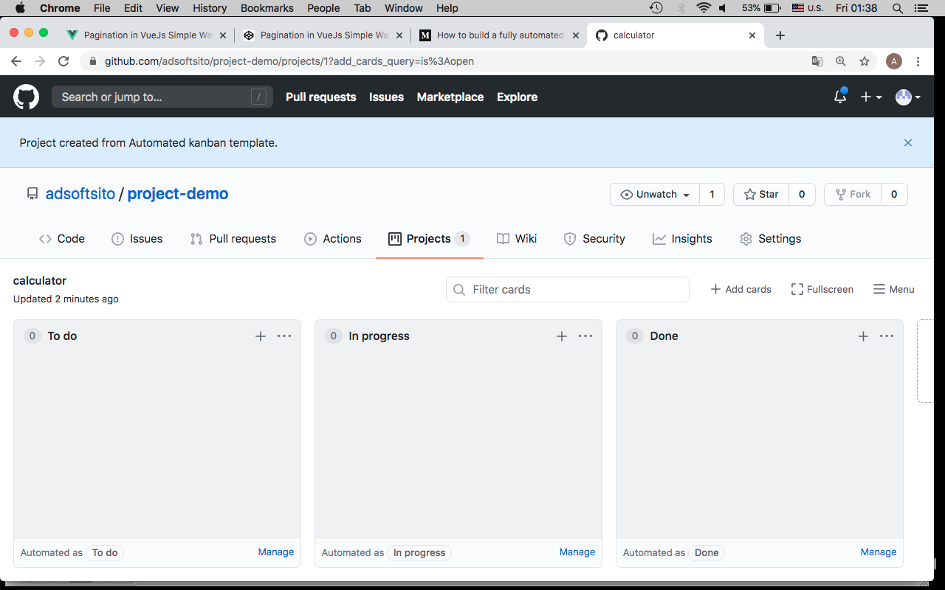

14.- créate “simple calculator” milestone

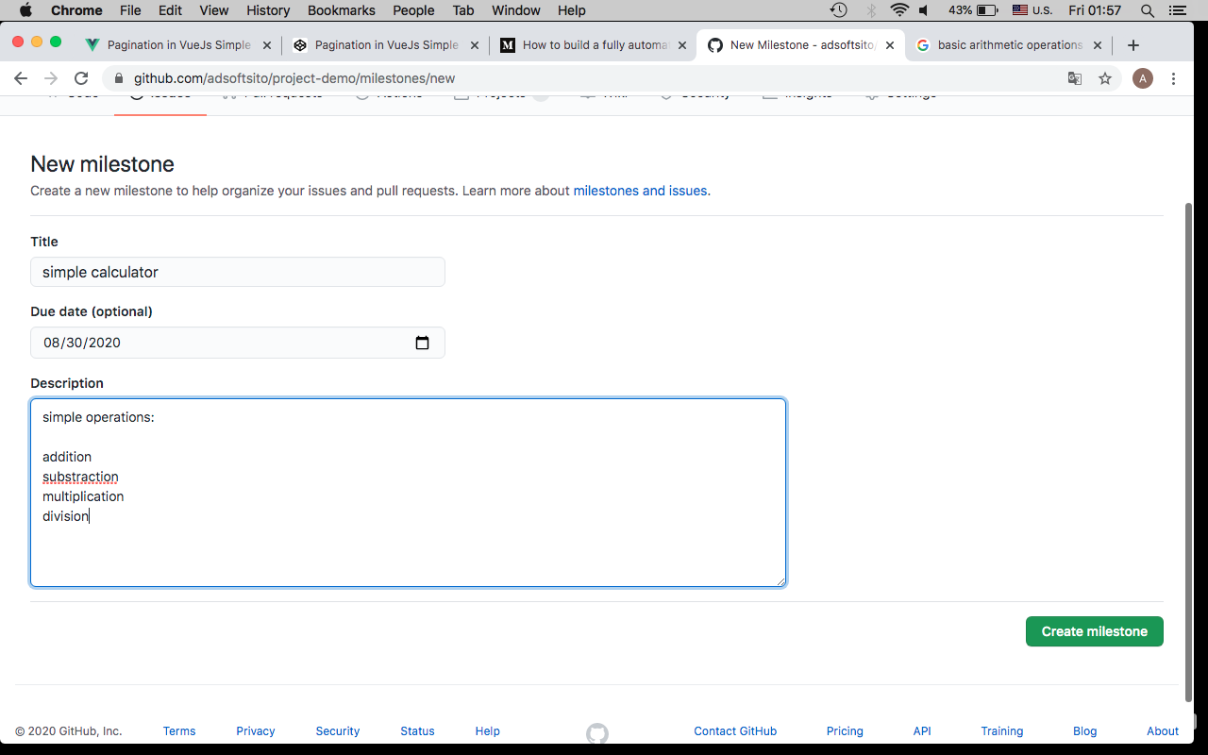

14.- créate “scientific calculator” milestone

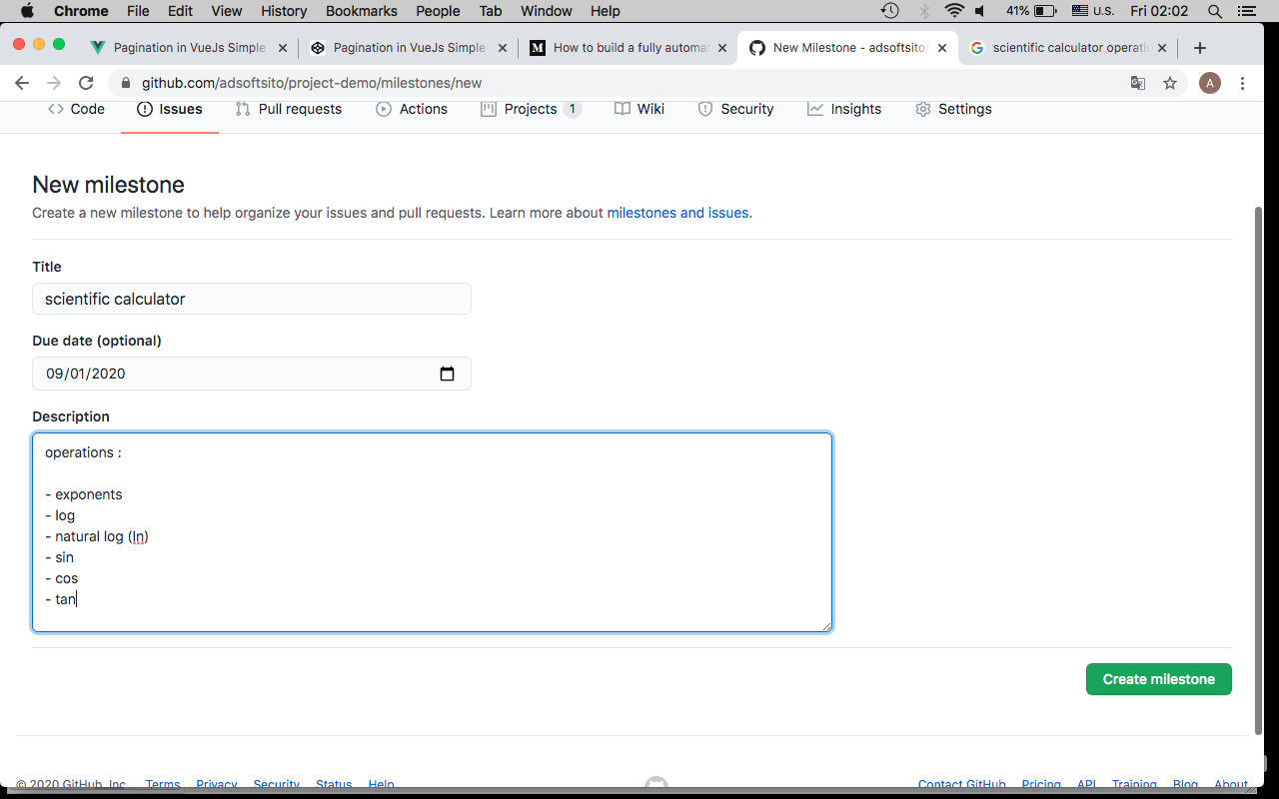

15.- Add addition issue’s to calculator Project

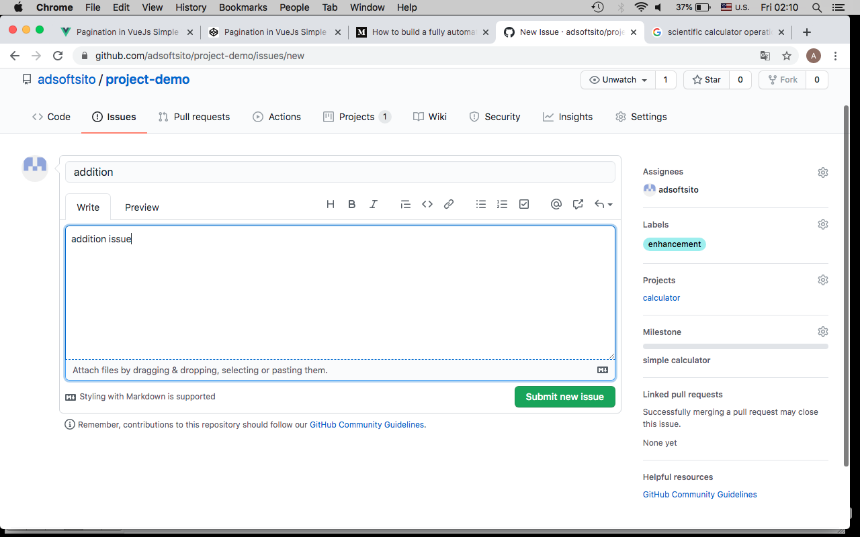

16.- complete issue’s according the next table

|  |  |  |  |  |  |
| --- | --- | --- | --- | --- | --- |
| issue name | write | assignees | labels | Project | milestone |
| addition | add .. | developer1 | enhancement | calculator | simple calculator |
| substraction | sub … | developer2 | enhancement | calculator | simple calculator |
| multiplication | mul … | developer3 | enhancement | calculator | simple calculator |
| division | div … | developer4 | enhancement | calculator | simple calculator |
| exponents | exp … | developer1 | enhancement | calculator | scientific calculator |
| log | log … | developer2 | enhancement | calculator | scientific calculator |
| natural log | ln … | developer3 | enhancement | calculator | scientific calculator |
| sin | sin … | developer4 | enhancement | calculator | scientific calculator |
| cos | cos … | developern | enhancement | calculator | scientific calculator |
| tan | ln … | developern | enhancement | calculator | scientific calculator |

17.- issue’s should looks like :

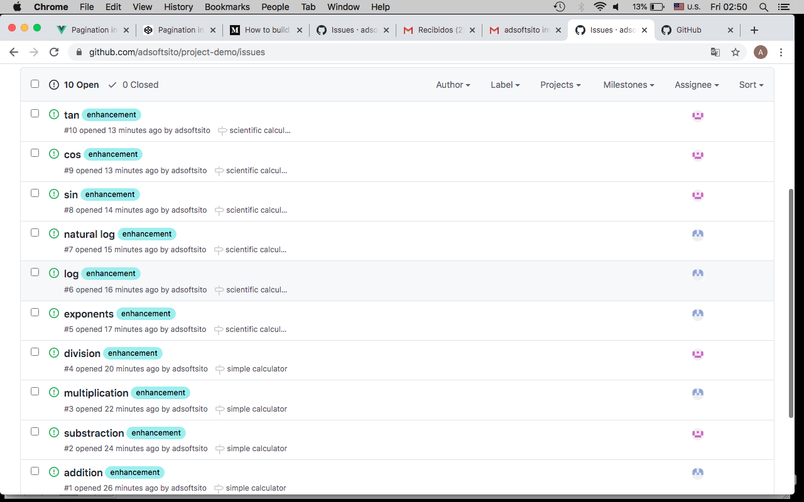

18.- calculator Project board looks like :

