**Introduction to Computer Programming (Java A)**

**Lab 10**

**[Objective]**

* Learn inheritance.
* Learn protected keyword.
* Learn to use enum types.

**[Exercises]**

**Part 1: Enumerations**

An enum type is a special data type that enables a variable to be a set of predefined constants. The variable must be equal to one of the values that have been predefined for it. For example, a week has seven days (MONDAY to SUNDAY).

A enum type is declared using the enum keyword, not class. Let’s create a new enum type Direction with four constants named “NORTH”, “SOUTH”, “EAST”, and “WEST”, respectively. In IDEA, creating a new enum type is similar to creating a new class. The only difference is to select “Enum” in the dropdown list.

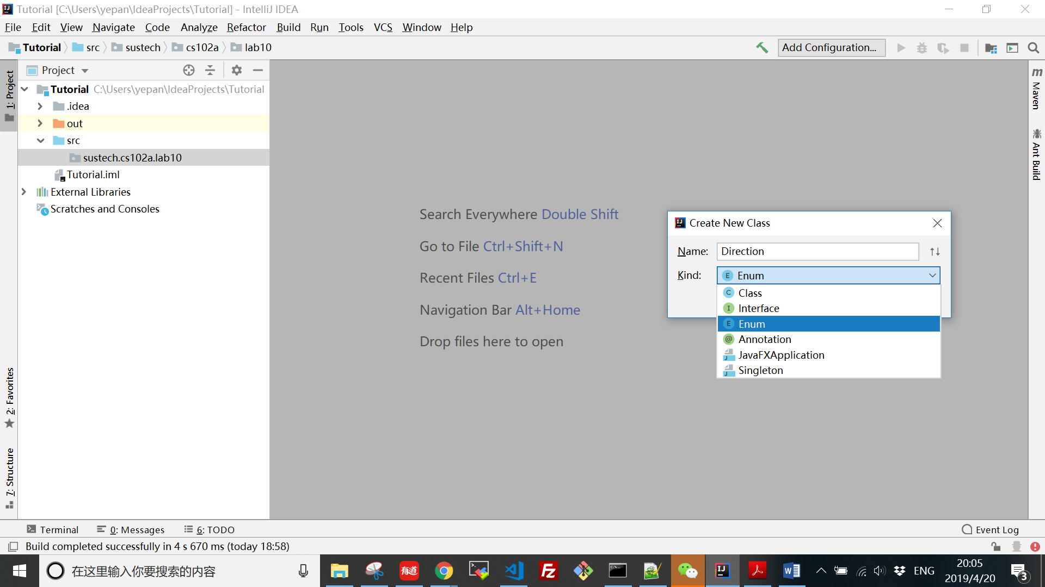

**package** sustech.cs102a.lab10;  
  
**public enum** Direction {  
 ***NORTH***, ***SOUTH***, ***EAST***, ***WEST*** *// semicolon unnecessary*}

Variables of this enum type Direction can only receive the values of the four enum constants. For example, the following code creates an object of this enum type.

**package** sustech.cs102a.lab10;  
  
**public class** DirectionTest {  
 **public static void** main(String[] args) {  
 Direction d = Direction.***EAST***;  
 System.***out***.println(d);  
 }  
}

The above code prints “EAST”. The last statement in the main method is equivalent to System.out.println(d.toString()). The toString() method returns the name of the enum constant EAST.

In the code, **we cannot create an object of the enum type using the “new” operator with a constructor call.** If you compile the following code, you will receive the error message “Enum types cannot be instantiated”.

public Direction d = new Direction();

This is because under the hood, every enum type is internally implemented using class (**the compiler will create a private constructor that cannot be called outside the enum type**).

*public final class Direction extends Enum {*

*public* ***static final*** *Direction NORTH = new Direction();*

*public* ***static final*** *Direction SOUTH = new Direction();*

*public* ***static final*** *Direction EAST = new Direction();*

*public* ***static final*** *Direction WEST = new Direction();*

*} // simplified for illustration*

From this internal view, we can see that NORTH, SOUTH, EAST, WEST are no more than four class variables pointing to four Direction objects. The final modifier makes them constants.

An enum type variable can be passed as an argument to a “switch” statement.

**package** sustech.cs102a.lab10;  
  
**public class** DirectionTest {  
  
 **private** Direction **d**;  
  
 **public** DirectionTest(Direction d) {  
 **this**.**d** = d;  
 }  
  
 **public** Direction getDirection() {  
 **return d**;  
 }  
  
 **public static void** main(String[] args) {  
 DirectionTest test = **new** DirectionTest(Direction.***EAST***);  
 **switch**(test.getDirection()) {  
 **case *EAST***: *// must be unqualified name of the enum constant* System.***out***.println(**"Countries in the east: Japan, Korea"**);  
 **break**;  
 **case *WEST***:  
 System.***out***.println(**"Countries in the west: US, Germany"**);  
 **break**;  
 **case *SOUTH***:  
 System.***out***.println(**"Countries in the south: Australia, New Zealand"**);  
 **break**;  
 **case *NORTH***:  
 System.***out***.println(**"Countries in the north: Russia, Mongolia"**);  
 **break**;  
 }  
 }  
}

When declaring an enum type, ***besides the enum constants, we can also declare other members*** such as **constructors**, **fields** and **methods**. A enum type constructor can specify any number of parameters and can be overloaded, but it cannot have the access modifier public (**must be private or no-modifier, meaning package private**).

**package** sustech.cs102a.lab10;  
  
**public enum** Book {  
 ***JHTP***(**"Java: How to Program"**, **"2012"**),  
 ***CHTP***(**"C: How to Program"**),  
 ***CPPHTP***(**"C++: How to Program"**, **"2012"**),  
 ***VBHTP***(**"Visual Basic: How to Program"**, **"2011"**),  
 ***CSHARPHTP***(**"Visual C#: How to Program"**);  
  
 **private final** String **title**;  
 **private final** String **year**;  
  
 **private** Book(String title, String year) {  
 **this**.**title** = title;  
 **this**.**year** = year;  
 }  
  
 **private** Book(String title) {  
 **this**.**title** = title;  
 **this**.**year** = **"no info"**;  
 }  
  
 **public** String getTitle() {  
 **return title**;  
 }  
  
 **public** String getYear() {  
 **return year**;  
 }  
}

In the enum type Book, there are two fields: title and year. They are declared to be constants since enum type objects only receive predefined constant values (enum constants). There are two getter methods. There are two overloaded constructors. The two constructors are used in the declarations of the enum constants. For example, when declaring the enum constant CHTP, the one-argument constructor is used.

We can further write the following program to test the enum type.

**package** sustech.cs102a.lab10;  
**import** java.util.EnumSet;  
  
**public class** BookTest {  
 **public static void** main(String[] args) {  
 System.***out***.println(**"All books:"**);  
  
 **for** (Book book : Book.*values*()) {  
 System.***out***.printf(**"%-10s"**, book);  
 System.***out***.printf(**"%-30s"**, book.getTitle());  
 System.***out***.printf(**"%s\n"**, book.getYear());  
 }  
  
 System.***out***.println(**"\nDisplaying a range of enum constants:"**);  
  
 **for**(Book book : EnumSet.*range*(Book.***JHTP***, Book.***CPPHTP***)) {  
 System.***out***.printf(**"%-10s"**, book);  
 System.***out***.printf(**"%-30s"**, book.getTitle());  
 System.***out***.printf(**"%s\n"**, book.getYear());  
 }  
 }  
}

The code prints:

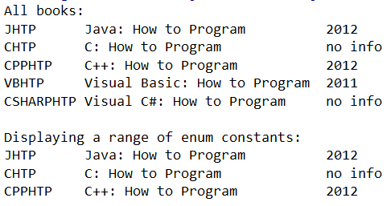

In the above example, only five Book objects will be created. The constants such as Book.JHTP stores the references to the objects.

The **values()** method is a static method that is automatically generated by the compiler to return an array of the enum constants (an array of references to the objects of the enum type).

The generic class EnumSet’s static method range() returns a collection of the enum constants in the range specified by two endpoints. In the above code, range() takes two enum constants as arguments. **The first constant should be declared before the second** (the ordinal() method of a enum constant can return the position of the constant in all declared constants). If this constraint is violated (for example, when **EnumSet.range(Book.CPPHTP, Book.JHTP)** is used in the code), an **java.lang.IllegalArgumentException** will be thrown.

**Lab exercise：**

1. Create an enum type PhoneModel, which contains the following constants: IPHONE, HUAWEI, PIXEL, SAMSUNG, LG.
2. Create a field named price (int type). Write a getter method for this field.
3. Create a one-argument constructor PhoneModel(int price) that can be used to create the enum constants. The prices for the five models are: 9999, 8888,6666, 9399, 5588.
4. Write a test program .It contains a main method that recommends possible phones for a user based on the user’s budget.

Three sample runs:

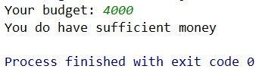

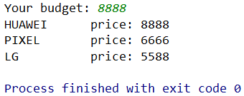

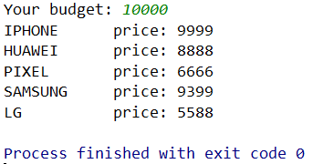

**Part 2: Inheritance**

**Copy the following code to Circle.java**

|  |
| --- |
| public class Circle {  private double radius;  private double x;  private double y;  static final int DEFAULT_RADIUS = 5;  private static int screenSize = 10;  private ShapeColor color = ShapeColor.GRAY;  public Circle(double radius, double x, double y) {  this.radius = radius;  this.x = x;  this.y = y;  }  public Circle(double radius) {  this.radius = radius;  this.x = 0;  this.y = 0;  }  public Circle(double x, double y) {  this.radius = DEFAULT_RADIUS;  this.x = x;  this.y = y;  }  public static int getScreenSize() {  return screenSize;  }  public static void setScreenSize(int screenSize) {  Circle.screenSize = screenSize;  }  public void checkColor() {  if (isInBoundary()) {  color = ShapeColor.GREEN;  } else {  color = ShapeColor.RED;  }  }  public boolean isInBoundary() {  if (-1 * Circle.screenSize > this.x - this.radius || Circle.screenSize < this.x + this.radius) {  return false;  }  if (-1 * Circle.screenSize > this.y - this.radius || Circle.screenSize < this.y + this.radius) {  return false;  }  return true;  }  @Override  public String toString() {  return "Circle{" + "radius=" + " x=" + x +  ", y=" + y + ", color=" + color + "}\n";  }  public double getRadius() {  return radius;  }  public void setRadius(double radius) {  this.radius = radius;  }  public double getX() {  return x;  }  public void setX(double x) {  this.x = x;  }  public double getY() {  return y;  }  public void setY(double y) {  this.y = y;  }  public void draw() {  StdDraw.setPenColor(color.getColor());  StdDraw.filledCircle(x, y, radius);  }  } |

**Copy the following code to Rectangle.java**

|  |
| --- |
| public class Rectangle {  private double x;  private double y;  private double width;  private double height;  private static int screenSize = 10;  private ShapeColor color = ShapeColor.GRAY;  public Rectangle(double x, double y) {  this.x = x;  this.y = y;  }  public Rectangle(double x, double y, double width, double height) {  this.x = x;  this.y = y;  this.width = width;  this.height = height;  }  public static int getScreenSize() {  return screenSize;  }  public static void setScreenSize(int screenSize) {  Rectangle.screenSize = screenSize;  }  public void checkColor() {  if (isInBoundary()) {  color = ShapeColor.GREEN;  } else {  color = ShapeColor.RED;  }  }  public boolean isInBoundary() {  if (-1 * Rectangle.screenSize > this.x - this.width / 2 || Rectangle.screenSize < this.x + this.width / 2) {  return false;  }  if (-1 * Rectangle.screenSize > this.y - this.height / 2 || Rectangle.screenSize < this.y + this.height / 2) {  return false;  }  return true;  }  public double getX() {  return x;  }  public void setX(double x) {  this.x = x;  }  public double getY() {  return y;  }  public void setY(double y) {  this.y = y;  }  public double getWidth() {  return width;  }  public void setWidth(double width) {  this.width = width;  }  public double getHeight() {  return height;  }  public void setHeight(double height) {  this.height = height;  }  public String toString() {  return "Rectangle{" + "width=" + width + ", height=" + height + " x=" + x +  ", y=" + y + ", color=" + color + "}\n";  }  public void draw() {  StdDraw.setPenColor(color.getColor());  StdDraw.filledRectangle(x, y, this.width / 2, this.height / 2);  }  } |

**Copy the following code to ShapeColor.java**

|  |
| --- |
| import java.awt.Color;  public enum ShapeColor {  GREEN("The shape is in the Screen", Color.GREEN), RED("The shape is not in the Screen",  Color.RED), GRAY("Haven't tested", Color.GRAY);  private String desc; // The description of instance  private Color color; // The color of instance  ShapeColor (String desc, Color color) {  this.desc = desc;  this.color = color;  }  public String getDesc() {  return this.desc;  }  public Color getColor() {  return this.color;  }  } |

**Download StdDraw.java from the internet or from our course site ( blackboard /sakai ) . Place it at the same location as the above 3 java files.**

Now, you should have 4 java files prepared and start the following exercises.

1. **Inheritance**

From the source code, it is observed that the two classes: Circle and Rectangle have a lot of common fields, e.g., **screenSize, x, y** and **ShapeColor**, and **a lot of similar methods.** It is a good time to practice inheritance by refactoring the code.

The idea of inheritance is simple but powerful: When you want to create a new class and there is an existing class which includes some of the code that you want, you can extend your new class from the existing class. In doing this, you can reuse the fields and methods of the existing class without having to write (and debug!) them yourself.

A subclass inherits all the members (fields, methods, and nested classes) from its superclass. Constructors are not members, so they are not inherited by subclasses, but the subclass must invoke one of the constructors in its superclass.

(<https://docs.oracle.com/javase/tutorial/java/IandI/subclasses.html> )

We found that, the attributes **x**, **y**, **color** and **screenSize** are both in **Circle** and **Rectangle**, then for those common attributes are more appropriated to be extracted into a super class named **Shape**, from which the subclass can use all attributes and methods.

Create a class Shape, which contains following members:

1. Adding attributes:

**private double x**;  
**private double y**;  
**private** ShapeColor **color** = ShapeColor.***GRAY***;  
**private static int** *screenSize* = 10;

1. Adding constructors with two parameters **x** and **y** in the Shape class.

**public** Shape(**double** x, **double** y) {  
 **this**.**x** = x;  
 **this**.**y** = y;  
}

1. Adding getter/setter methods for the private variable;
2. Adding toString() method (override the method of the Object class) to output the property of the Shape object;

@Override  
**public** String toString() {  
 **return " x="** + **x** + **", y="** + **y** + **", color="** + **color**;  
}

**Now, modify class Circle.**

**Let it inherit class Shape by using the keyword extends.**

**Remove those methods and attributes which can be inherited from class Shape.**

Now class Circle only needs to define two specific attributes: radius and DEFAULT_RADIUS.

**private double radius**;  
**private static final int *DEFAULT_RADIUS*** = 5;

**Modify the constructor of class Circle as follows and use super ().**

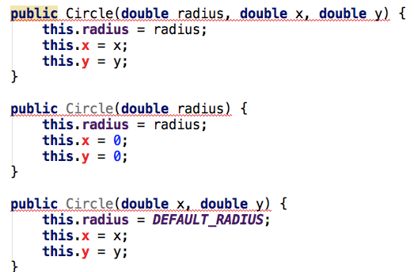

Now, x and y are the attributes inherited from **Shape.** A recommend way is to use the constructor of super class to initial the supper class.

For example:

**public** Circle(**double** radius) {  
 **super**(0,0);  
 **this**.**radius** = radius;  
}

**this** serves as the current object, while **super** serves as the only supper class for current object.

Rewrite other constructors in the same way.

**Learn how to access the instance fields and static fields of super class in a subclass.**

We will find that some errors occur in other methods, for example:

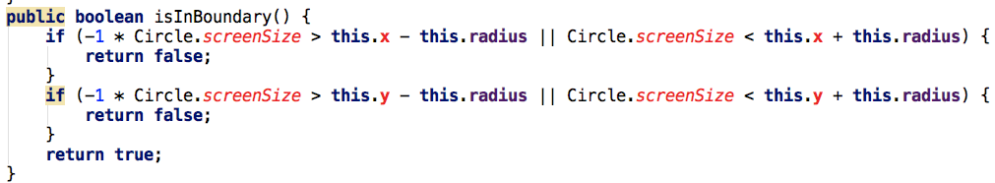

Change **Circle.screenSize** to **Shape.getScreenSize()** since screenSize is a private static field.

Change **this.x** to **super.getX()** since x is a private field of supper class, and so on.

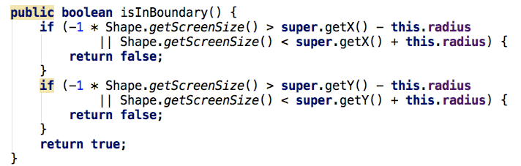

Change other methods in the same way.

**Learn protected keyword**

We can find that Circle is inconvenient to access the private attributes of superclass, so we can consider making these frequent-used attributes accessible to subclass.

**Protected** can help us.

**Step1:** Change **x, y** and **color** from **private** to **protected**.



**Step2:** Then we change the isInBoundary() back to the original one except Shape.getScreenSize(), it can work well.

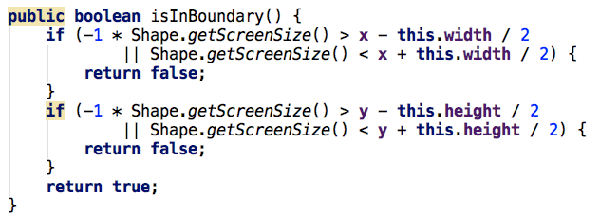

Change other methods in the same way.

The access right of each access modifier is shown as follows:

|  |  |  |  |  |
| --- | --- | --- | --- | --- |
|  | private | default | protected | public |
| Same package same class | √ | √ | √ | √ |
| Same package other classes |  | √ | √ | √ |
| Other packages Other classes  Inheritance |  |  | Inherit but cannot access directly | √ |
| Other packages Other classes  No inheritance |  |  |  | √ |

**Lab exercise：**

Now, modify the given class **Rectangle** to make it inherits from class Shape

1. Make **Rectangle** extends **Shape**.
2. Modify the constructors of **Rectangle**
3. Modify other methods of **Rectangle**.
4. Modify **toString()** method.

Run the following **ShapeTest** to test your modifications.

|  |
| --- |
| public class ShapeTest {  public static void main(String[] args) {  Circle c1=new Circle(0.1,1,1);  Circle c2=new Circle(0.1,0.5,2);  Circle.setScreenSize(2);  System.out.print(c1);  c1.checkColor();  c2.checkColor();  System.out.print(c1);  System.out.print(c2);    Rectangle r1=new Rectangle(0,0,0.5,0.5);  Rectangle r2=new Rectangle(2,1,0.5,0.5);  Rectangle.setScreenSize(2);  System.out.print(r1);  r1.checkColor();  r2.checkColor();  System.out.print(r1);  System.out.print(r2);    StdDraw.setXscale(-Circle.getScreenSize(), Circle.getScreenSize());  StdDraw.setYscale(-Circle.getScreenSize(), Circle.getScreenSize());  c1.draw();  c2.draw();  r1.draw();  r2.draw();  Circle c3=new Circle(0.1,0.5,-2);  Rectangle r3=new Rectangle(-2,1,0.5,0.5);  c3.draw();  r3.draw();  }  } |

Output:

Circle{radius=0.1, x=1.0, y=1.0, color=GRAY}

Circle{radius=0.1, x=1.0, y=1.0, color=GREEN}

Circle{radius=0.1, x=0.5, y=2.0, color=RED}

Rectangle{width=0.5, height=0.5 x=0.0, y=0.0, color=GRAY}

Rectangle{width=0.5, height=0.5 x=0.0, y=0.0, color=GREEN}

Rectangle{width=0.5, height=0.5 x=2.0, y=1.0, color=RED}

