**Basis of Computer Programming (Java A)**

**Lab Exercise 6**

**[Experimental Objective]**

* Learn how to use static method
* Learn how to use static method from other class
* Learn how to use method overloading
* Learn how to use two dimensional arrays
* Learn to develop and invoke methods with array arguments and return values.

**[****Exercises]**

1. Create a class named ***MyTriangle*** that contains two static methods
   1. **public static double area(double a, double b, double c)**
   2. **public static double perimeter(double a, double b, double c)**

to compute area and perimeter of a triangle respectively given three *valid* sides ***a***, ***b*** and ***c***.

And add a static method

/** Return true if the sum of any two sides is greater than the third side. **/

* 1. **public static boolean isValid(double a, double b, double c)**

In the main method of ***MyTriangle***, test the three methods you write.

1) Get ***a***, ***b*** and ***c*** from the Console

2) If ***a*** is -1, exit your program and print **“Bye~”**

3) If ***a*** is not -1, use ***isValid*** to check the input

4) If the input is valid, compute the area and perimeter and print them

5) If the input is not valid, return false and print **“The input is invalid.”**

6) Go to **1)**

*Tips: To call a method in the same class, you can try* ***method_name****( ).*

Sample:

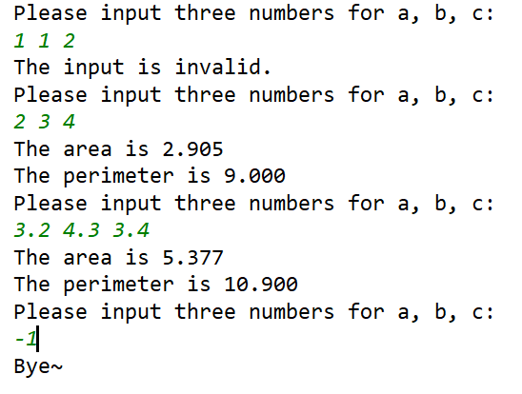

1. In the ***MyTriangle***class created in Exercise 1, add two another static overloaded methods
   1. **public static double area(double bottom, double height)**
   2. **public static double area(double a, double b, int angleOfAandB)**

to compute the area.

The **a)** method is to compute area by ***bottom*** and ***height***:

***area*** = 1/2 * ***bottom*** * ***height***

And the **b)** method is to compute area by two sides ***a***, ***b*** and the angle between the two sides(***angleOfAandB***)

***area*** = 1/2 * ***a*** * ***b*** * sin(***angleOfAandB***)

Then create another class ***Lab6E2*** that contains the main method.

In the main method:

1) Read ***bottom*** and ***height*** from the Console to compute area by calling the corresponding method you created in ***MyTriangle***;

2) Read two sides ***a***, ***b*** and ***angleOfAandB*** from the Console to compute area by calling the corresponding method you created in ***MyTriangle***.

*Tips: To call a* **static** *method in another class* ***class_name*** *under the same file directory, you can try* ***class_name****.****method_name****( ).*

Sample:

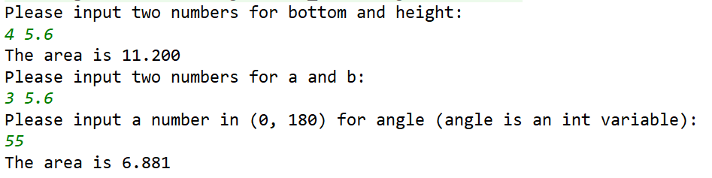

1. Enter an integer ***n***, please output the ***n***th term of Fibonacci sequence. (starting from 0, the 0th term is 0)

*\** *Fibonacci sequence: f(n) = f(n-1) + f(n-2)*

Sample：



1. Given a chessboard, 1 represents a black grid and 0 represents a white grid. If a grid is white and the top, bottom, left, and right grids of it are black, we call this grid a "bingo" grid. Please write a method:

**public static boolean check(int[][] board, int row, int column)**

*\*board is the chessboard, board[row][column] is the target grid*

to determine whether a grid is a bingo grid. Use this method to calculate how many bingo grids are on the board and output the result.

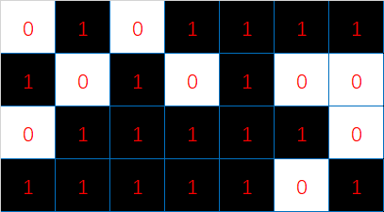

Sample:

