Lab 5 - Report

Student name: Bakhramov Abdulaziz
Student ID: 24B031692
Group: Mon 11:00-13:00

L3 Switch
- Create VLANs
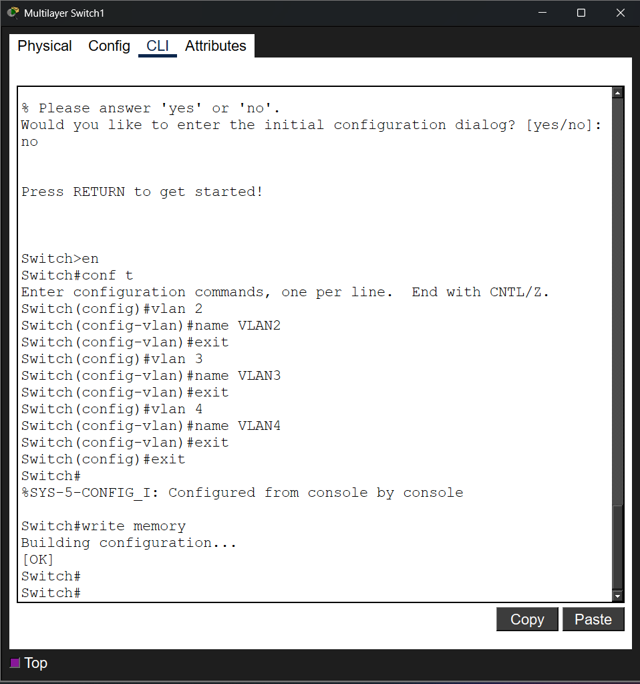

- Assign ports to VLAN
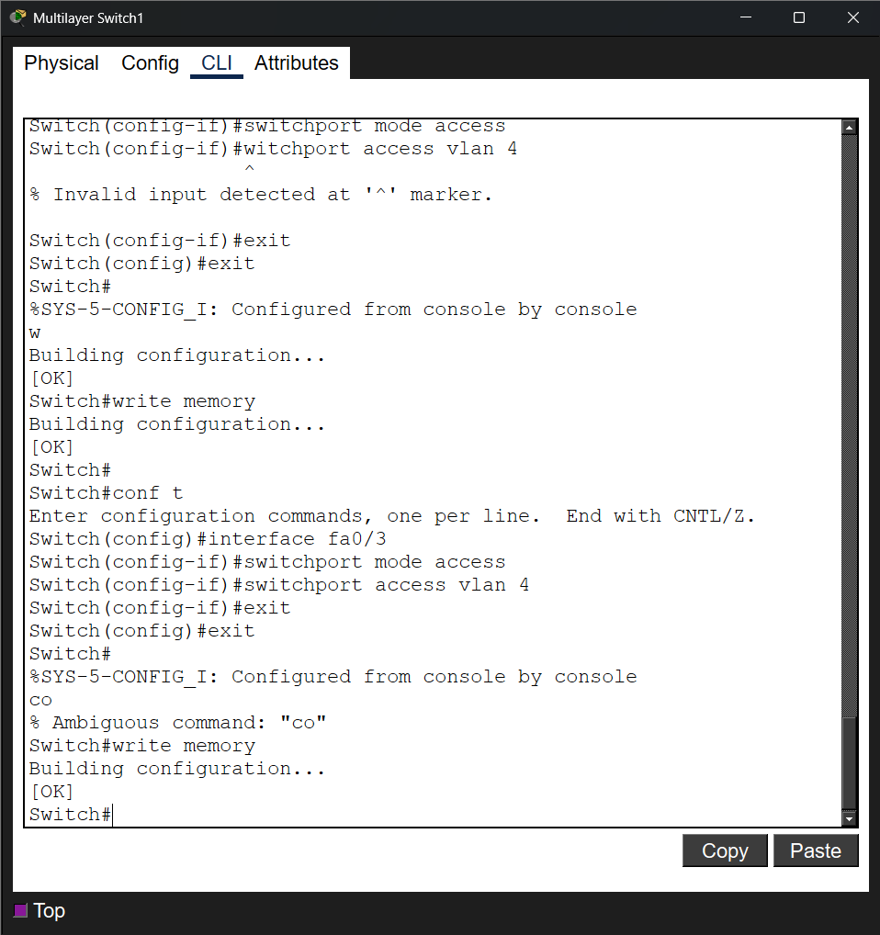

- Assign IP Addresses to VLAN Interfaces
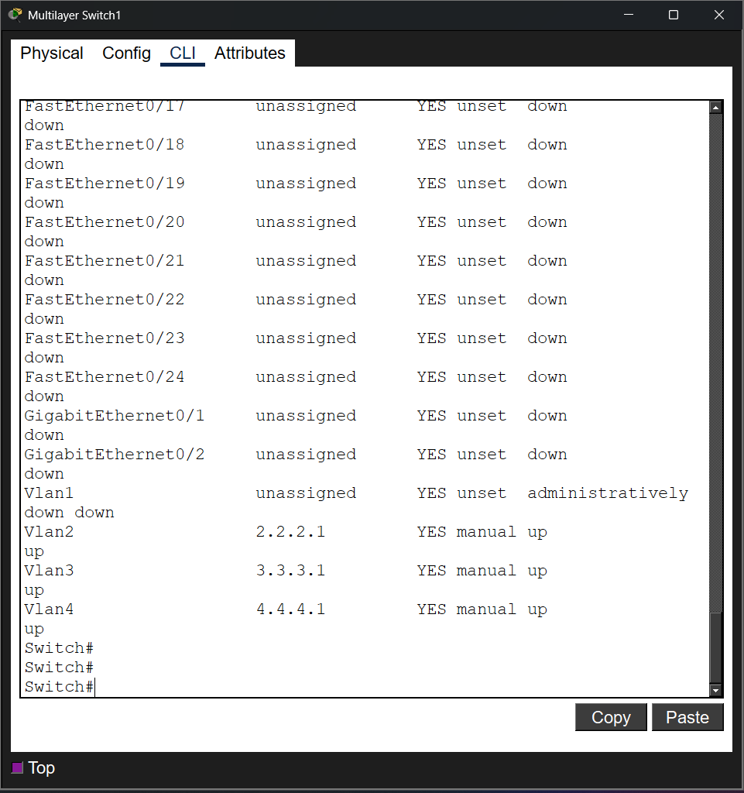

- Assign IP addresses
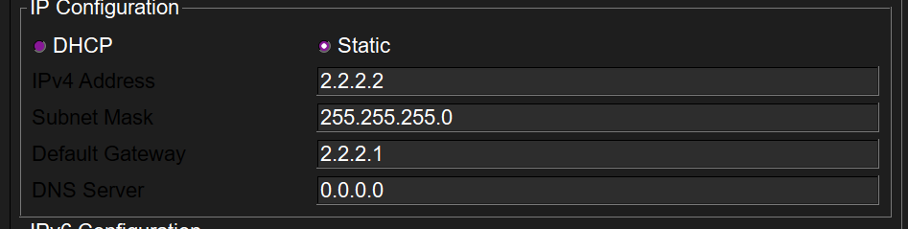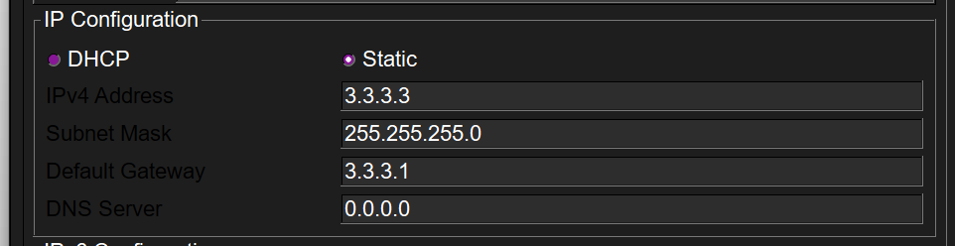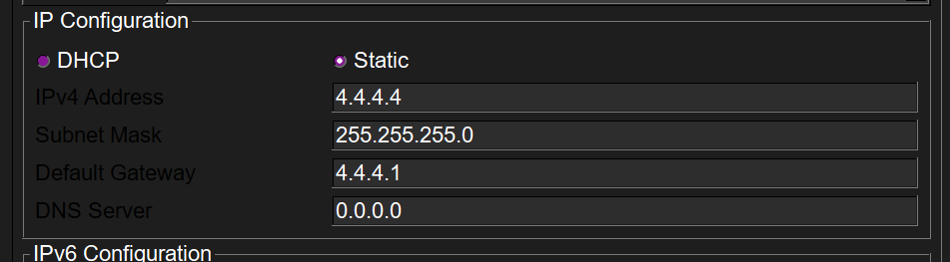

- Enable IP Routing
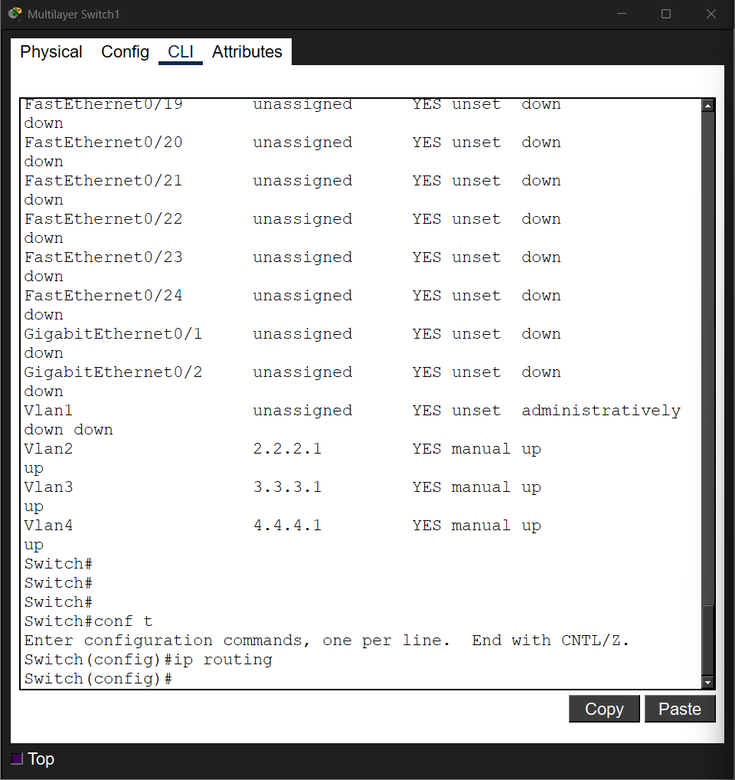

QUESTIONS:
- What problem does VLAN segmentation solve in a network?
Separates isolated segments in the network, reduces broadcast traffic and improves security.

- What does the ip routing command do in a L3 switch?
Enables inter-VLAN routing

- What is the difference between L2 and L3 Switches?
L2: switches via MAC, no routing.
L3: switches via MAC + routes via IP.

- L3 Switch as a Distribution Layer
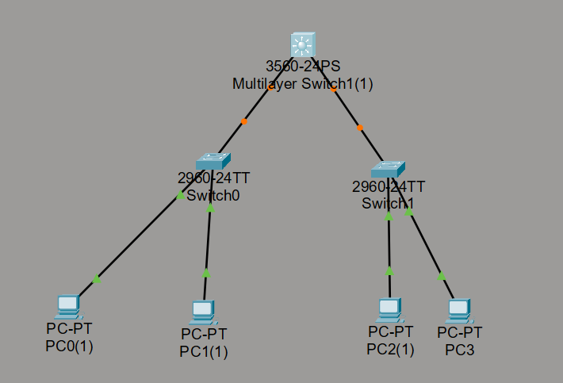

- L2 Swich 3 and 4
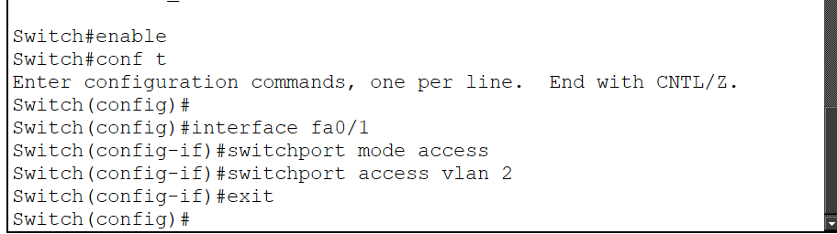
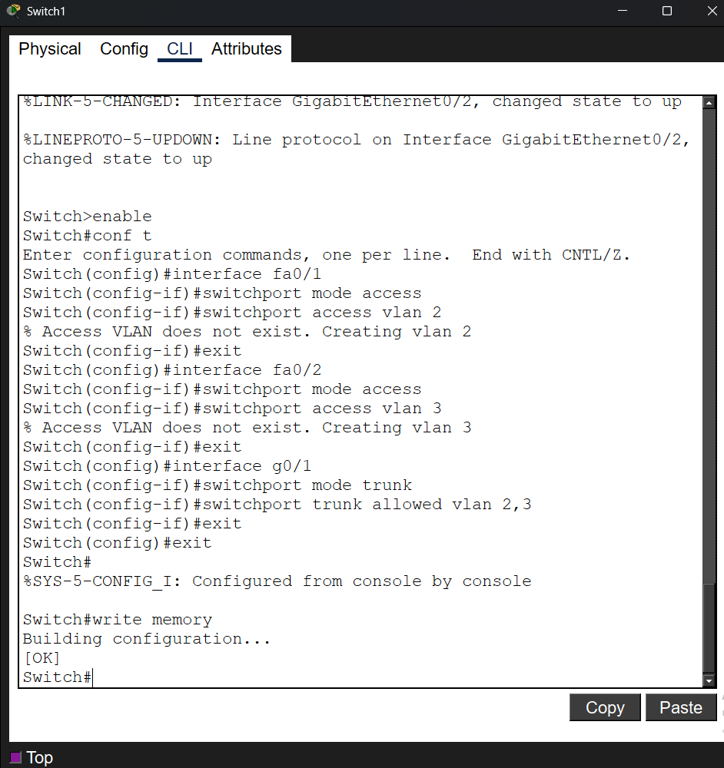

- L3 Switch
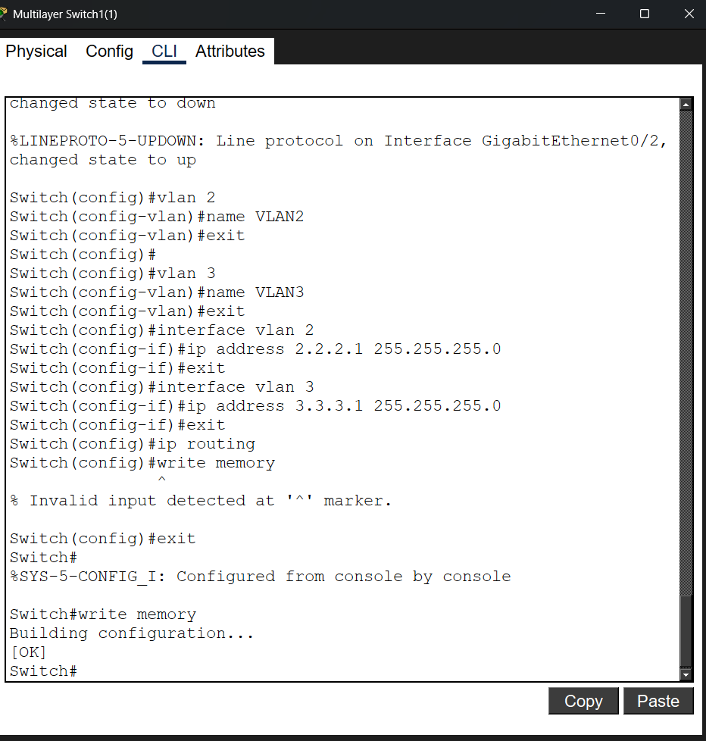

- Configuring PCs
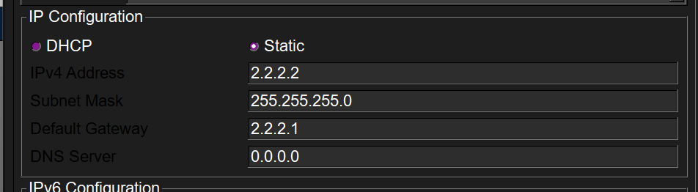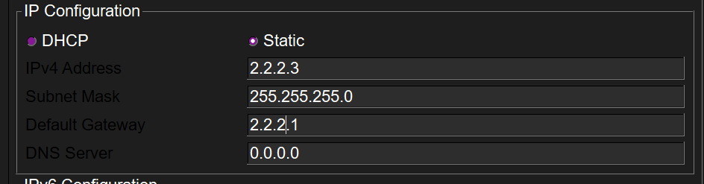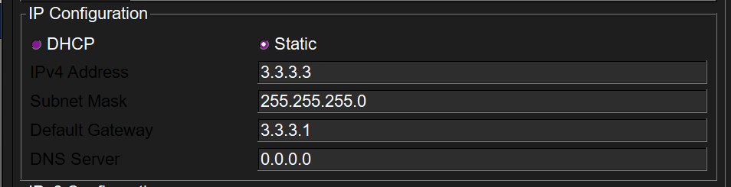

- Test connections
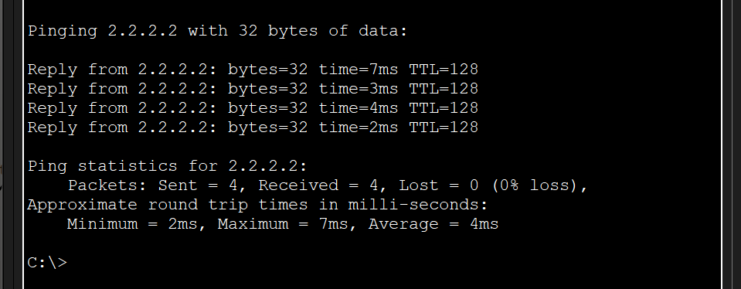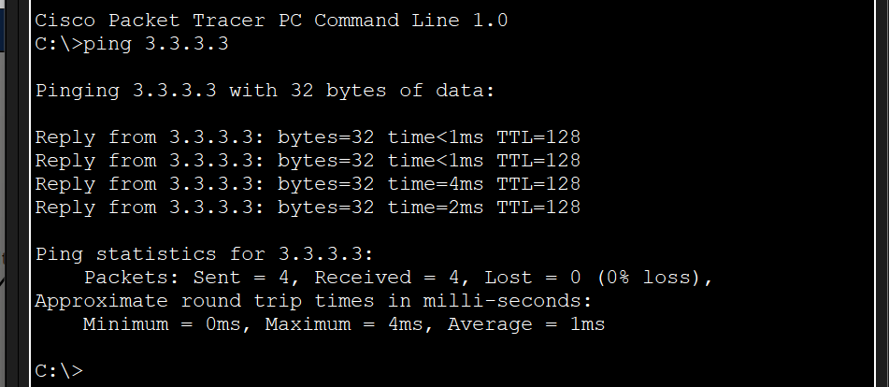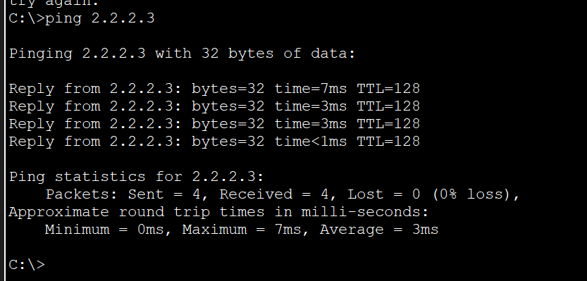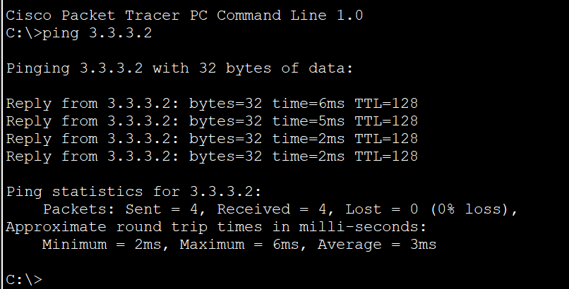

Part 2: Setting Up a Router for VLAN Communication
- Switch Configuration
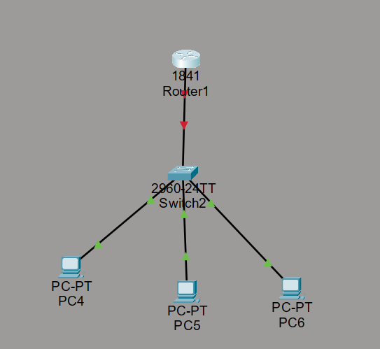
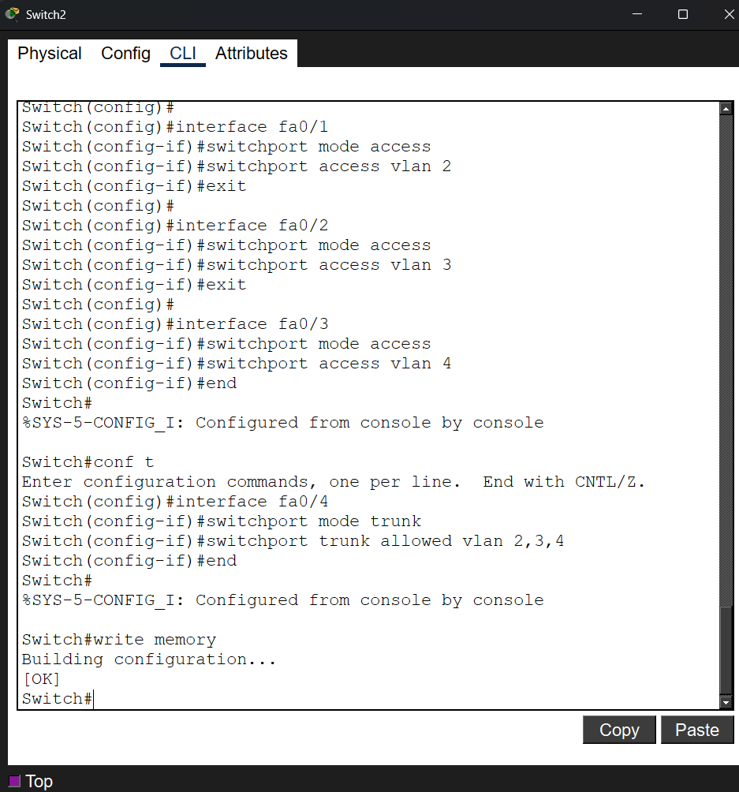

- Router Configuration for Inter-VLAN Routing
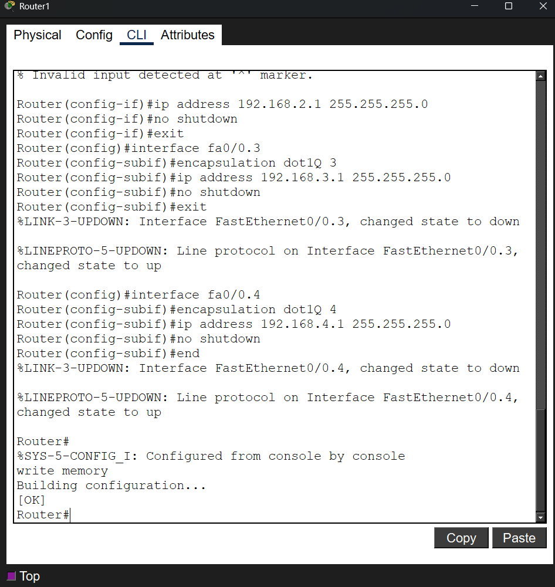

QUESTIONS

1. Why do we configure trunk encapsulation before enabling trunk mode on a Layer 3 switch?
Trunk encapsulation sets the VLAN tagging protocol before trunking can work.

2. Why does the switch automatically create a VLAN when assigning it to a port if it does not exist?
Switch auto-creates VLANs to prevent errors when assigning a non-existent VLAN.

3. If ip routing is not enabled on a Layer 3 switch, how will that impact network communication?
Without IP routing, the switch cannot route between VLANs; inter-VLAN traffic is blocked.

4. What is the difference between an access port and a trunk port on a switch?
Access port carries one VLAN; trunk port carries multiple VLANs.

5. What is the purpose of the encapsulation dot1Q X command on a router?
It tags packets with VLAN ID X for routing across a trunk.

6. Why do we need subinterfaces on a router for inter-VLAN routing?
Subinterfaces allow one physical interface to handle multiple VLANs.

7. What is the function of no shutdown command?
Activates an interface; without it, the interface stays administratively down.

TASK:
- Build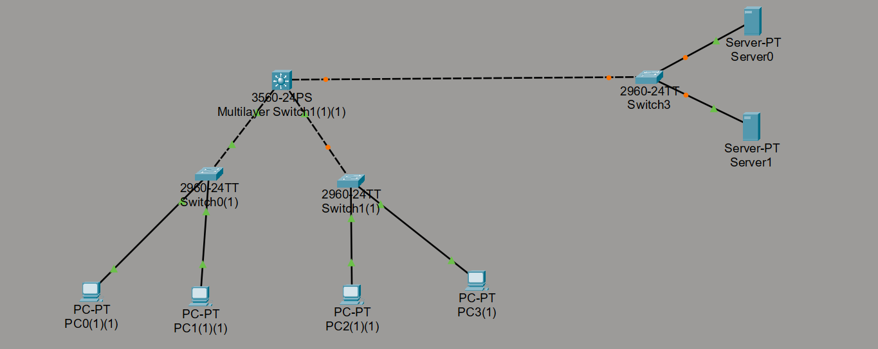
- Create VLAN 5 on the L3 Switch
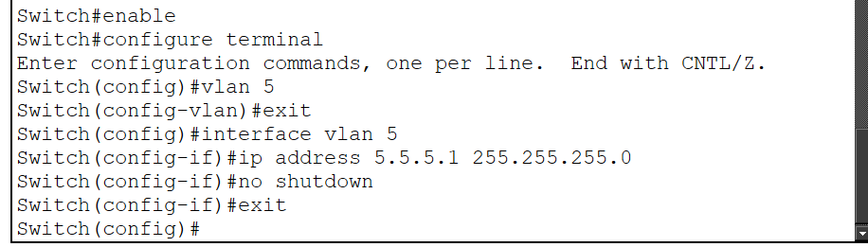
- Configure the Switch Connected to the Servers
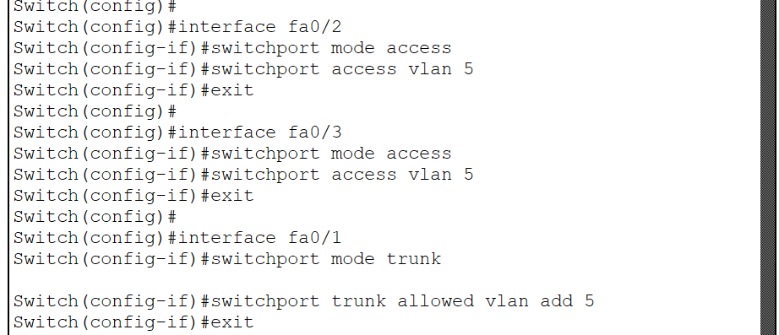

- Configure IP addresses
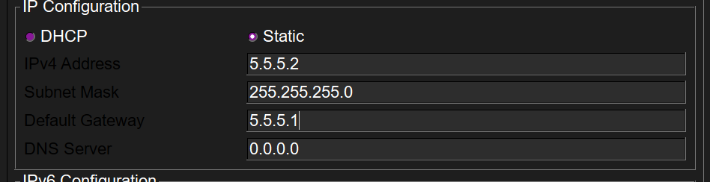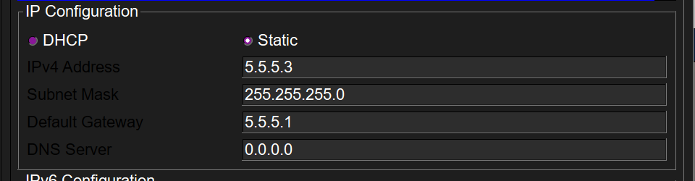

- Verify Connectivity
