Practice 1 – Basics of working with the interface of Cisco equipment. Remote connection to network equipment.

Student name: Bakhramov Abdulaziz
Student ID: 24B031692
Group: Mon 11:00-13:00

1. Drag a PC and a Cisco 2960 switch onto the workspace.
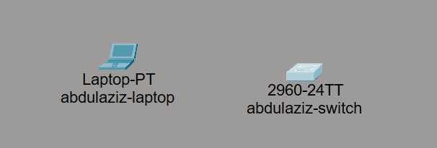

2. Connect Laptop (RS-232) to Switch (Console) using console cable
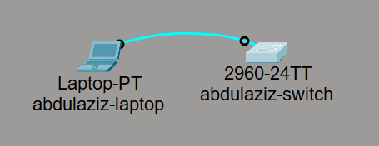

3. Accessing Switch via Terminal
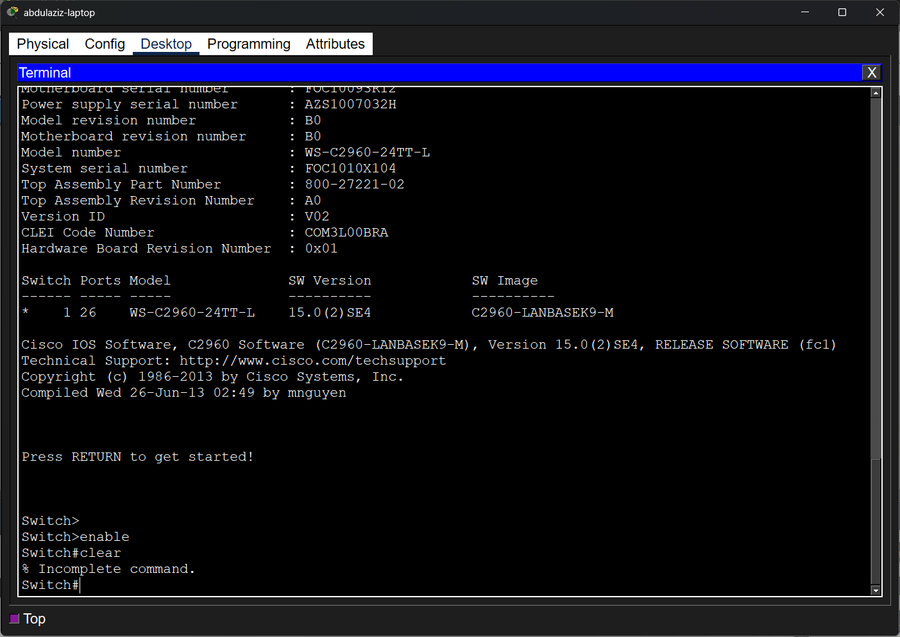
4. Setup hostname and banner
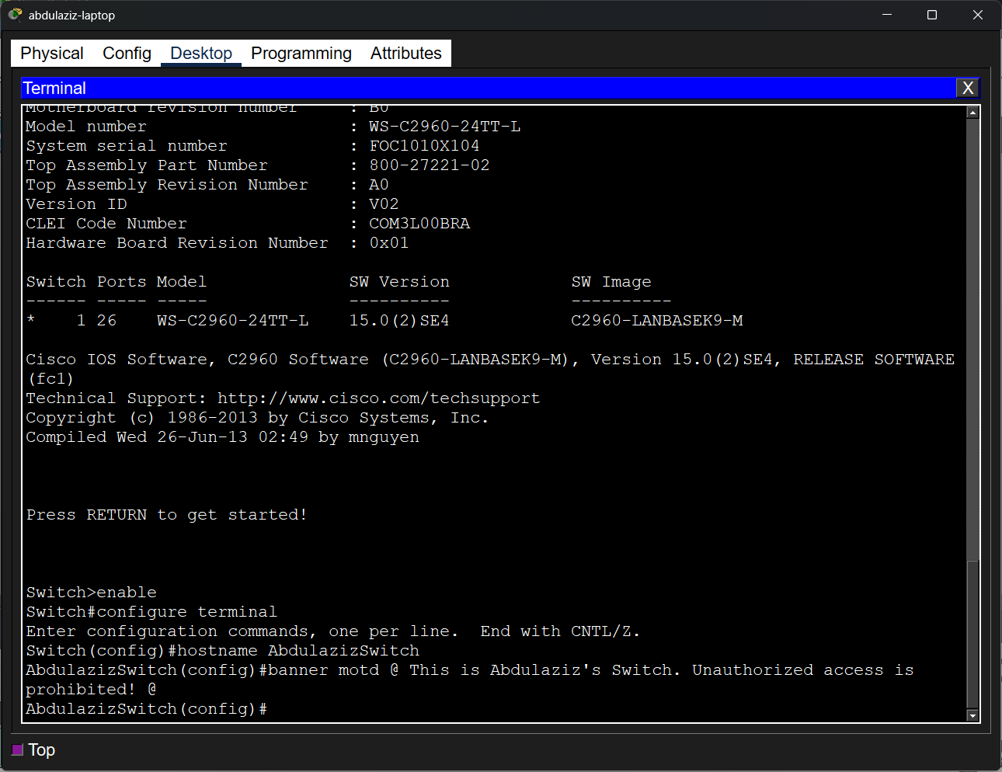

5. Set password and secret
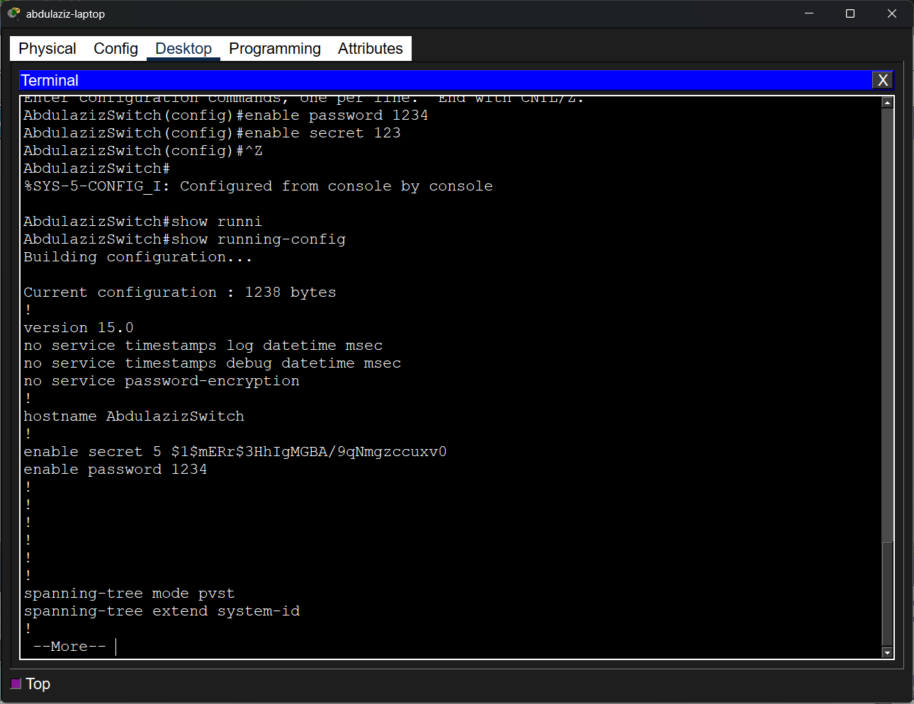
6. Password encryption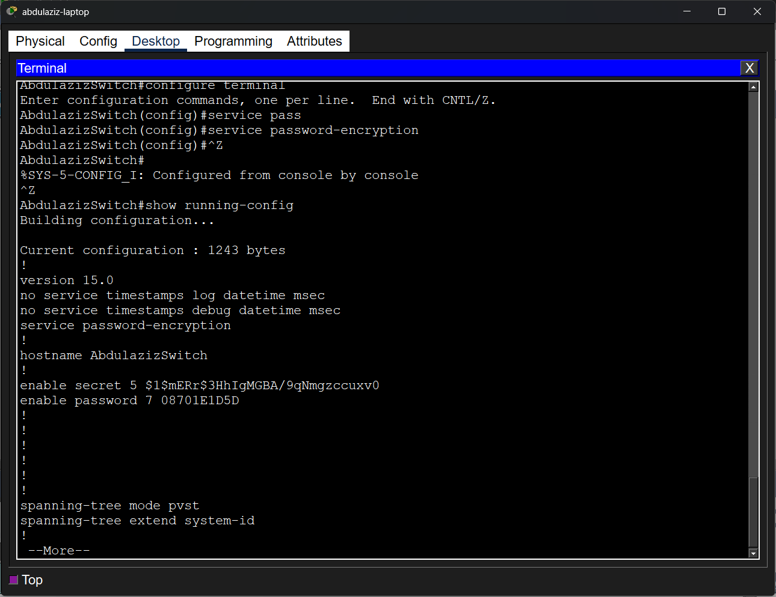

7. Set up authorization to connect to the console.
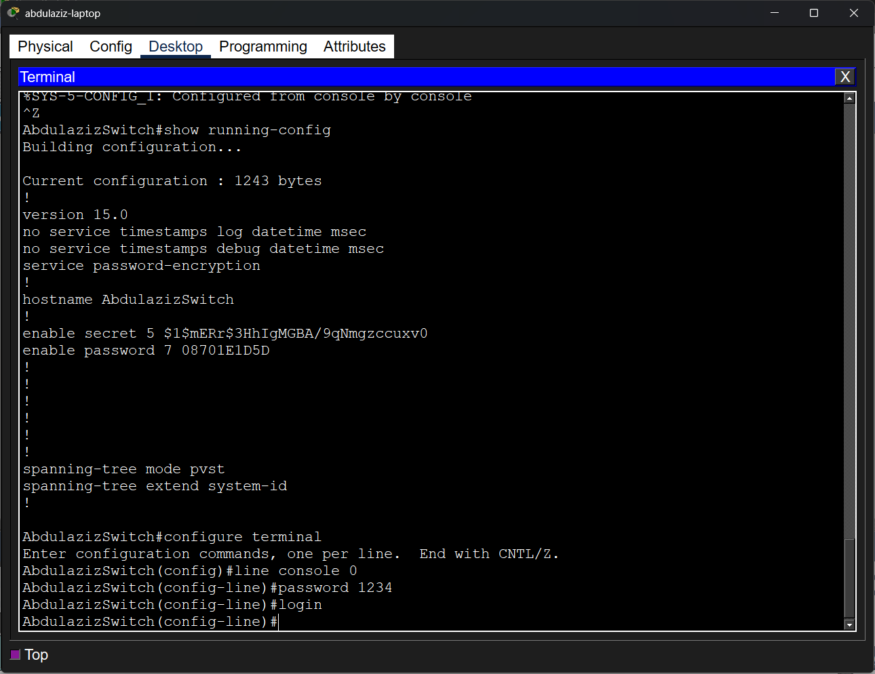
8. Set up a user account
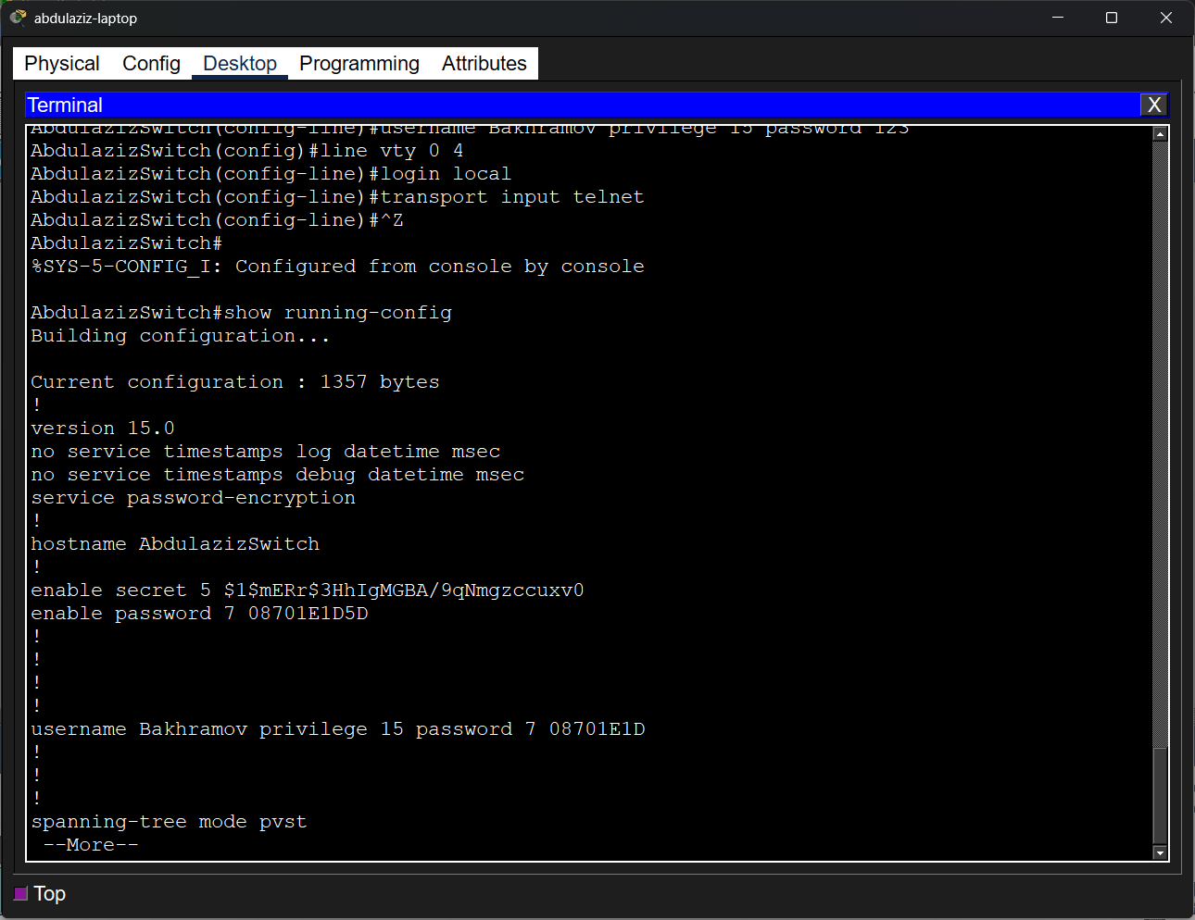
9. Configuring IP Address for Remote Access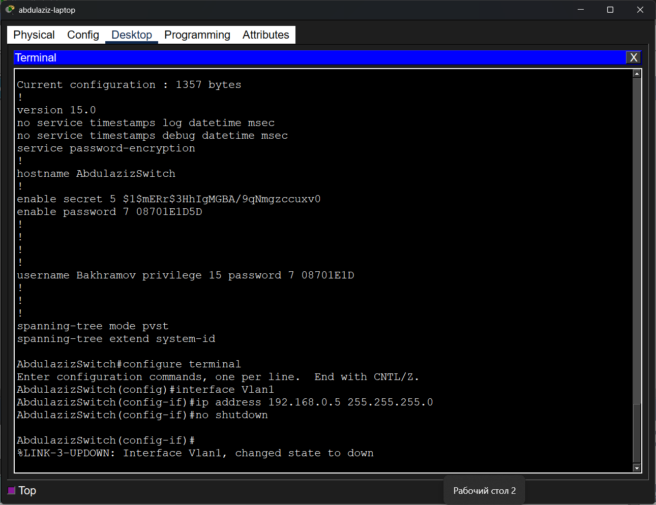
10. Saving startup config
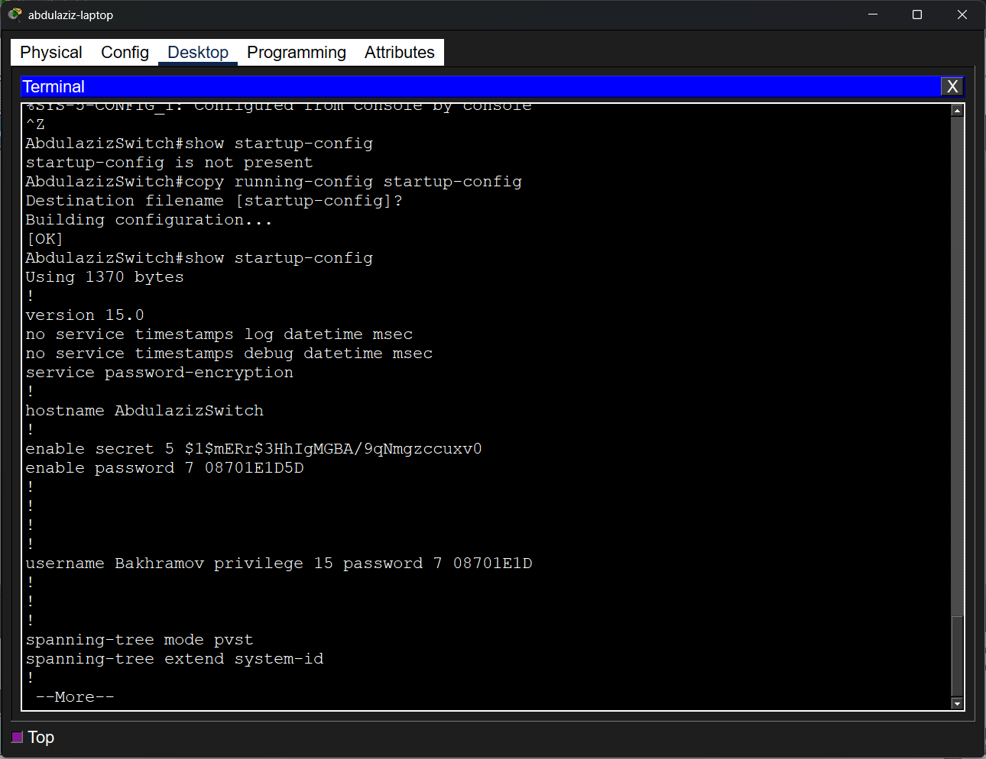

11. PC added
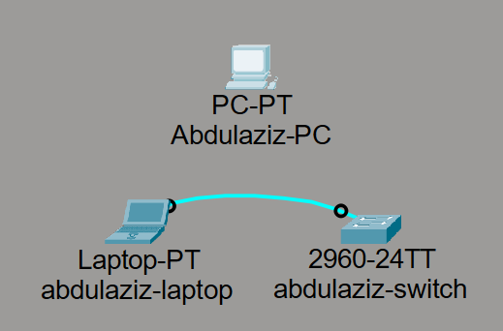
12. Set up PC ip address
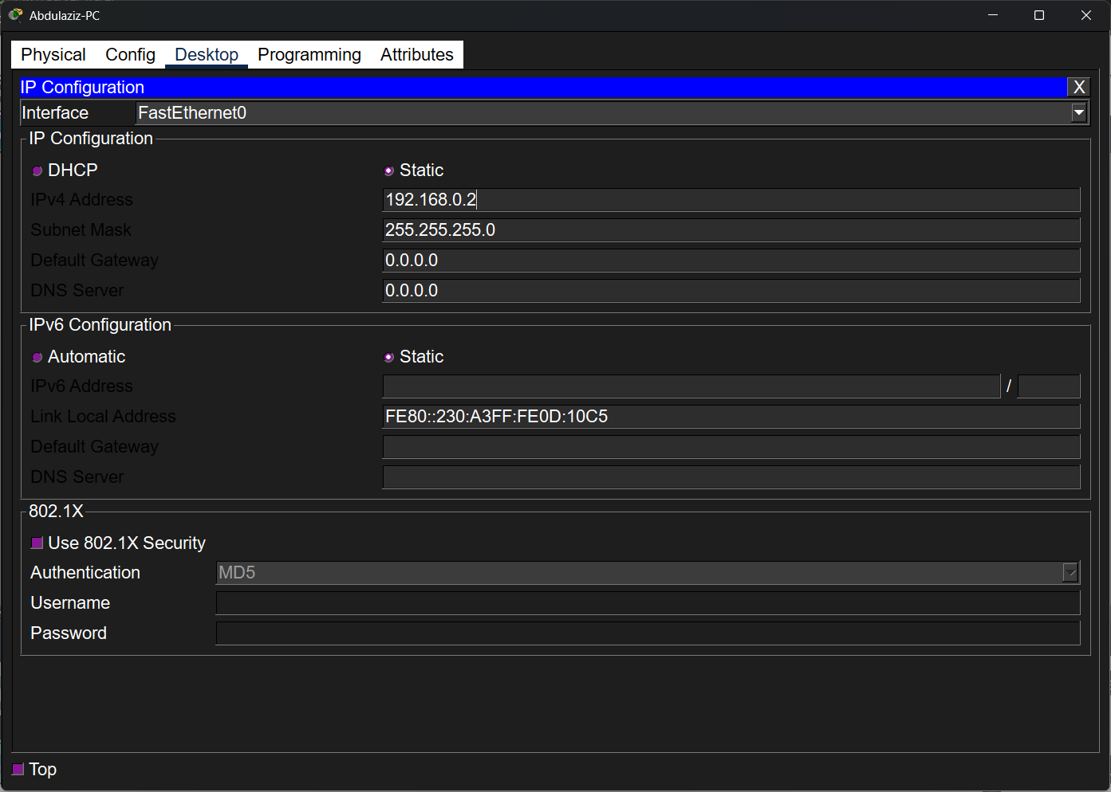

13. Connected Copper-Cable
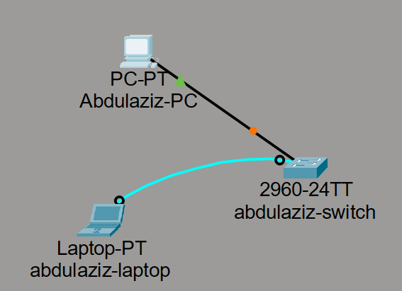
14. Ping command
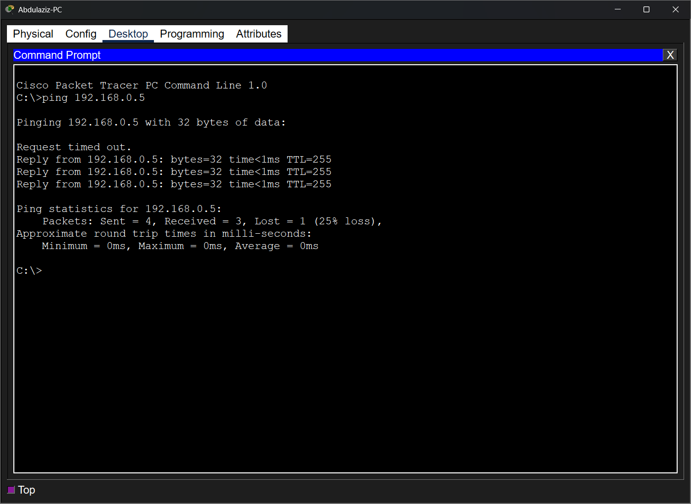

15. Telnet connection
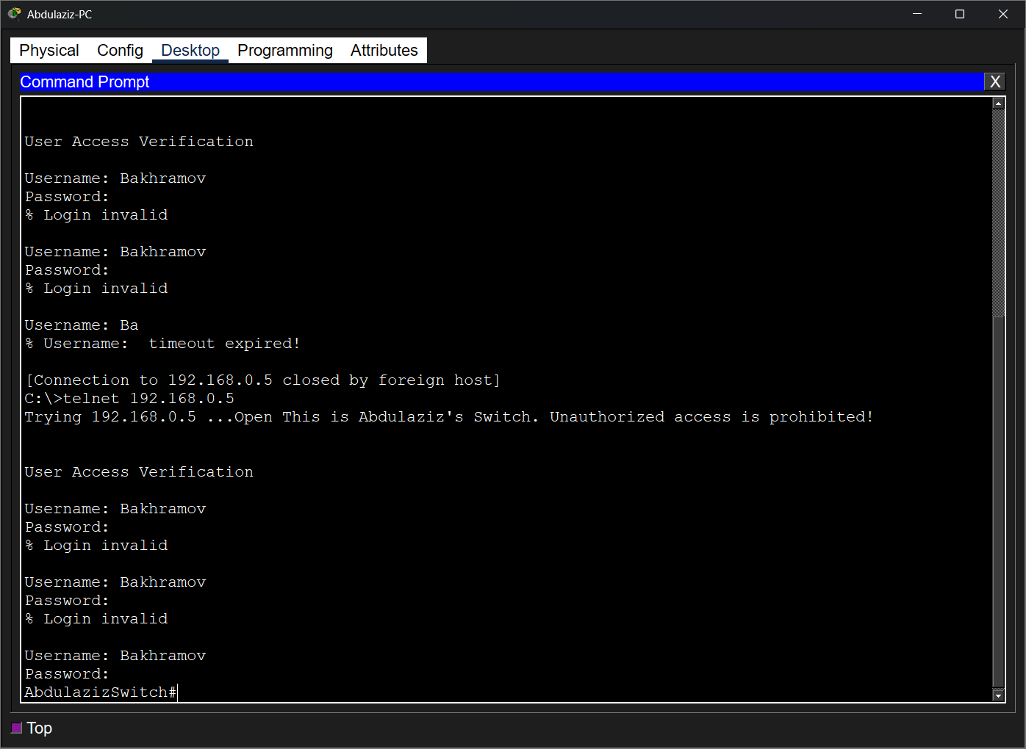
16. Router added
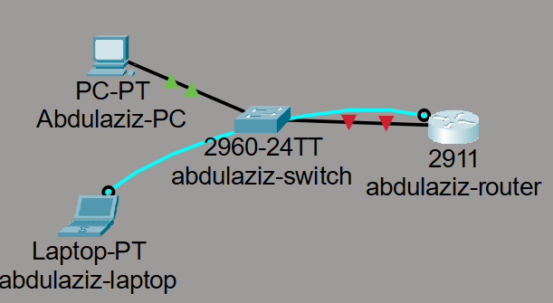

17. Basic router configuration
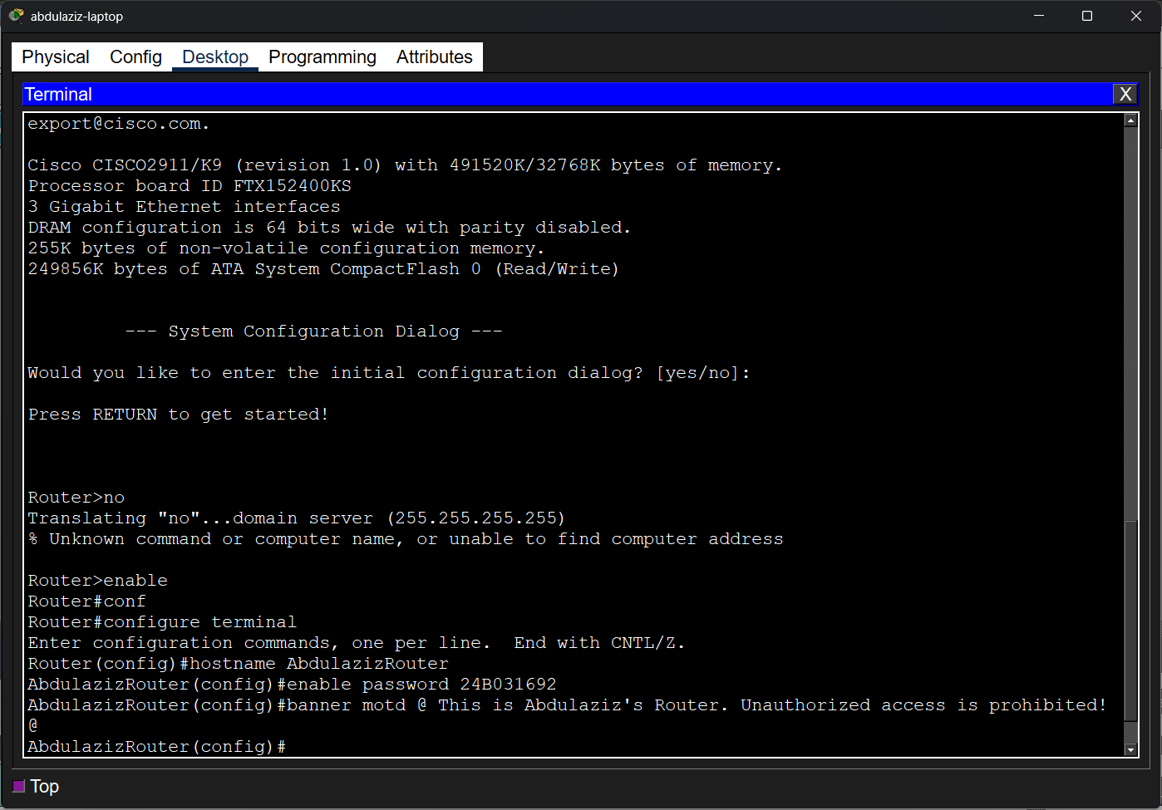

18. Console line configuration
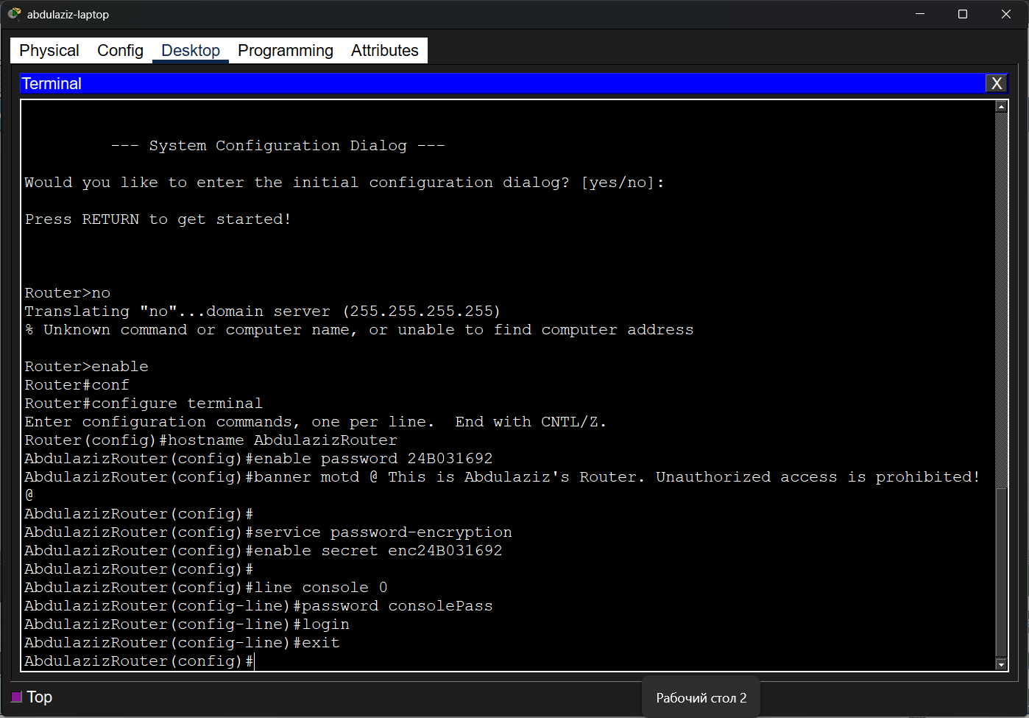

19. Creating user account
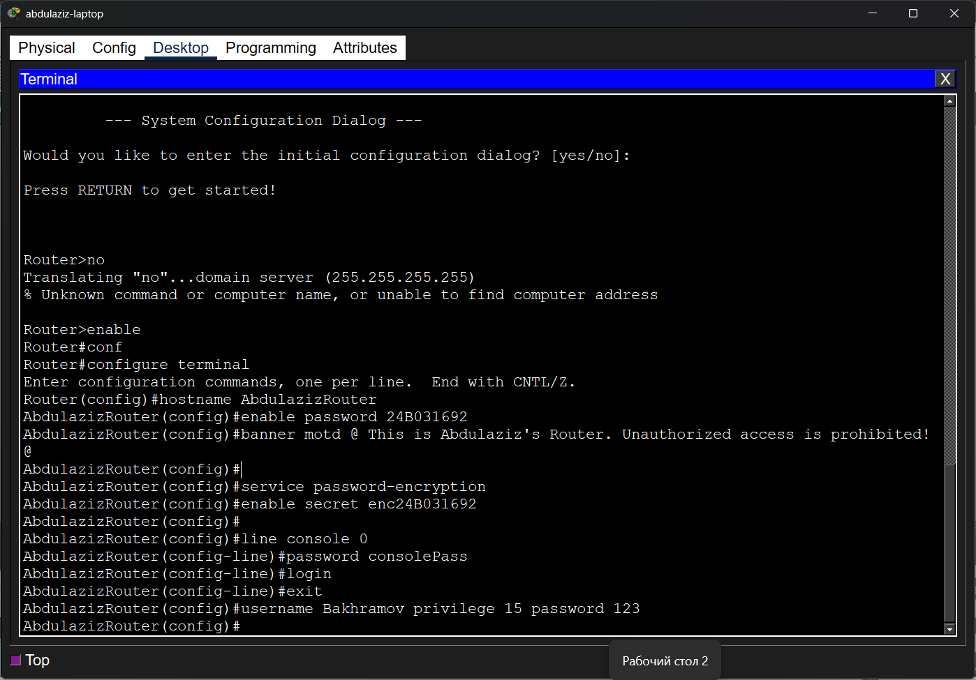

20. Configuring IP Address on Router Interface
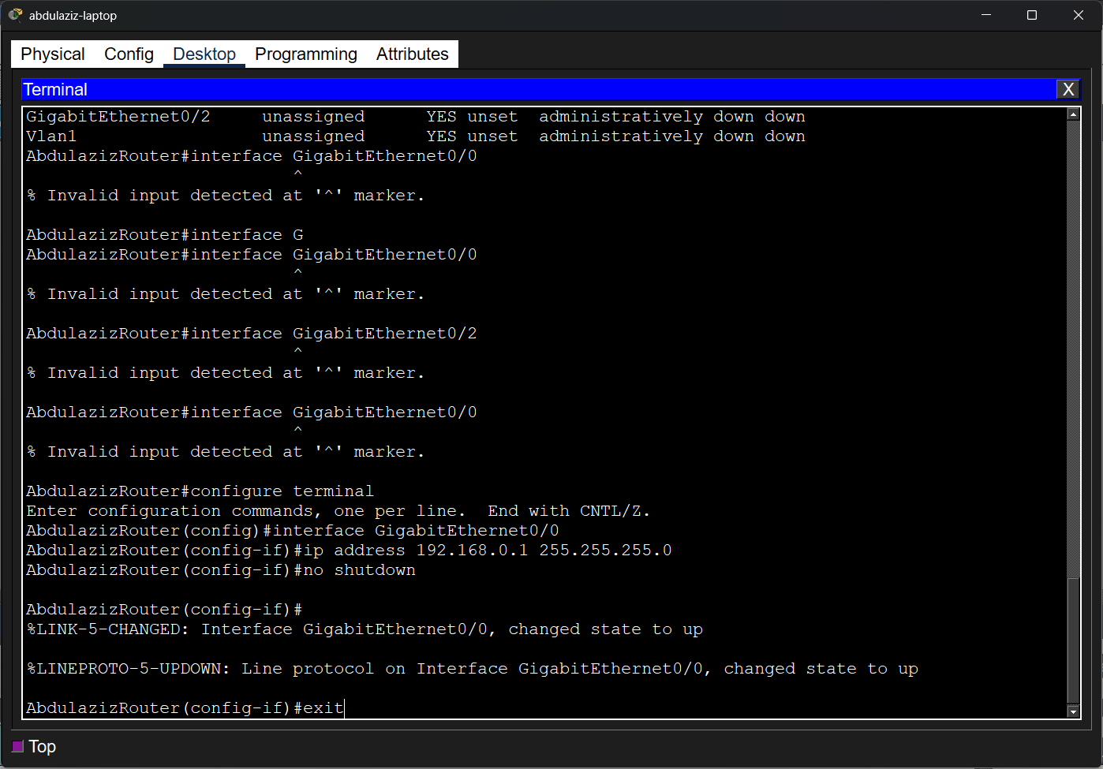

21. Configuring Remote Access (Telnet)
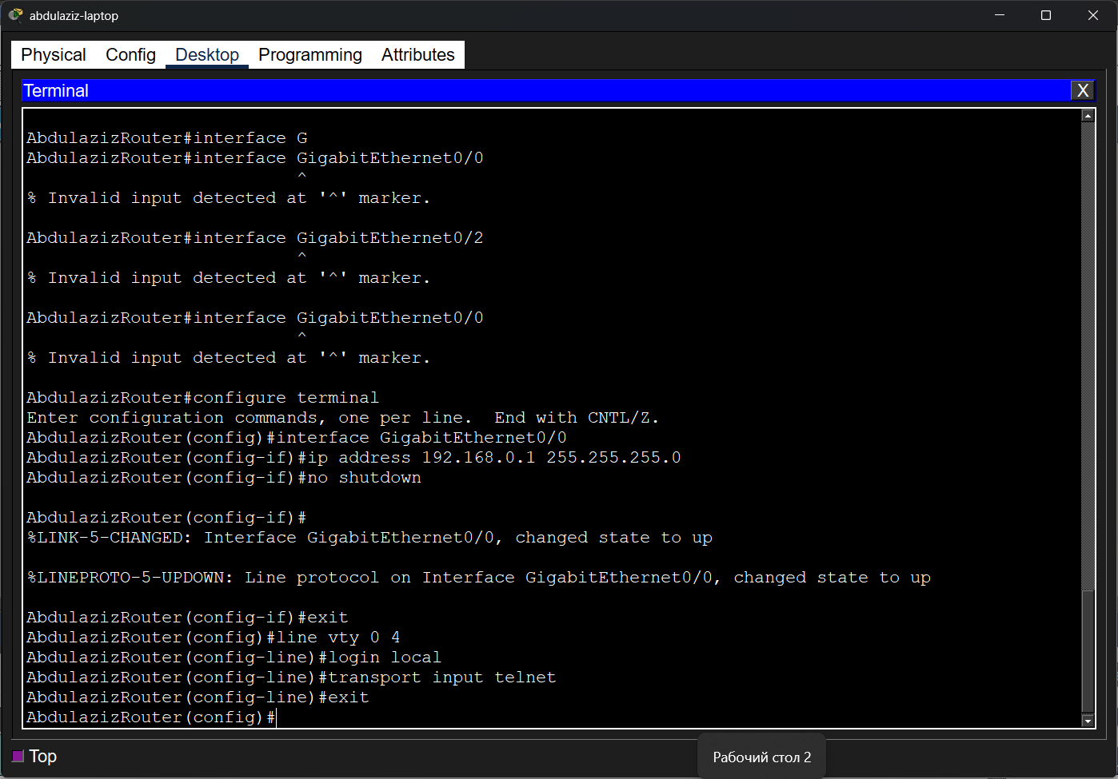

22. Verify the configurations
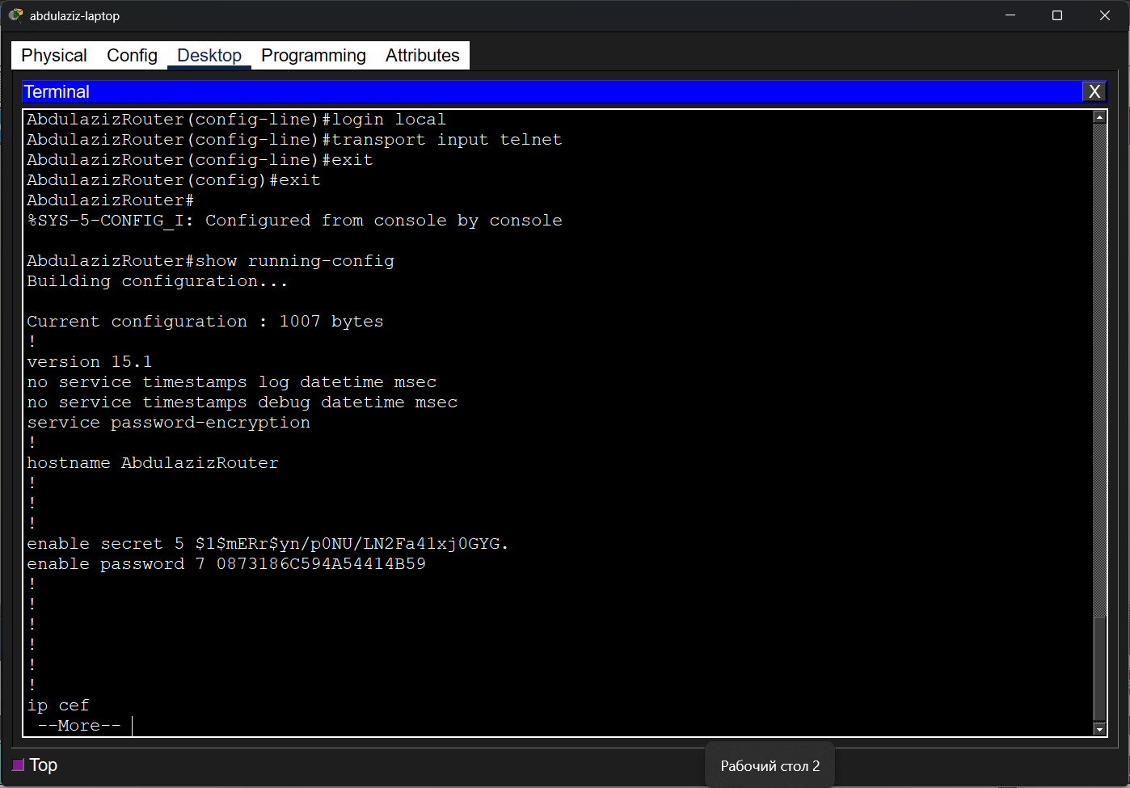

23. Verify interface status and IP addresses
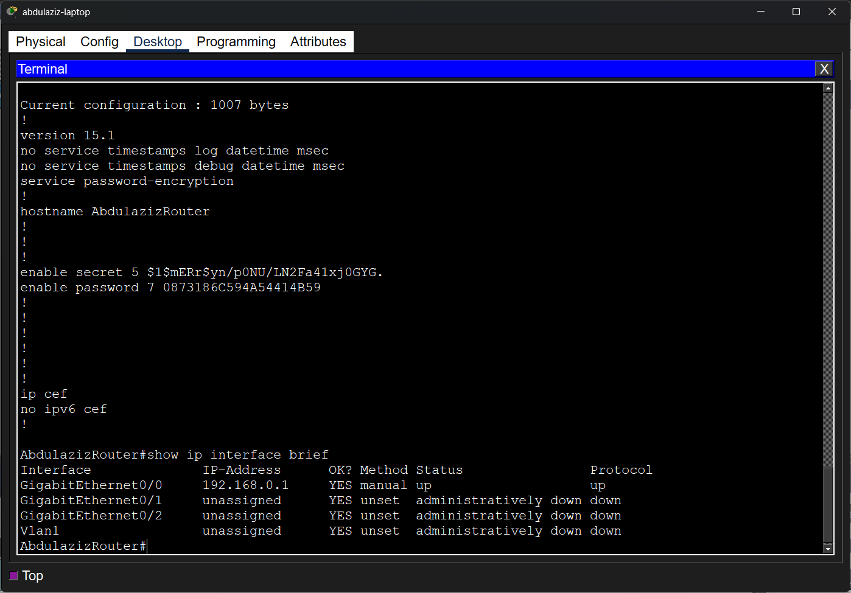

24. Saving router configurations
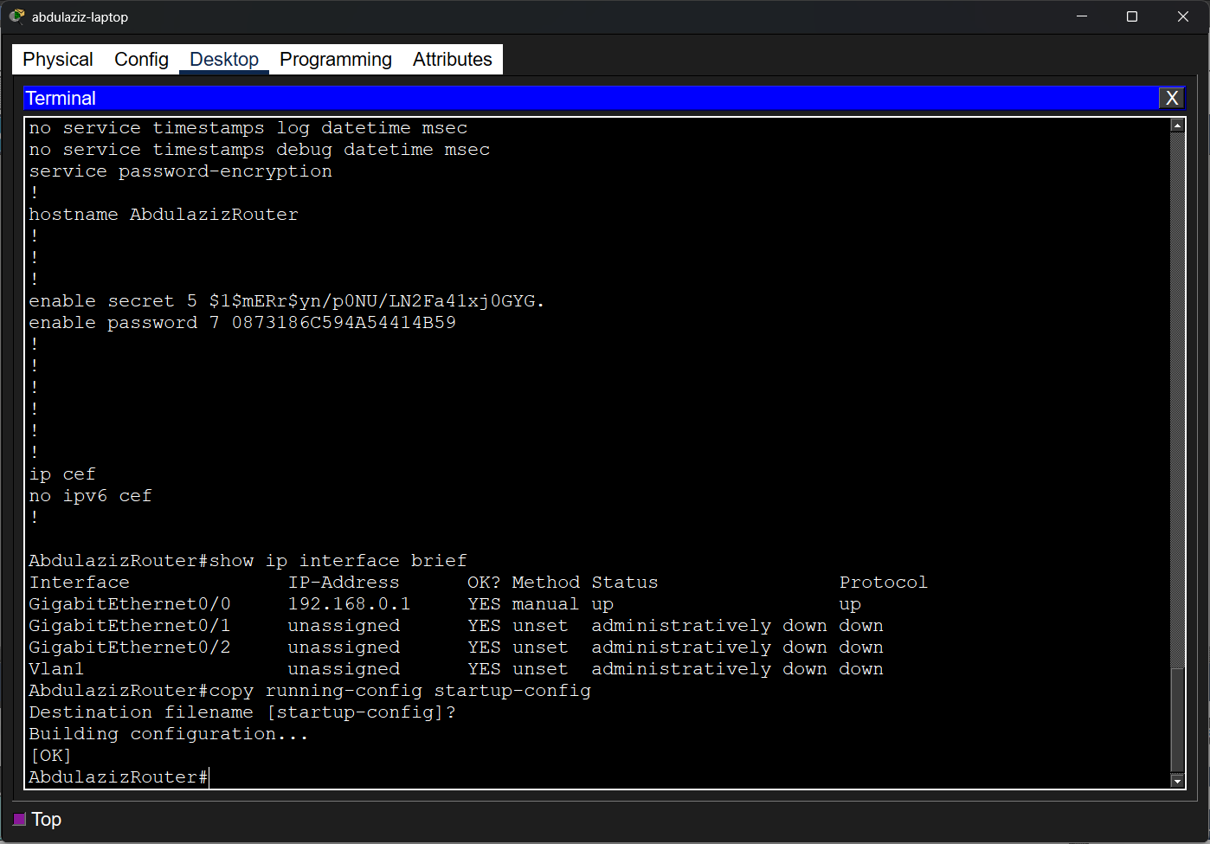

25. Testing Router
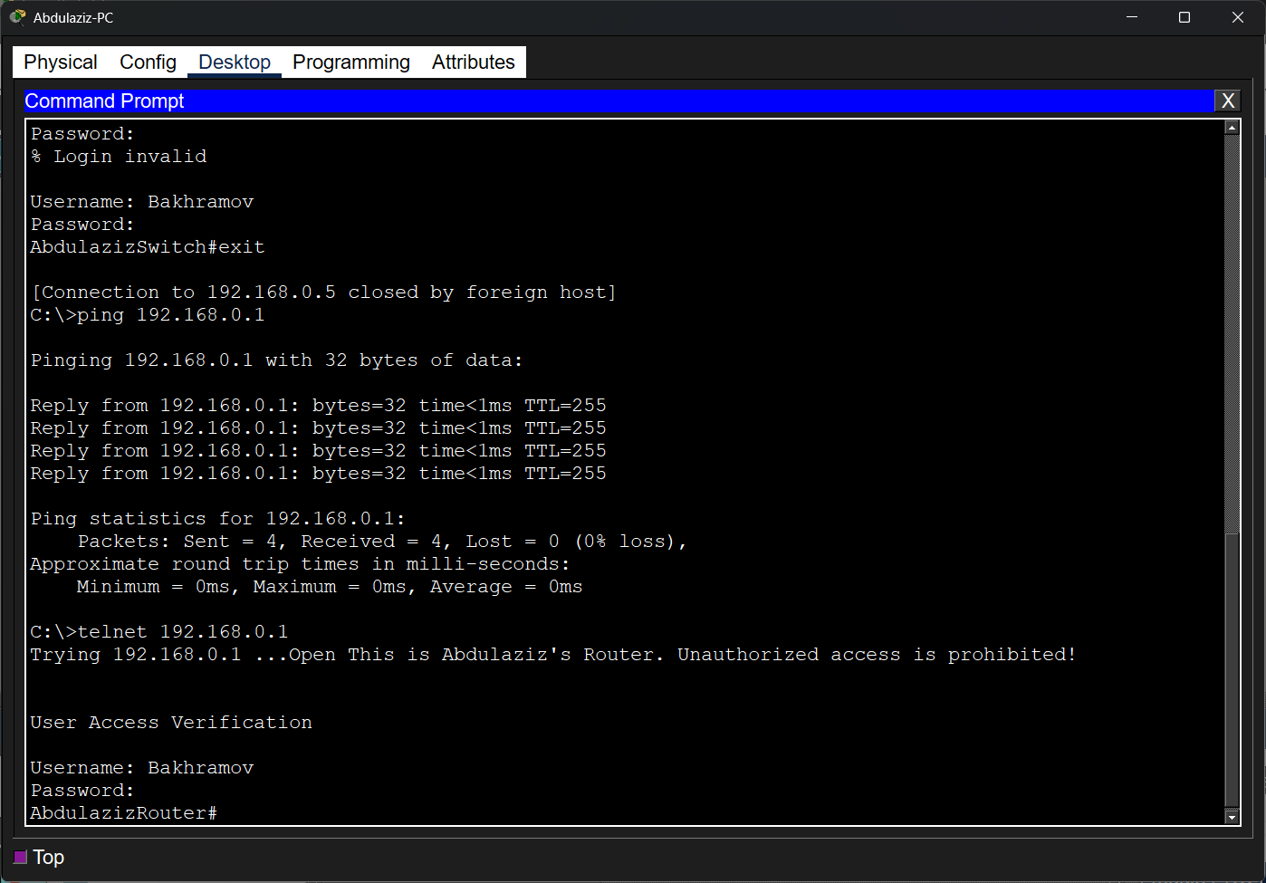

Questions:
- To move from User Mode to Privileged Mode, you must enter the "enable" command

- The "enable password" command stores the password in clear, readable text. The "enable secret" command is a more secure option that encrypts the password, and it has a higher priority than the standard enable password

- To configure an IP address on the VLAN1 interface, you must enter the interface configuration mode, assign the IP and subnet mask, and then administratively enable the interface
Switch(config)# interface Vlan1
Switch(config-if)# ip address 192.168.0.5 255.255.255.0
Switch(config-if)# no shutdown

- The "running-config" is the current configuration stored in RAM, which is lost if the device reboots. The "startup-config" is the configuration stored in NVRAM that is loaded when the device boots up. To save the changes, use the command "copy running-config startup-config" or the short form "write memory" (wr mem).

