Lab 6 & 7 - Report

Student name: Bakhramov Abdulaziz
Student ID: 24B031692
Group: Mon 11:00-13:00

Lab 6
- Part 1: Examine Network Requirements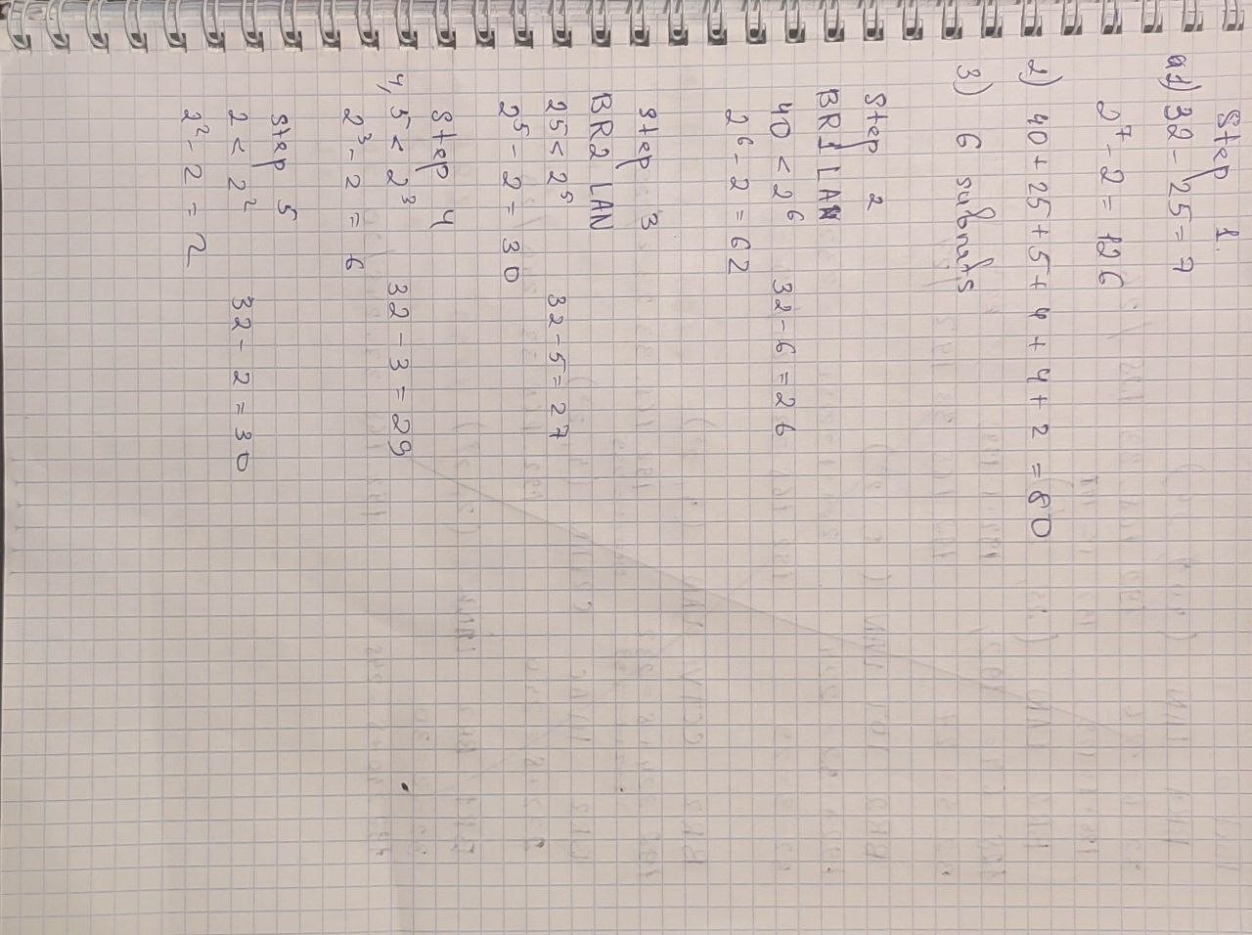
Step 1: Determine how many host addresses and subnets are available.
How many host addresses are available in a /25 network?
126

What is the total number of host addresses needed in the topology diagram?
80

How many subnets are needed in the network topology?
6

Step 2: Determine the largest subnet.
What is the subnet description (e.g. BR1 LAN or BR1-BR2 link)?
BR1 LAN

How many IP addresses are required in the largest subnet?
40

What subnet mask can support that many host addresses?
/26 (255.255.255.192)

How many total host addresses can that subnet mask support?
62

Can you subnet the 192.168.33.128/25 network address to support this subnet? Yes

What are the network addresses that would result from this subnetting? 192.168.33.128/26 and 192.168.33.192/26

Step 3: Determine the second largest subnet.
What is the subnet description?
BR2 LAN

How many IP addresses are required for the second largest subnet?
25

What subnet mask can support that many host addresses?
/27 or 255.255.255.224

How many total host addresses can that subnet mask support?
30

Can you subnet the remaining subnet again and still support this subnet?
Yes

What are the network addresses that would result from this subnetting? 192.168.33.192/27 and 192.168.33.224/27

Step 4: Determine the third largest subnet.
What is the subnet description?
BR2 IoT LAN

How many IP addresses are required for the next largest subnet?
5

What subnet mask can support that many host addresses? /29 or 255.255.255.248

How many total host addresses can that subnet mask support?
6

Can you subnet the remaining subnet again and still support this subnet?
yes

What are the network addresses that would result from this subnetting? 192.168.33.224/29, 192.168.33.232/29, 192.168.33.240/29, 192.168.33.248/29

Step 5: Determine the fourth largest subnet.
What is the subnet description?
BR11-BR2 Link

How many IP addresses are required for the next largest subnet?
2

What subnet mask can support that many host addresses?
/30 or 255.255.255.252

How many total host addresses can that subnet mask support?
2

Can you subnet the remaining subnet again and still support this subnet?
yes

What are the network addresses that would result from this subnetting? 192.168.33.248/30, 192.168.33.252/30

- Part 1: Examine Network Requirements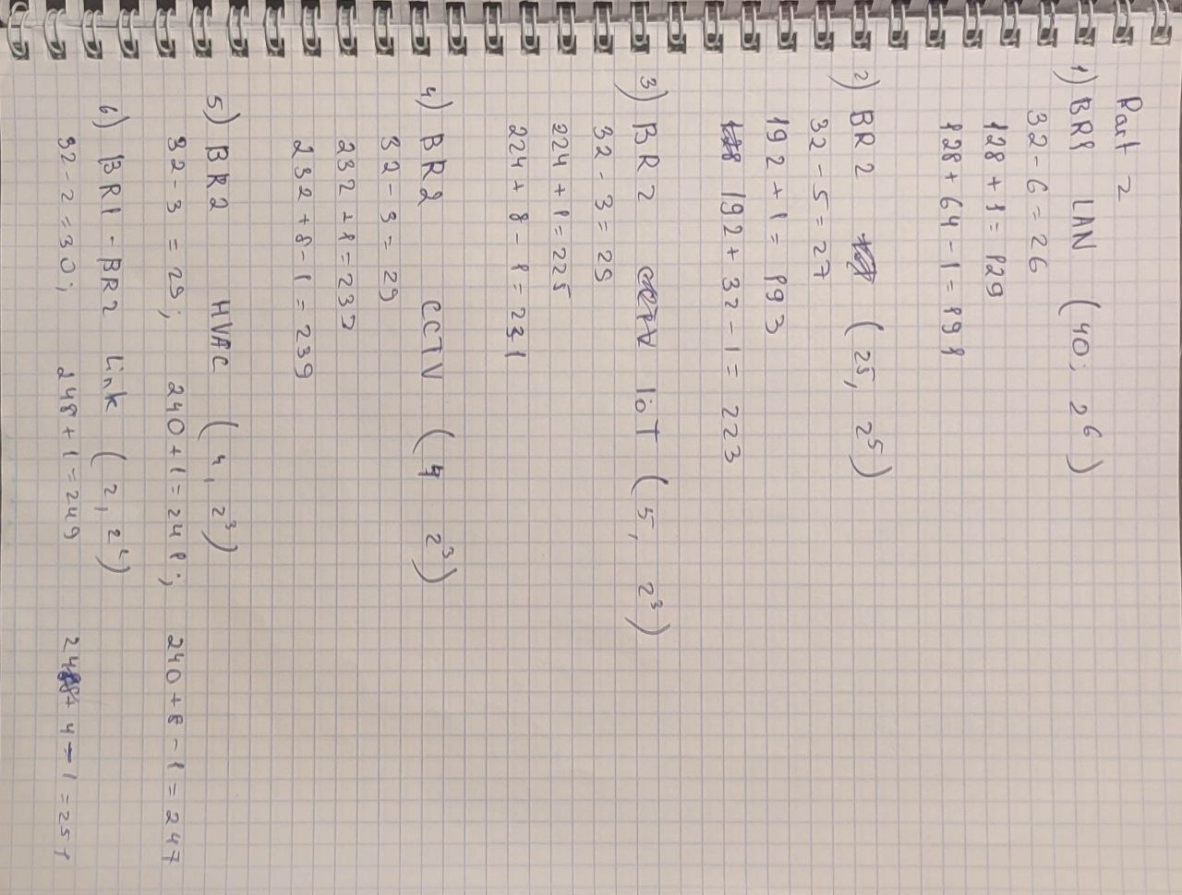
Step 1: Calculate the subnet information.
Subnet Description | Number of Hosts Needed | Network Address /CIDR | First Host Address | Broadcast Address
BR1 LAN | 40 | 192.168.33.128/25 | 192.168.33.129 | 192.168.33.191
BR2 LAN | 25 | 192.168.33.192/27 | 192.168.33.193 | 192.168.33.223
BR2 IoT LAN | 5 | 192.168.33.224/29 | 192.168.33.225 | 192.168.33.231
BR2 CCTV LAN | 4 | 192.168.33.232/29 | 192.168.33.233 | 192.168.33.239
BR2 HVAC C2LAN | 4 | 192.168.33.240/29 | 192.168.33.241 | 192.168.33.247
BR1-BR2 Link | 2 | 192.168.33.248/30 | 192.168.33.249 | 192.168.33.251
Step 2: Complete the device interface address table.
Device | Interface | IP Address | Subnet Mask | Device Interface
BR1 | G0/0/0 | 192.168.33.249 | 255.255.255.252 | BR1-BR2 Link
BR1 | G0/0/1 | 192.168.33.129 | 255.255.255.192 | 40 Host LAN
BR2 | G0/0/0 | 192.168.33.250 | 255.255.255.252 | BR1-BR2 Link
BR2 | G0/0/1 | 192.168.33.193 | 255.255.255.224 | 25 Host LAN

- Part 3: Cable and Configure the IPv4 Network
Step 1
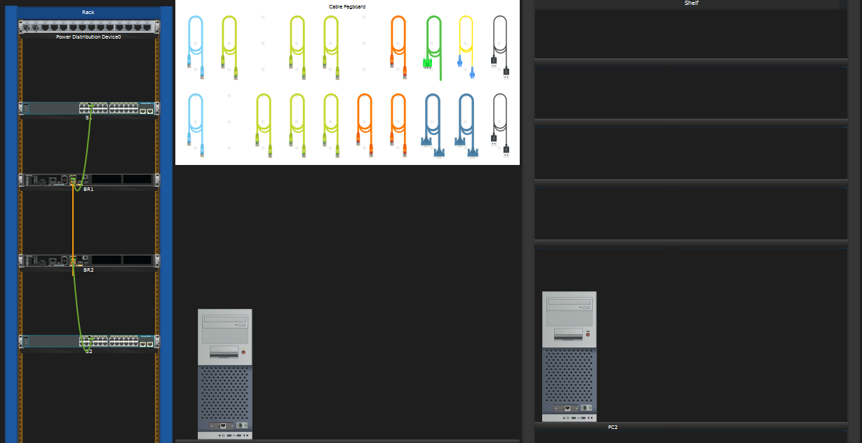

Step 2
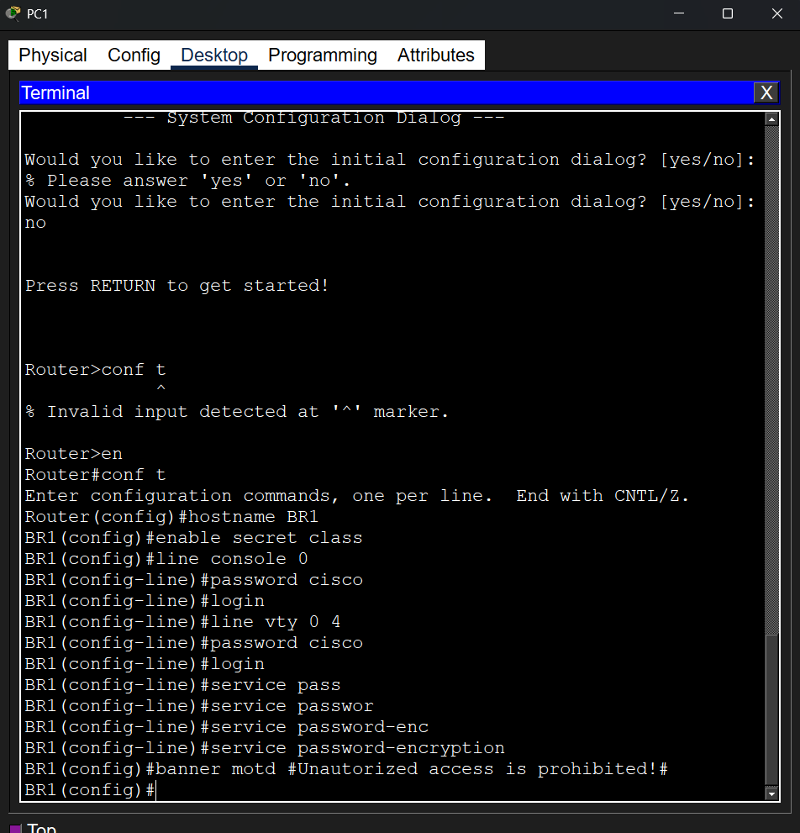
Step 3
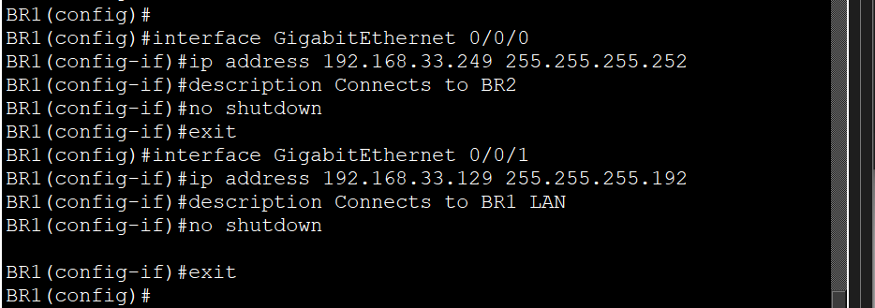

Step 4
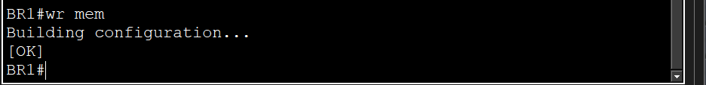

Step 5 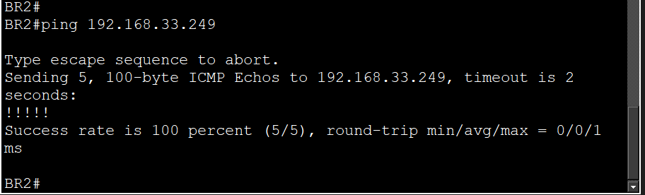 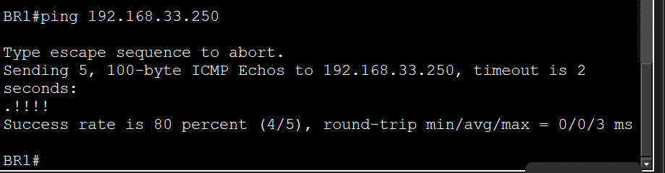

Reflection Question
Can you think of a shortcut for calculating the network addresses of consecutive /30 subnets?
The step between network addresses in a /30 mask is always 4. To find the next /30 subnet, simply add 4 to the current network address.

Lab 7

Part 1: Cable the Network and Configure Basic Router and Switch Settings
Step 1
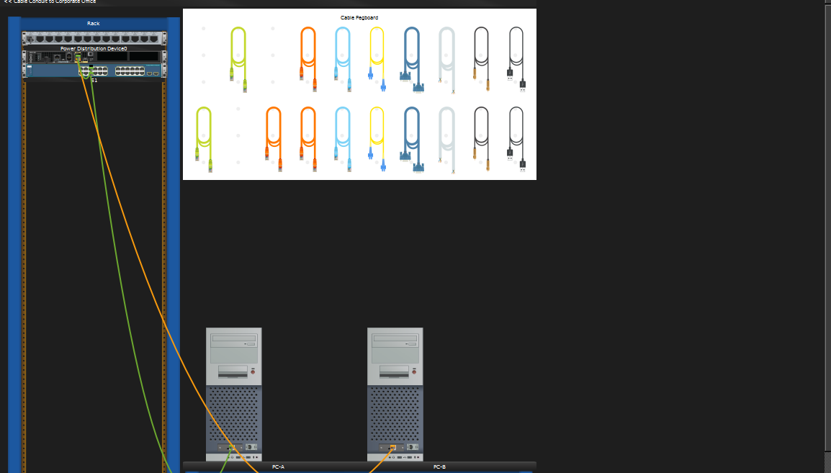

Step 2
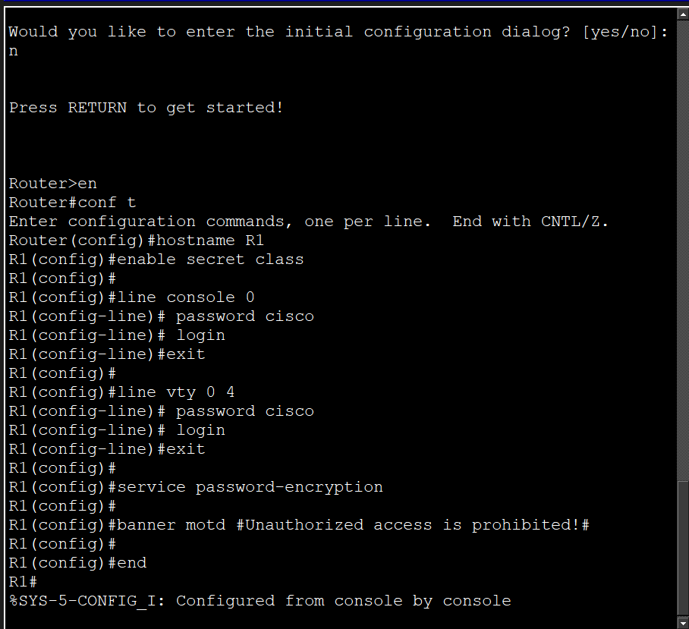

Step 3
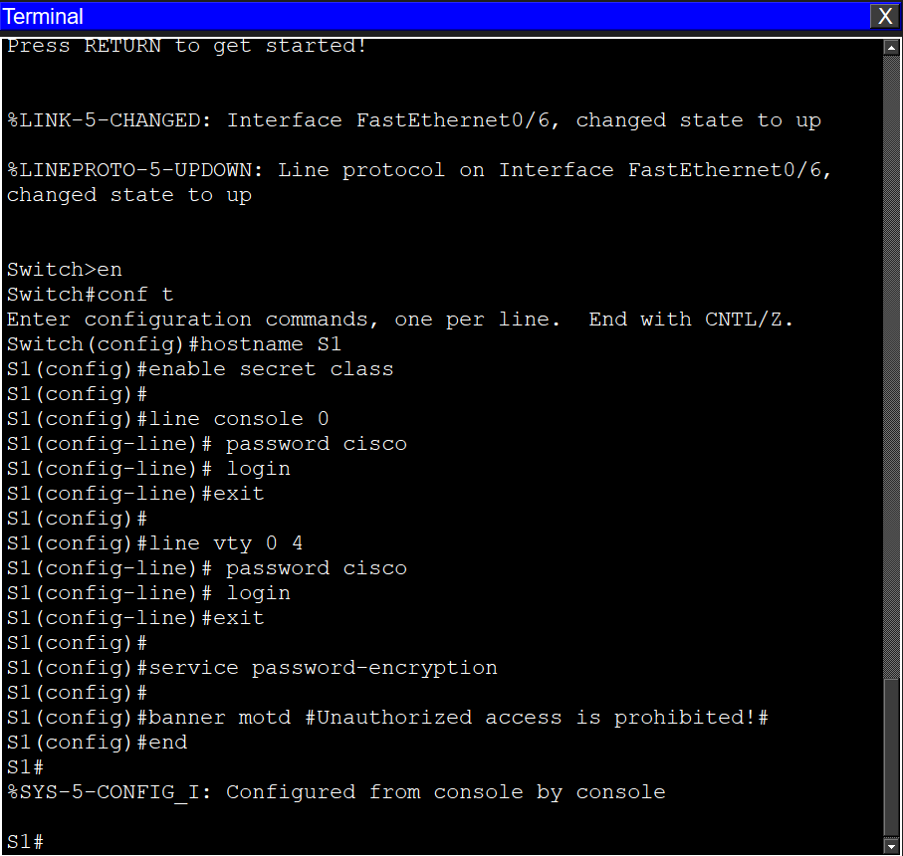

Part 2: Configure IPv6 Addresses Manually

Step 1

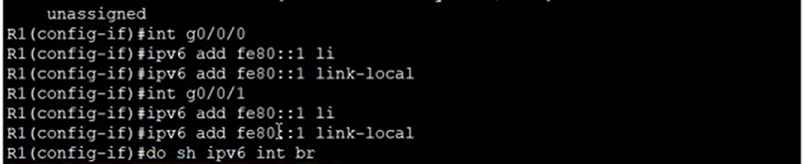
What is the multicast group for the G0/0/0 interface?

You will see groups FF02::1 and FF02::1:FF00:1. These groups allow nodes on the local network to find each other.

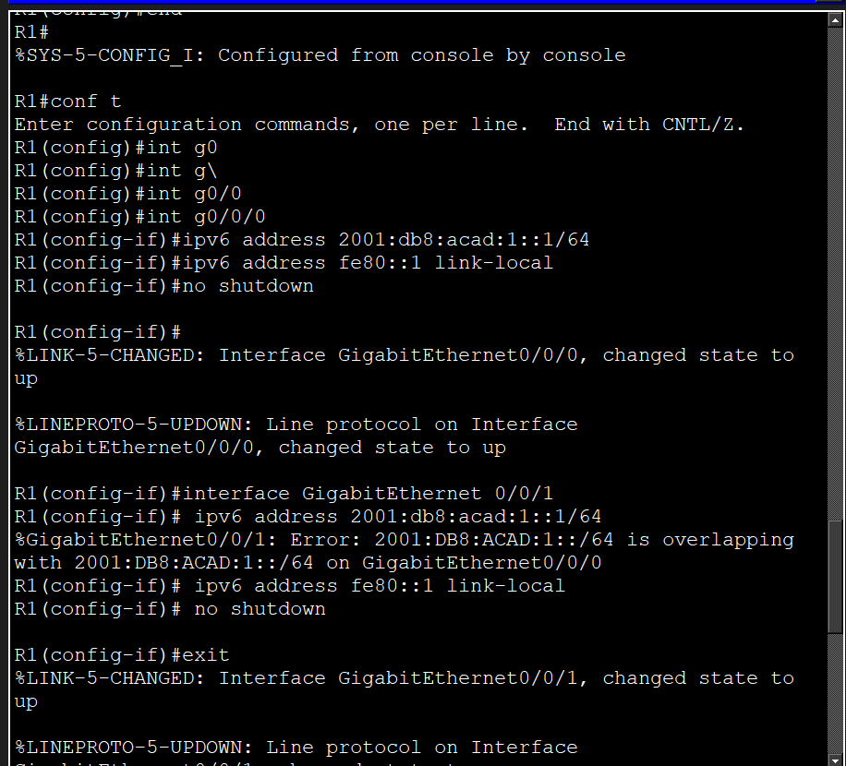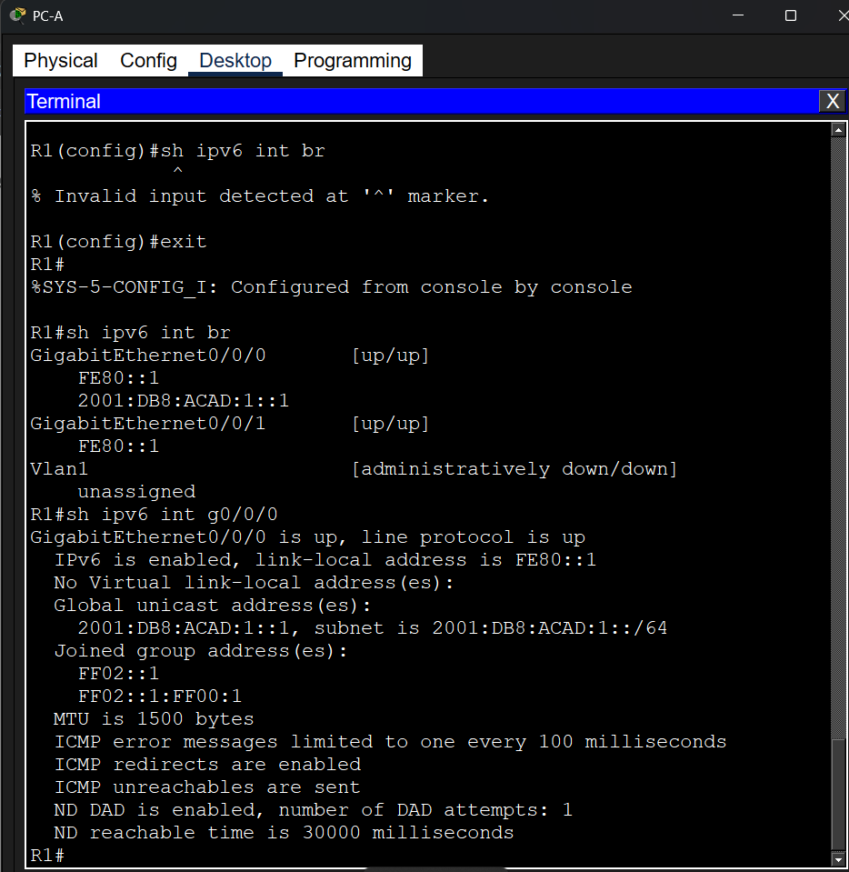

Step 2
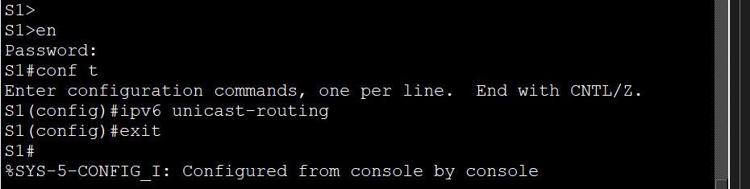
Has an IPv6 unicast address been assigned to the network interface card (NIC) on PC-B?
Answer: No. (Before we enabled routing on the router, the PC could only have a Link-Local address starting with fe80::).
Why did PC-B receive the Global Routing Prefix and Subnet ID that you configured on R1?
Because router R1 started sending RA messages. PC-B, using the SLAAC mechanism, automatically extracted the network prefix from this message and generated a fully functional address.

Step 3
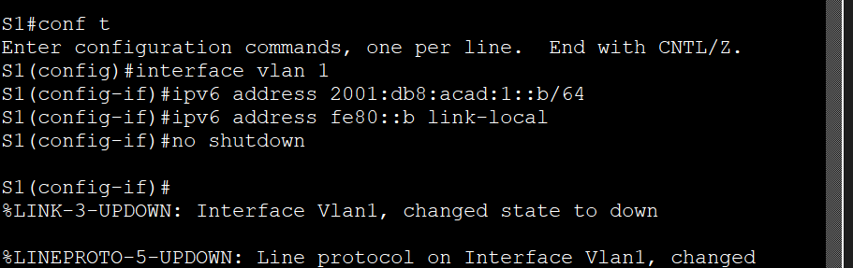
Step 4
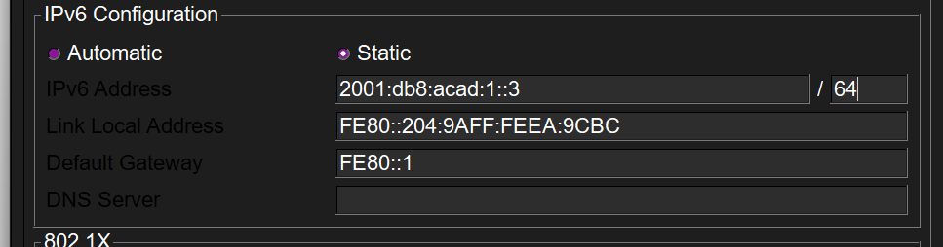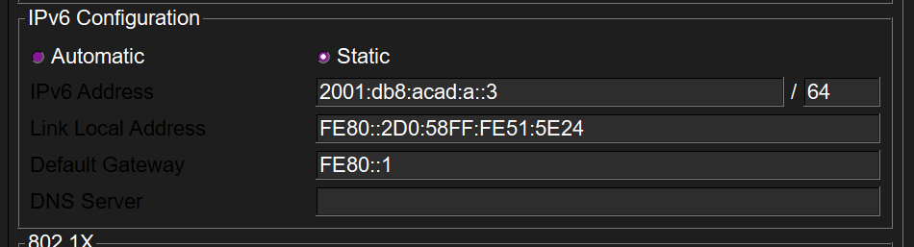

Part 3: Verify End-to-End Connectivity
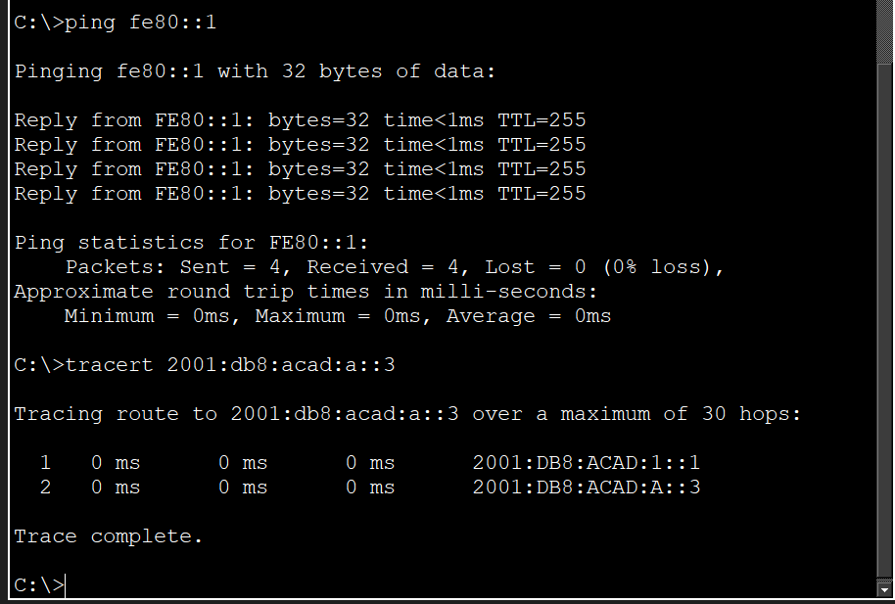
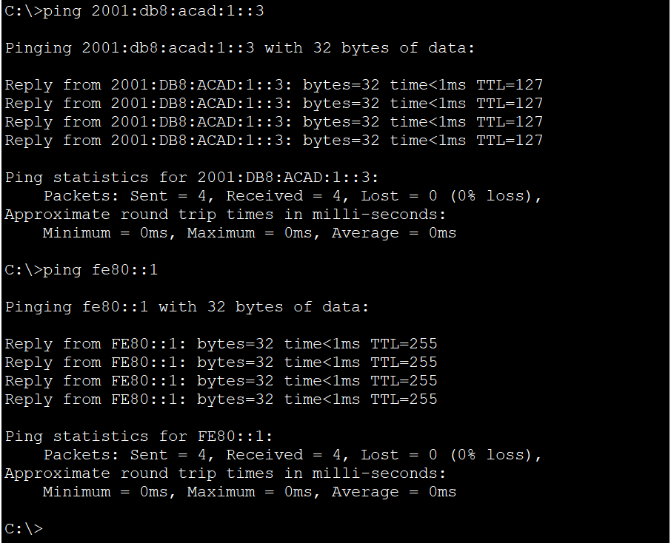

Reflection Question
1. Why can the same link-local address, fe80::1, be assigned to both Ethernet interfaces on R1?
Packets with link-local addresses never leave their local network. Since interfaces G0/0/0 and G0/0/1 point to different isolated networks, there is no address conflict.
2. What is the Subnet ID of the IPv6 address 2001:db8:acad::aaaa:1234/64, if the network prefix is ​​/48?
0000. With a /48 prefix, the global part is 2001:db8:acad. The fourth hextet is the Subnet ID. In this address, after acad, there are double colons ::, indicating padding with zeros.

