Practice 8 Defense
Topology:
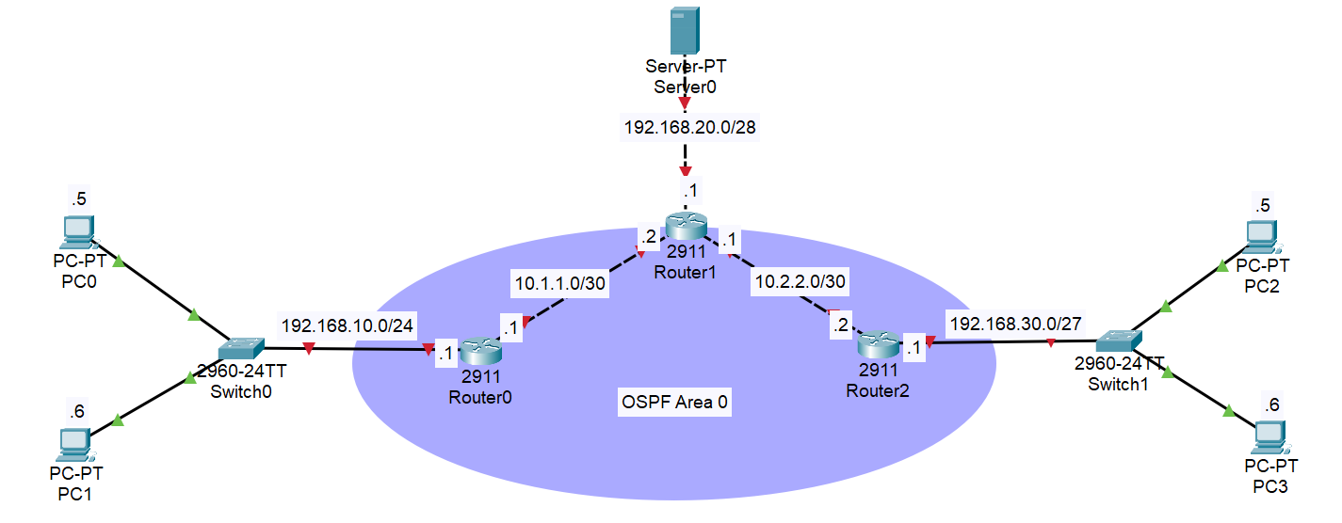
Task:
- All routers exchange routes using OSPF (Area 0), including LAN networks
- The 192.168.20.0/28 (Server network) is reachable using static routing only
- Full connectivity is achieved between all devices

Addressing Table:
Device | Interface | IP address/Prefix | Subnet mask | Default gateway
R0 | Gig0/0 | 192.168.10.1/24 | 255.255.255.0 | N/A
 | Gig0/1 | 10.1.1.1/30 | 255.255.255.252 | N/A
R1 | Gig0/0 | 10.1.1.2/30 | 255.255.255.252 | N/A
 | Gig0/1 | 10.2.2.1/30 | 255.255.255.252 | N/A
 | Gig0/2 | 192.168.20.1/28 | 255.255.255.240 | N/A
R2 | Gig0/0 | 10.2.2.2/30 | 255.255.255.252 | N/A
 | Gig0/1 | 192.168.30.1/27 | 255.255.255.224 | N/A
PC0 | Fa0 | 192.168.10.5/24 | 255.255.255.0 | 192.168.10.1
PC1 | Fa0 | 192.168.10.6/24 | 255.255.255.0 | 192.168.10.1
PC2 | Fa0 | 192.168.30.5/27 | 255.255.255.224 | 192.168.30.1
PC3 | Fa0 | 192.168.30.6/27 | 255.255.255.224 | 192.168.30.1
Server | Fa0 | 192.168.20.5/28 | 255.255.255.240 | 192.168.20.1

Step 1: Configure IP addressing:
- Assign the correct IP address and subnet mask to every interface on Router0, Router1, and Router2
- Configure the default gateway on each PC based on the table
Step 2: Configure static routes to the Server on Router0 and Router2
Step 3: Configure OSPF with the following requirements:
- Process ID: 1
- Area: 0
- Manually configure router-id on each router:
Router | Router ID
Router0 | 1.1.1.1
Router1 | 2.2.2.2
Router2 | 3.3.3.3

Step 4: Verify full end-to-end connectivity:
- Every router should have reachability to all remote networks
- All end devices (PC0, PC1, PC2, PC3, Server) should be able to successfully communicate with each other

