Lab 8 - Report

Student name: Bakhramov Abdulaziz
Student ID: 24B031692
Group: Mon 11:00-13:00
Static Routing
Part 1: Network Setup
  - Topology and Components
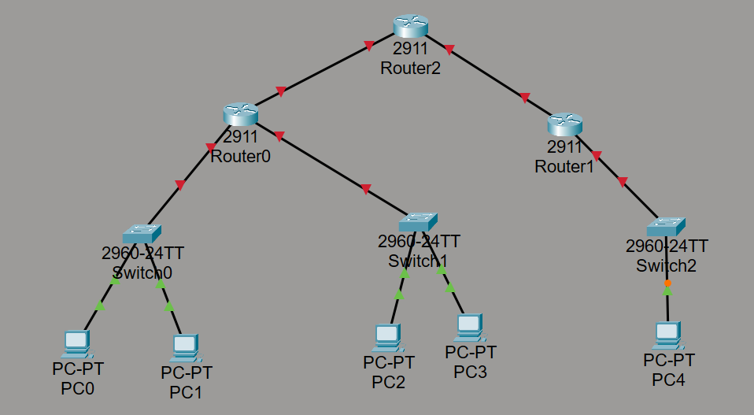

  - IP Address Configuration
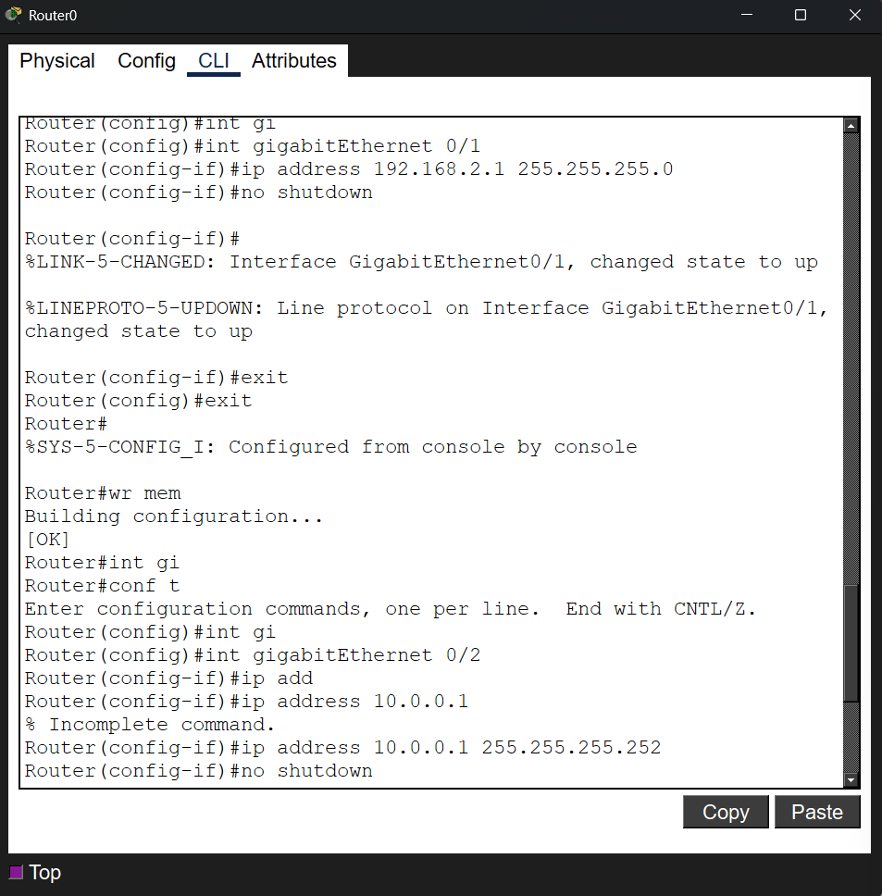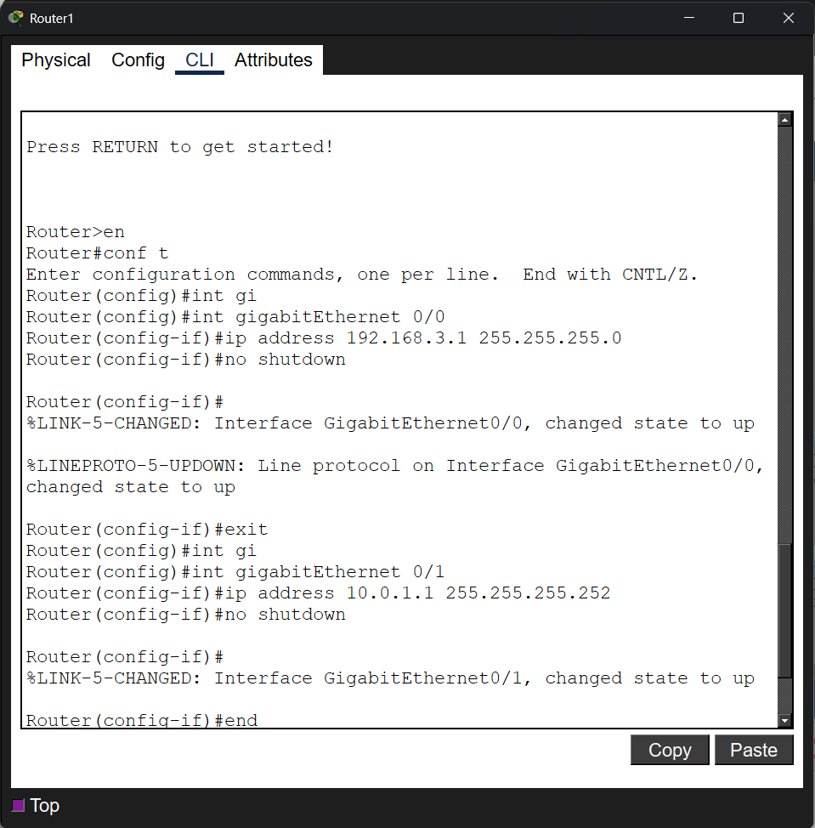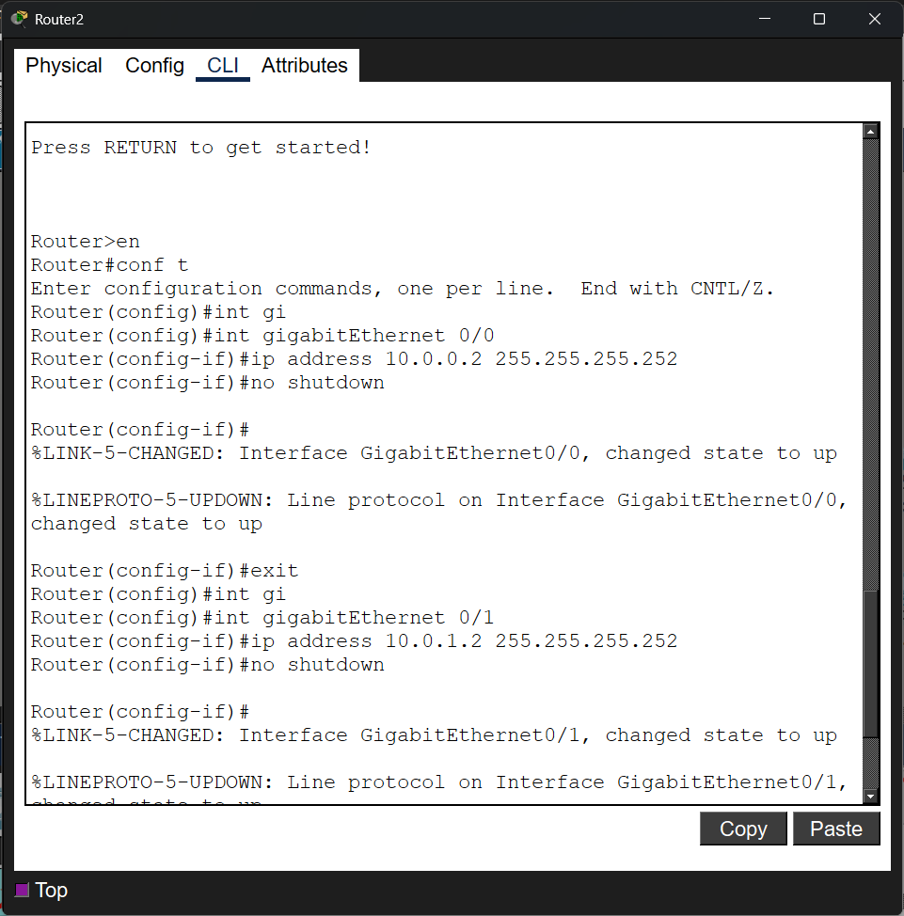

Step 4: Test the connectivity from PC0 to PC1, Router0 and PC2 using ping command. Was it possible to ping PC2? Why?

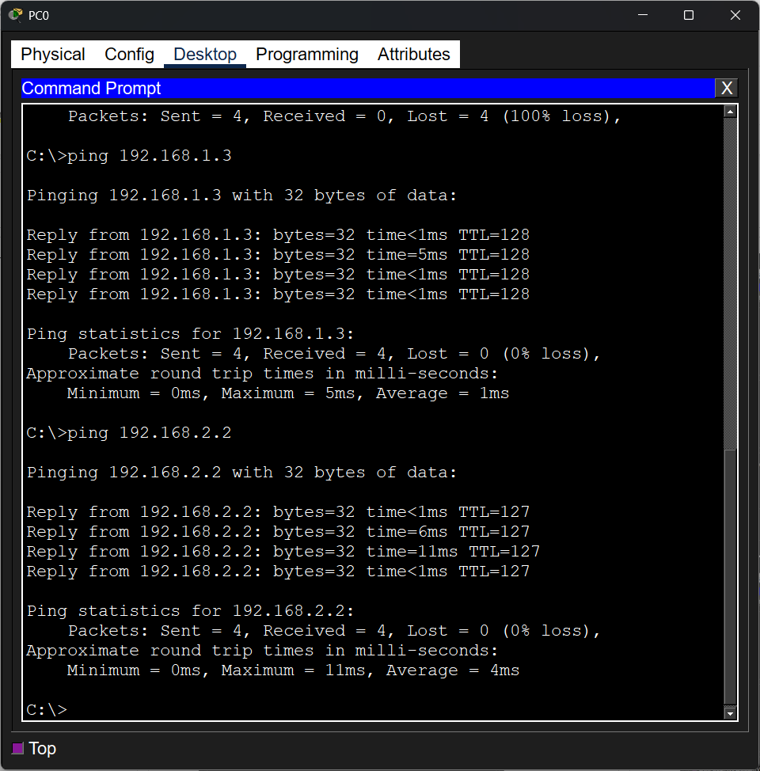

Yes. Because both PC are directly connected to Router0

1.2.2 Assign IP Addresses to PCs
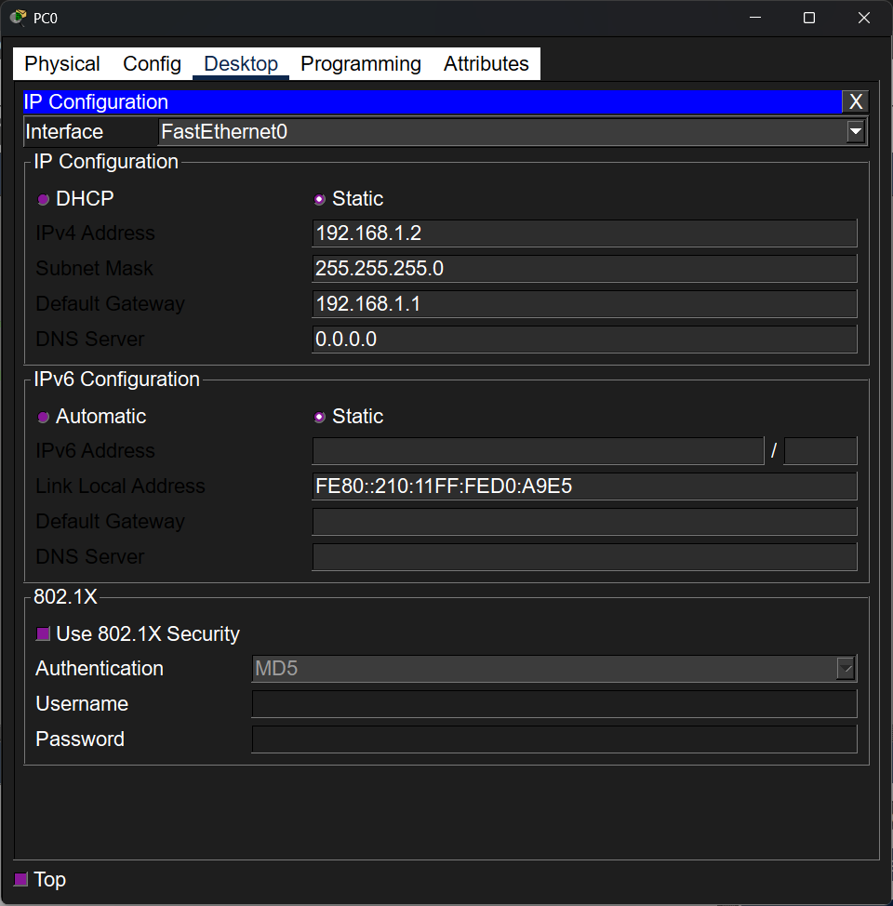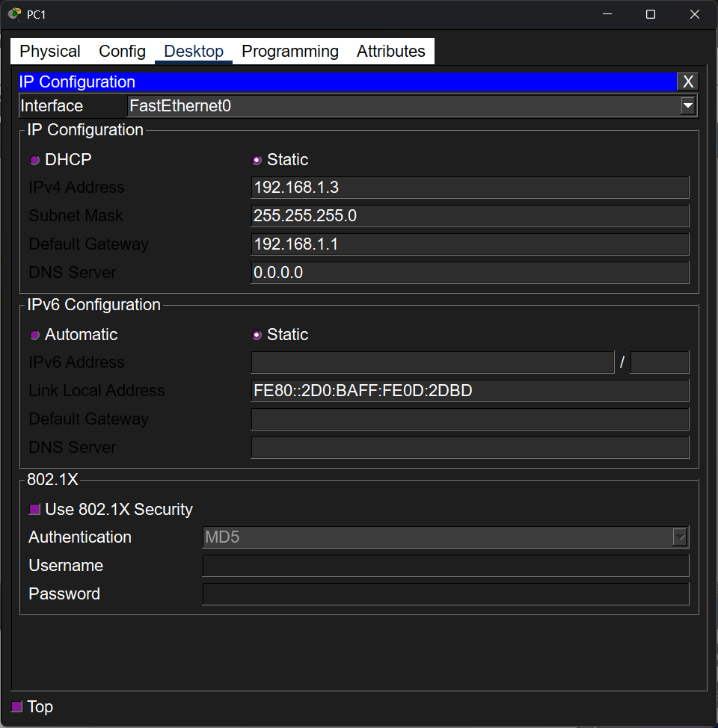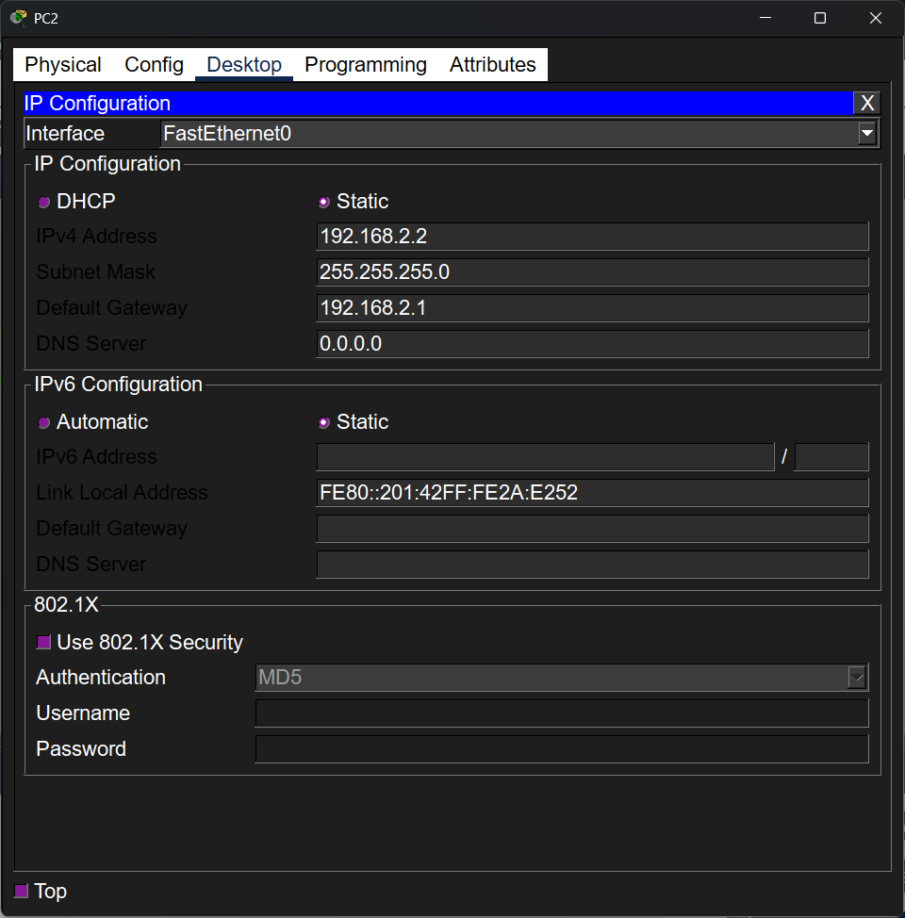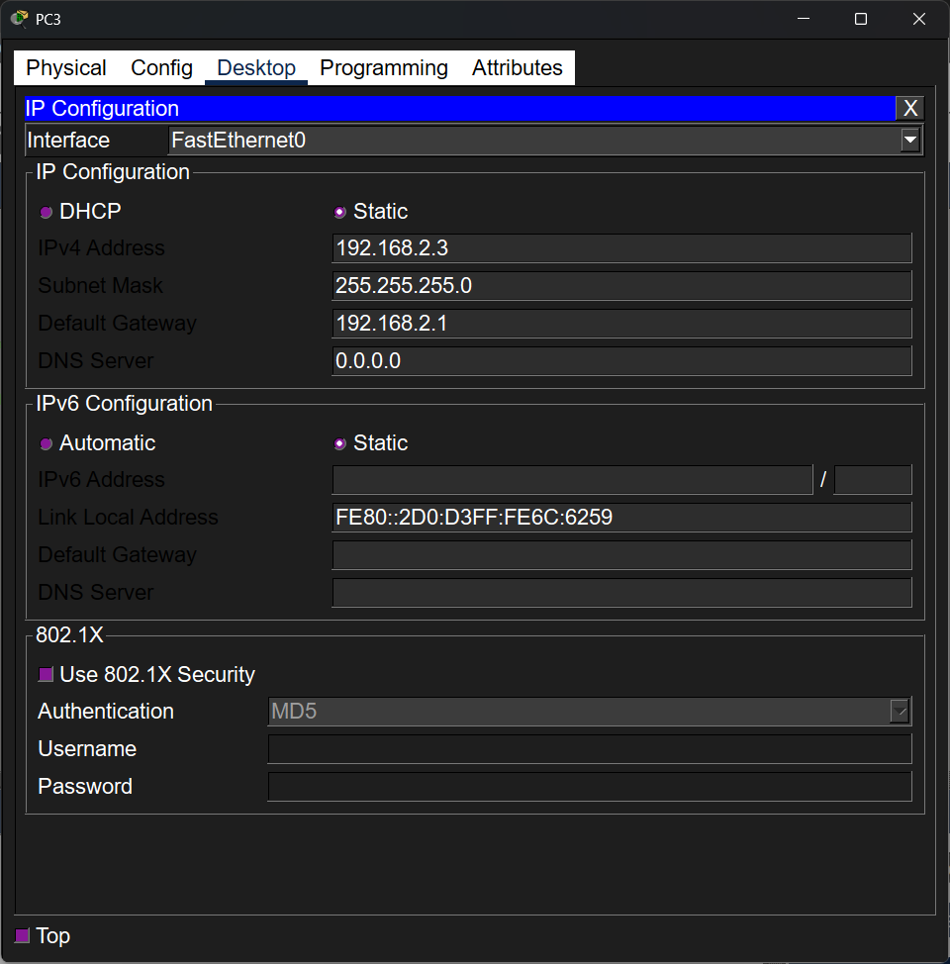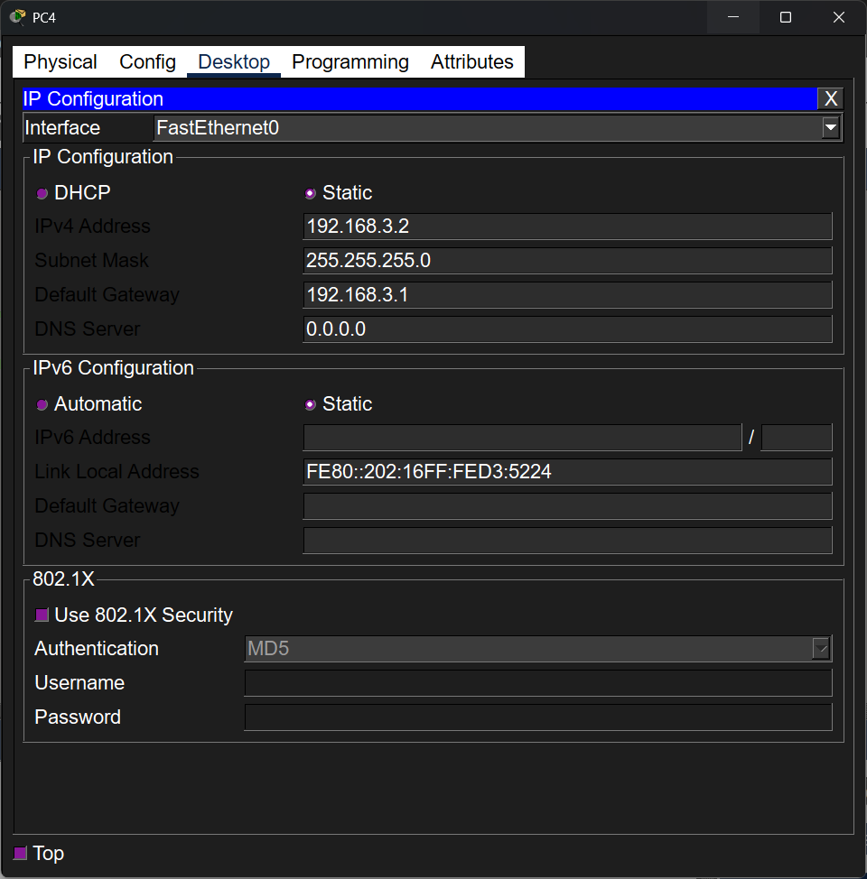

Part 2: Static Routing Configuration
2.1 Configure Static Routes
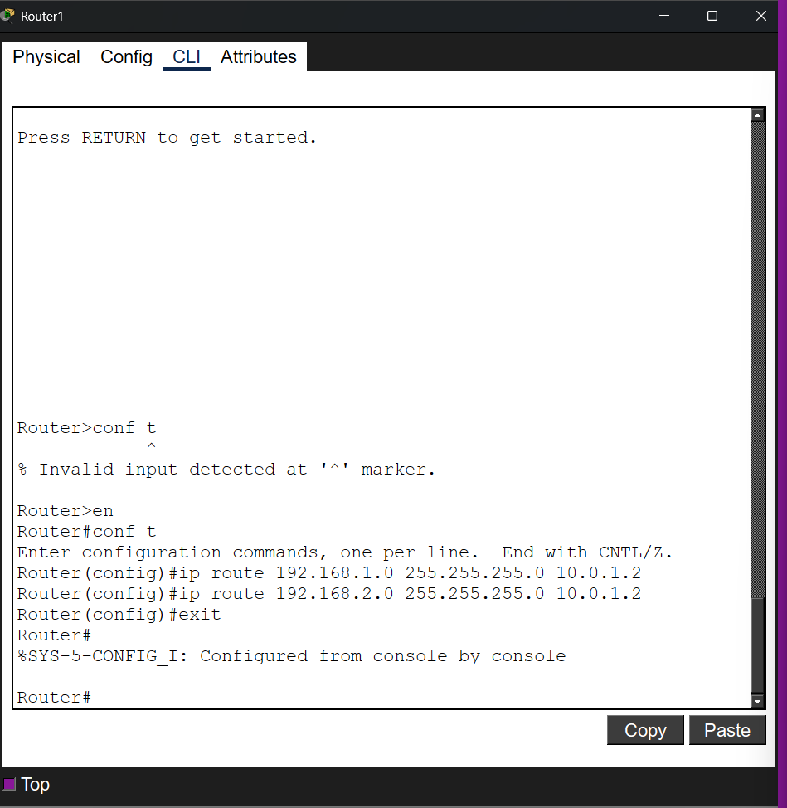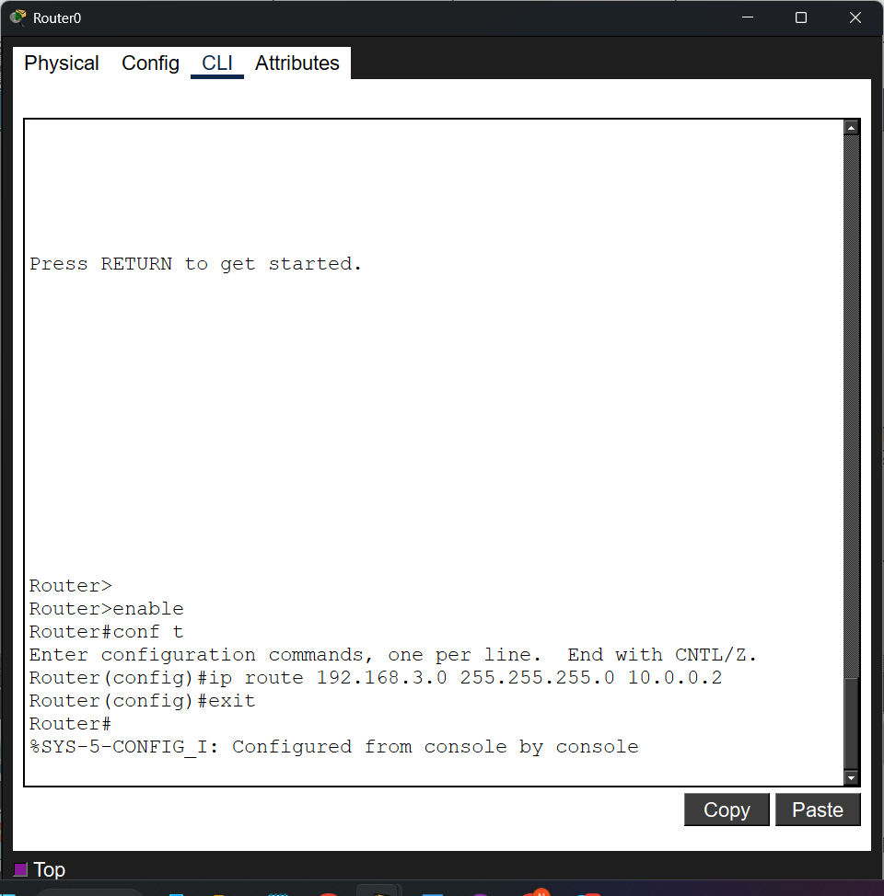
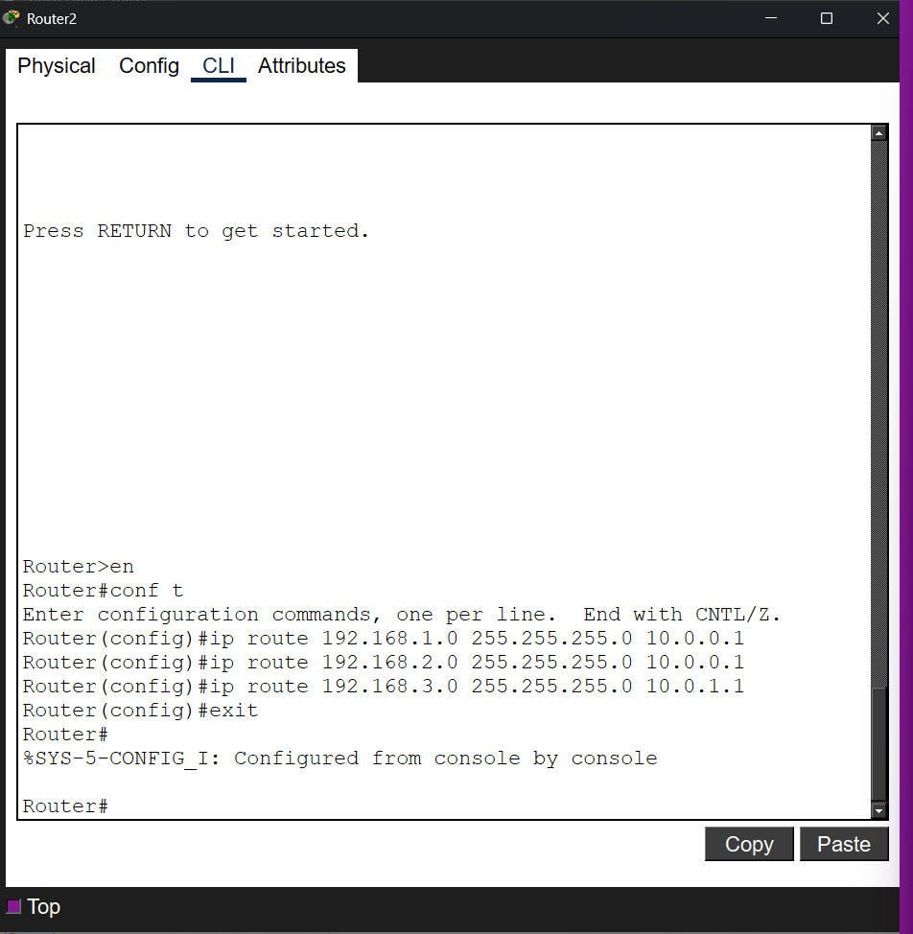

2.2 Configure Default Routes

Part 3: Testing and Verification
3.1 Verify Routing Tables
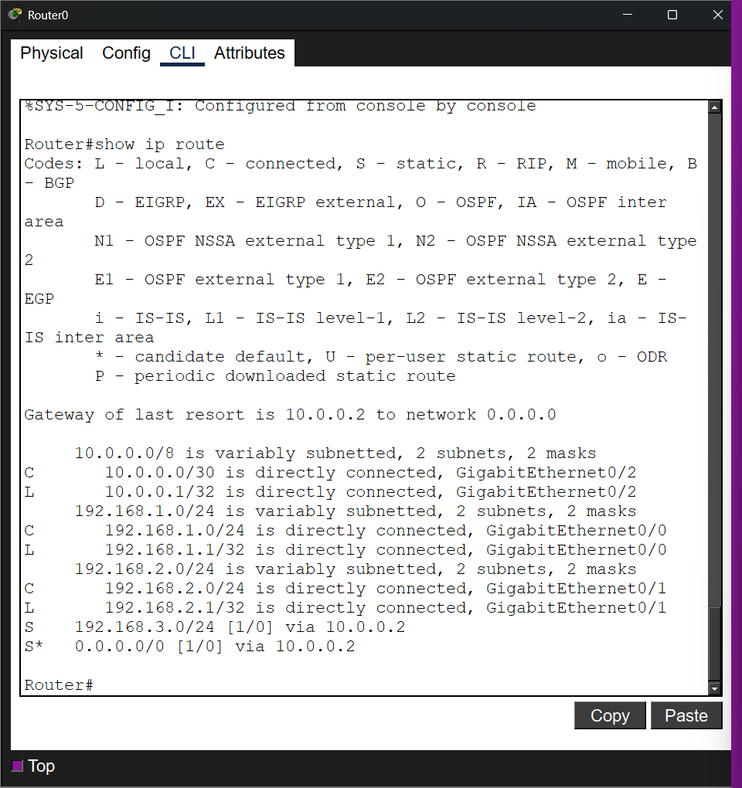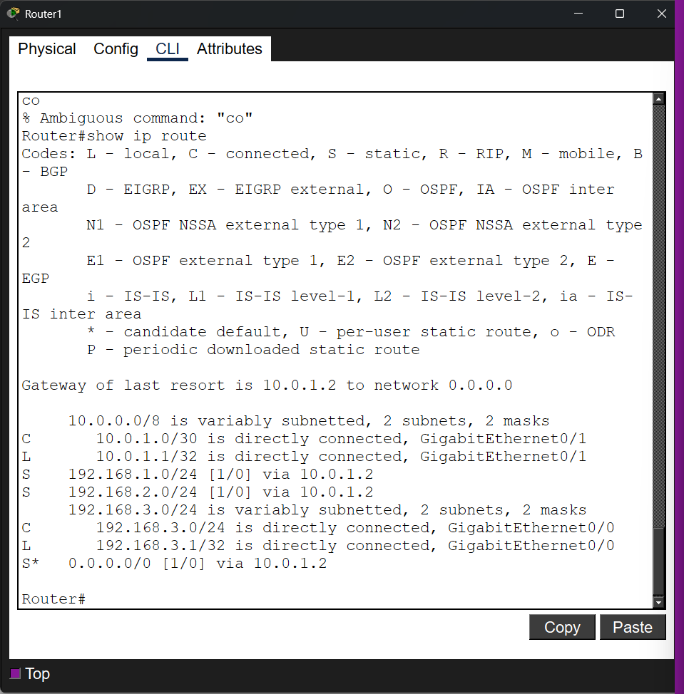
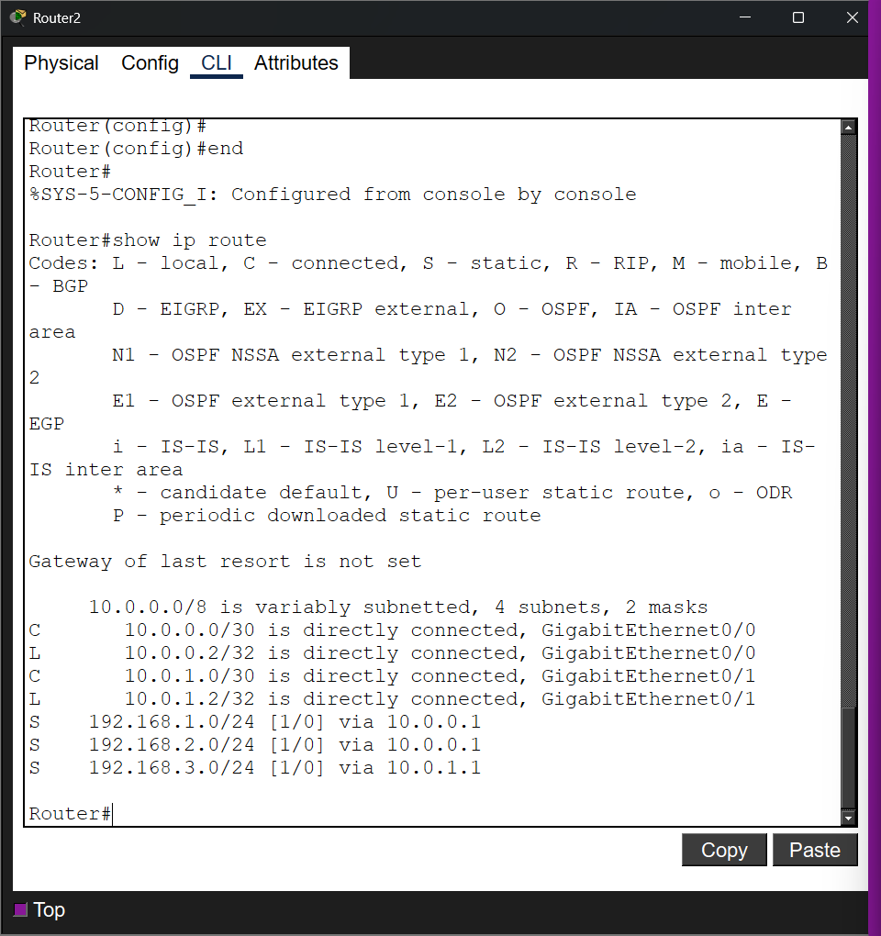

Note the difference between the routing tables of Router2 and Router0/Router1. What does “Gateway of last resort is not set” indicate? How can you configure it?
Router0/1 has a default gateway on Router2, and Router2 is a Backbone, so it knows all the routes and has no place to forward "unknown" packets. If it receives a packet with an address not in its table, it simply drops it. How to configure: You need to enter the command: iproute

3.2 Test Connectivity with Ping
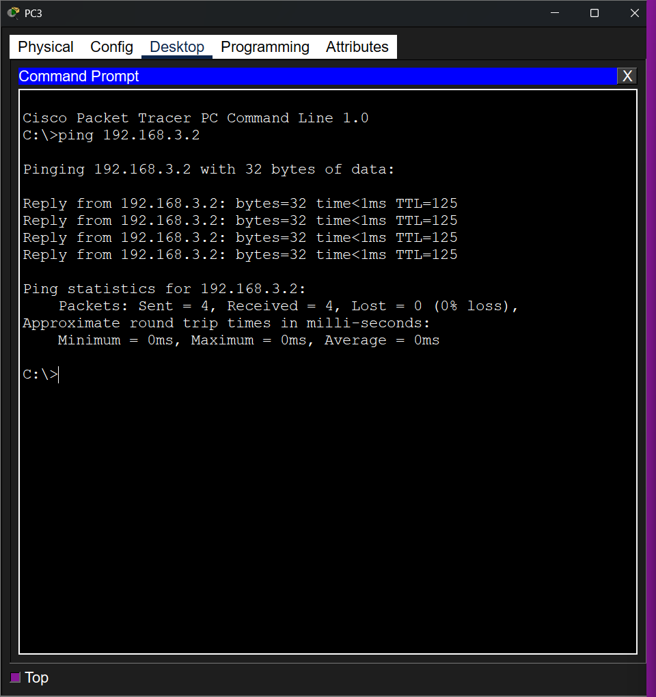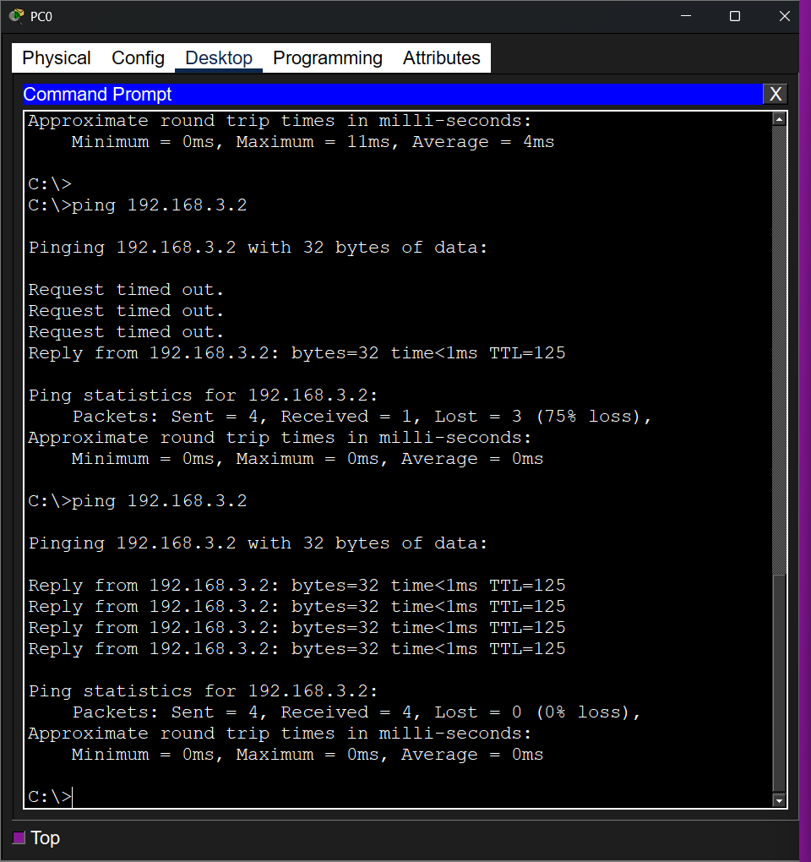

Part 4: Additional Task - Adding a New Subnet
1. Add a new PC5 and connect it to Router1 via a new switch and PC6 to Router2 via a new switch too.
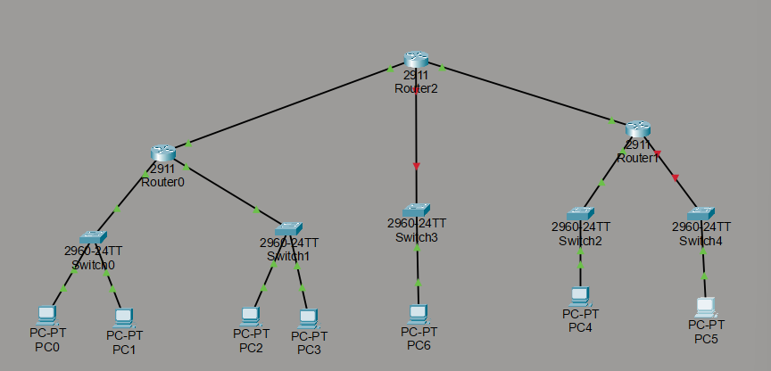
2. Choose an appropriate IP address range for these new subnets (e.g., 192.168.4.0/24).
- Range 192.168.4.0/24 for PC5 and 192.168.5.0/24 for PC6.

3,4. Assign an IP address to the new router interface and configure the new subnet on Router1
Repeat step 3 for Router2.
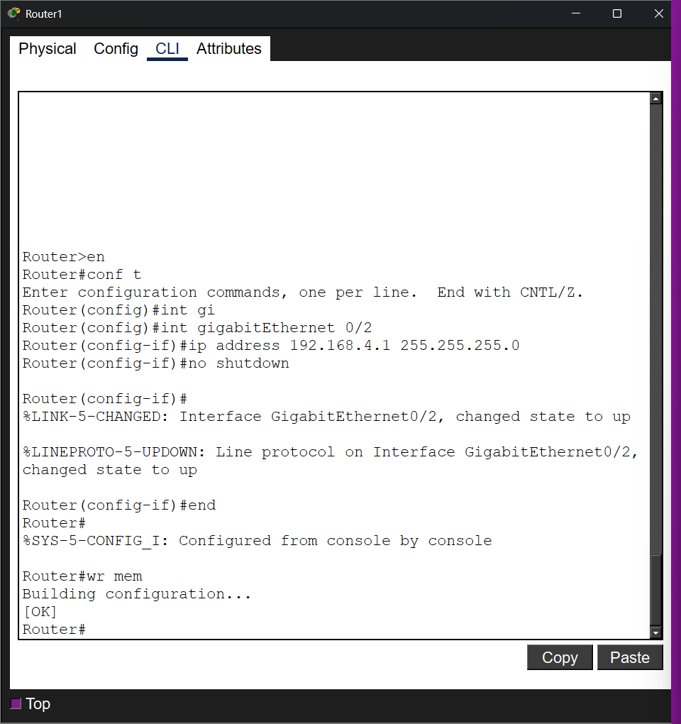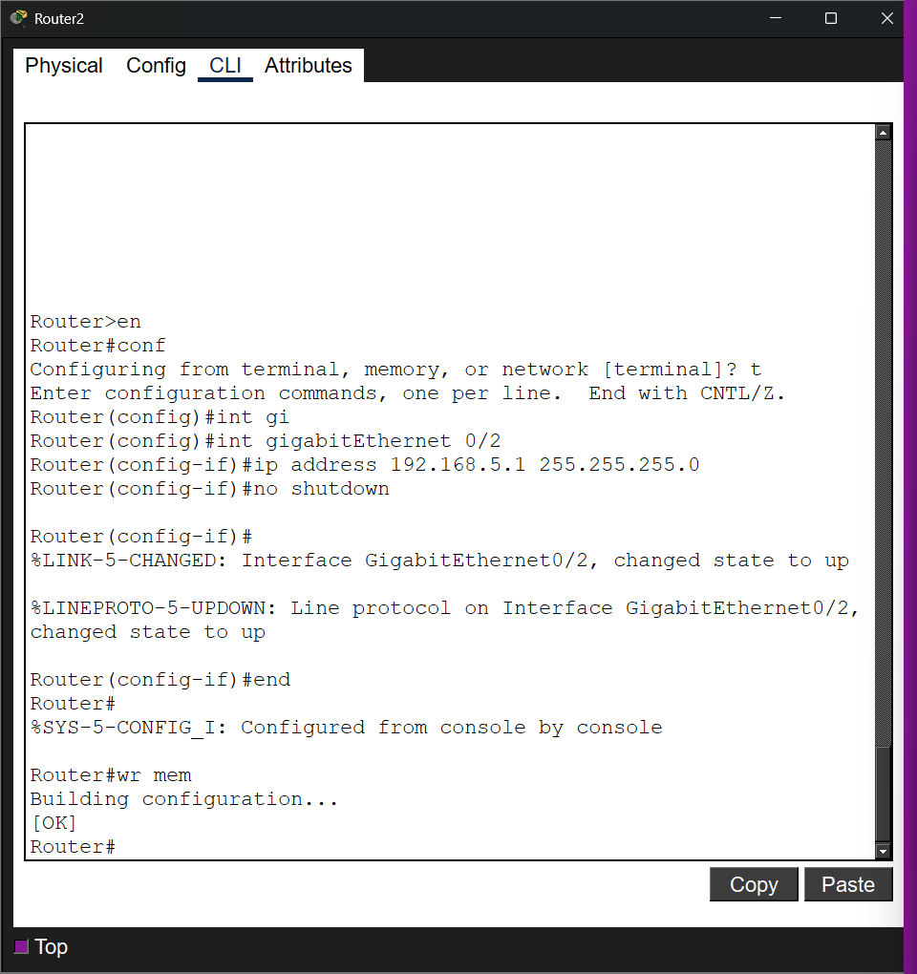
5,6. Assign an IP address and default gateway to PC5. Repeat step 5 for PC6.
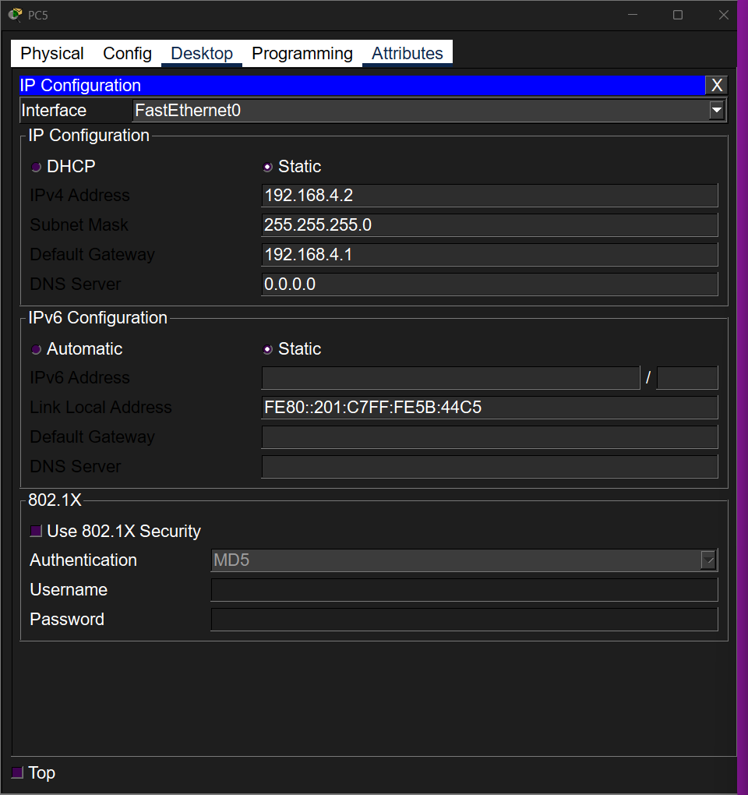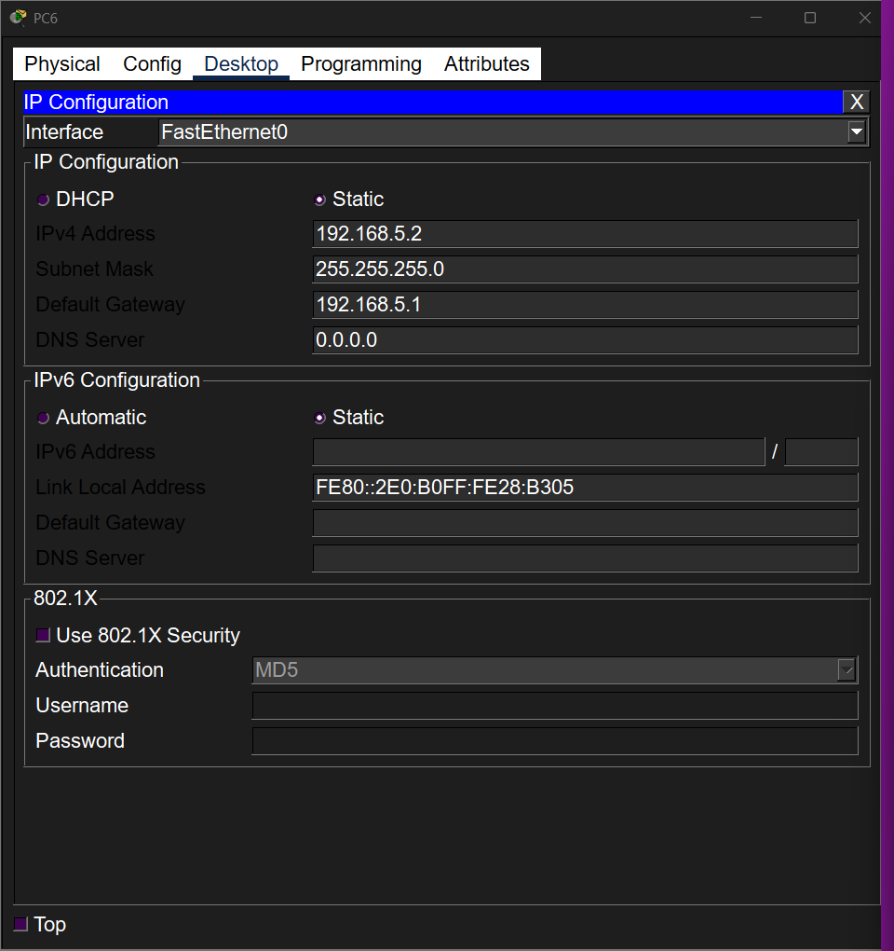

7. Configure static routes on Router0, Router1 and Router2 to allow full communication with the new subnet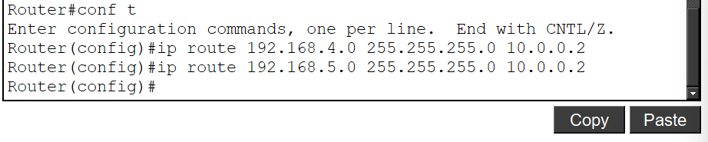 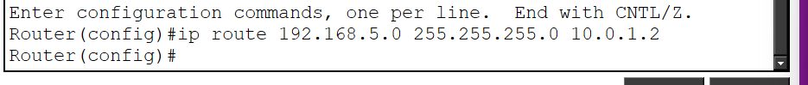 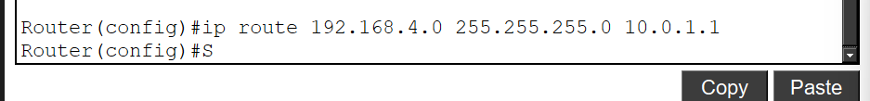

8. Verify connectivity by testing the routing tables and using the ping command. 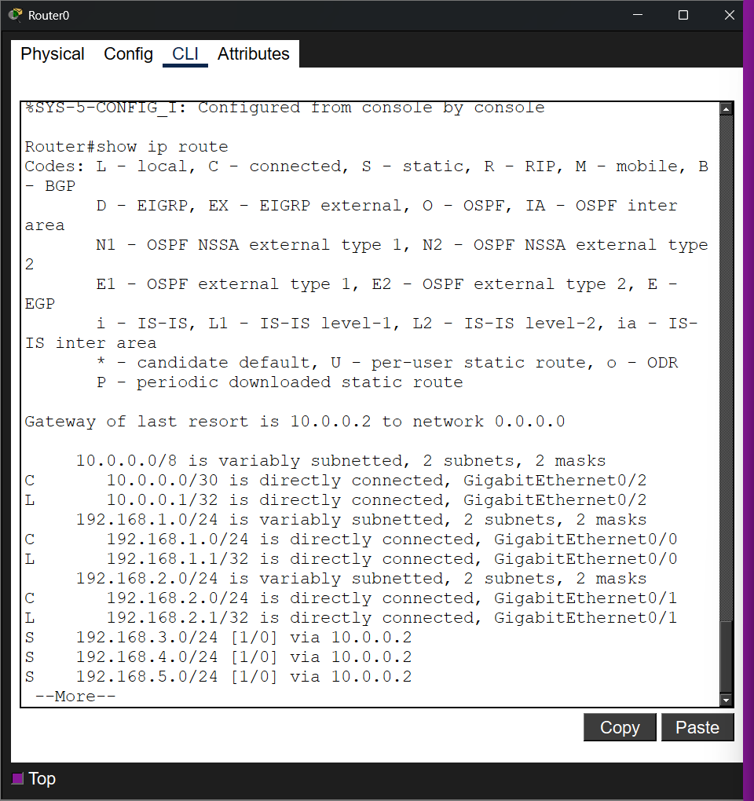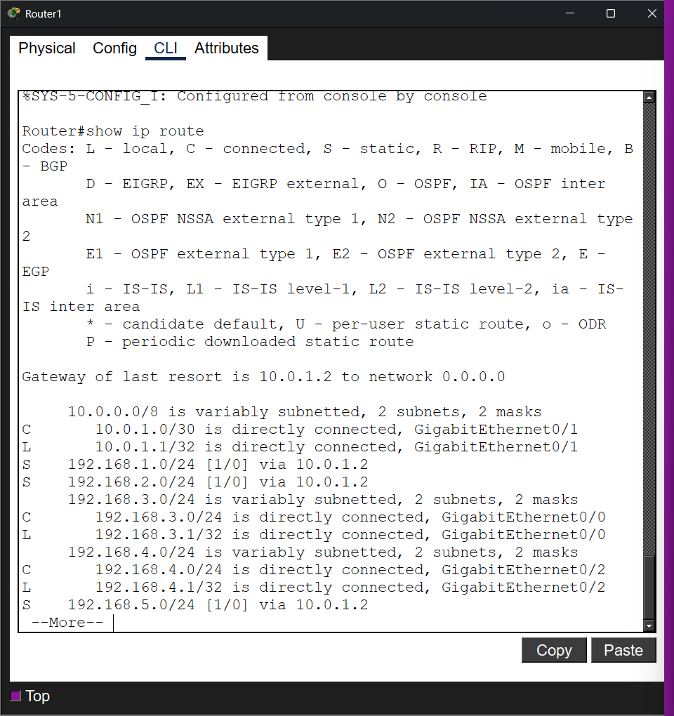
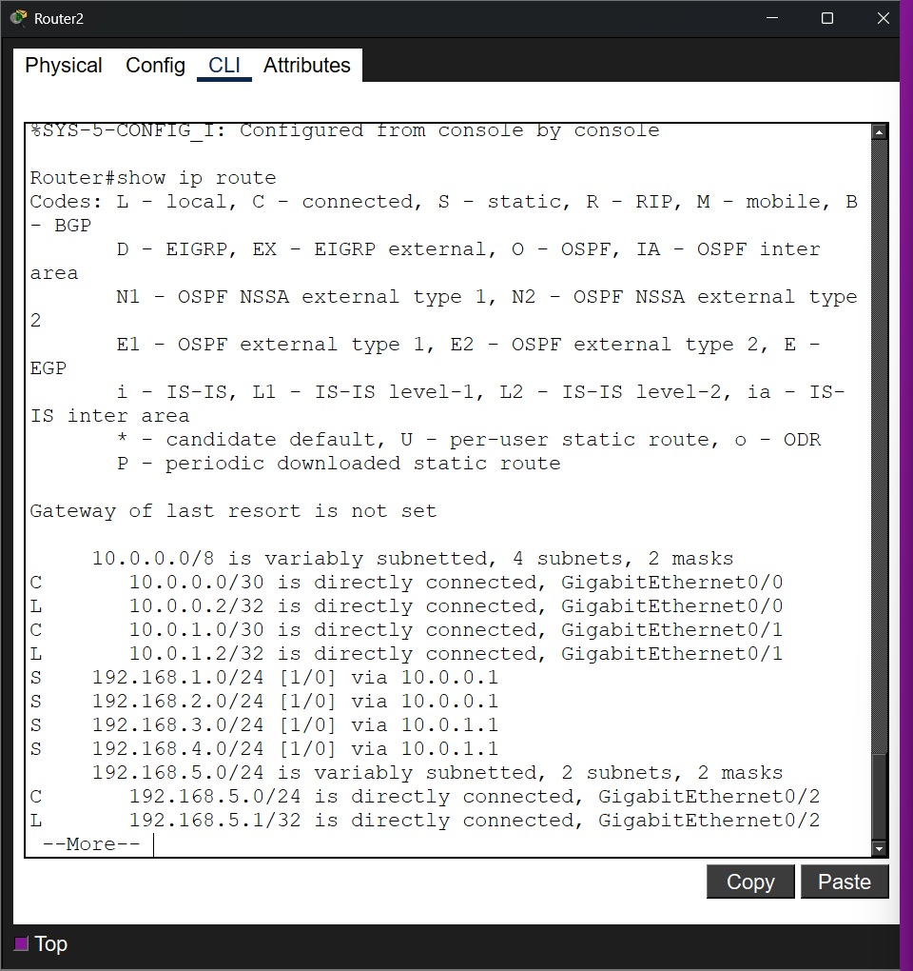

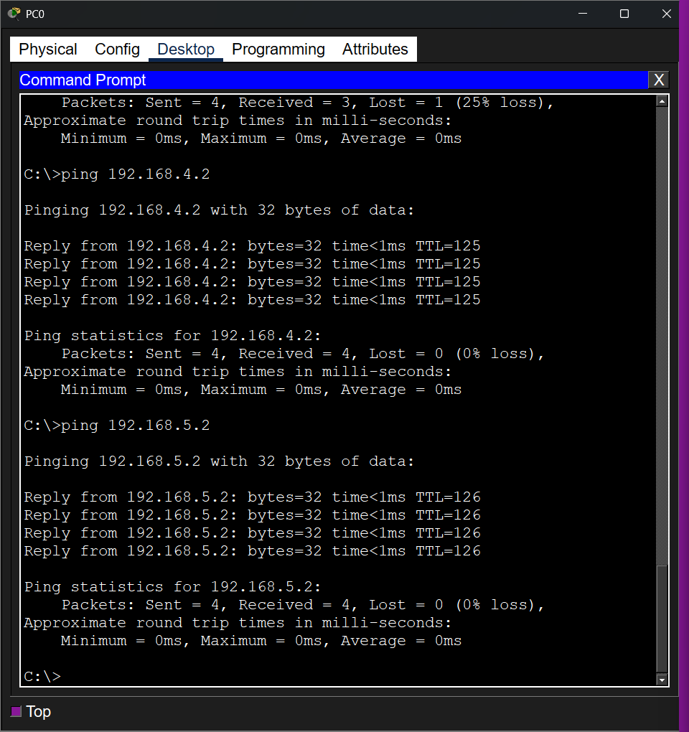
Part 5: Dynamic Routing with OSPF
Router 0 Configuration
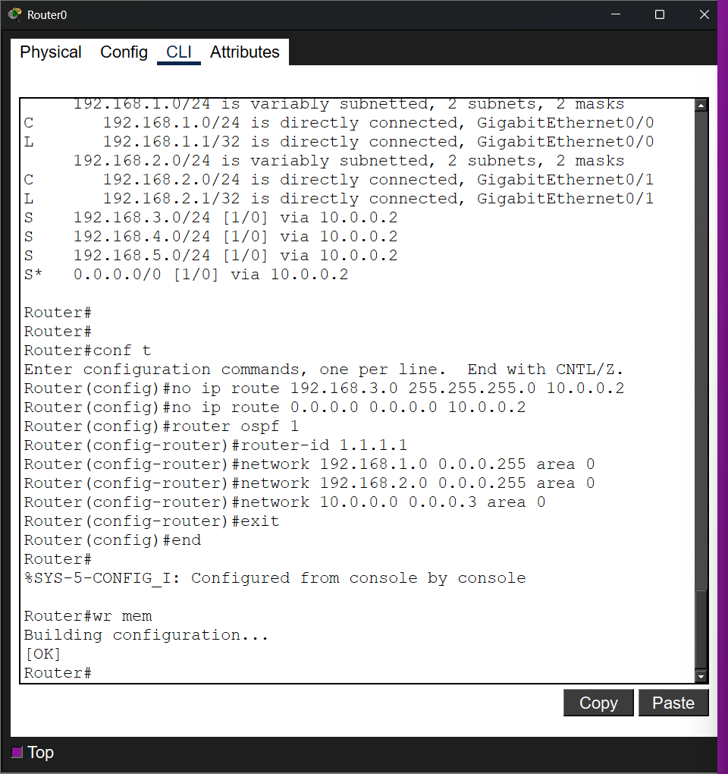

Router 1 Configuration
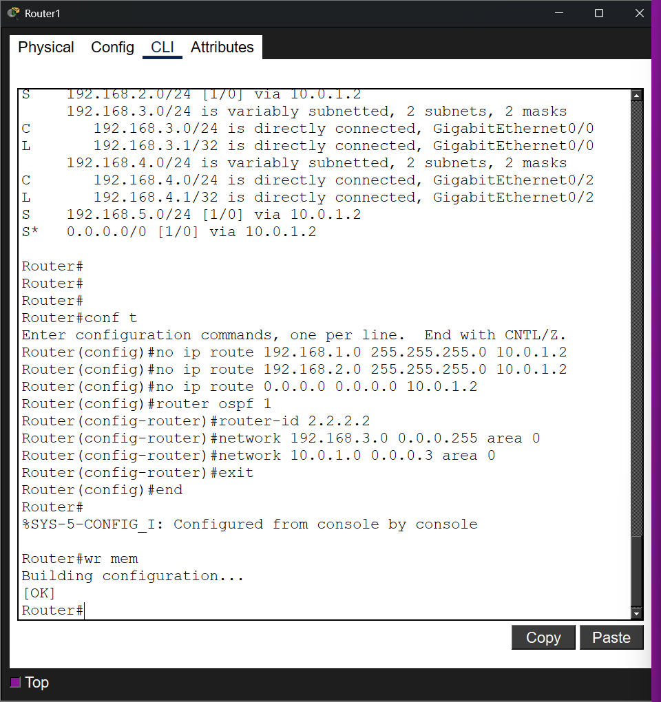

Router 2 Configuration
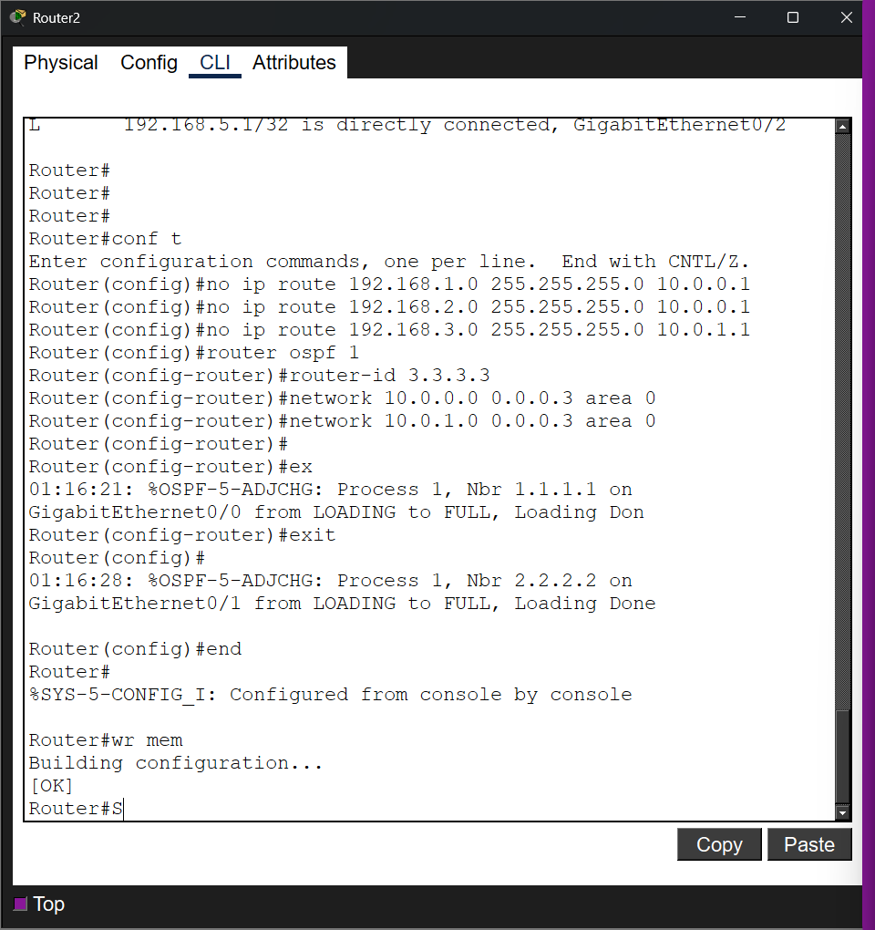

5.4 Verification
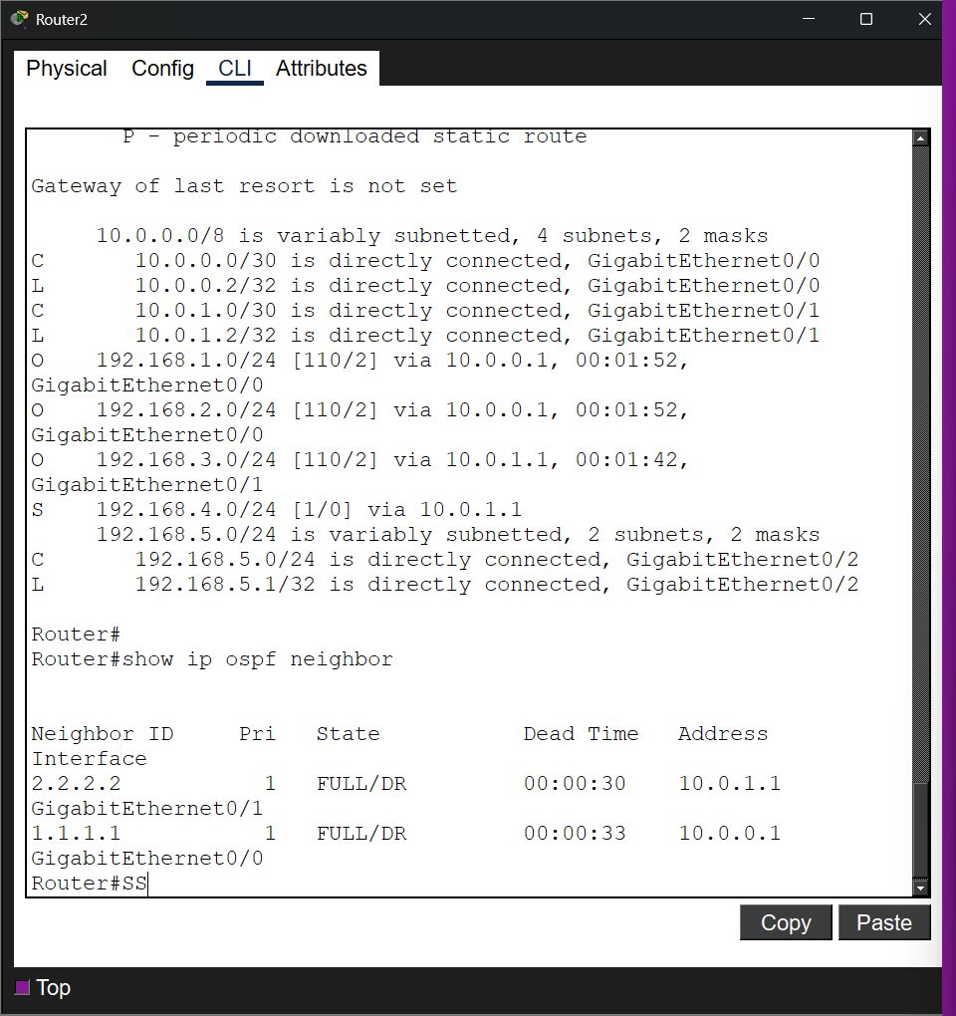

Static requires manual configuration of each route on all nodes, while OSPF automatically propagates routes throughout the network when only neighboring subnets are specified.

5.5 Testing Connectivity
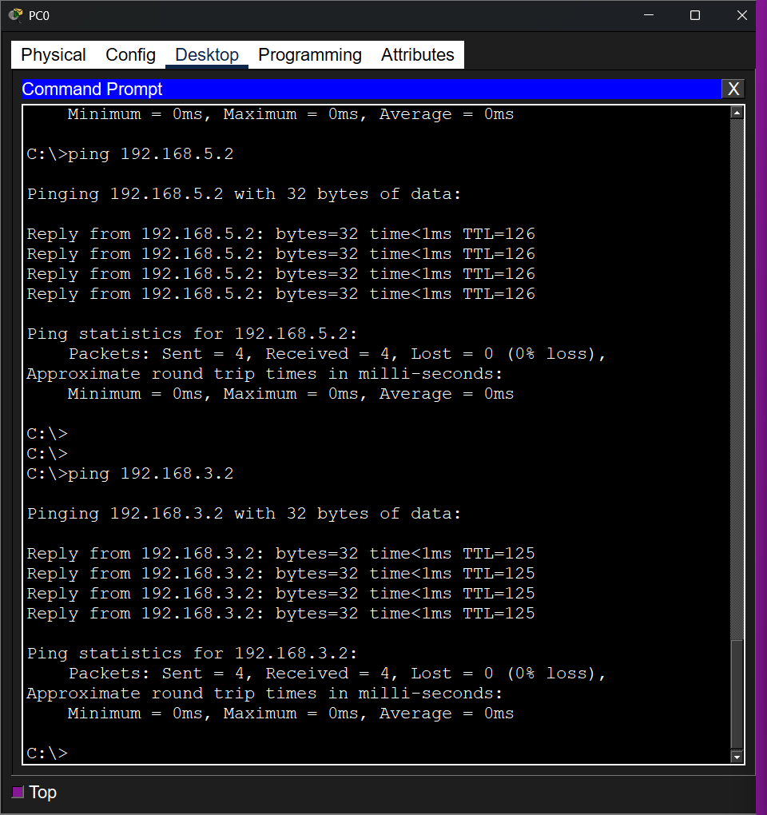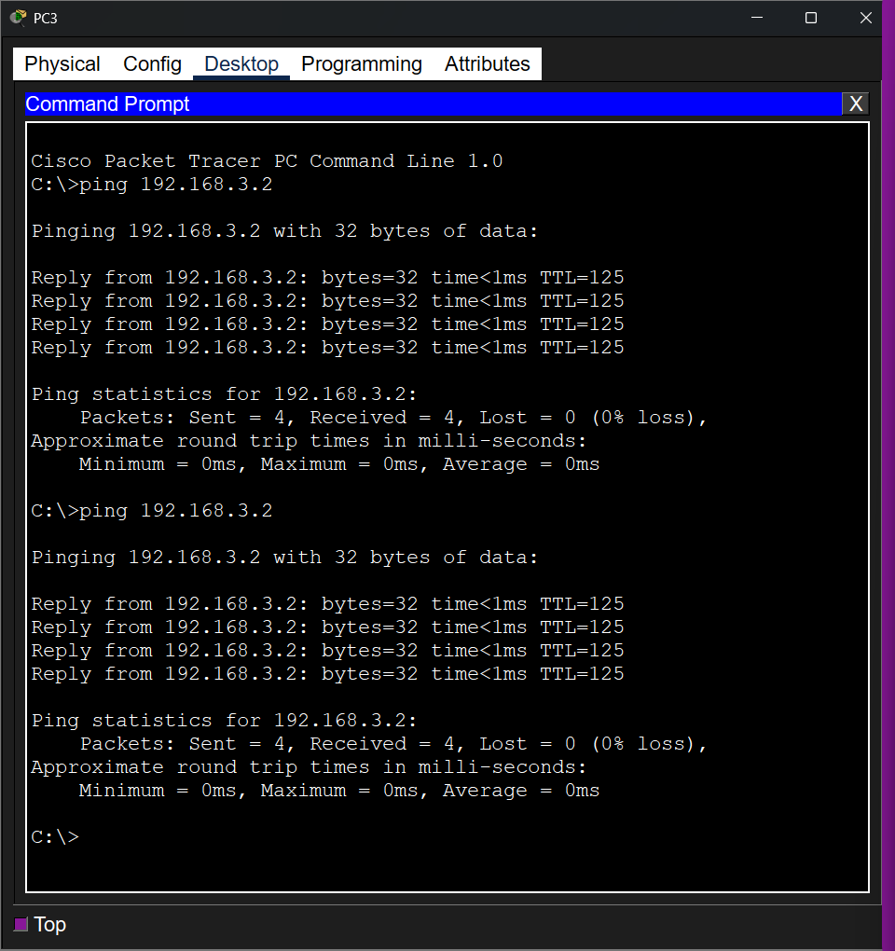
Questions:
1. How does a default static route differ from a manually configured static route to a specific network?
A specific static route defines a path to one particular network, while a default route handles all traffic for destinations not found in the routing table.

2. How does a router decide which route to use if multiple static routes exist?
The router selects the route with the longest prefix match to forward the packet.

3. What command would you use to remove a static route from a router?
Use the no ip route command followed by the exact network, mask, and next-hop address used during configuration.

4. How does the output of show ip route help in verifying static route configurations?
It displays installed routes, where static routes are marked with an "S" and the default route is marked with "S".

5. What is the main difference between static routing and OSPF?
Static routing requires manual entry for every path, while OSPF automatically discovers neighbors and updates the routing table dynamically.

6. What does the “O” symbol in the routing table represent?
The "O" symbol indicates that the route was learned through the OSPF dynamic routing protocol.

7. Why do we use wildcard masks in OSPF instead of subnet masks?
Wildcard masks are used to precisely define which interface IP addresses or ranges should participate in the OSPF process.

8. What is the purpose of Area 0 in OSPF?
Area 0 is the mandatory backbone area that connects all other OSPF areas to allow inter-area communication.

9. What happens if one link between routers goes down in OSPF?
OSPF automatically detects the failure and recalculates a new best path using the Link State Advertisement updates.

10. In which cases would you prefer to use static routing, and when would you choose dynamic routing?
Use static routing for small, stable networks or stub links, and dynamic routing for large, complex networks that require automatic failover.

