Lab 4 - Report

Student name: Bakhramov Abdulaziz
Student ID: 24B031692
Group: Mon 11:00-13:00

- Build the network using the topology shown below.
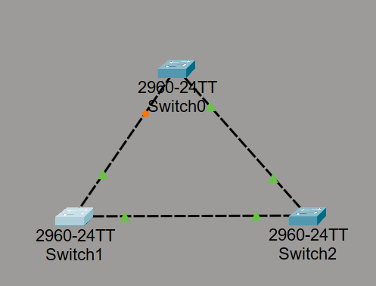

- Configure Basic STP on Switches.
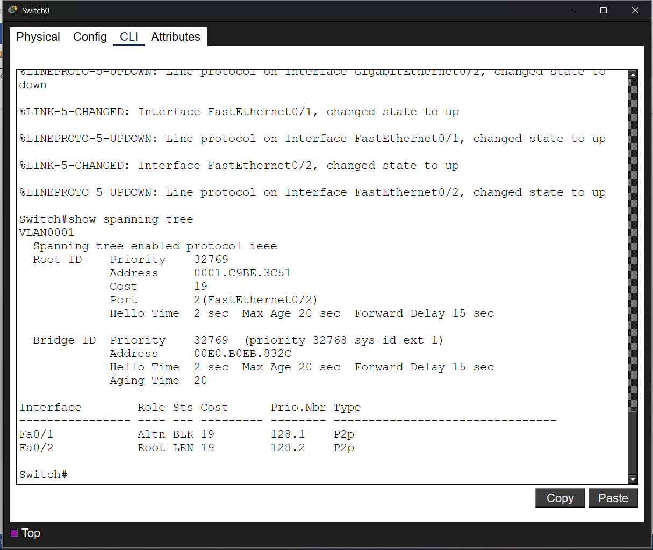

- Simulate STP operation by blocking a redundant link:
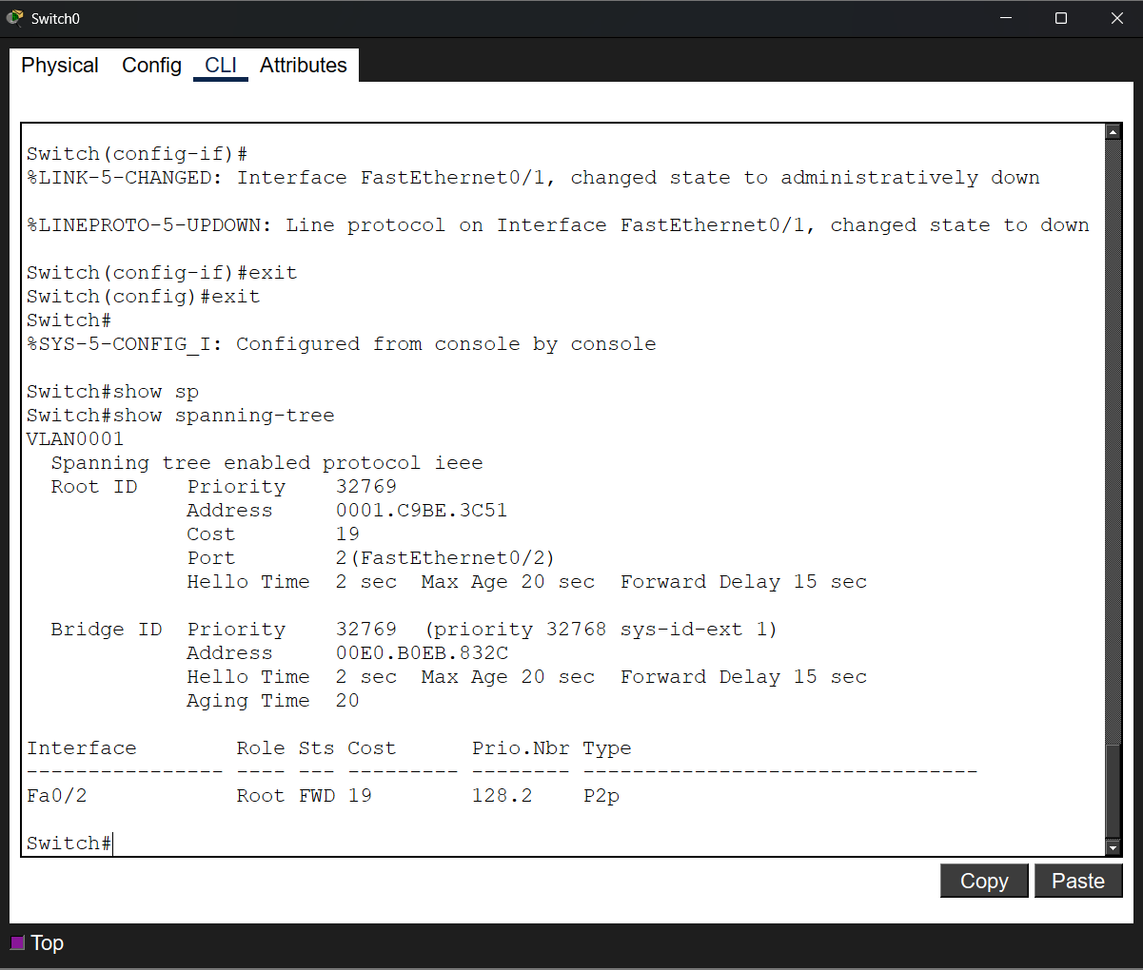

- Build the Topology and assign IP addresses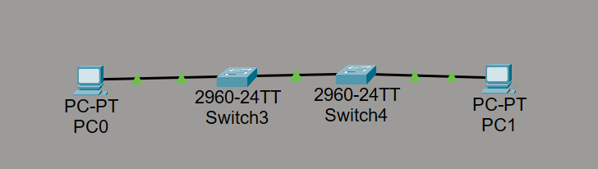
- Test connectivity using a ping from
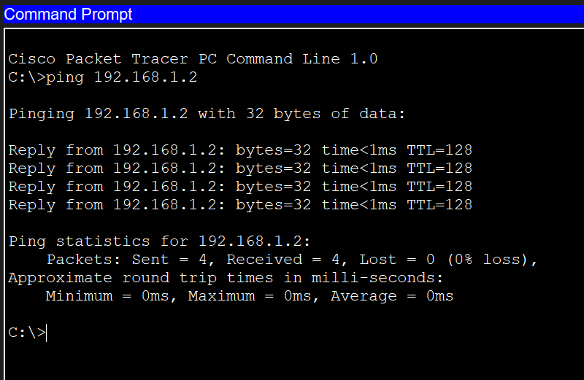

- Enable RSTP on Switches
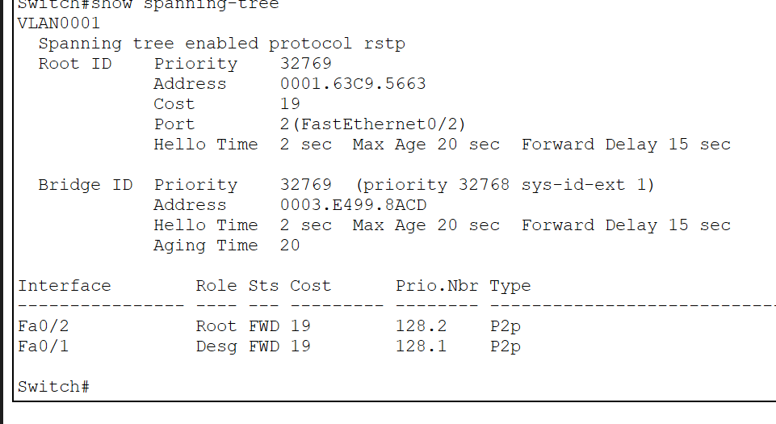

- Disable an active link (simulate failure)
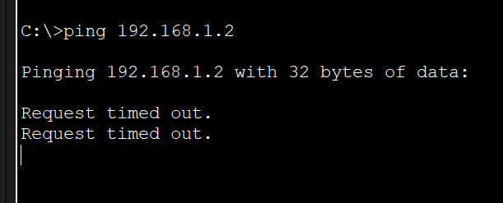
- Build the Topology (link aggregation)
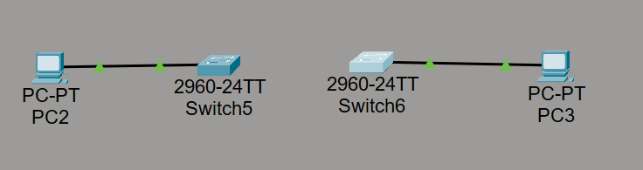
- Configure Static EtherChannel
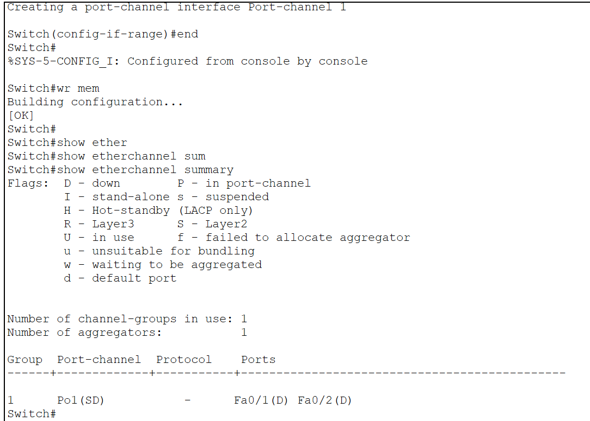
- Connect switches
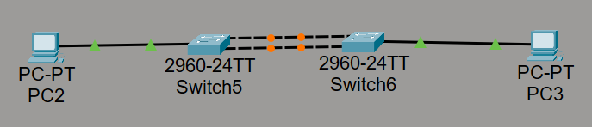

- Answer for the questions:

- Which switch became the Root Bridge, and why?
The one with the lowest priority or MAC address (in the lab, this is usually Switch0).

- Which ports were blocked by STP?
Those that are orange (for example, Fa0/1 on Switch2) to avoid loops.

- How did the traffic path change after disabling a link?
Data was bypassed through a backup link that was previously blocked.

4. What are the advantages of using EtherChannel in this network?
Increased throughput (channels are summed) and instantaneous operation if one of the measurements is lost.

