Lab 2 - Report

Student name: Bakhramov Abdulaziz
Student ID: 24B031692
Group: Mon 11:00-13:00

4.6.5-packet-tracer---connect-a-wired-and-wireless-lan

- Connect to the cloud
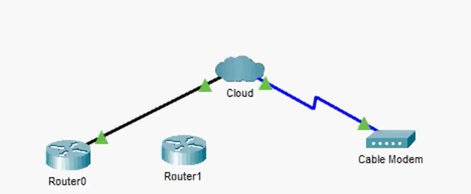
- Connect Router0
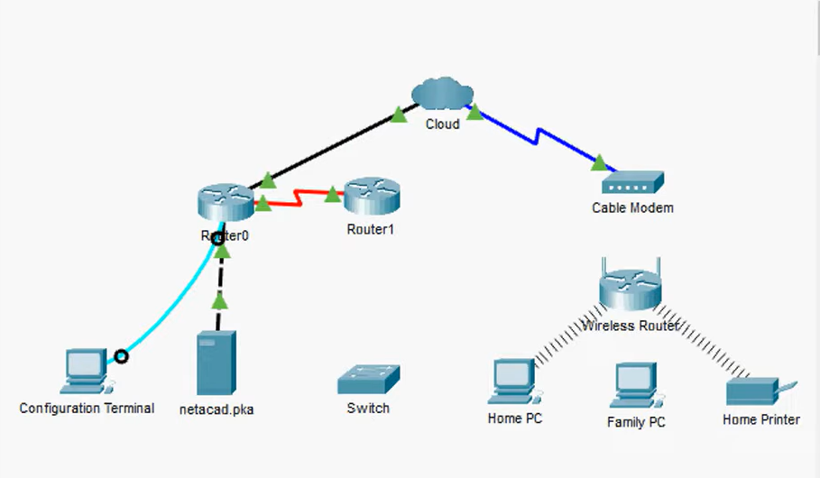

- Connect Remaining Devices 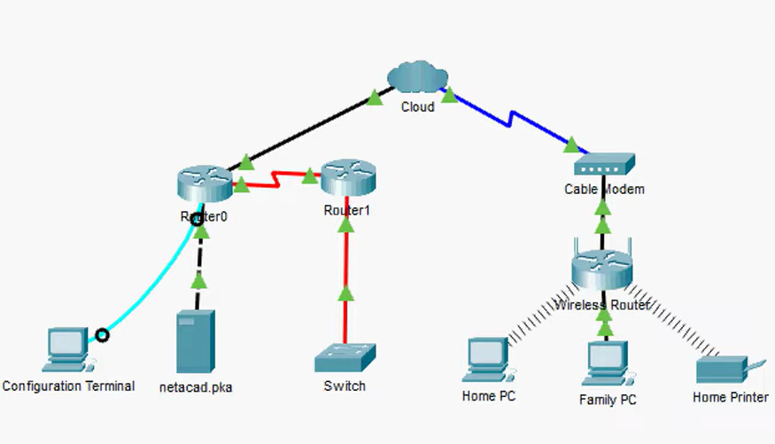

- Verify connections

- Ping netacad.pka
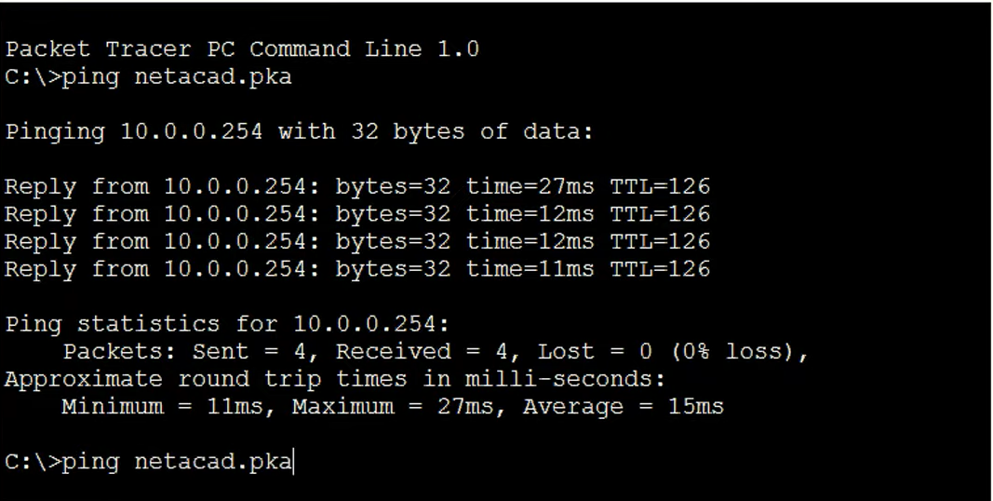
- Web browser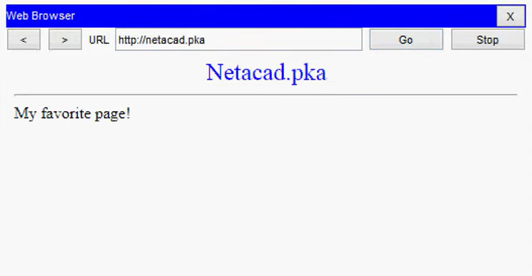

- Ping (Home PC)
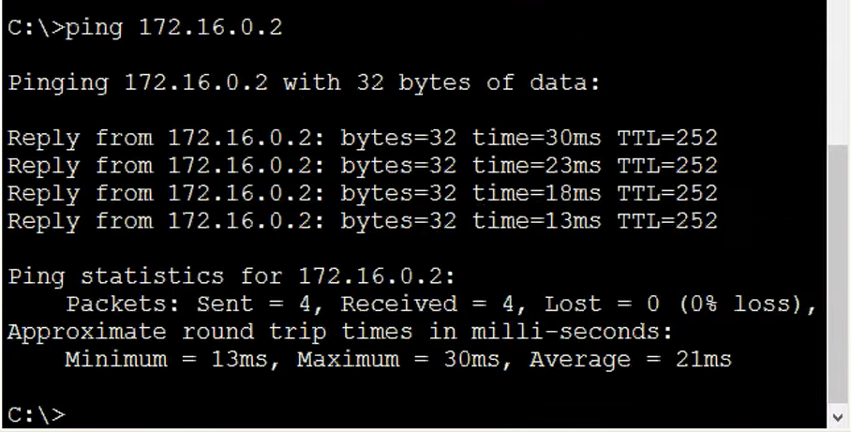
- Open from configuration terminal
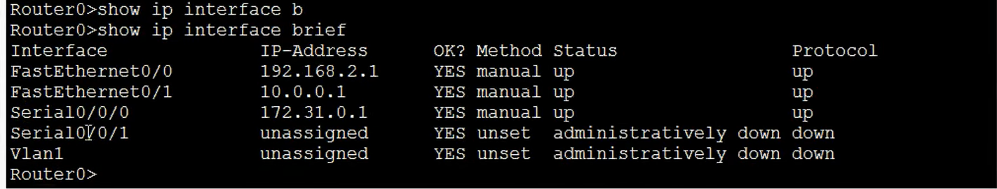

- Examine the cloud

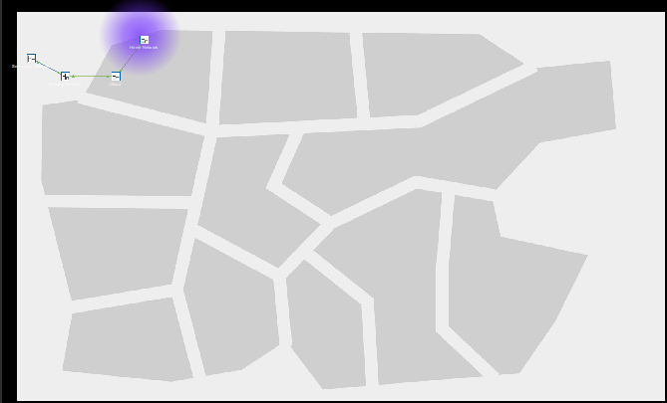

- Examine the primary network
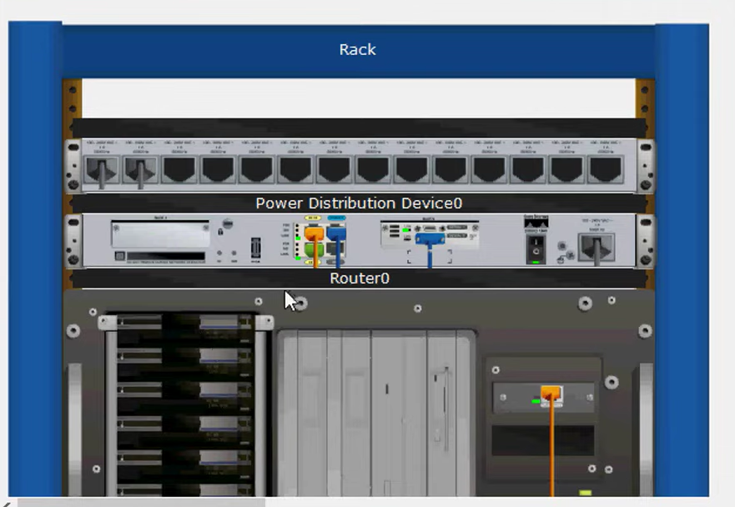

- Examine the secondary network
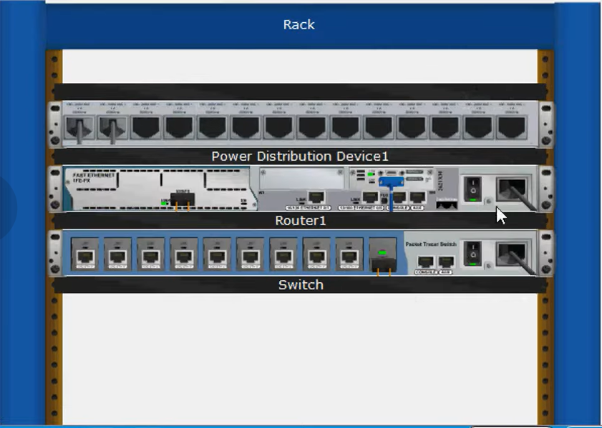

- Examine the home network
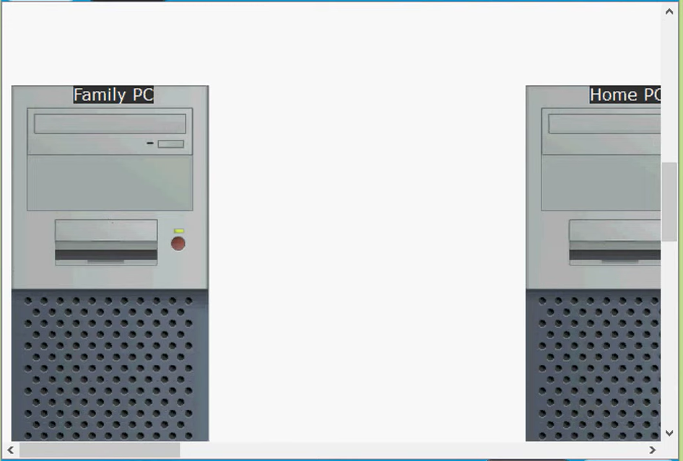

4.7.2-packet-tracer---connect-the-physical-layer
9. Identify Physical Characteristics of Internetworking Devices
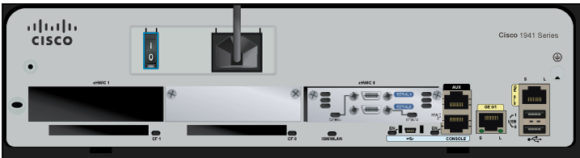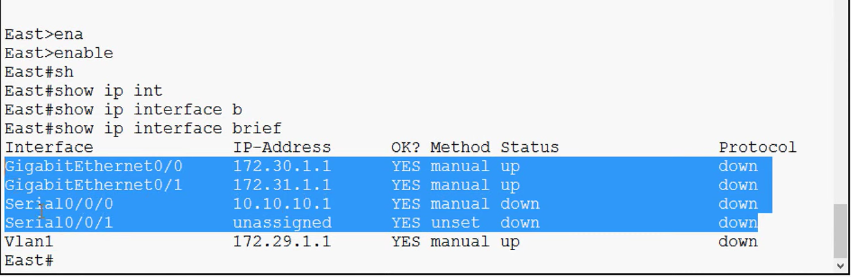

- Identify module of expansion slots
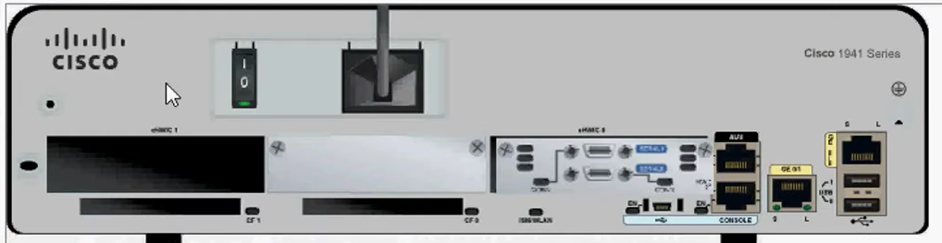

- Connect all devices

0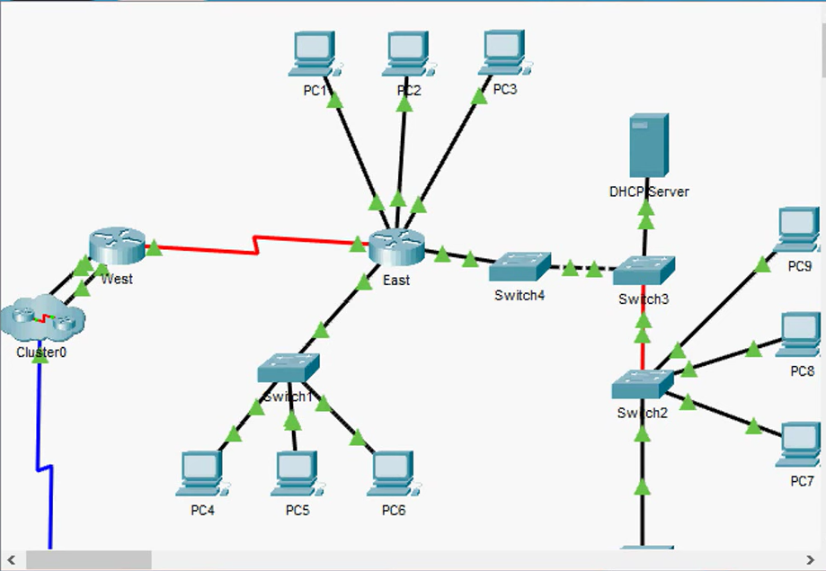

- Check connectivity
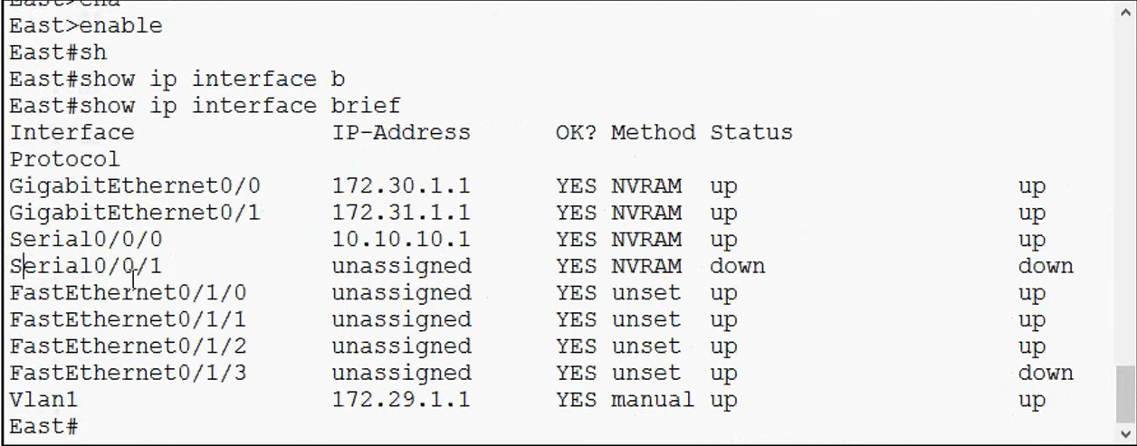

- Connect wireless devices (laptop and tablet PC)
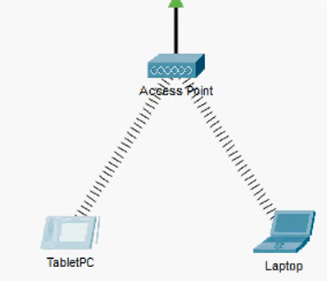

- Check connectivity
