Lab 9 - Report

Student name: Bakhramov Abdulaziz
Student ID: 24B031692
Group: Mon 11:00-13:00
Configuring Network Address
Translation (NAT)

Part 1: Network Setup
1.1 Topology and Addressing Scheme
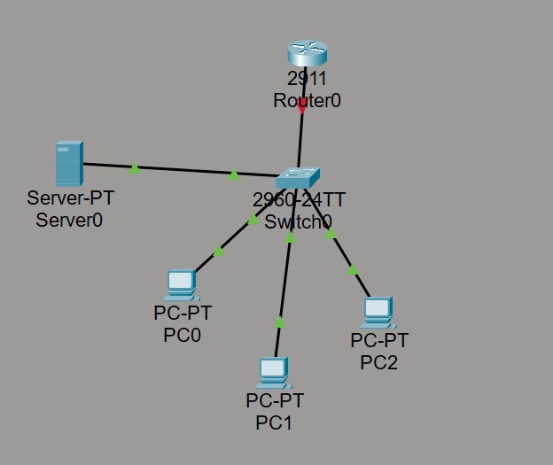

1.2 Configure VLANs on the Switch
Create VLANs
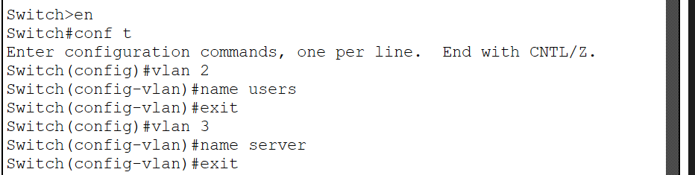
Configure accesses
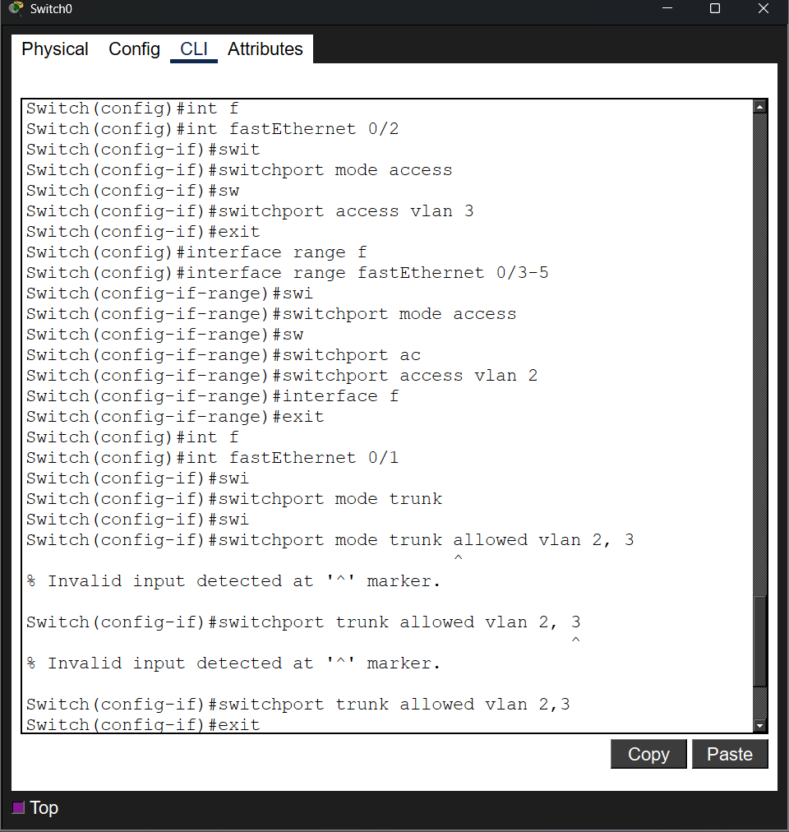

1.2 Configure Inter-VLAN Routing on the Office Router
Enable the physical interface:
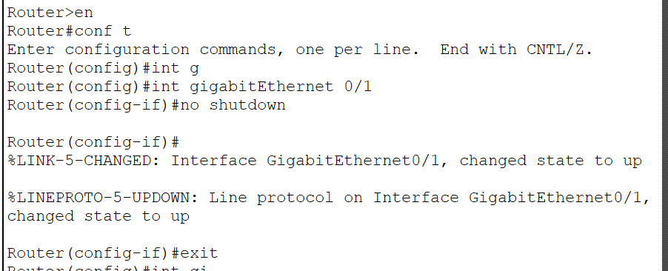
Create sub-interfaces for each VLAN:
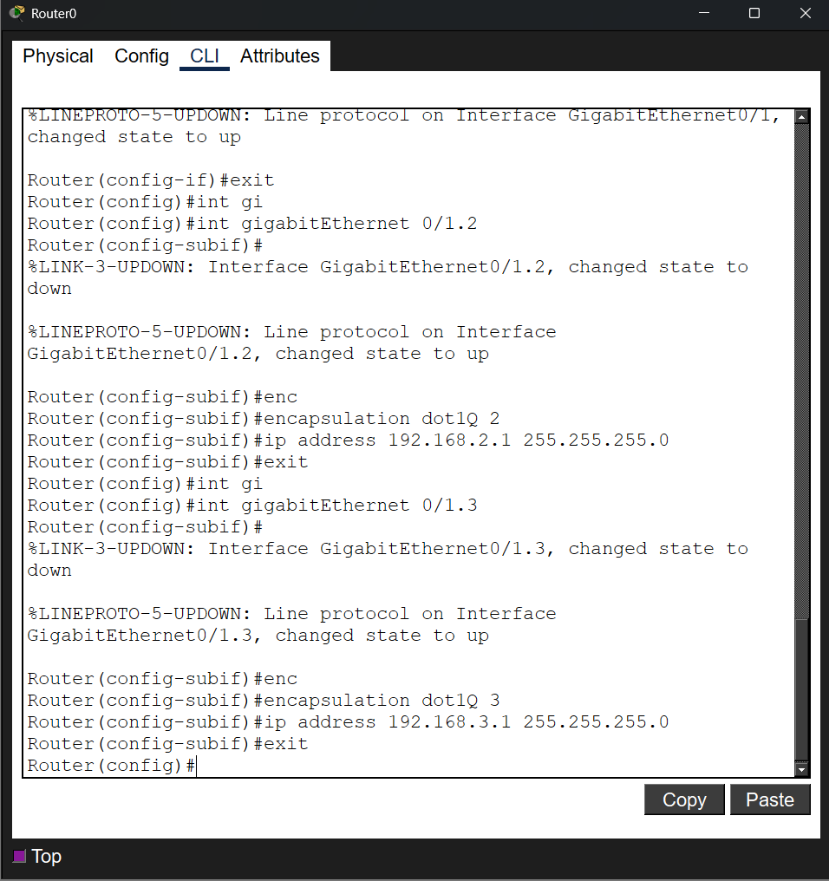
1.3 Check the Connectivity
Assign IP:
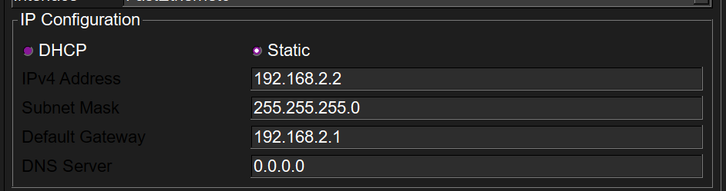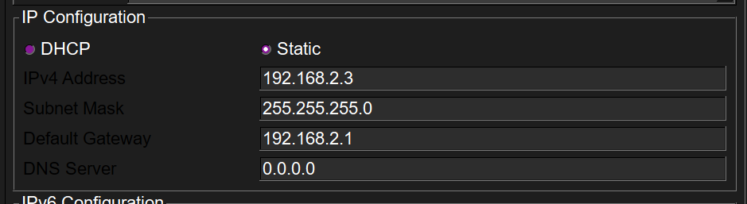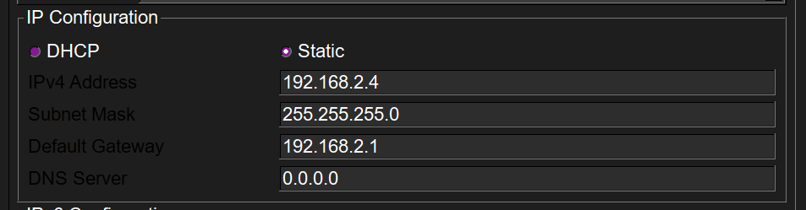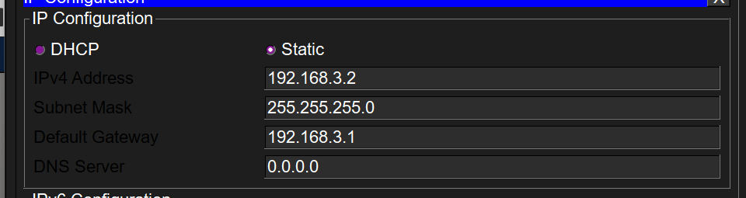
Ping test
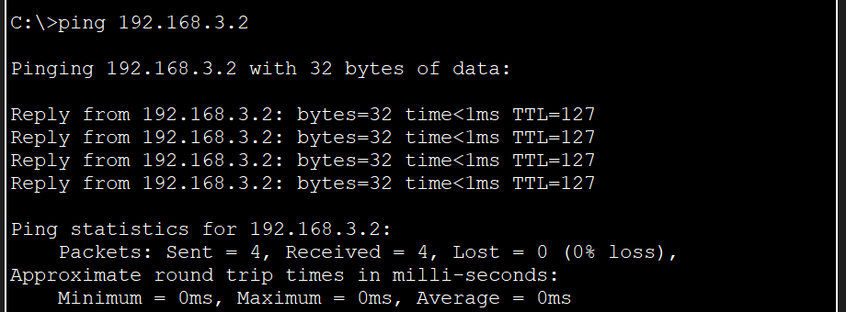
Part 2: Internet Connectivity Setup
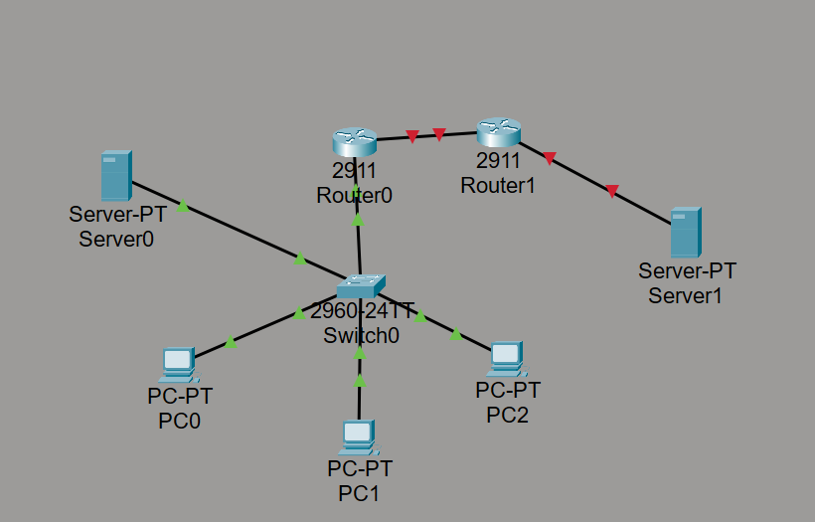
2.1 Configure ISP Router
Office router IP
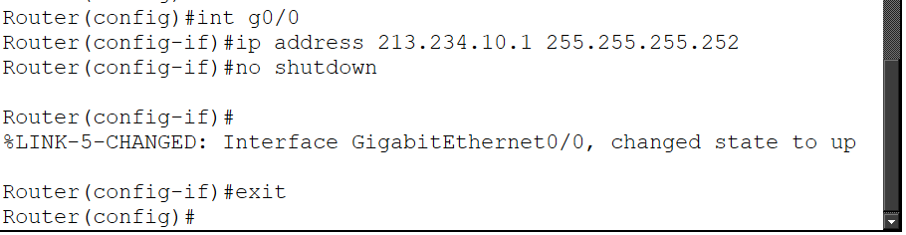
ISP router IP
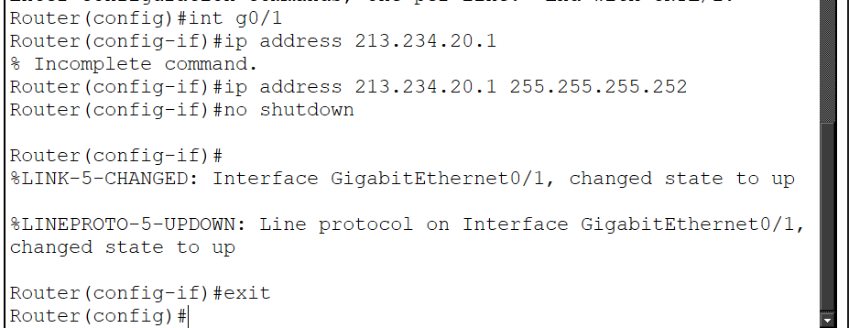

Step 2: Set up IP address, subnet mask and gateway on Server1.
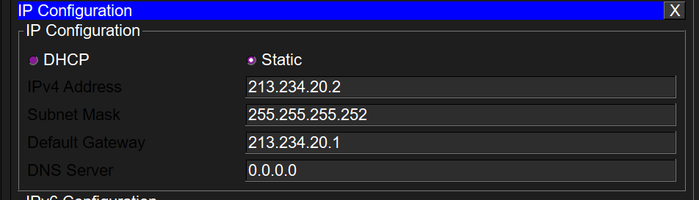

2.2 Configure Office Router for Internet Access
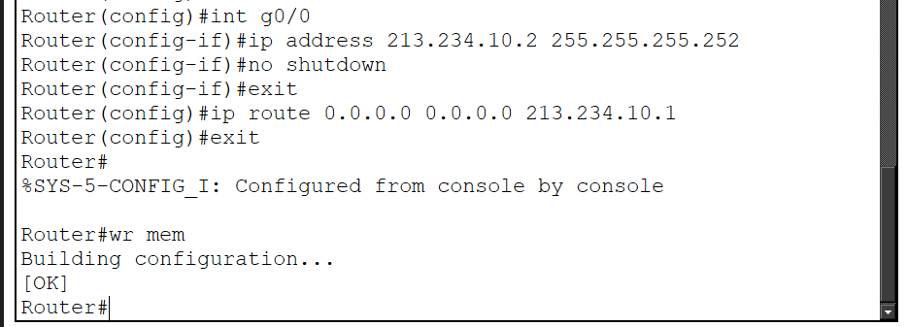

Part 3: NAT Configuration
3.1 Dynamic NAT (PAT) for Internal Users on the Office Router
Define NAT inside/outside interfaces:
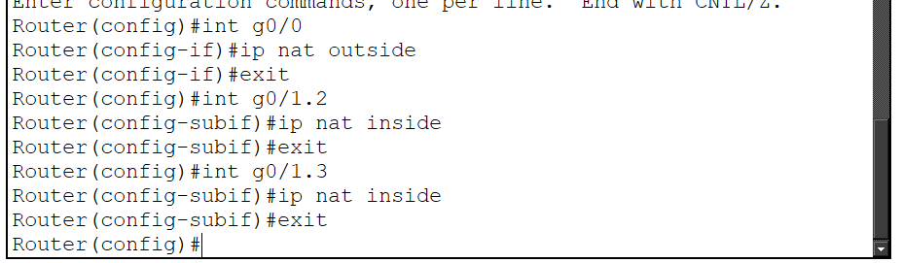
Create an Access Control List (ACL) for NAT traffic:
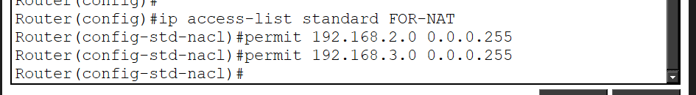
Enable NAT Overload (PAT) on the WAN interface:

3.2 Static NAT for Web Server

Part 4: Testing and Verification
4.1 Verify NAT Translations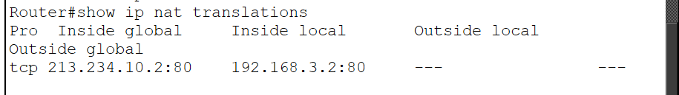
4.2 Verify End-to-End Connectivity
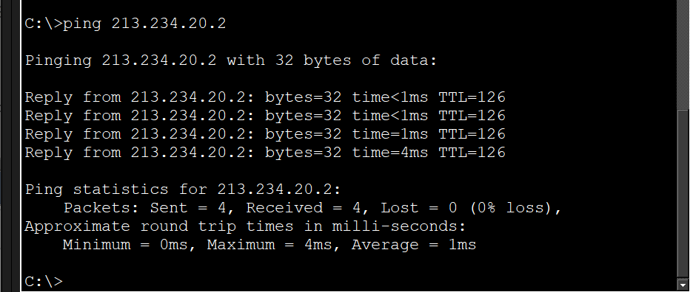
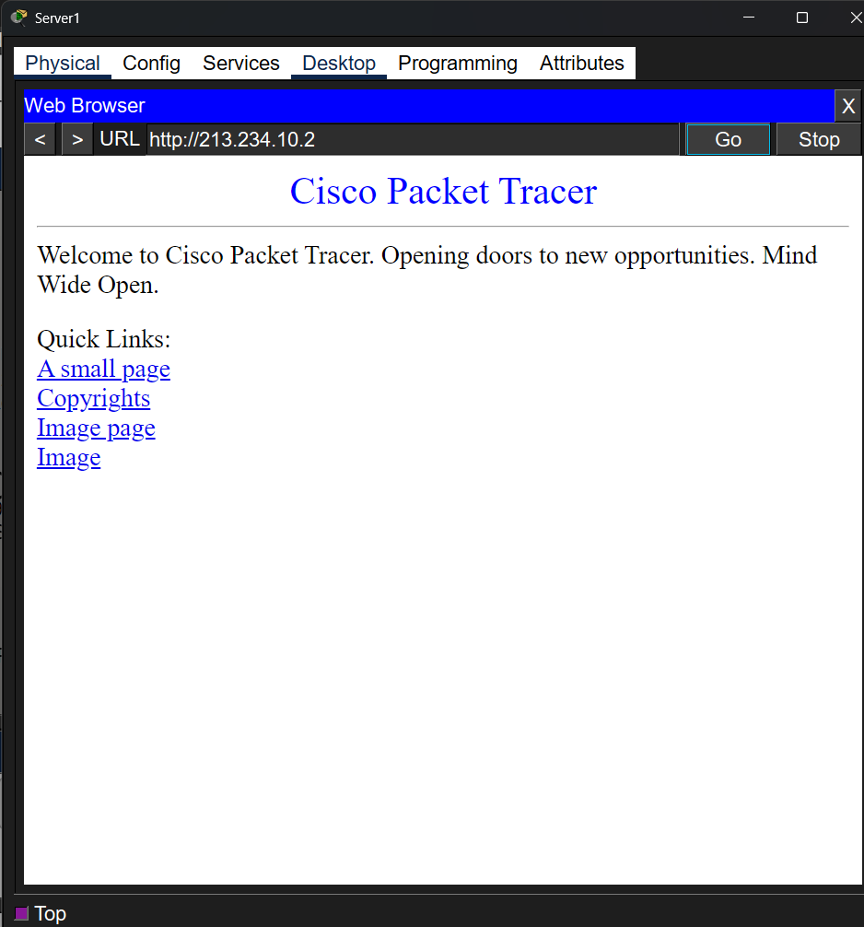
Part 5: Independent Task
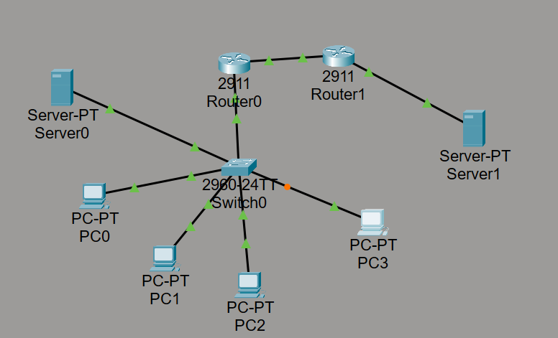
Create a new VLAN on the switch (e.g., VLAN 4) and name it Guests
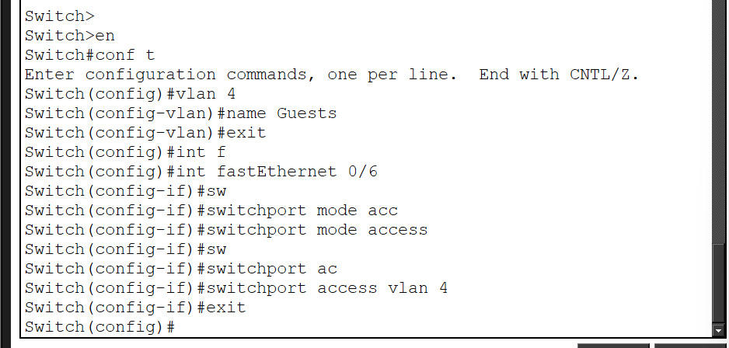



Configuring Inter-VLAN Routing on Router0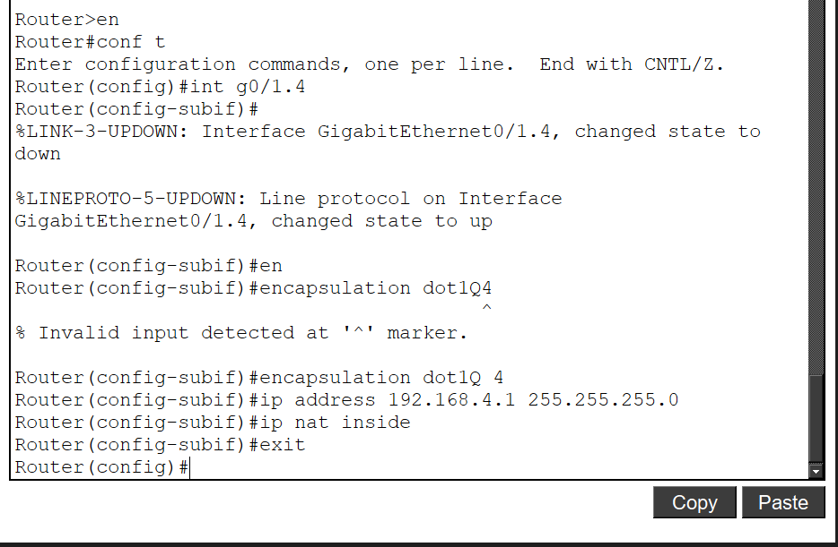

Set a static IP, subnet mask, and default gateway for the new PC.
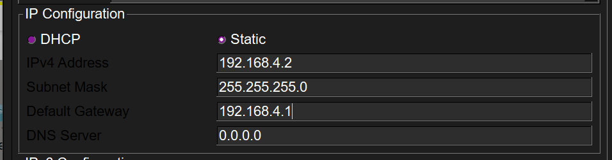
Update your NAT configuration to include the new subnet in the NAT ACL
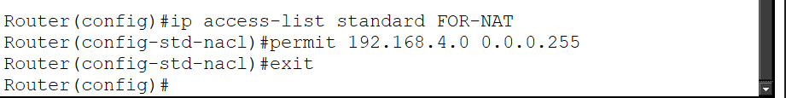
Verify that the new PC can ping Server1 and access the web server using the public IP.
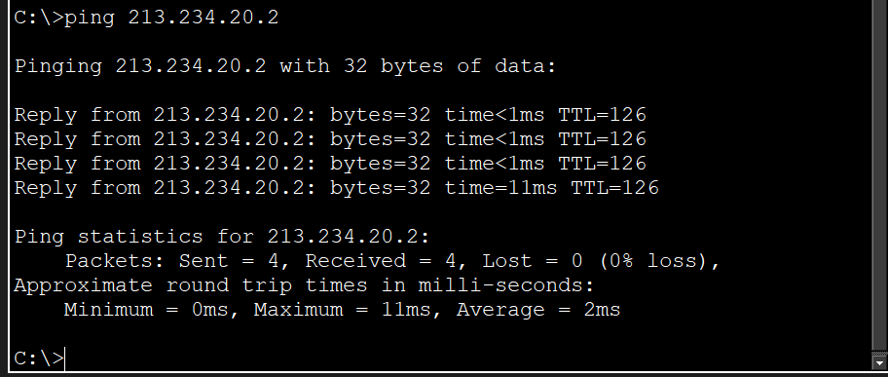
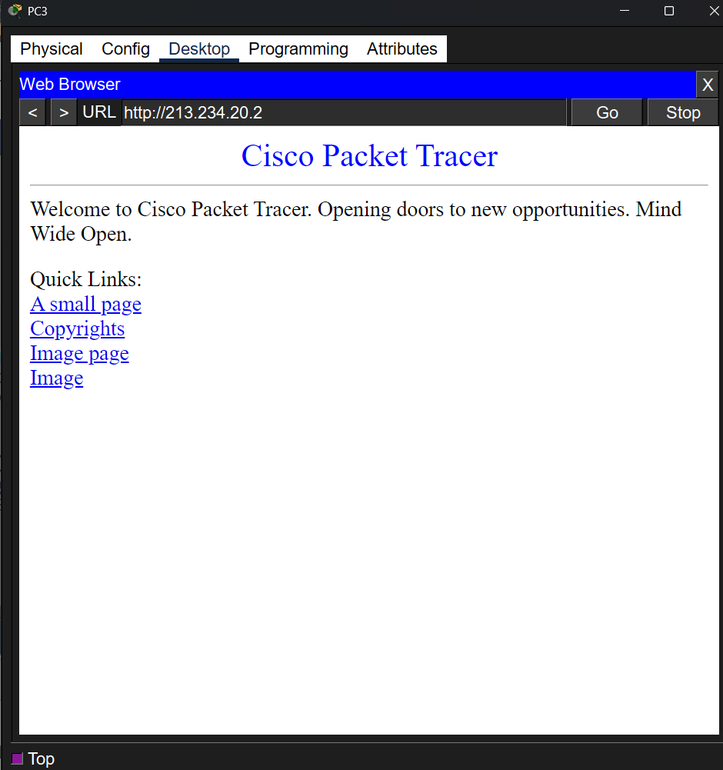

Part 6: Questions

1. What is the purpose of using subinterfaces in inter-VLAN routing?
They allow a single physical router port to be used to route traffic between multiple VLANs. Each subinterface acts as a separate gateway for its own virtual network.

2. Why do we need overload in PAT configuration?
It allows multiple devices on a local network to access the internet using just one public IP address.

3. What roles do inside and outside interfaces play in NAT?
This tells the router exactly where to replace addresses in packets.
Inside: Marks the interface facing the local network.
Outside: Marks the interface facing the external network.

4. How would NAT behave without a defined ACL?
NAT won't work. The ACL serves as a filter: it tells the router which subnets of traffic are allowed to forward. If there's no list or it's empty, the router won't understand that the addresses need to be changed.

5. Can static and dynamic NAT be used simultaneously? Explain.
Yes. For example, dynamic NAT is used to allow all employees to access the internet, while static NAT is used to allow the outside world to access a specific internal web server.

