Lab 6 & 7 - Report

Student name: Bakhramov Abdulaziz
Student ID: 24B031692
Group: Mon 11:00-13:00

Lab 6
- Part 1: Examine Network Requirements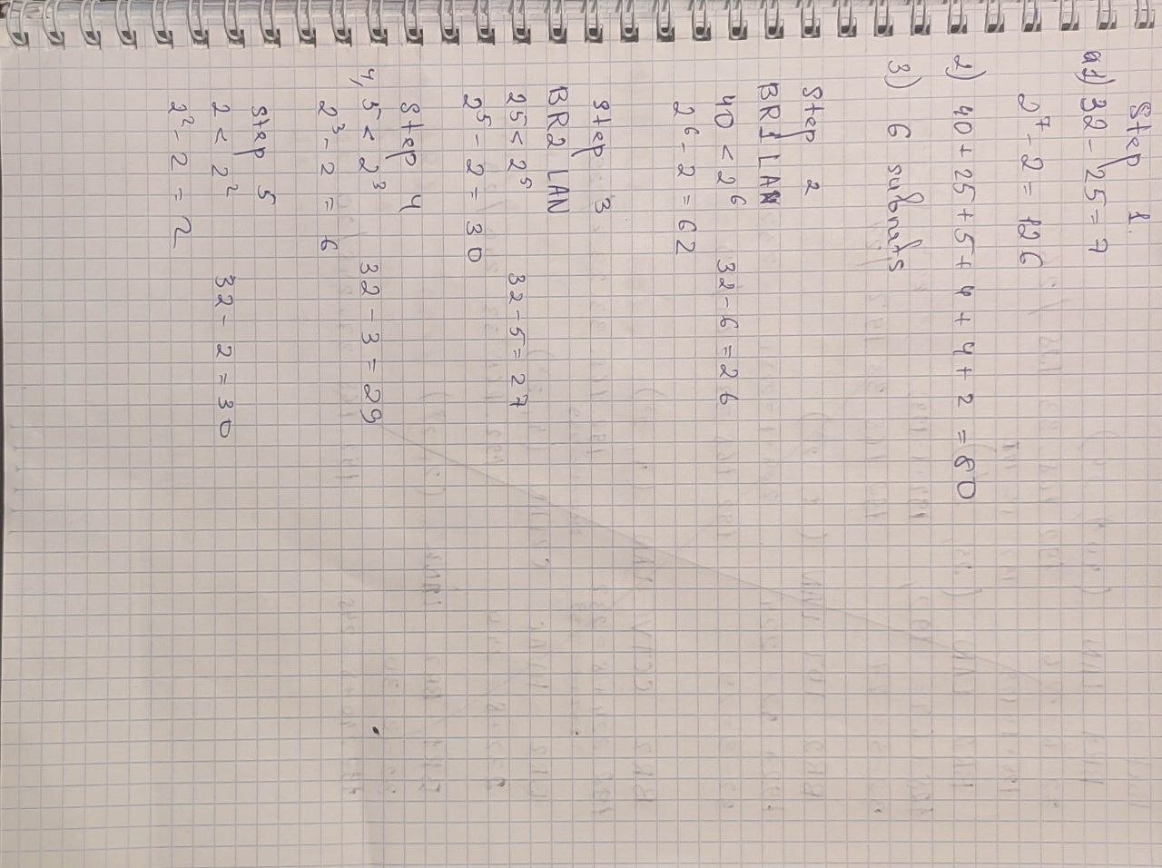
Step 1: Determine how many host addresses and subnets are available.
How many host addresses are available in a /25 network?
126

What is the total number of host addresses needed in the topology diagram?
80

How many subnets are needed in the network topology?
6

Step 2: Determine the largest subnet.
What is the subnet description (e.g. BR1 LAN or BR1-BR2 link)?
BR1 LAN

How many IP addresses are required in the largest subnet?
40

What subnet mask can support that many host addresses?
/26 (255.255.255.192)

How many total host addresses can that subnet mask support?
62

Can you subnet the 192.168.33.128/25 network address to support this subnet? Yes

What are the network addresses that would result from this subnetting? 192.168.33.128/26 and 192.168.33.192/26

Step 3: Determine the second largest subnet.
What is the subnet description?
BR2 LAN

How many IP addresses are required for the second largest subnet?
25

What subnet mask can support that many host addresses?
/27 or 255.255.255.224

How many total host addresses can that subnet mask support?
30

Can you subnet the remaining subnet again and still support this subnet?
Yes

What are the network addresses that would result from this subnetting? 192.168.33.192/27 and 192.168.33.224/27

Step 4: Determine the third largest subnet.
What is the subnet description?
BR2 IoT LAN

How many IP addresses are required for the next largest subnet?
5

What subnet mask can support that many host addresses? /29 or 255.255.255.248

How many total host addresses can that subnet mask support?
6

Can you subnet the remaining subnet again and still support this subnet?
yes

What are the network addresses that would result from this subnetting? 192.168.33.224/29, 192.168.33.232/29, 192.168.33.240/29, 192.168.33.248/29

Step 5: Determine the fourth largest subnet.
What is the subnet description?
BR11-BR2 Link

How many IP addresses are required for the next largest subnet?
2

What subnet mask can support that many host addresses?
/30 or 255.255.255.252

How many total host addresses can that subnet mask support?
2

Can you subnet the remaining subnet again and still support this subnet?
yes

What are the network addresses that would result from this subnetting? 192.168.33.248/30, 192.168.33.252/30

- Part 1: Examine Network Requirements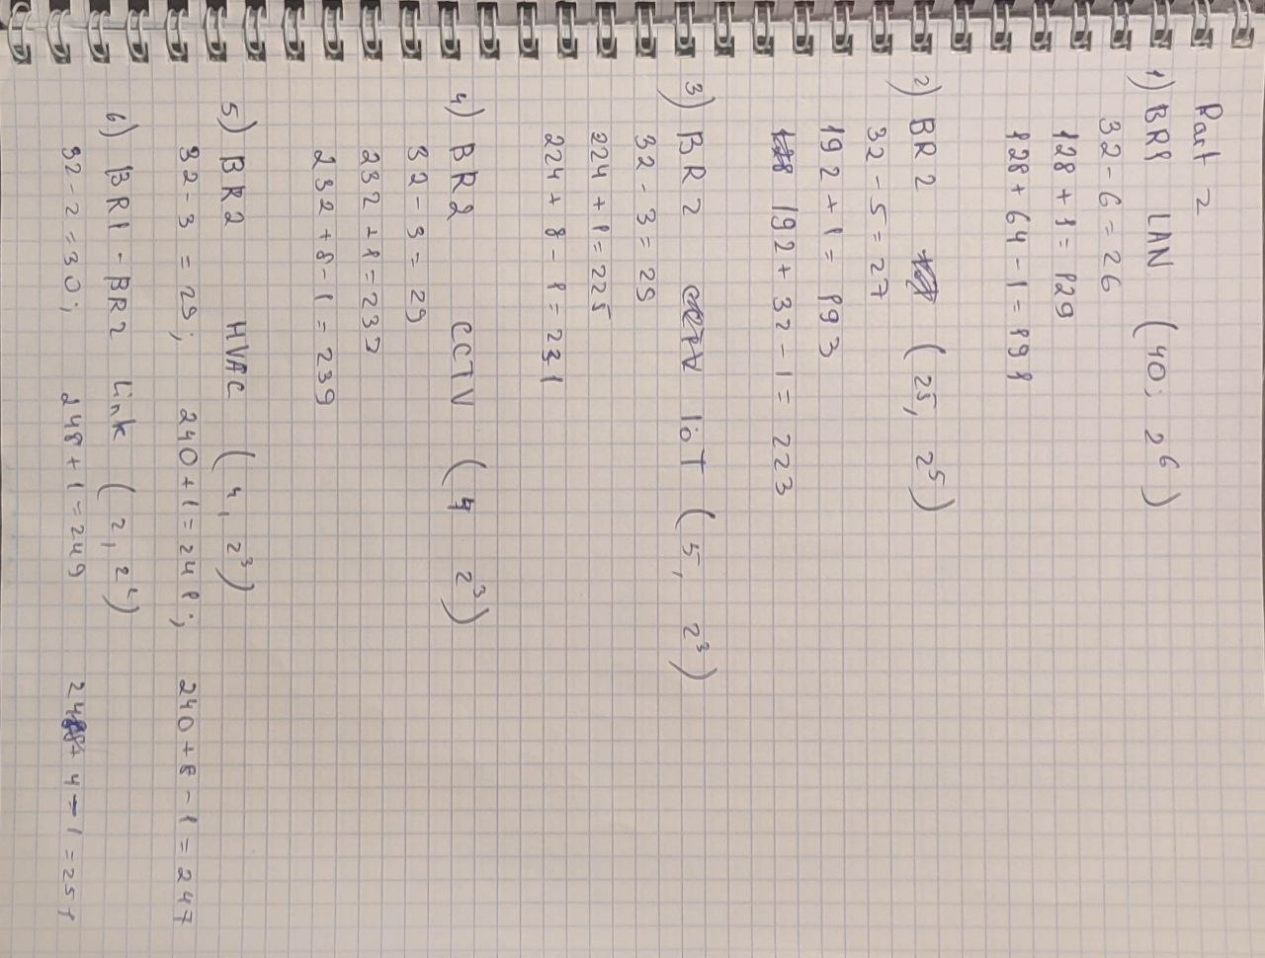
Step 1: Calculate the subnet information.
Subnet Description | Number of Hosts Needed | Network Address /CIDR | First Host Address | Broadcast Address
BR1 LAN | 40 | 192.168.33.128/25 | 192.168.33.129 | 192.168.33.191
BR2 LAN | 25 | 192.168.33.192/27 | 192.168.33.193 | 192.168.33.223
BR2 IoT LAN | 5 | 192.168.33.224/29 | 192.168.33.225 | 192.168.33.231
BR2 CCTV LAN | 4 | 192.168.33.232/29 | 192.168.33.233 | 192.168.33.239
BR2 HVAC C2LAN | 4 | 192.168.33.240/29 | 192.168.33.241 | 192.168.33.247
BR1-BR2 Link | 2 | 192.168.33.248/30 | 192.168.33.249 | 192.168.33.251
Step 2: Complete the device interface address table.
Device | Interface | IP Address | Subnet Mask | Device Interface
BR1 | G0/0/0 | 192.168.33.249 | 255.255.255.252 | BR1-BR2 Link
BR1 | G0/0/1 | 192.168.33.129 | 255.255.255.192 | 40 Host LAN
BR2 | G0/0/0 | 192.168.33.250 | 255.255.255.252 | BR1-BR2 Link
BR2 | G0/0/1 | 192.168.33.193 | 255.255.255.224 | 25 Host LAN

- Part 3: Cable and Configure the IPv4 Network
Step 1
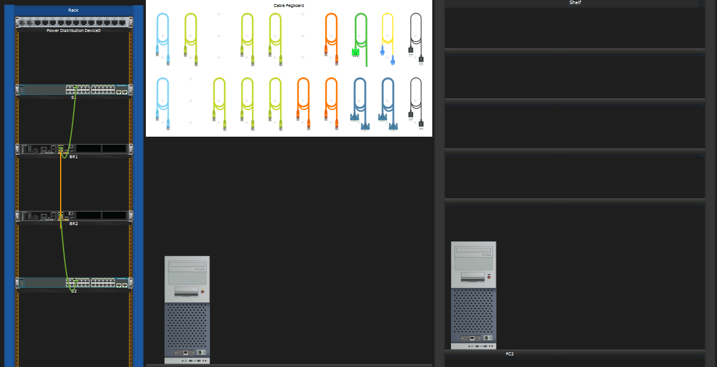

Step 2
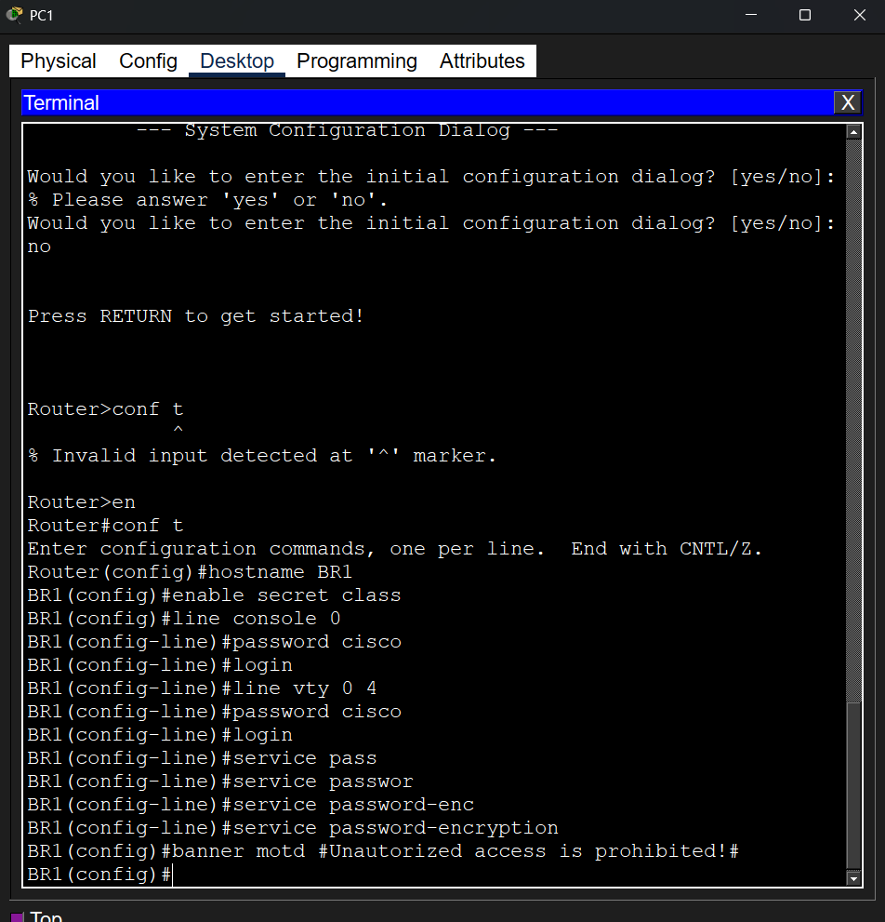
Step 3
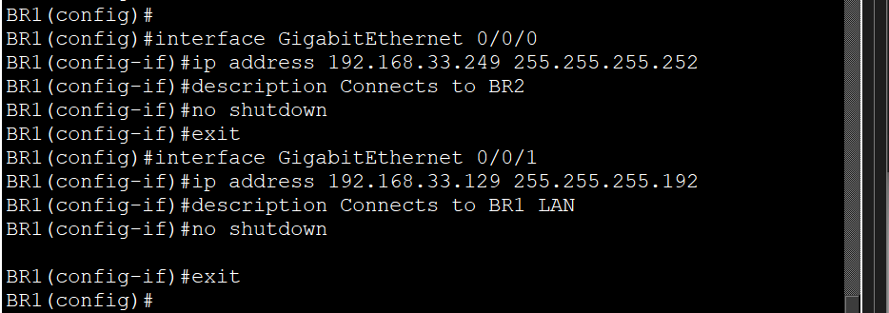

Step 4
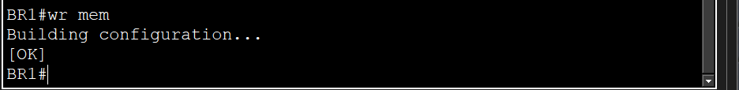

Step 5 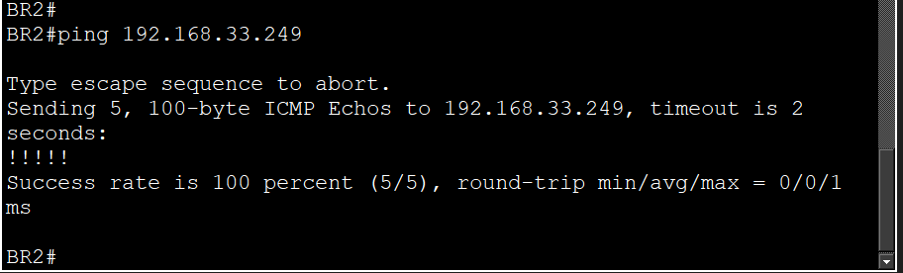 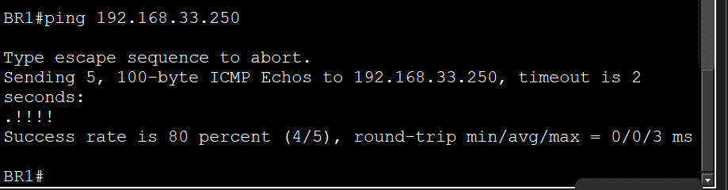

Reflection Question
Can you think of a shortcut for calculating the network addresses of consecutive /30 subnets?
The step between network addresses in a /30 mask is always 4. To find the next /30 subnet, simply add 4 to the current network address.

