Lab 3 - Report

Student name: Bakhramov Abdulaziz
Student ID: 24B031692
Group: Mon 11:00-13:00

VLAN Technology
- Part 1. Access port
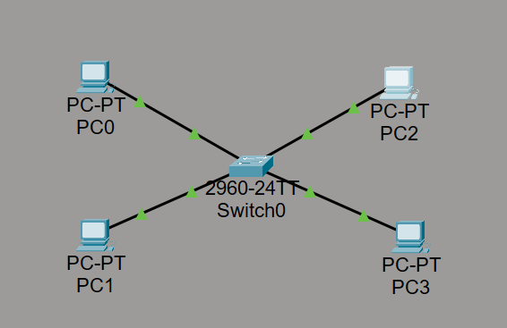
- Access the CLI of the switch and enter the configuration mode: 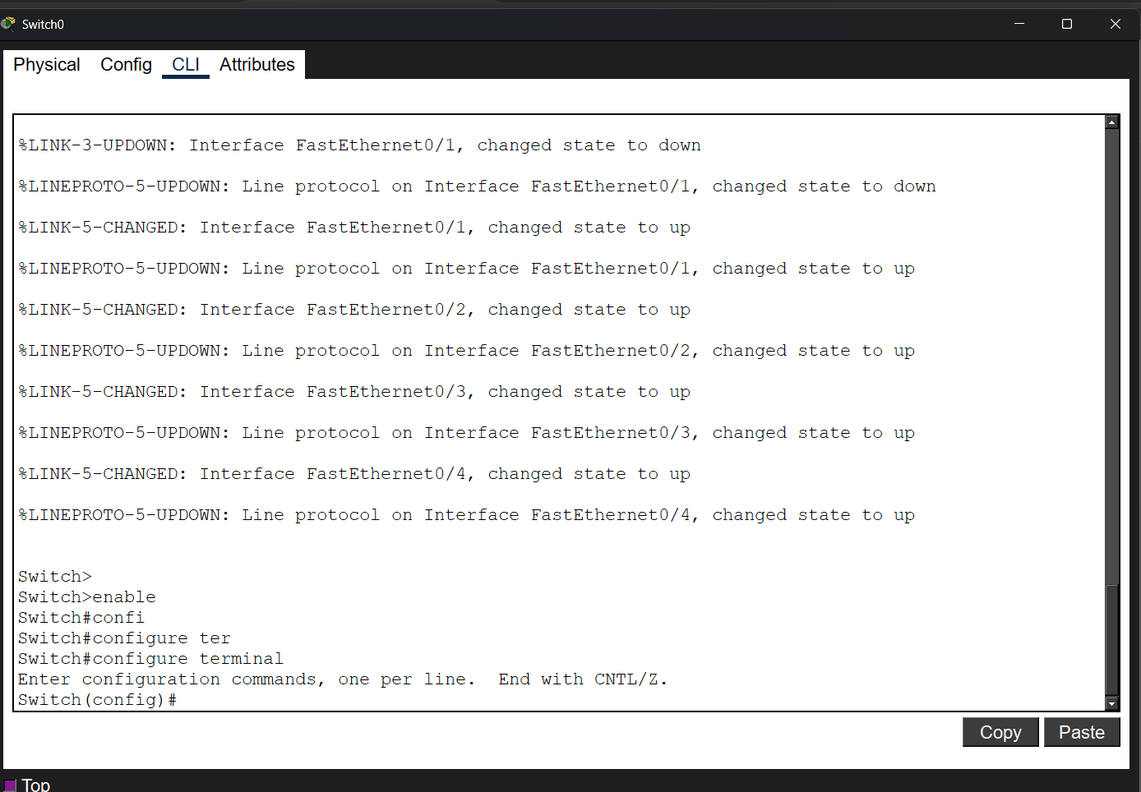
- Create Vlans
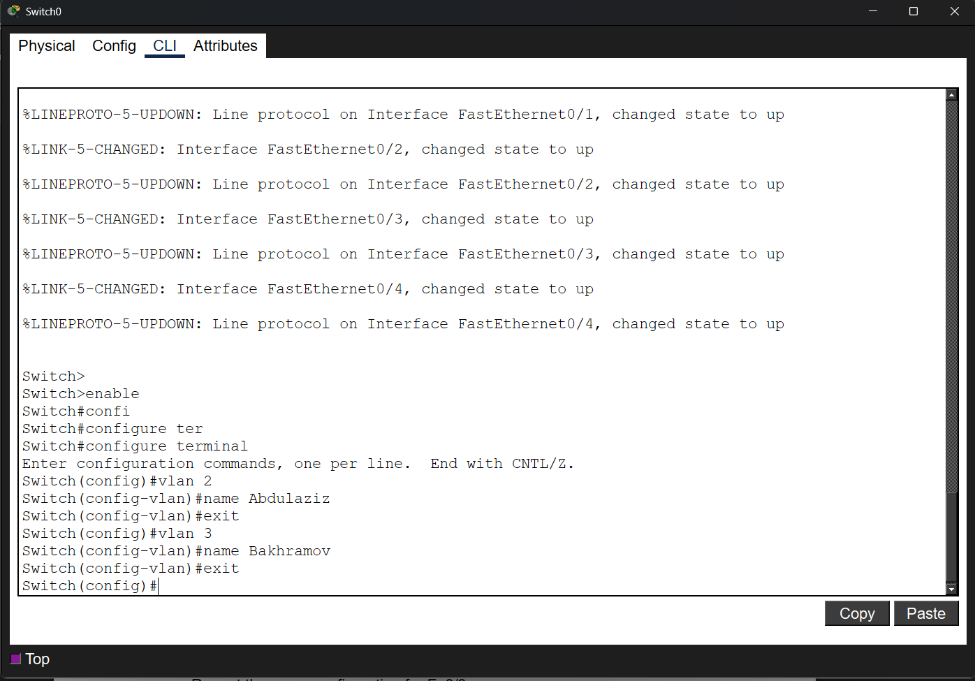

4.Configurating interfaces
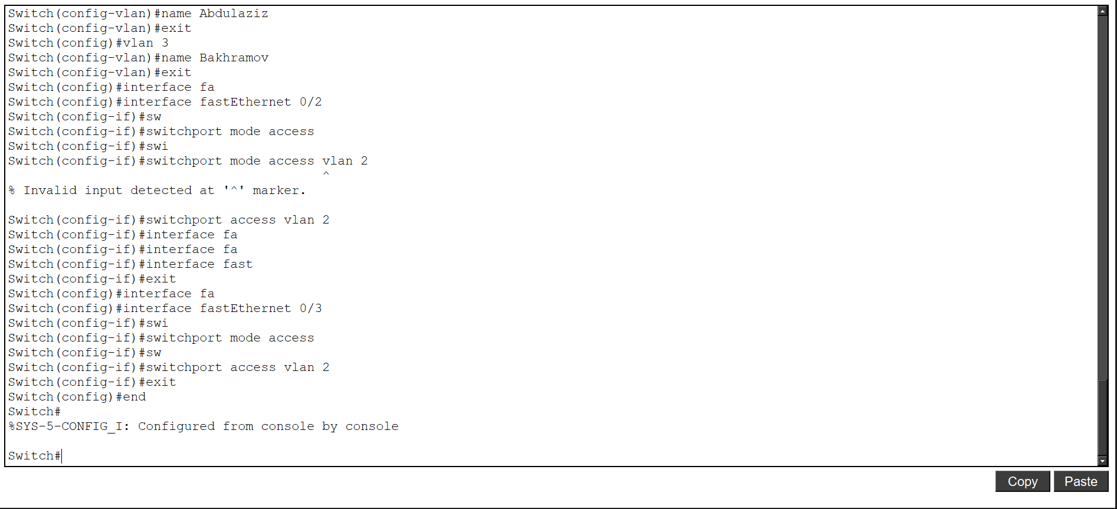
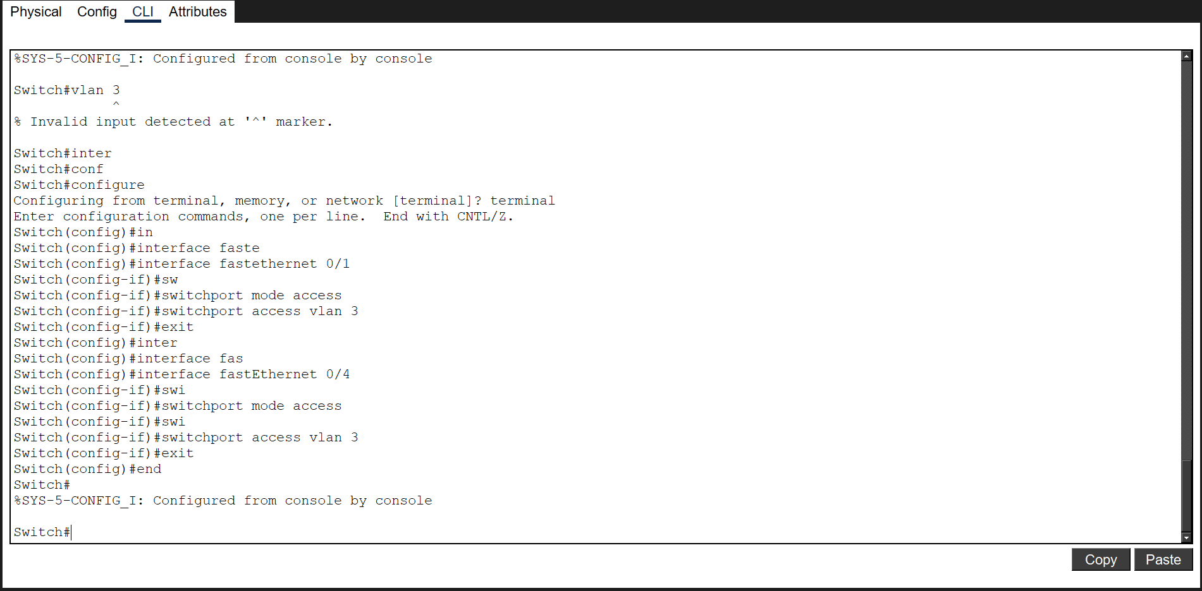

- Check VLAN configuration
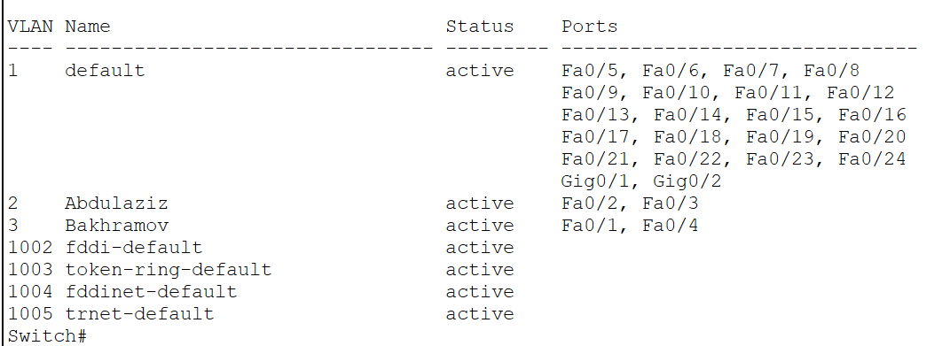

- Save the configuration to memory
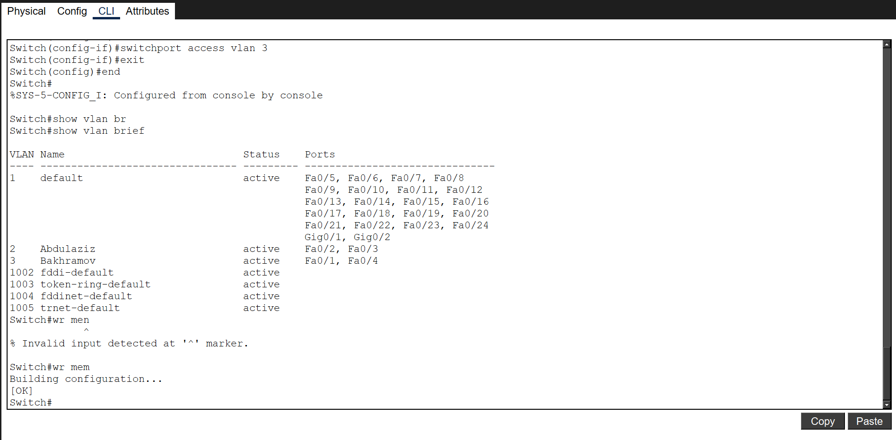

- Configure IP addresses for all PCs.
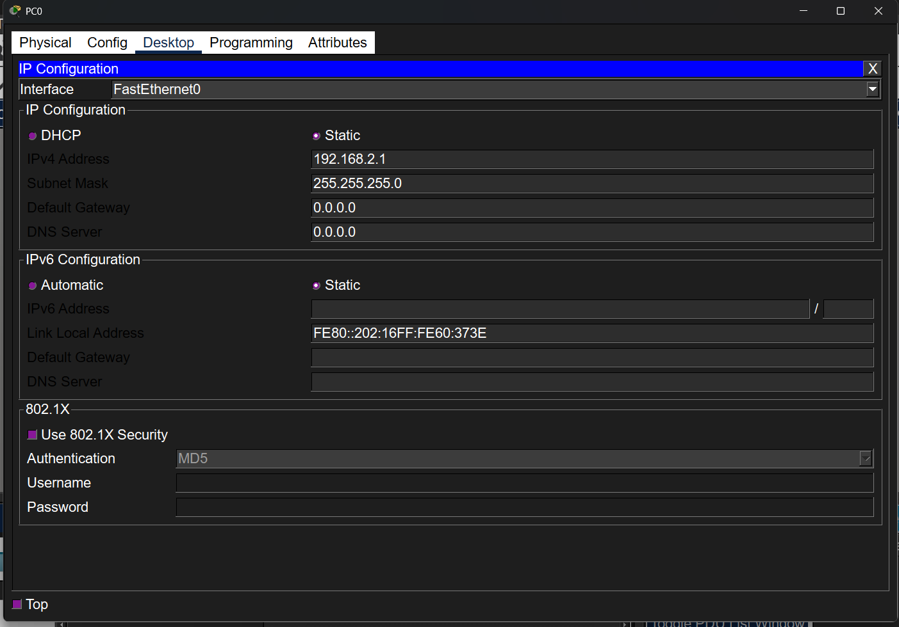

- Verify with ping
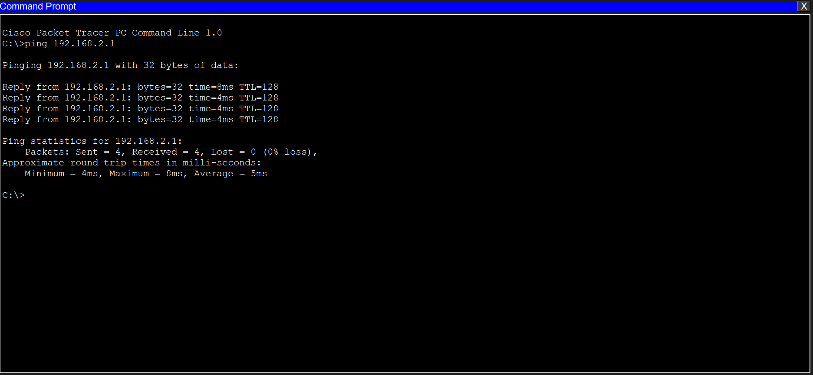

- Part 2: Trunk port’s topology
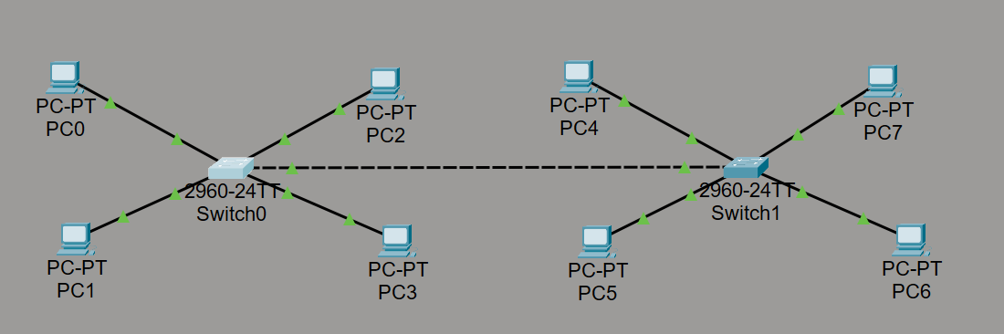

- Configure Trunk Port on the GigabitEthernet0/1 Interface.
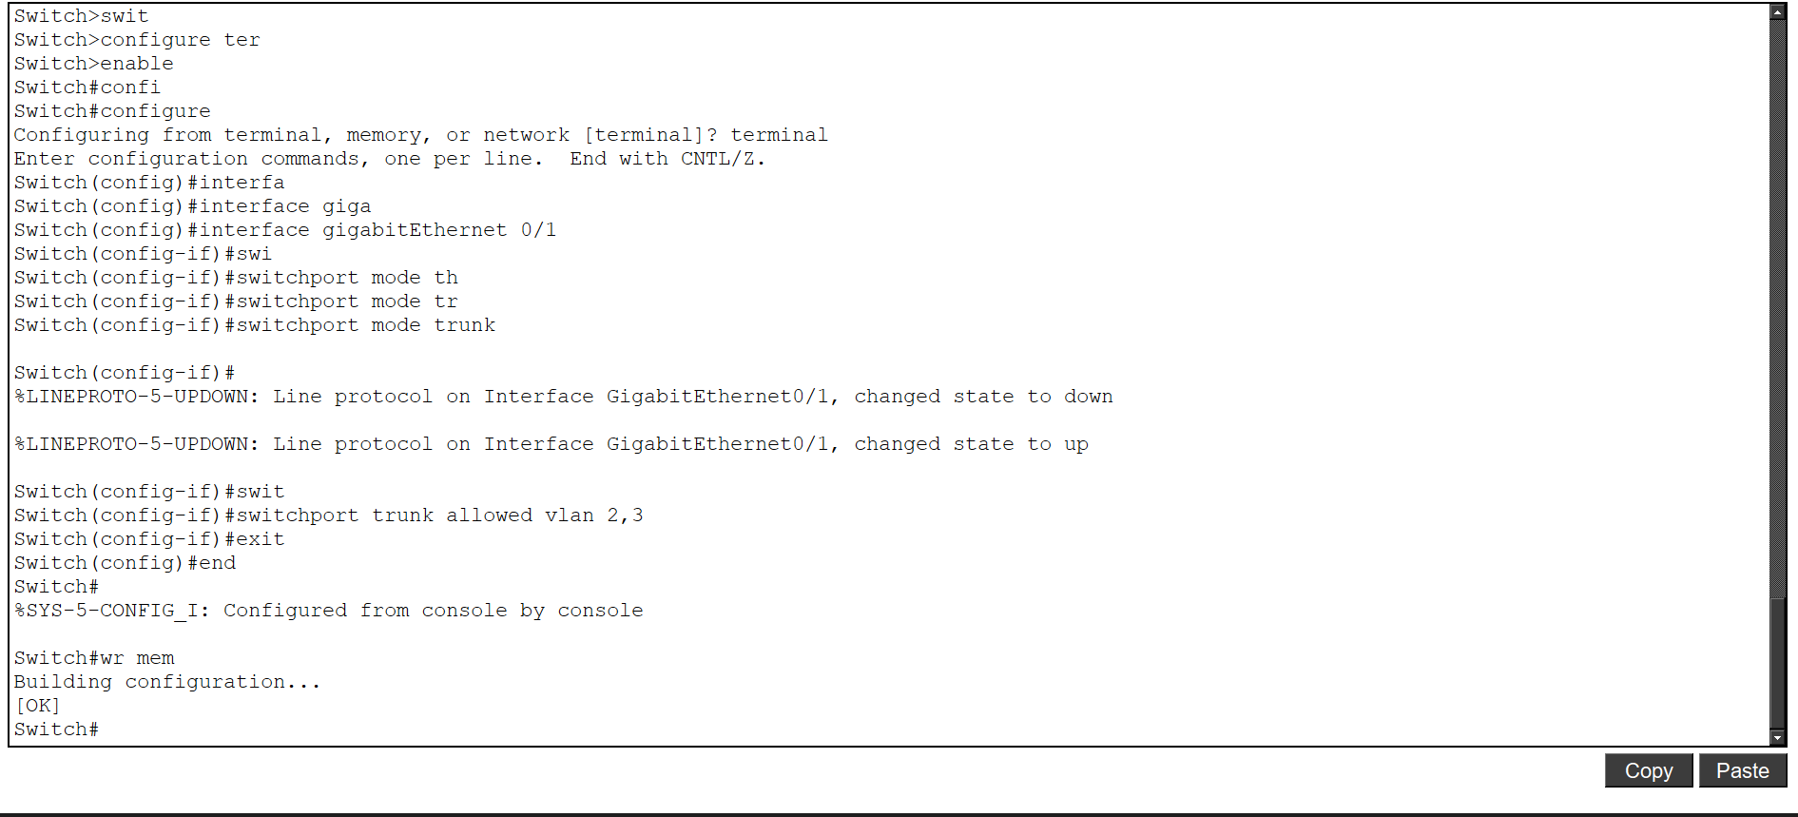

- Verify Connectivity with Ping
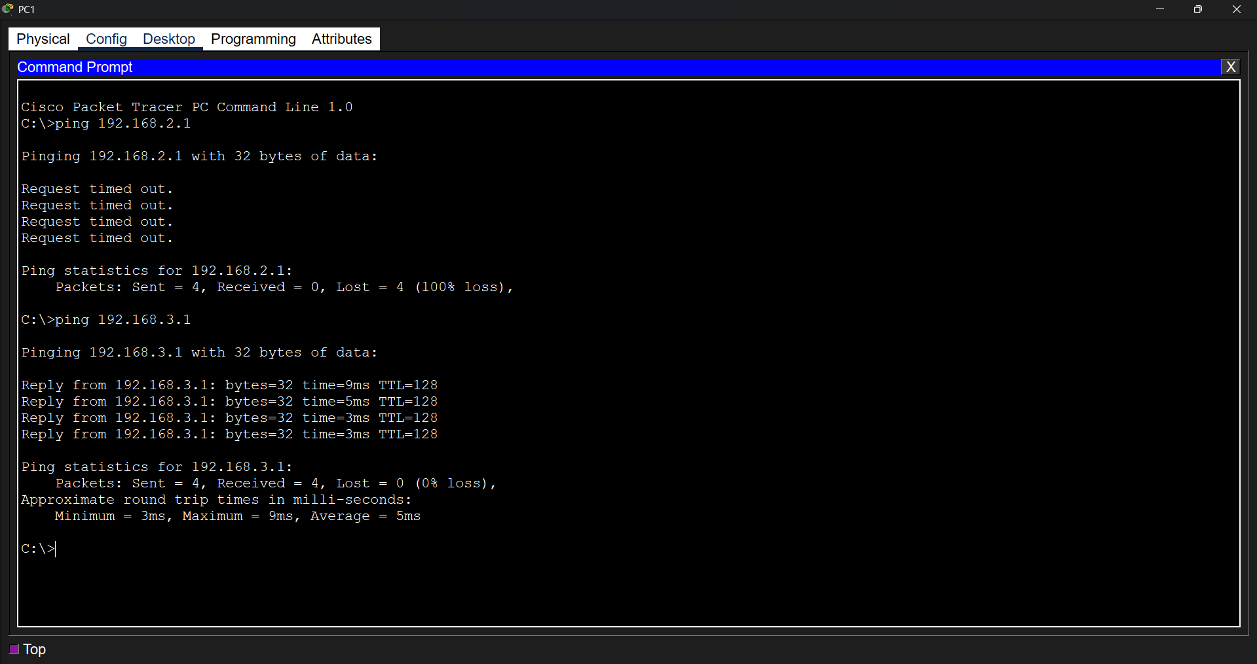

- Practice
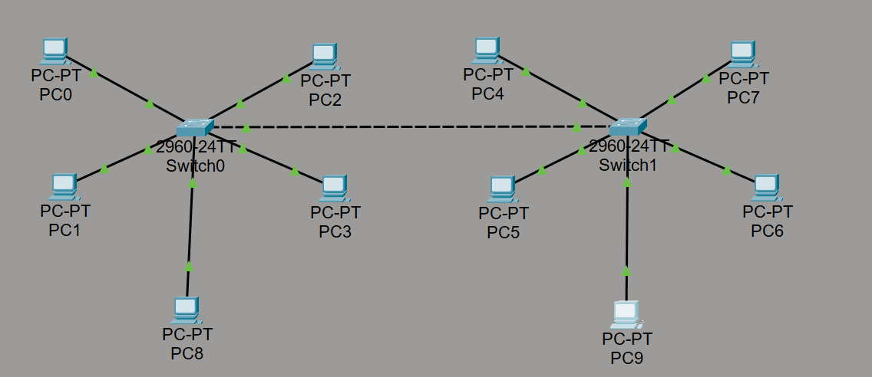

- Ip configuration

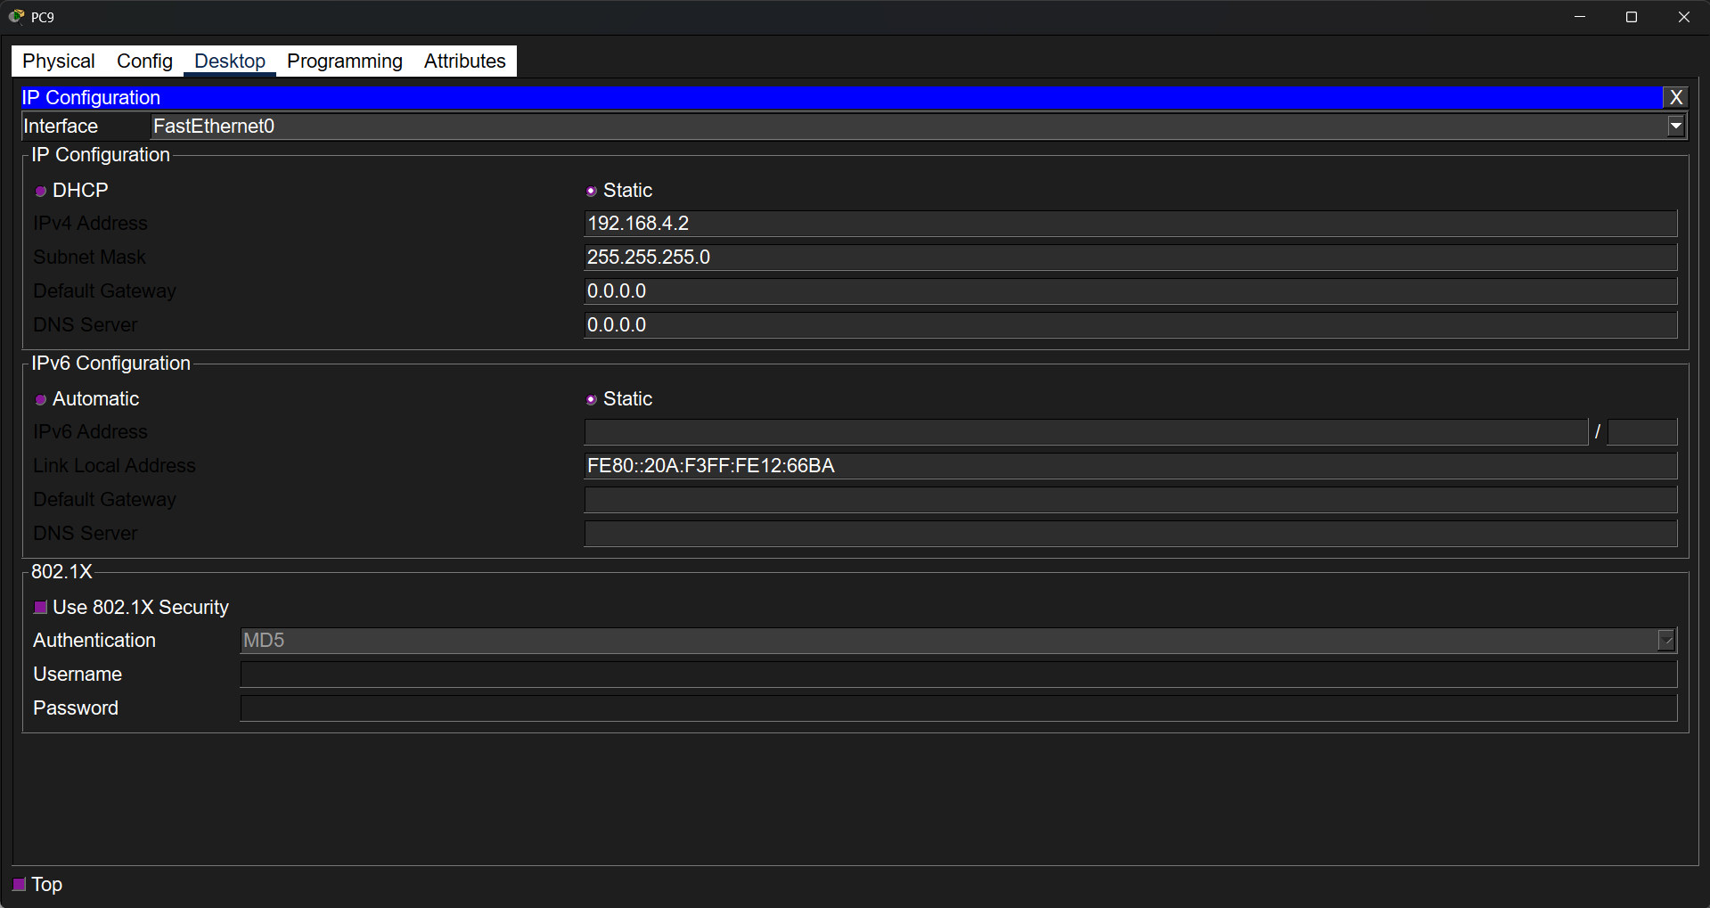

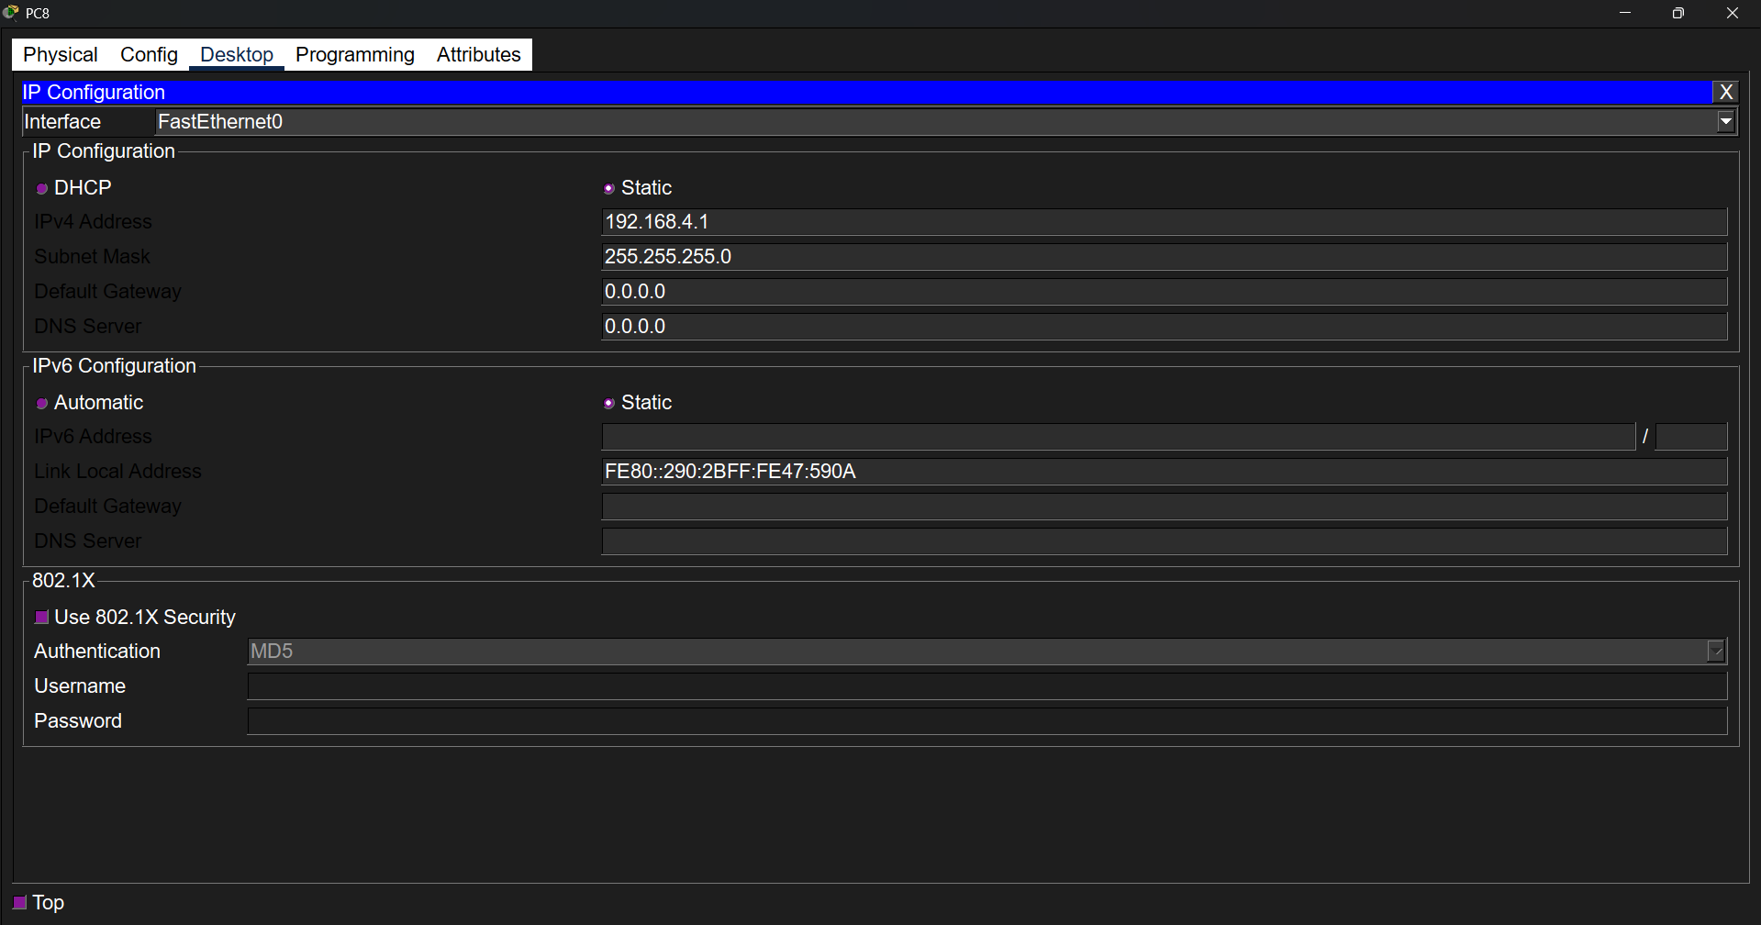
- Create Vlan
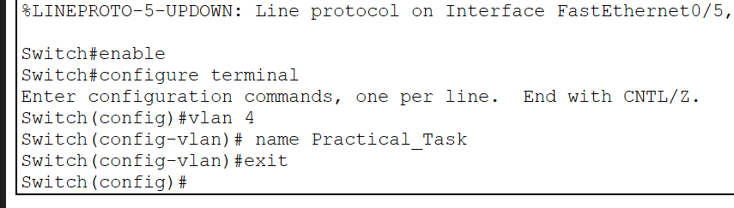
- Configure interfaces
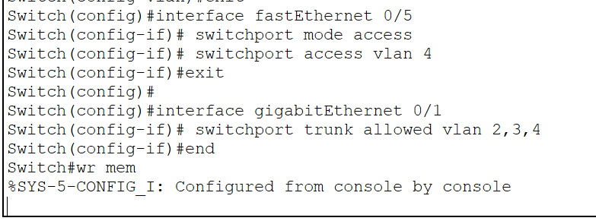

- Verify with ping
