**DJANGO INSTALLATION**

***Step 0: Pre-requisites***

Make sure you have:

* Python installed
* Git installed

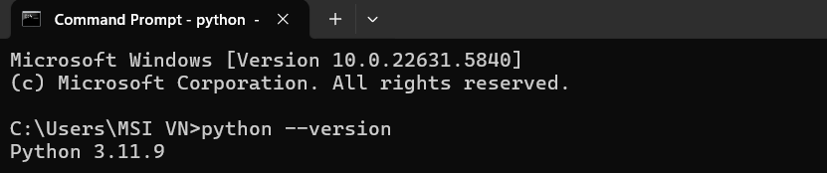To test whether you have installed python, open command prompt and type python --version. You should see something like Python 3.14.0 (your Python version).

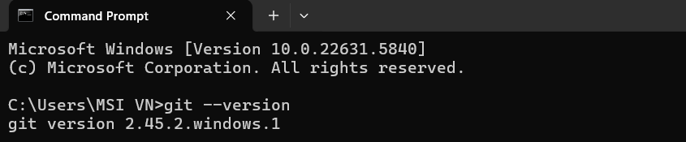Now we do the same thing (git --version) to test git:

***Step 1: Create your project folder***

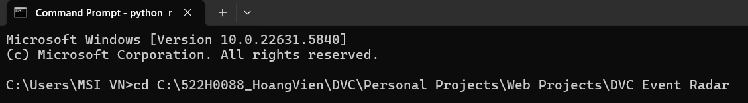Find a place and create a beautiful name for the project folder and cd to it! For example: (DVC Event Radar is the project folder / project name in my laptop)

***Step 2: Create a virtual environment***

Open Command Prompt, cd to the project folder and create a virtual environment.

cd "C:\Users\MSI VN\web projects\DVC Event Radar"

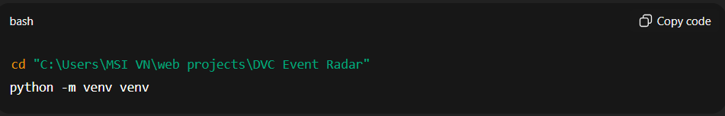python -m venv venv

Activate it:

* **On Windows:**

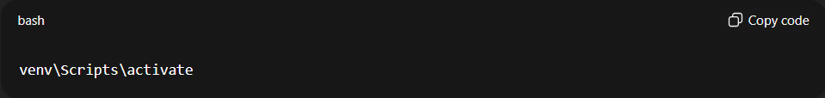venv\Scripts\activate

* **On Mac/Linux:**

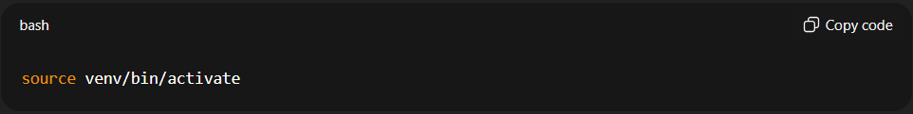source venv/bin/activate

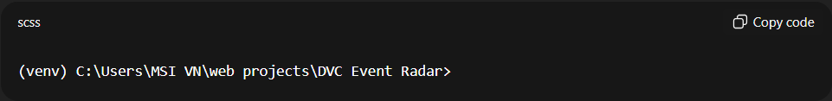Your prompt should now look like:

This ensures all Python packages stay **local to this project**. (If we don’t create a virtual environment before installing Django, all other Django projects on your device would use the same Django version).

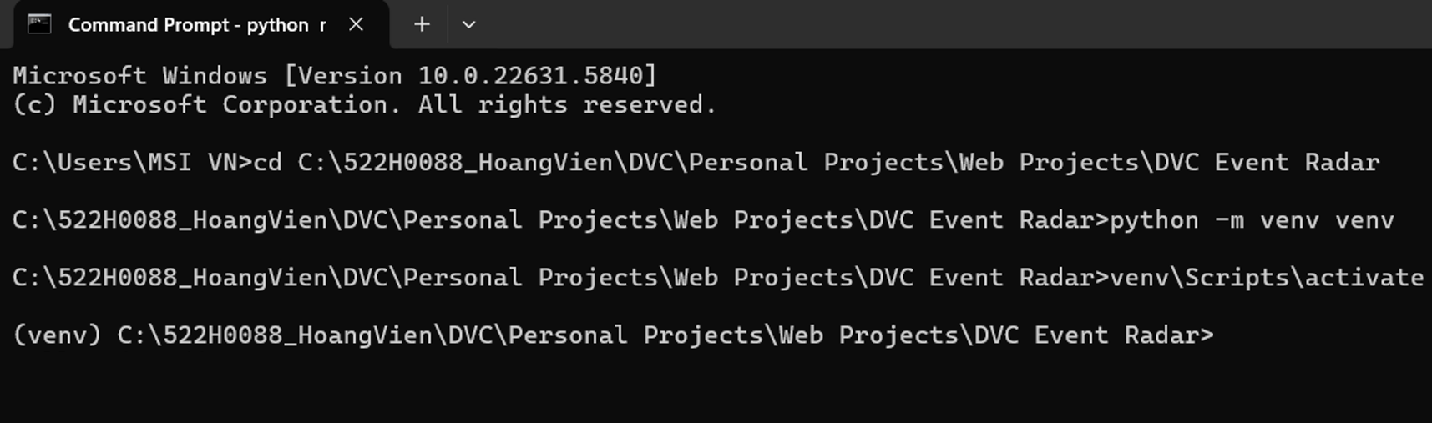For example:

***Step 3: Install Django***

Do this:

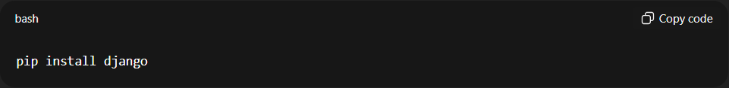pip install django

Check to see if it worked:

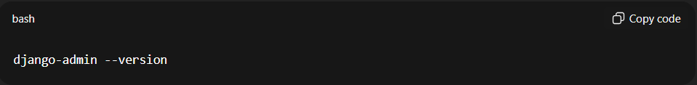django-admin --version

You should see something like 5.1.1 or similar.

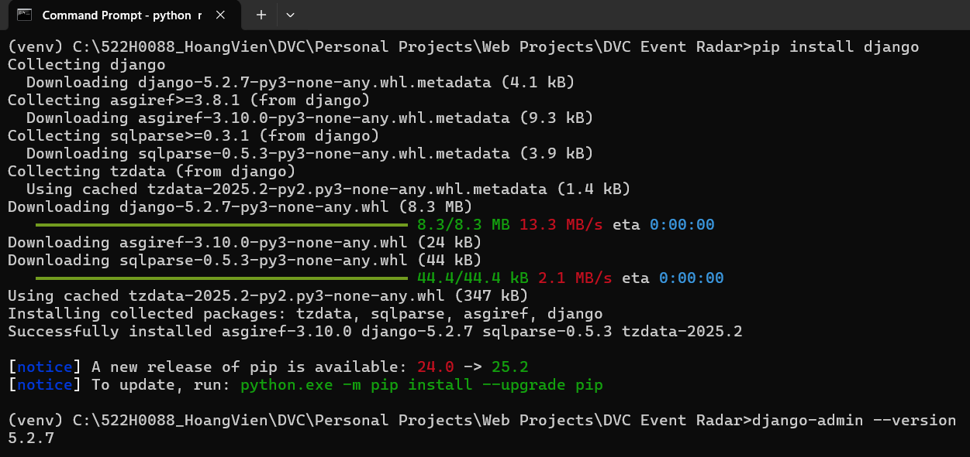For example:

***Step 4: Create the Django project inside this folder***

Since the folder already exists, run:

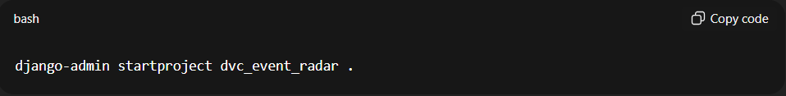django-admin startproject dvc_event_radar .

⚠️ **Important:** the **dot .** at the end ensures it installs the Django project **inside your current folder** without creating another nested folder.

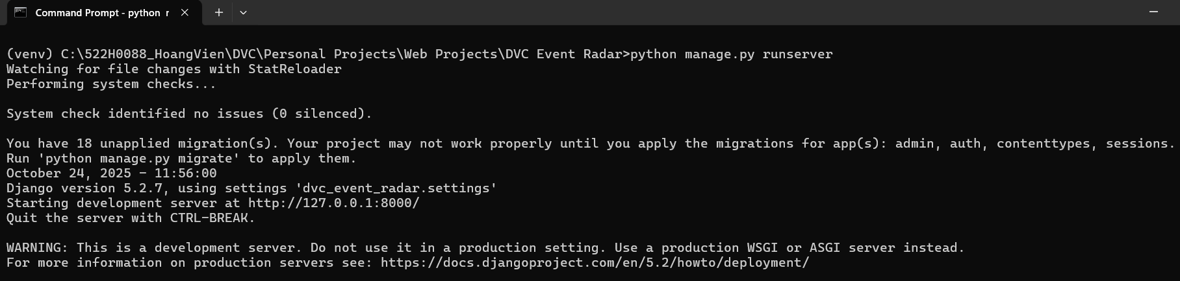  
If you encounter some issues like this: (unapplied migrations)

Then you’d have to run:

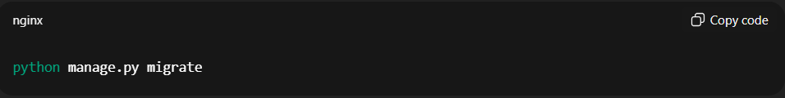python manage.py migrate

This will (hopefully) clear the issues. Now you can run the first command of step 4 again.

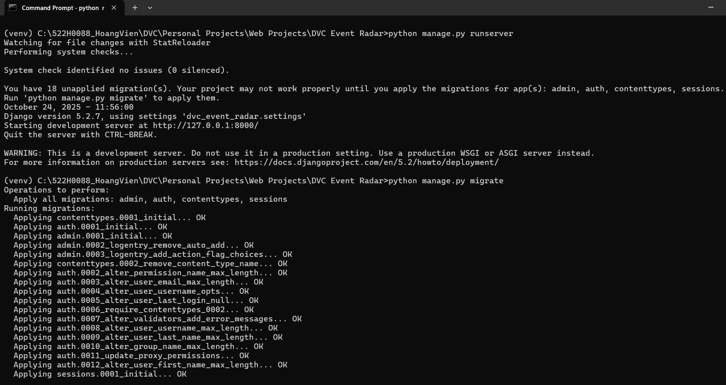Example:

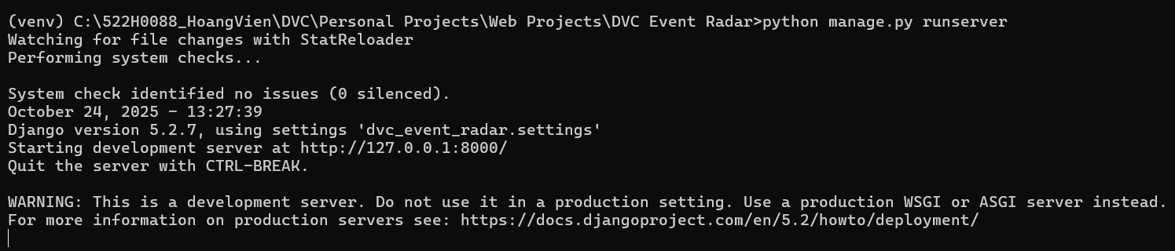After fixing:

***Step 5: Run the server to test***

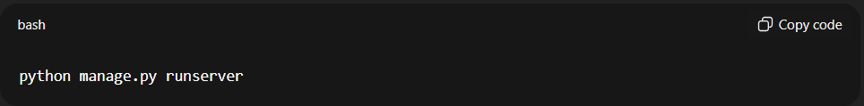python manage.py runserver  
Then open your browser to:  
<http://127.0.0.1:8000/>

If you see the Django welcome page, Django is successfully installed and running ✅

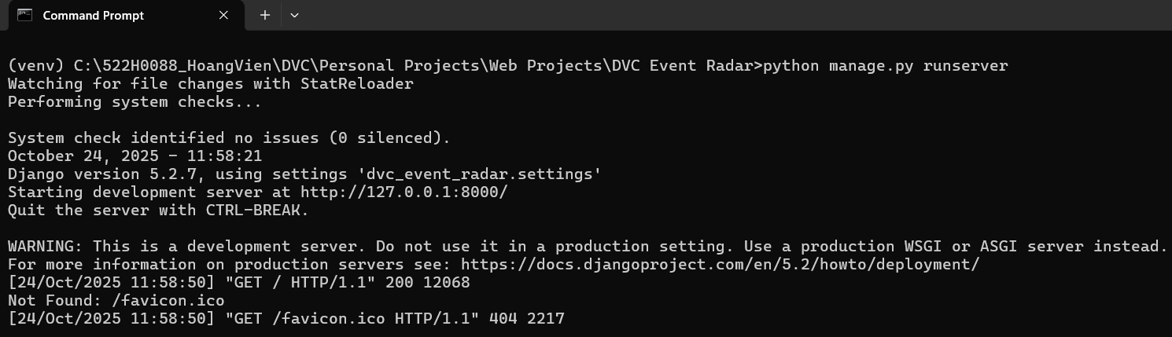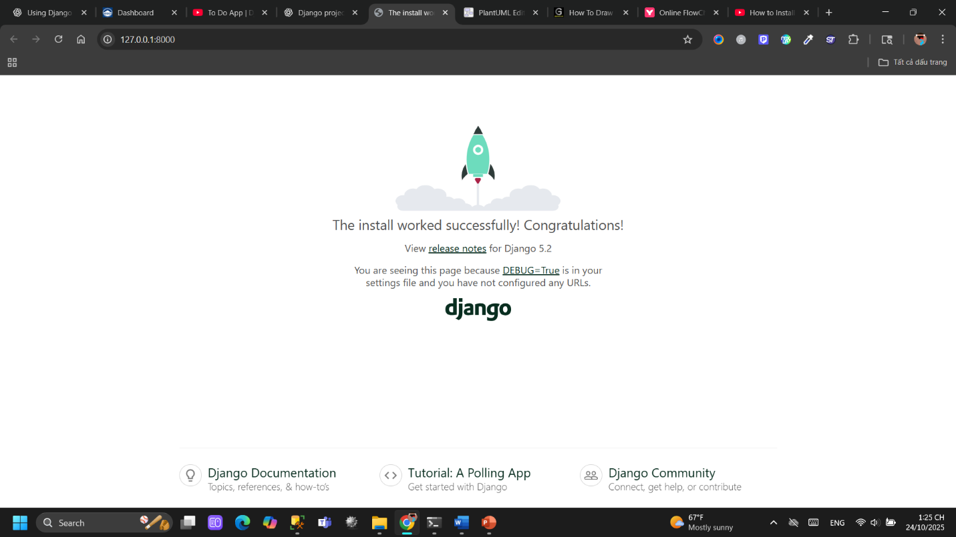Example: