**CONNECT LOCAL PROJECT FOLDER TO GITHUB REPO**

***Step 1: Make sure you’re in your project folder***

Open your terminal (Command Prompt / PowerShell) and navigate to your Django project folder. For example:

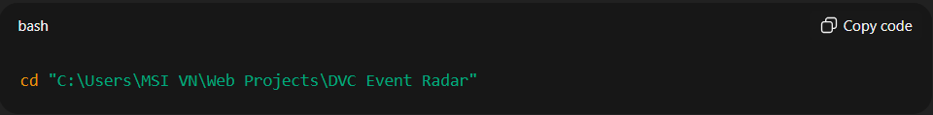cd "C:\Users\MSI VN\Web Projects\DVC Event Radar"

Check you’re in the right place:

dir

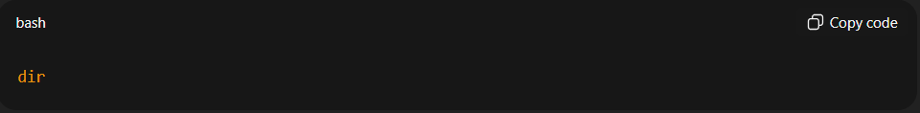

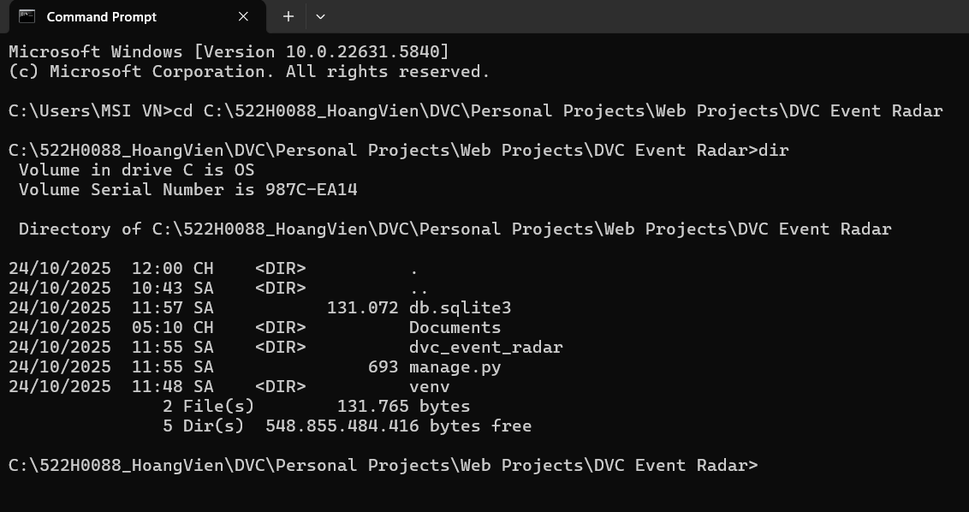You should see something similar to this:

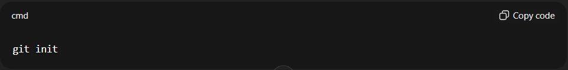***Step 2: Initialize Git (if not done already)***

git init

This creates a local Git repository.

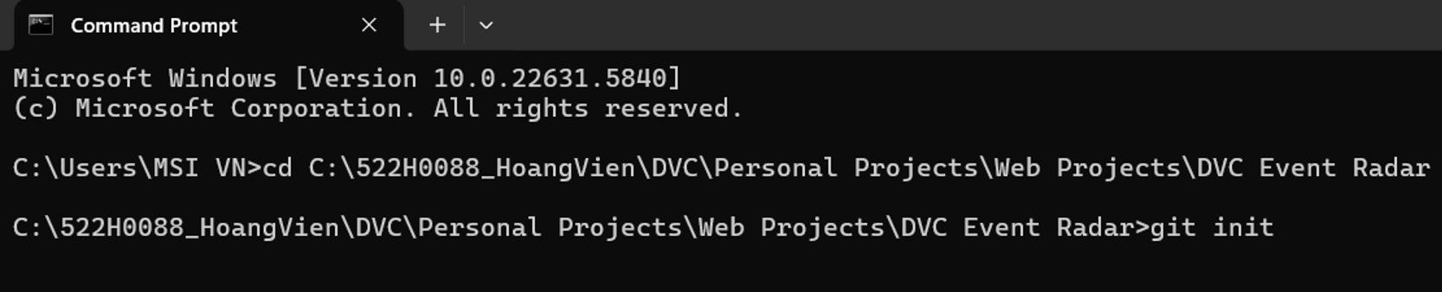Example:

***Step 3: Create a .gitignore file***

This prevents unnecessary files from being committed.

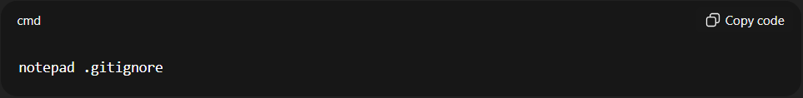notepad .gitignore

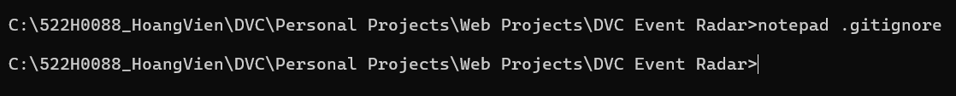Example:

This creates a .gitignore file. Now copy and paste this in the file:

# Python

*.pyc

__pycache__/

# Virtual environment

venv/

# Database

db.sqlite3

# Environment variables

.env

# OS-specific

.DS_Store

Thumbs.db

# Django migrations

*/migrations/*.py

*/migrations/*.pyc

Now save and close the file.

***4. Add files to Git***

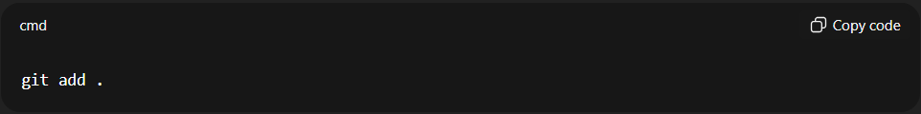git add .  
Only the files that are **not** in .gitignore will be added.

***5. Commit your changes***

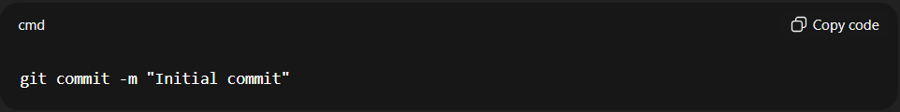git commit -m "Initial commit"

***6. Create your personal branch***

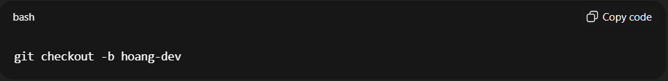git checkout -b hoang-dev

This creates a branch called hoang-dev and switches you to it.

All your future commits will now go to this branch, leaving master untouched.

Now verify the branch:

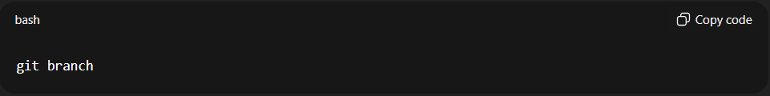git branch

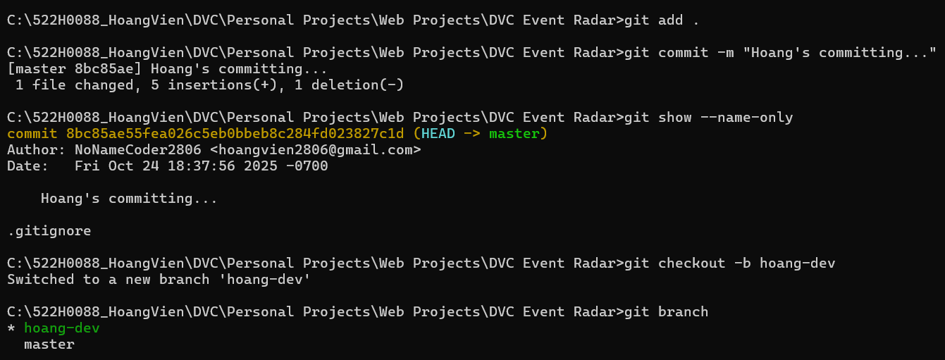Example:

***7. Push to your personal branch***

Now connect your local repo to GitHub by doing this:

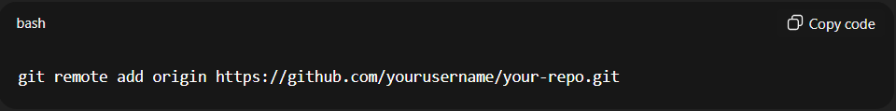git remote add origin <https://github.com/NoNameCoder2806/DVC-Events-Radar.git>

And finally, push to your branch:

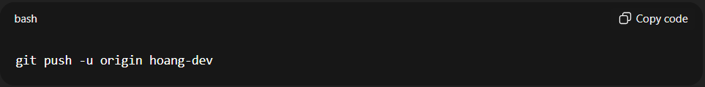git push -u origin hoang-dev

* The -u flag sets this branch to track the remote branch.
* Future pushes are as simple as:

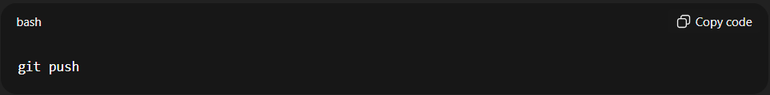git push

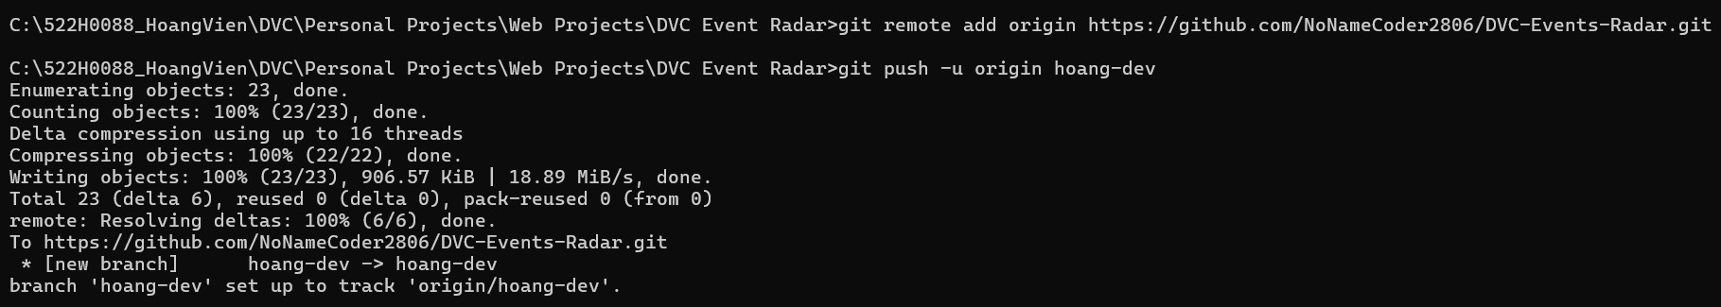Example: