PROGRAM SCREENSHOTS
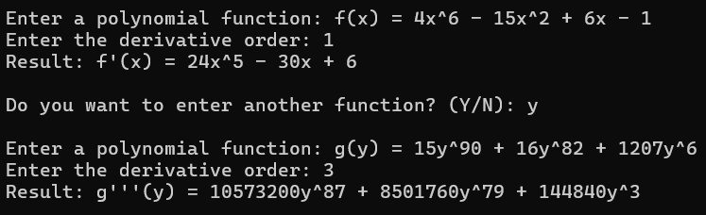
- Positive exponents

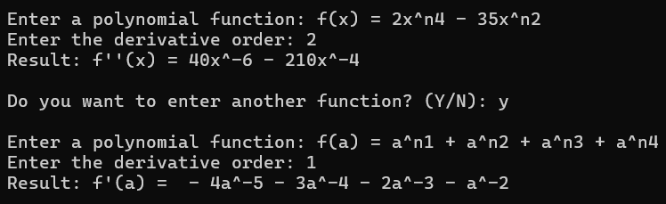
- Negative exponents

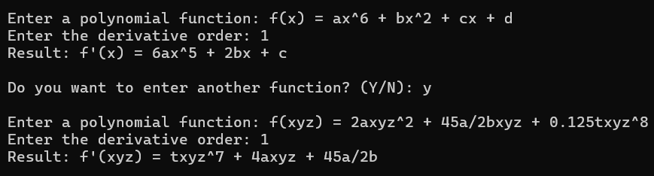
- Constants coefficients

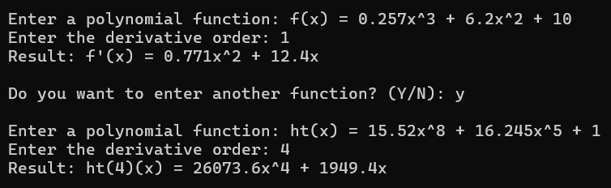
- Decimal coefficients

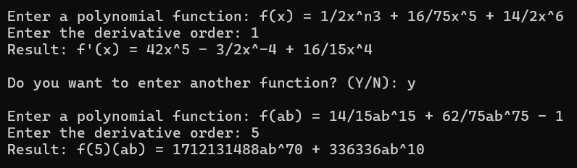
- Fraction coefficients

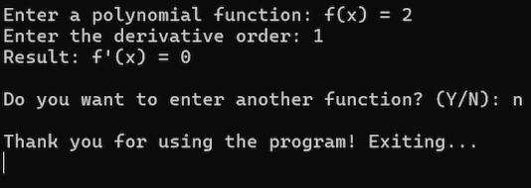
- Quitting the program

