Name: Sheryar Sher

RollNo: 21p-8027

Section: BSCS

Q1:

Code:

*;a programme to add three numbers using byte variables*

[org 0x0100]

*;initilize stuff*

    mov ax, 0 *; reset the accumulator*

    mov cx, 6 *; set the iterator count*

*outerloop:*

        mov bx, 0

*innerloop:*

            mov ax, [rollNum + bx]

            cmp ax, [rollNum + bx + 2]

            jae noExchange

*;the exchange portion*

                mov dx, [rollNum + bx + 2]

                mov [rollNum + bx + 2], ax

                mov [rollNum + bx], dx

*noExchange:*

                add bx,2

                cmp bx, 10

                jne innerloop

*;Outerloop*

        sub cx,1

        jnz outerloop

    mov dx ,[rollNum + 2]

    mov [secondLargest],dx

    mov dx, [rollNum + 8]

    mov [secondSmallest], dx

*; mov [secondSmallest], [ax + 8]*

    mov ax, 0x4c00  *;terminate the program*

    int 0x21

*rollNum:* dw 2,1,8,0,2,7

*secondLargest:* dw 0

*secondSmallest:* dw 0

screenshot:

start:

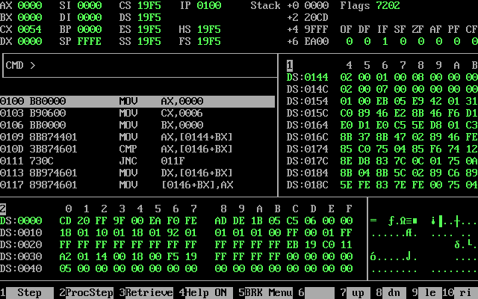

End:

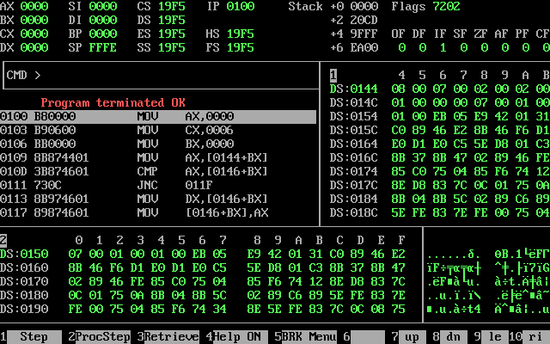

Q2:

Code:

*;a programme to add three numbers using byte variables*

[org 0x0100]

*;initilize stuff*

    mov ax, 0 *; reset the accumulator*

    mov cx, 6 *; set the iterator count*

*outerloop:*

        mov bx, 0

*innerloop:*

            mov ax, [rollNum + bx]

            cmp ax, [rollNum + bx + 2]

            jae noExchange

*;the exchange portion*

                mov dx, [rollNum + bx + 2]

                mov [rollNum + bx + 2], ax

                mov [rollNum + bx], dx

*noExchange:*

                add bx,2

                cmp bx, 10

                jne innerloop

*;Outerloop*

        sub cx,1

        jnz outerloop

    mov ax, 0x4c00  *;terminate the program*

    int 0x21

*rollNum:* dw 2,1,8,0,2,7

screenshot:

start:

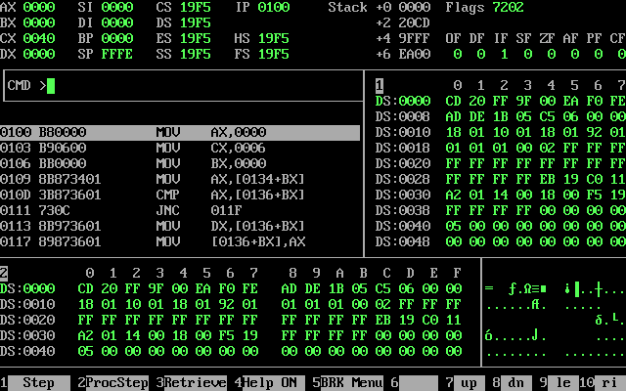

End:

