**4-bit Password Security System using (XOR, AND & NOT):**

The idea is of this system is that the 4 switches “Key Code Switches” acts as holding the correct password for unlocking the lock. On the other hand, the other 6 switches “Data Entry Switches” acts as data entry points where the code is to be entered to open the lock. The “Key Code Switches” have static value and is hidden from the person who is trying to open the lock. If the person who is trying to open the lock enters the code at “Data Entry Switches” which is similar to the code kept static at the “Key Code Switches” then the green LED will light up and the lock will open while, if he enters the wrong code then the red LED will lit up and BUZZER will be start ringing, which is an alarming situation that some wrong person is unlocking the lock.

**Material Required:**

* 2, XOR IC 74LS86
* 2, NOT IC 74LS04
* 2, AND IC 74LS08 • 2, DIP Switch 6-bit.
* Battery 9v.
* Green led (correct password)
* Red led (incorrect password).
* BUZZER
* 12, Resistances 10k ohm
* 12, Resistances 10k ohm
* Connecting wires.

**Equipment’s:**

1) XOR Gate: 2) AND Gate:

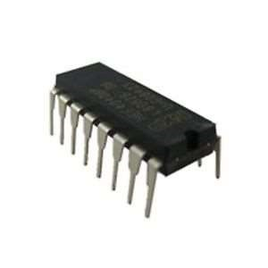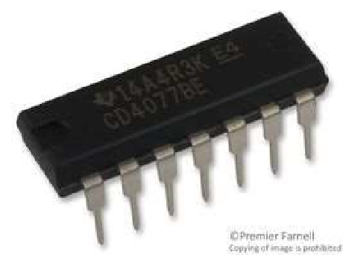

3) NOT Gate: 4) 6-bit DIP Switches:

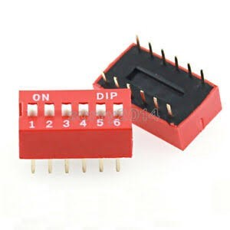

6)

Resistors:

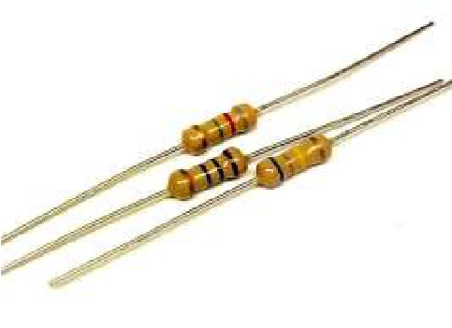

**Pin Configuration and Truth Table of ICs:**

**XOR Gate;**

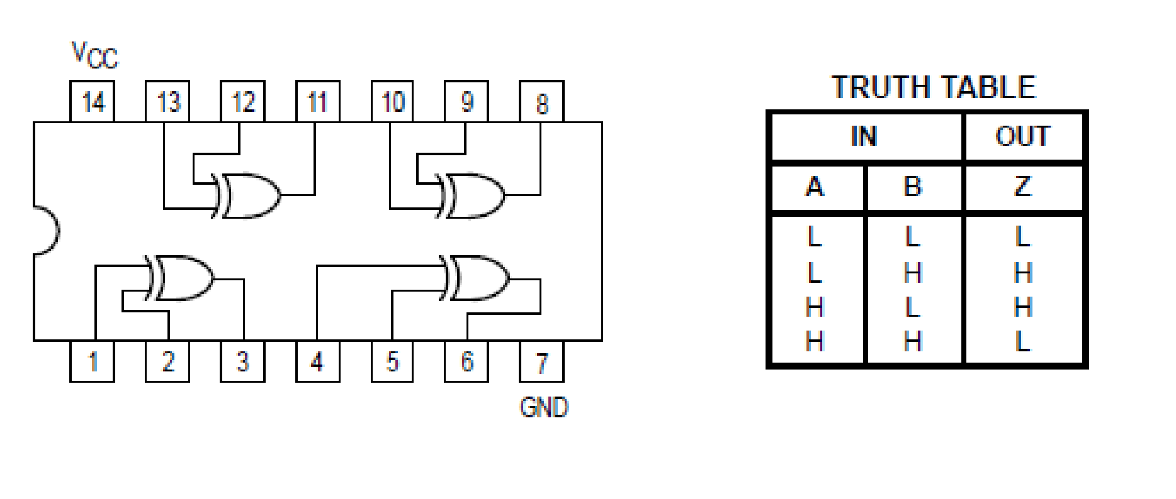

**AND Gate;**

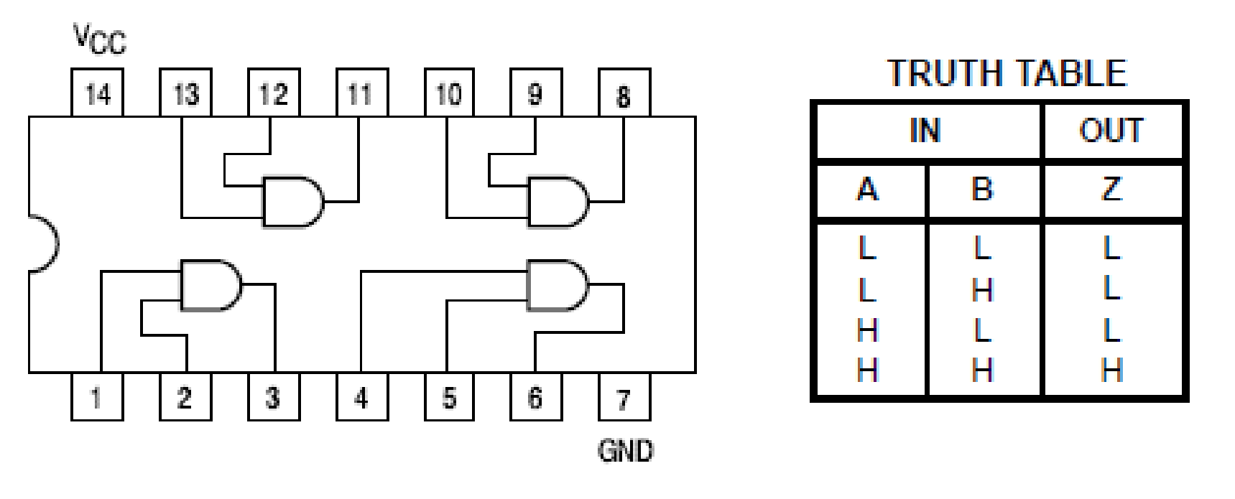

**NOT Gate;**

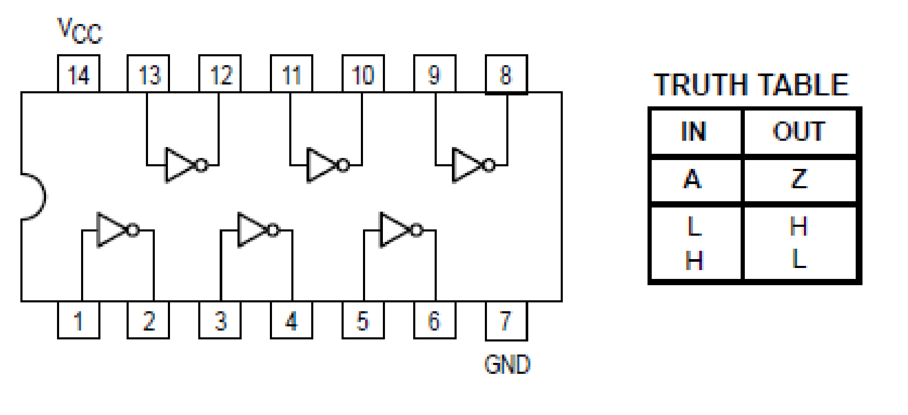

**Circuit Diagram:**

**Diagram with Incorrect Password;**

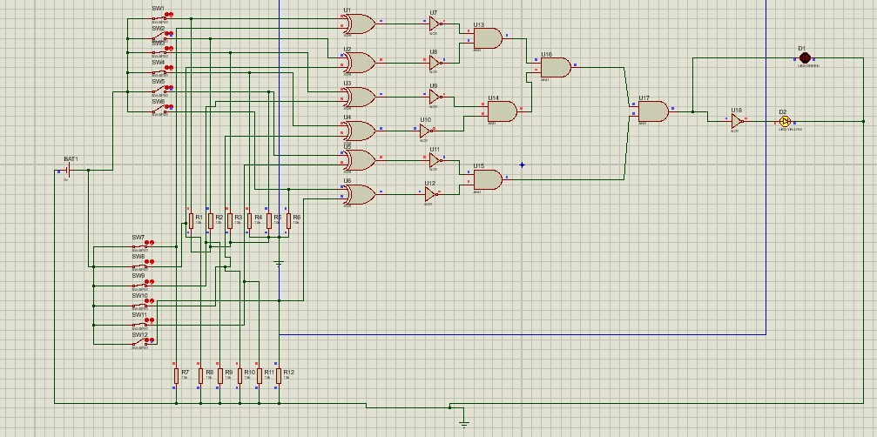

**Diagram with Correct Password;**

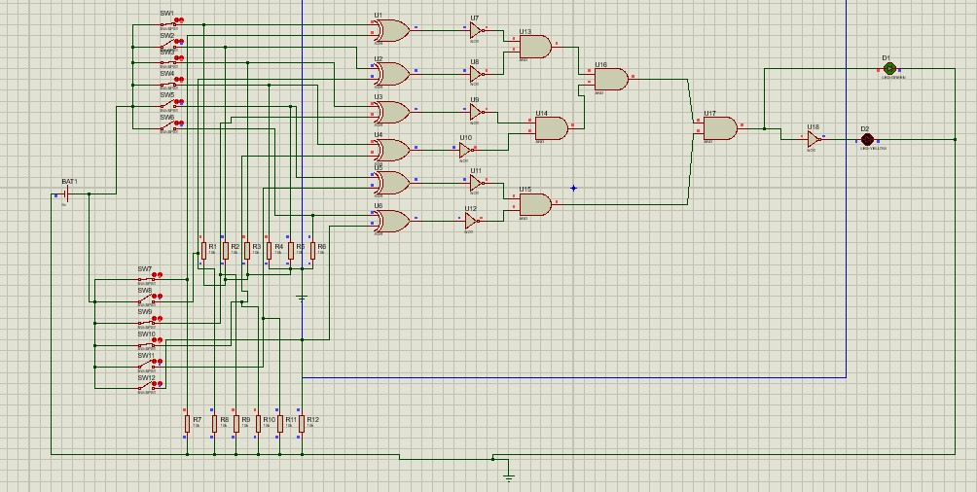

**Applications**

* + Home Security production
  + locker Security production
  + Private Room production
  + Bank Balance Room production • 5-star Restaurant else. Etc.

**Procedure:**

1. Install the IC’s and Resistors neatly on the bread board.
2. Wire the Pins 7 and 14 of all IC’s to VCC and GND Respectively. **iii.** Wire one end of the switches with VCC. **iv.** Wire one end of resistors to GND.
3. Now connect the other end of the switches to the resistors and wire it to the gates of

XOR

IC.

1. Now the output of the XOR is sent as inputs in NOT IC and is grounded with help of a resistor simultaneously.
2. Now the output of the NOT is sent as inputs in AND IC. **viii.** Now the single output of the AND gate is Direct Connect to Green LED and Ground the LED with 470-ohm Resistor.
3. Another Hand the single output of the AND gate is Connect NOT gate.
4. Now the Output of NOT gate is Connect to Red LED and Ground the LED with 470ohm Resistor.

**Precautions:**

i. Always check to see that the power switch is OFF before plugging into the outlet. Also turn instrument or equipment OFF before unplugging from the outlet. ii. Check the IC’s before using them in the circuit. iii. Connect the Wire’s to IC’s with Soldier Very carefully. Because circuit

iv. Don’t use battery more then 12 Volts or it might result in causing damage to the LED’s