**Nested Loops**

Name : Sheryar Sher

Section : Bs-Cs

Rollno: 21p-8027

Q1:

# this program give us a triangle

num = int(input('enter number'))

for i in range(num):

for j in range(i+1):

print('*',end="")

print()

output:

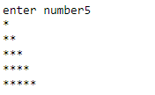

Code:

num = int(input('enter number'))

for i in range(num,0,-1):

for j in range(i):

print('*',end="")

print()

output:

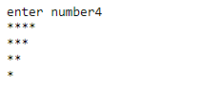

Code:

num = int(input('enter number'))

for i in range(0,num):

for j in range(i):

print(' ',end="")

for k in range(num,i,-1):

print('*',end='')

print()

output:

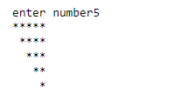

Code:

num = int(input('enter number'))

for i in range(num,0,-1):

for j in range(i):

print(' ',end="")

for k in range(i,num+1):

print('*',end='')

print()

ouput:

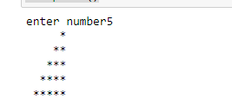

Q2:

# this programs builds a piramid for user using desire symbols

symbol = input("enter your desire symbol")

num = int(input('enter number'))

for i in range(num+1):

for j in range(i+1):

print(symbol,end="")

print()

for i in range(num,0,-1):

for j in range(i):

print(symbol,end="")

print()

output:

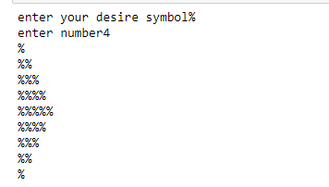

Q3:

# this programs calculate the average numbers for a student

counter = 1

Counter = 1

for i in range(3):

Sum = 0

sName = input('enter name of student{}:'.format(counter))

for j in range(3):

score = int(input('Enter score{}:'.format(Counter)))

Counter+=1

Sum += score

print('Name:',sName)

print('Average: ',round(Sum/3,2))

Counter=1

counter+=1

output:

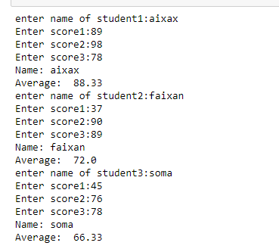

EXTRA TASKS:

Q1:

# this programs build a piramid for user

num = int(input('enter number of rows:'))

symbol = input('enter symbol:')

for i in range(num,0,-1):

for j in range(i):

print(' ',end="")

for k in range(i,num+1):

print(symbol,end='')

# for i in range(num):

for l in range(i,num):

print(symbol,end="")

print()

output:

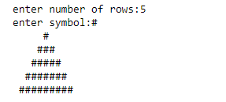

Q2;

# this program builds us a diamond with our desirer rows and symbol

num = int(input('enter number'))

symbol = input('enter symbol:')

for i in range(num,0,-1):

for j in range(i):

print(' ',end="")

for k in range(i,num+1):

print(symbol,end='')

for l in range(i,num):

print(symbol,end="")

print()

for i in range(num+1):

for j in range(i):

print(' ',end="")

for k in range(num,i,-1):

print(symbol,end='')

for l in range(i,num+1):

print(symbol,end="")

print()

output:

