***Rollno_name = 21P8027_Sheryar_Sher***

***Instructor = Muhammad Usman***

***Q.1:*** Write a function that takes quantity in pounds and convert it into gram and kilogram

**Sample Code :**

def converter(pound):

gram = pound * 453.59327

print(pound, "pound = ", gram, "Grams")

kilogram = pound * 0.454

print(pound, "pound = ", kilogram, "Kilograms" )

Pound = float(input('Enter the pound you want to convert into grams or in kilograms :'))

converter(Pound)

**Output:**

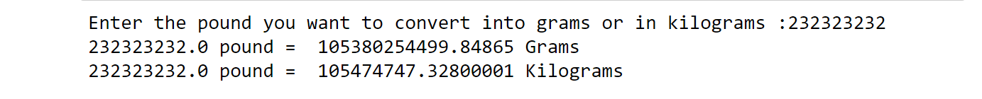

**Q.2:** Write a function that takes two numbers and perform all arithmetic operations.

**Sample Code :**

def calculator(num1 = 1,num2 = 1):

add = num1 + num2

print("The sum of",num1, "and", num2, "is:",add )

sub = num1 - num2

print("The subtraction of",num1, "and", num2, "is:",sub )

mul = num1 * num2

print("The multiplication of",num1, "and", num2, "is:",mul )

div = num1 / num2

print("The division of",num1, "and", num2, "is:",div )

number1 = float(input("Enter number one:"))

number2 = float(input("Enter number two:"))

calculator(number1, number2)

**Output:**

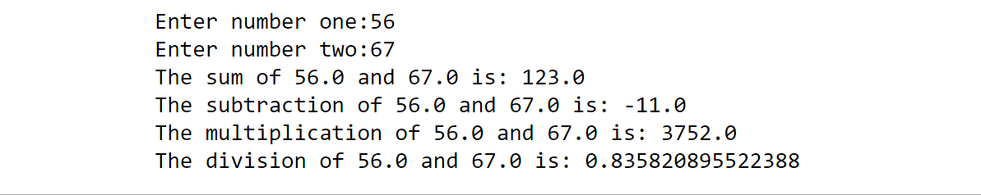

**Q3:** Write a function that takes seconds from the user and displays the time in Hours,

minutes and seconds’ format.

**Sample Code :**

def seconds_converter(seconds):

hour = seconds // 3600

reminder_one = seconds % 3600

minute = reminder_one // 60

second = reminder_one % 60

print(hour, "Hour", minute, "minute and",second, "seconds" )

Seconds = int(input("Enter seconds you want to convert into standard time: "))

seconds_converter(Seconds)

**Output:**

