PF Task

Name:Sheryar Sher

Rollnum: 21p8027

Q1:

Code:

# this programs gives us the factorials of the given number

fact = 1

i = 1

num = int(input('enter number: '))

while num > 1:

fact = fact * num

num -= 1

print(fact, "is the factorial")

output:



Q2:

Code:

# this programs calculate the table of a given number

number = int(input("enter number: "))

n = 1

while n<=10:

print(number," * ", n , " = ",number*n)

n+=1

output:

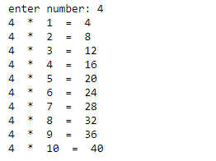

Q3:

# this programe simple mathmathical operations for us

num = int(input('enter a number: '))

num2 = int(input('enter second number: '))

operator = int(input('press 1 for add / press 2 for sub / press 3 for mult / press 4 for div:'))

check = input("you want to continue 'Y/N':")

check = check.upper()

while check !="N":

if check =="Y" :

if operator == 1:

print('sum of ',num, 'and', num2,'is:',num + num2)

elif operator == 2:

print('subtraction of ',num ,'and', num2,'is:',num - num2)

elif operator == 3:

print('product of ',num ,'and', num2,'is:',num * num2)

elif operator == 4:

print('division of ',num, 'and', num2,'is:',num / num2)

else:

print('press correct number')

else:

print('Enter valid condition')

check = input("you want to continue 'Y/N':")

check = check.upper()

num = int(input('enter a number: '))

num2 = int(input('enter second number: '))

operator = int(input('press 1 for add / press 2 for sub / press 3 for mult / press 4 for div:'))

output:

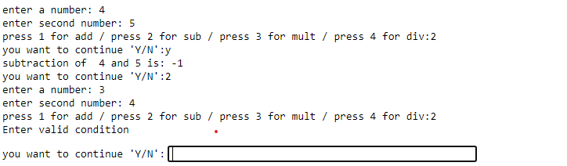

Q4:

# this program find the lcm of given two number

num1 = int(input("enter first number"))

num2 = int(input("enter second number"))

n = 1

while True: #run until this becomes false

if (n%num1==0) and (n%num2==0):

print("LCM of",num1, "and", num2, "is:",n)

break

else:

n+=1

output:

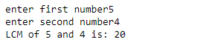

Q4

Code:

num1 = int(input("enter first number"))

num2 = int(input("enter second number"))

def hcf(c,d):

Min = min(num1,num2)

Max = max(num1,num2)

while True:

if Max%Min == 0:

a = Min

break

a = Max%Min

Max = Min

Min = a

return a

total = hcf(num1,num2)

print('hcf of ',num1,'and',num2,'is: ', total)

Output:

