Name = Sheryar Sher

Roll# = 21P8027

Example 0:

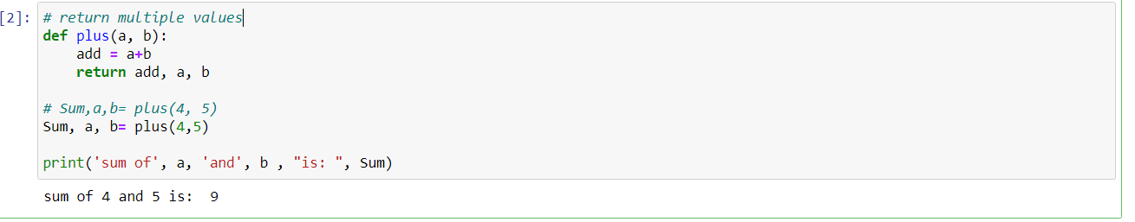

Example 1:

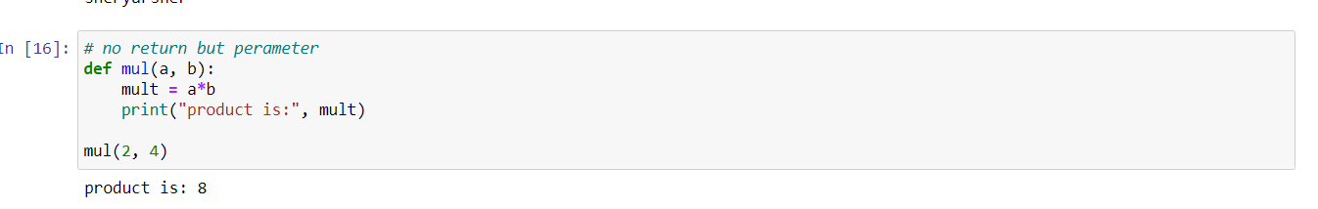

Example 2:

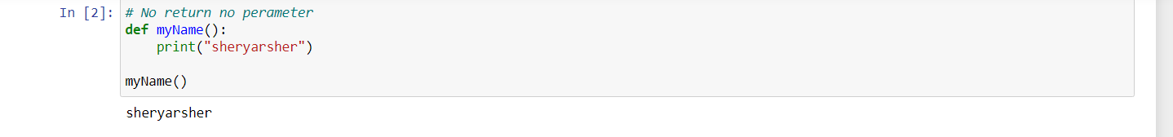

Example 3:

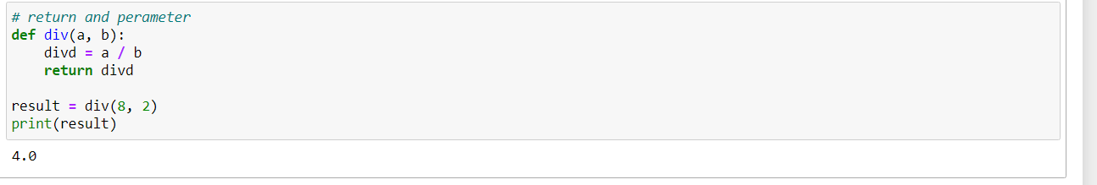

Example 4:

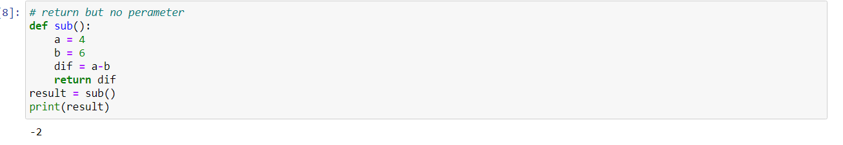

Example 5:

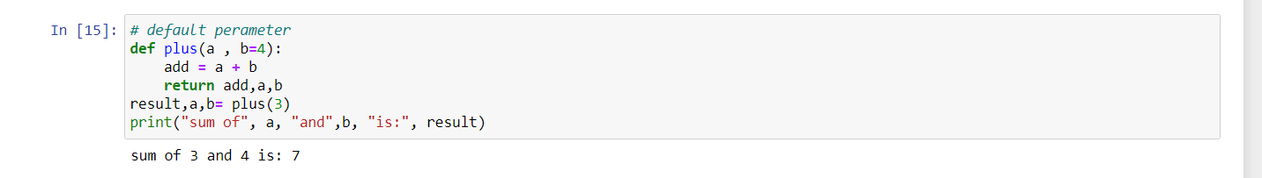

Example 6:

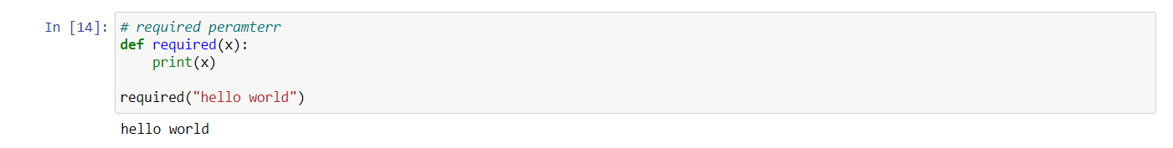

Example 7:

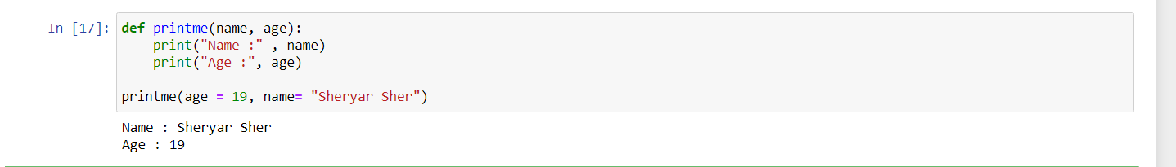

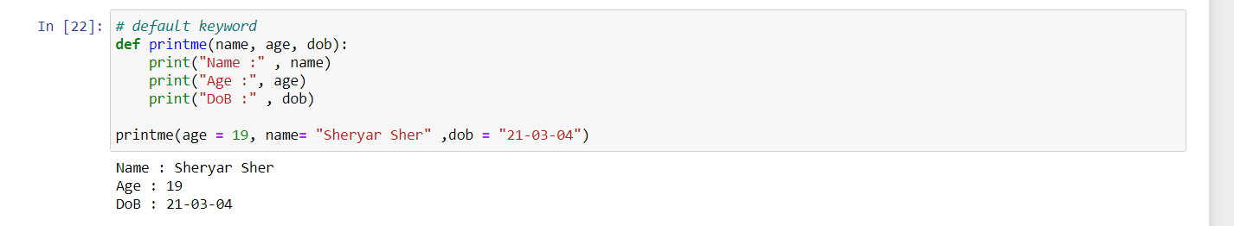

Example 8: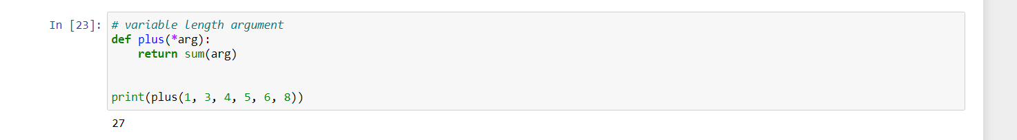

Example 9:

