***Name: Sheryar Sher***

***Roll#: 21P-8027***

***Program: BS(CS)***

***Lecturer: Maryam Omar***

1. take radius as an input from user and calculate area and circumference of a  
   circle.

**CODE:**

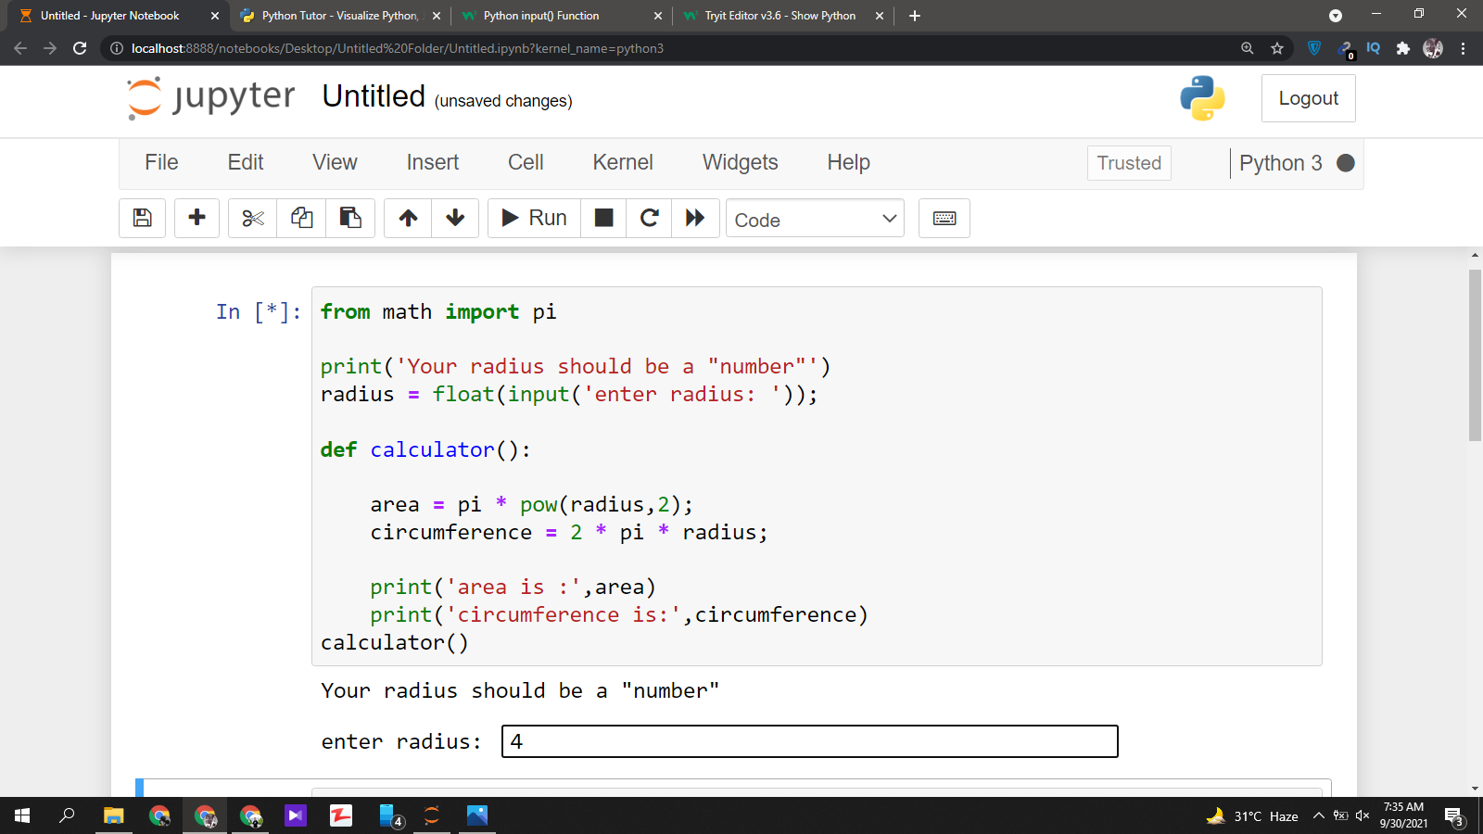

**OUTPUT:**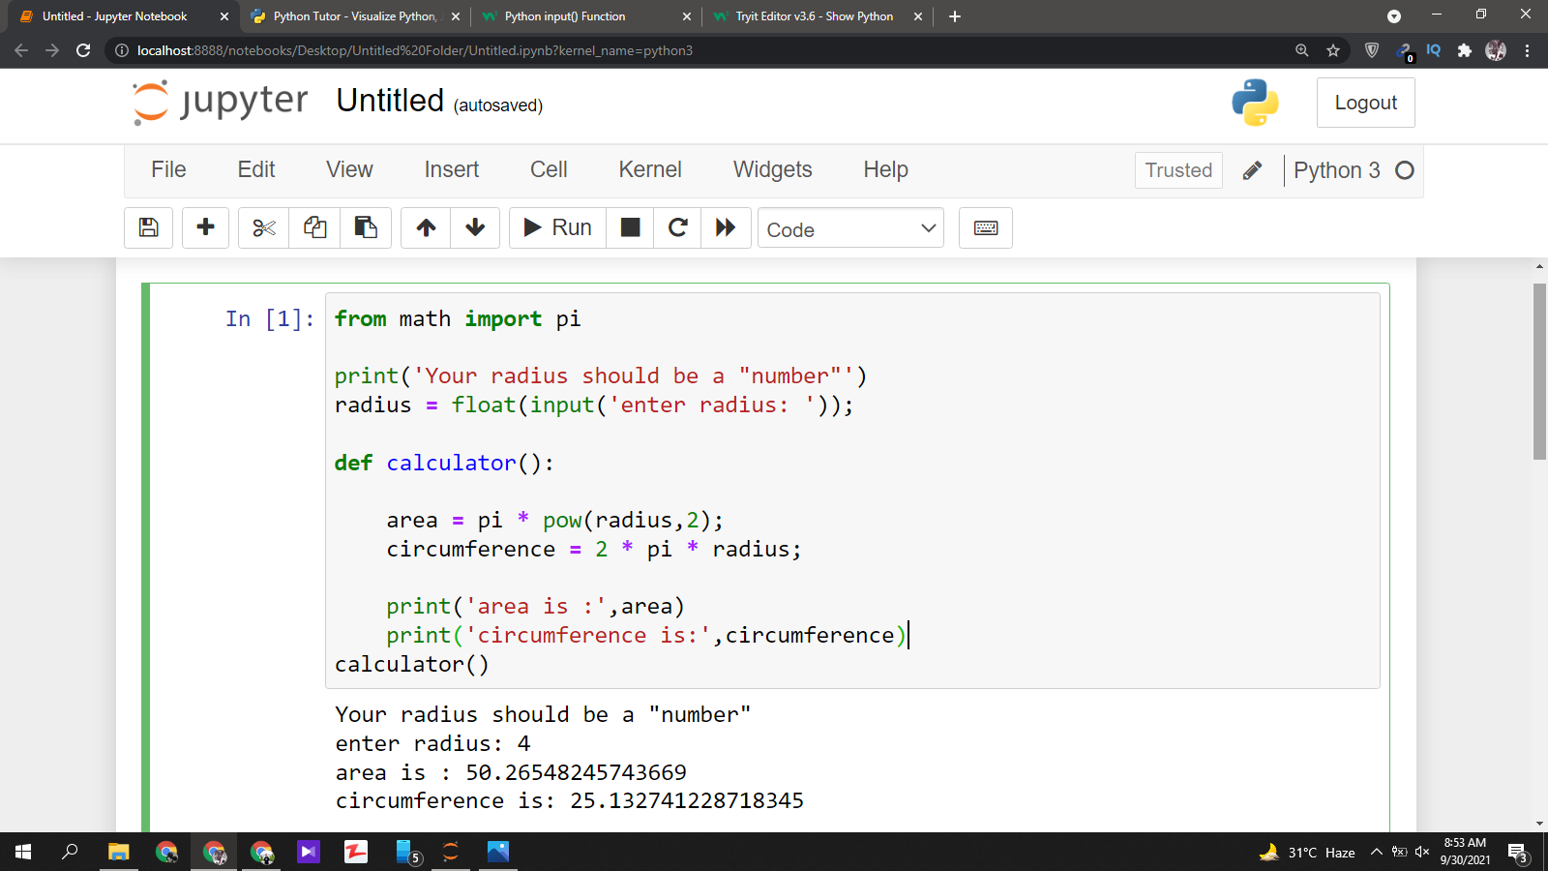

1. take length of a square as an input from user and calculate its area and  
   parameter.

**CODE:**

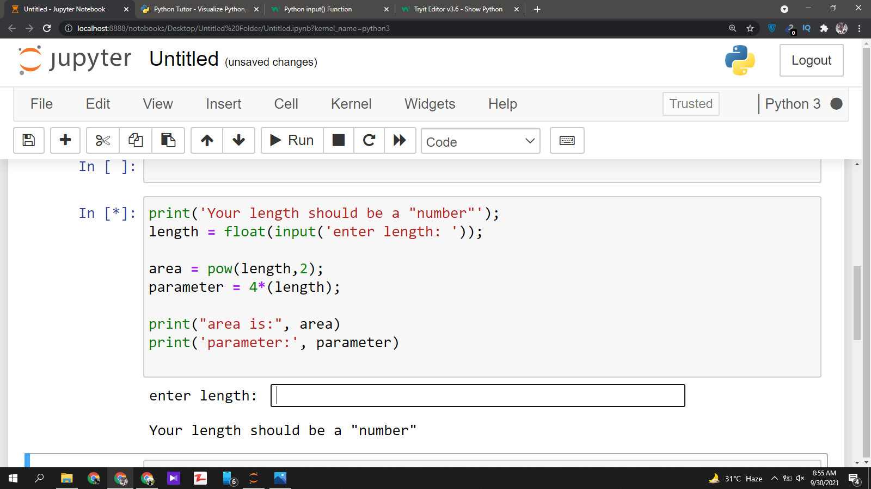

**OUTOUT:**

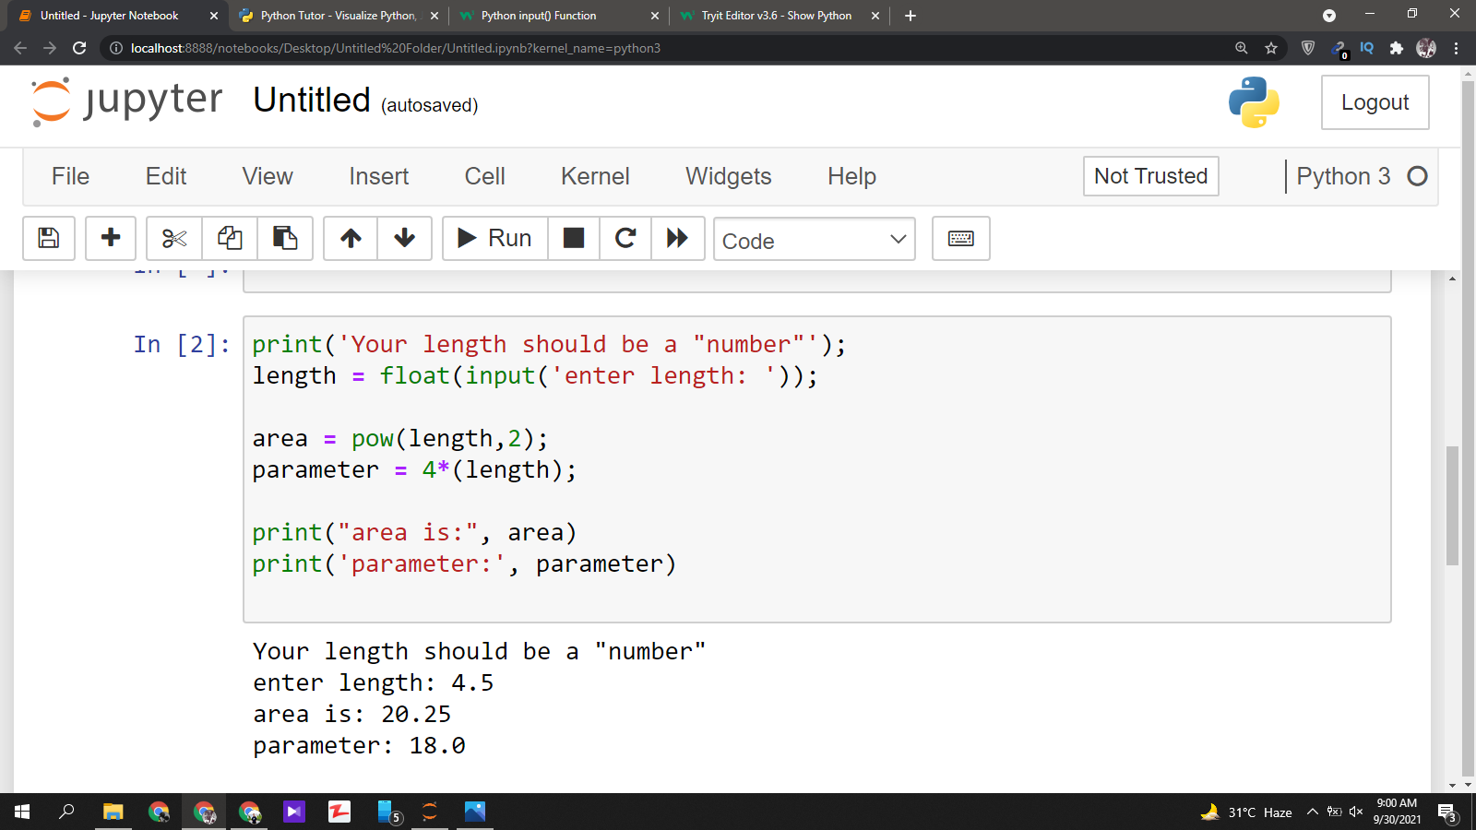

1. take length and width of a rectangle as an input from user and calculate its  
   area and parameter.

**CODE:**

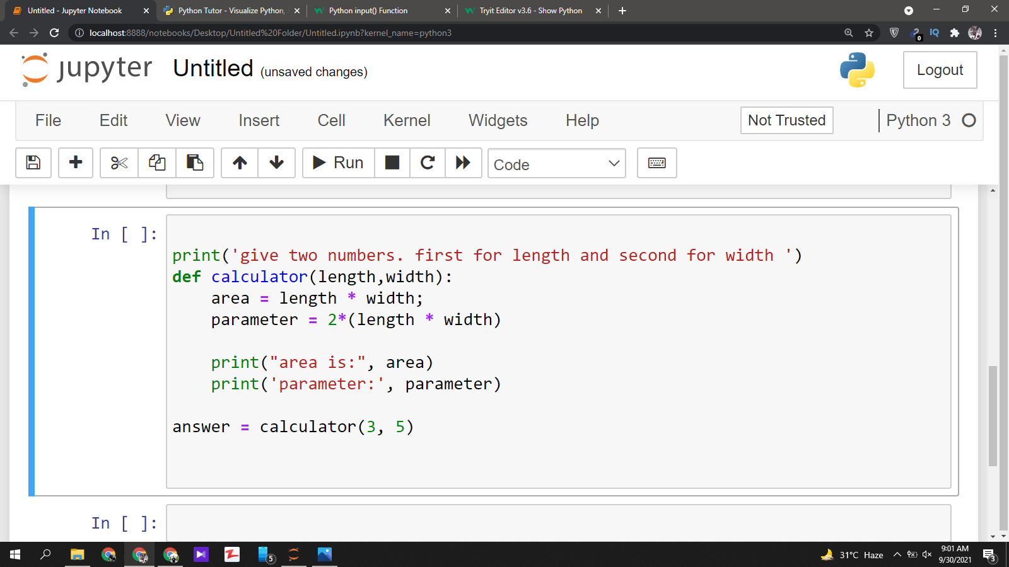

**OUTPUT:**

