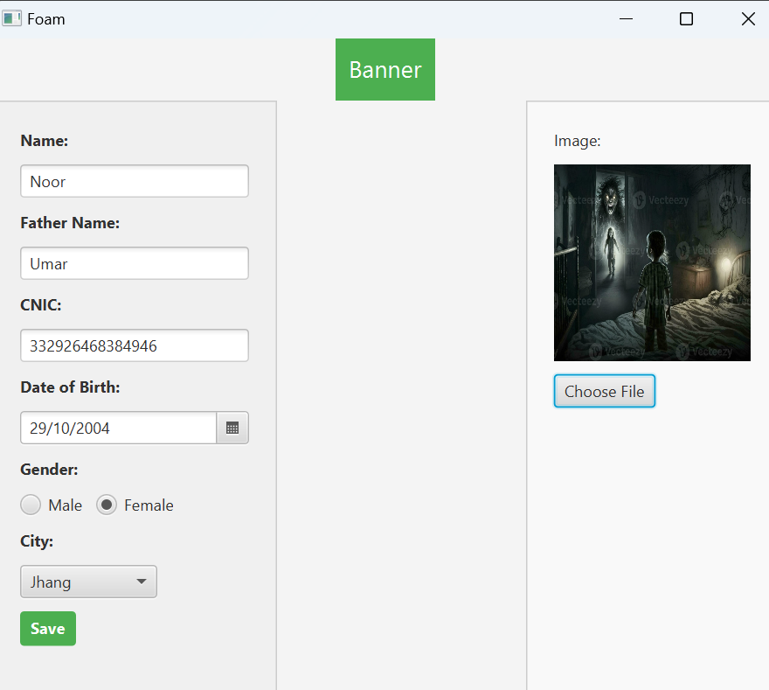

This is how my foam looks like after filling the data

After clicking the save button->

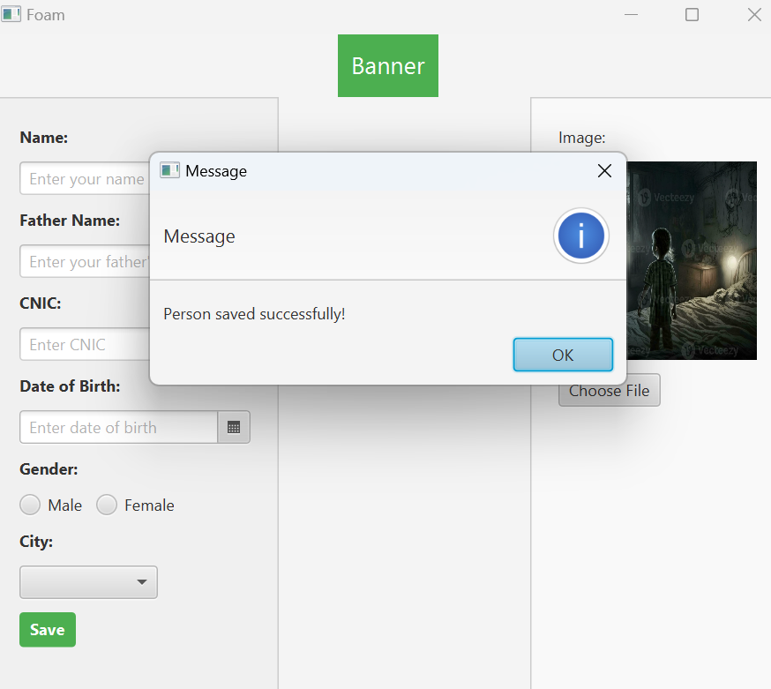

The person is saved successfully