This appears when i run my program

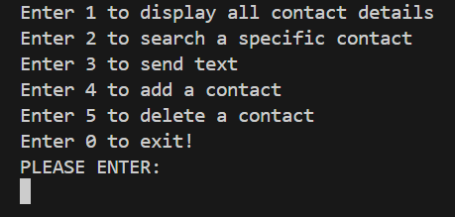

After pressing 1 , this displayed.

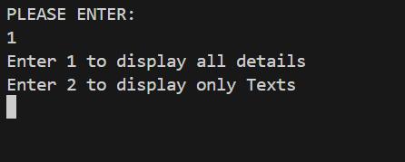

This 1 will display all the details of the contacts including the texts that are already available in my code

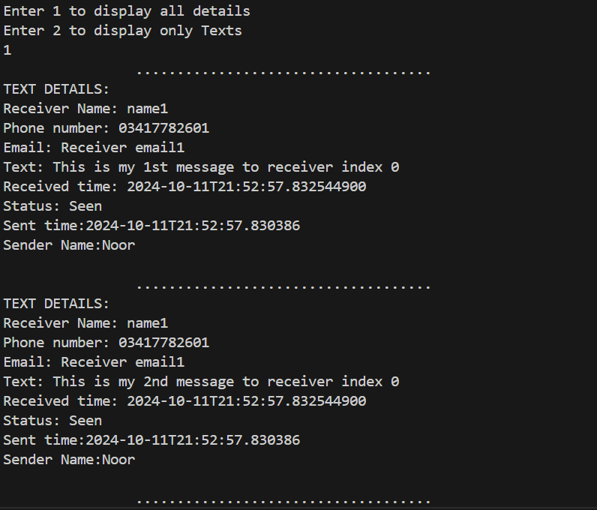

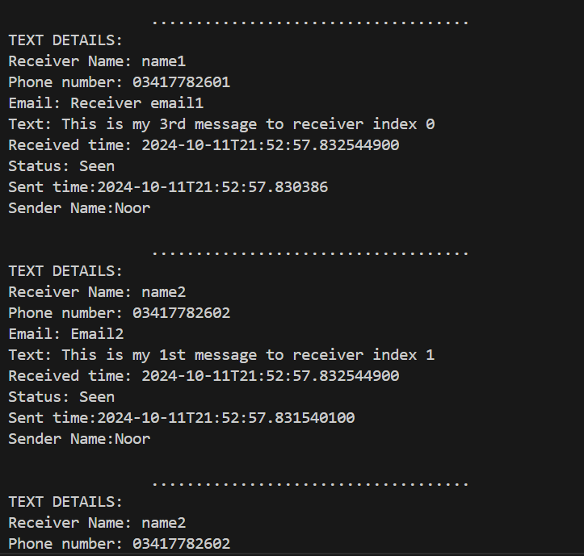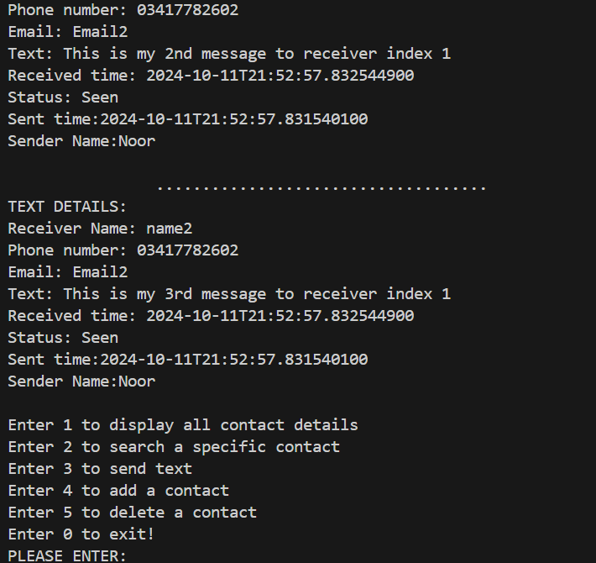

This displayed all the messages including the details of receiver and sender

Another option in display function is to display only the messages, so when I press 2 after calling the display function, this appears

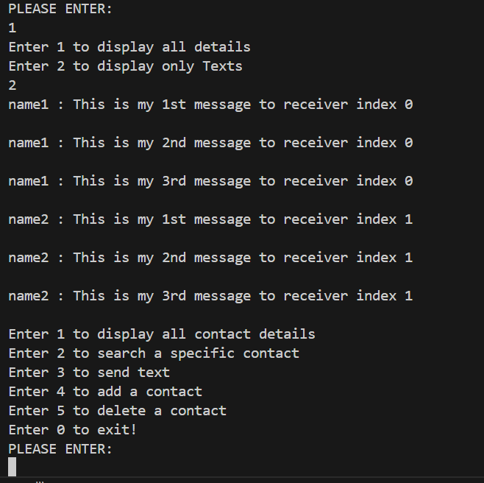

This is only displaying the messages as well as the person name to which the messages are being sent

Now if I press 2, a specific contact details will appear

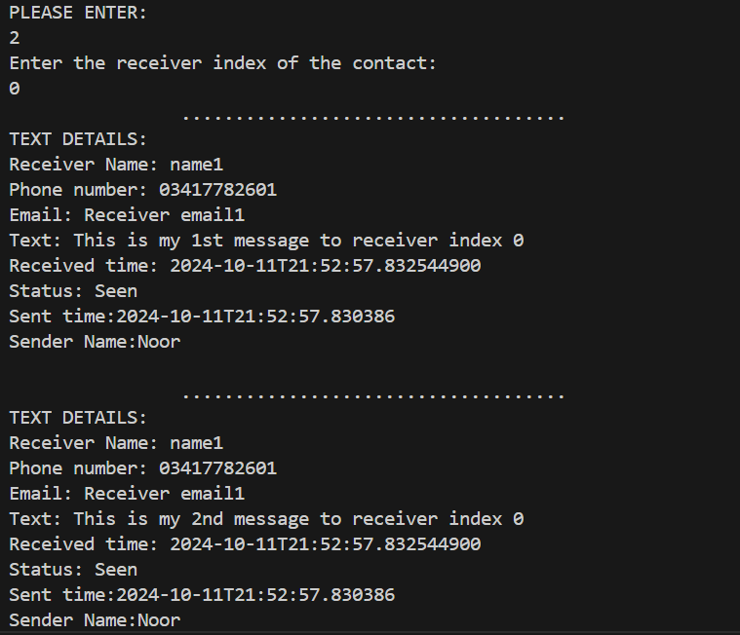

I entered 2 and then I was asked to enter the index of the receiver

So then i entered 0 and it displayed the contact details at index 0

Now I entered 3

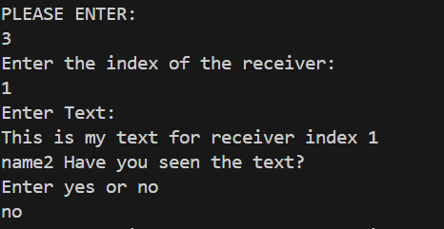

This is the function to send message to a specific receiver

It firstly asks the index of the receiver and the asks to enter the text

After that it asks the receiver that weather the receiver has seen the text or not and I entered no

Now, I will show the display method and in that the 1 index will add the message and the received time will be none because I entered that I have not seen it

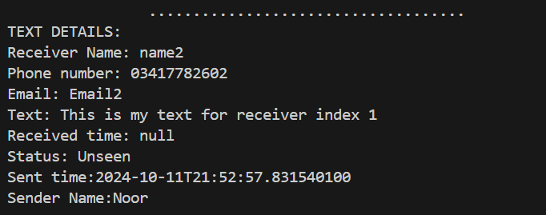

Now I entered 4 to add a contact

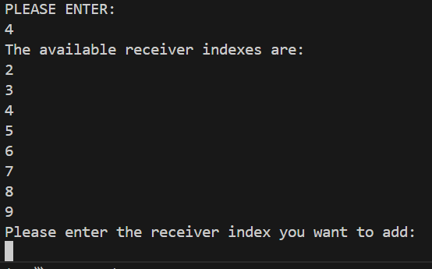

It showed that the following indexes are available and then asked to enter the index you want to add

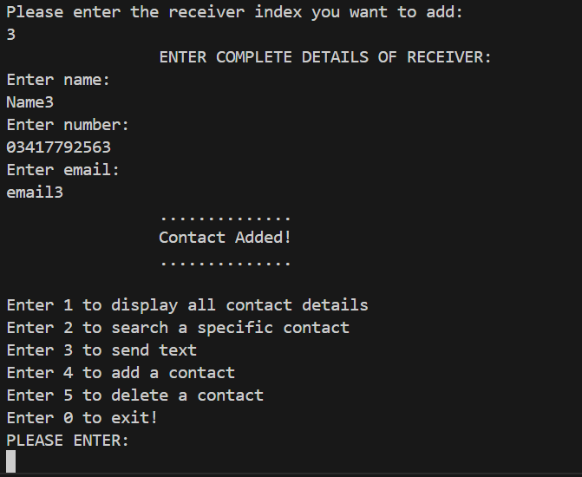

Then I entered the following the details and the contact got added

Now I can send the text to this contact also

Now I will enter 3 and send message to this 3rd index and after that I will display 3rd index

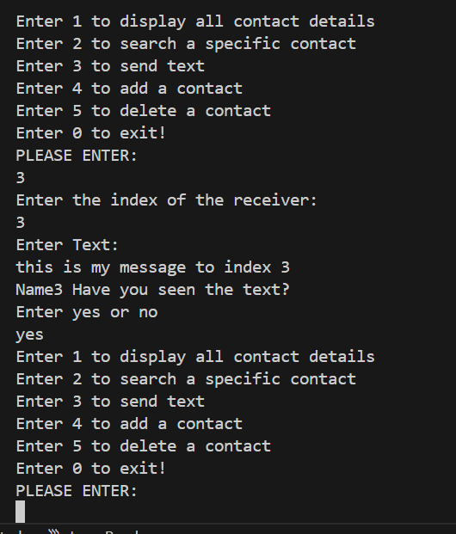

Now I will display the complete details of index 3

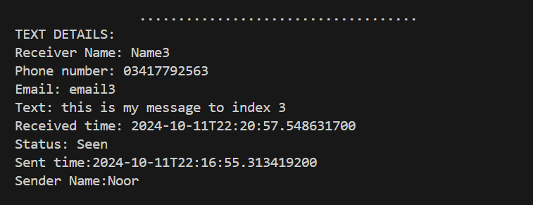

This status is seen because I entered yes while I was sending text to index 3

Now I will enter 5 to delete a contact

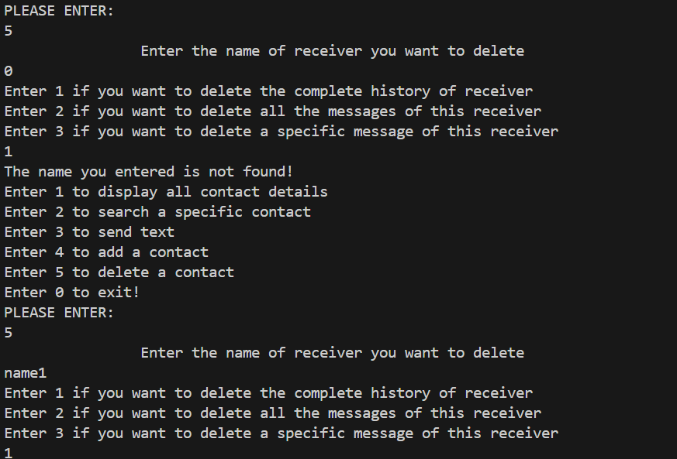

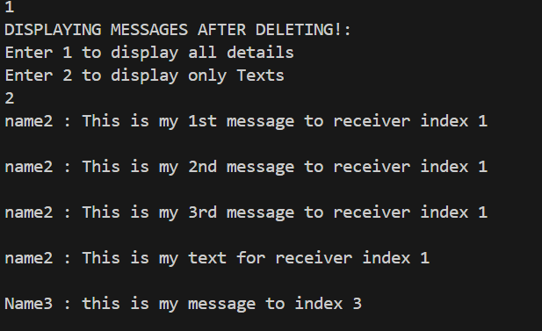

This is my code and will work accordingly

If I will press zero then the code will exit