Orchestra Project

#1 UML Deliverables

Group C

Cédric CLIGNIEZ
Siqi LEI
Antoine MALINET

Class diagram

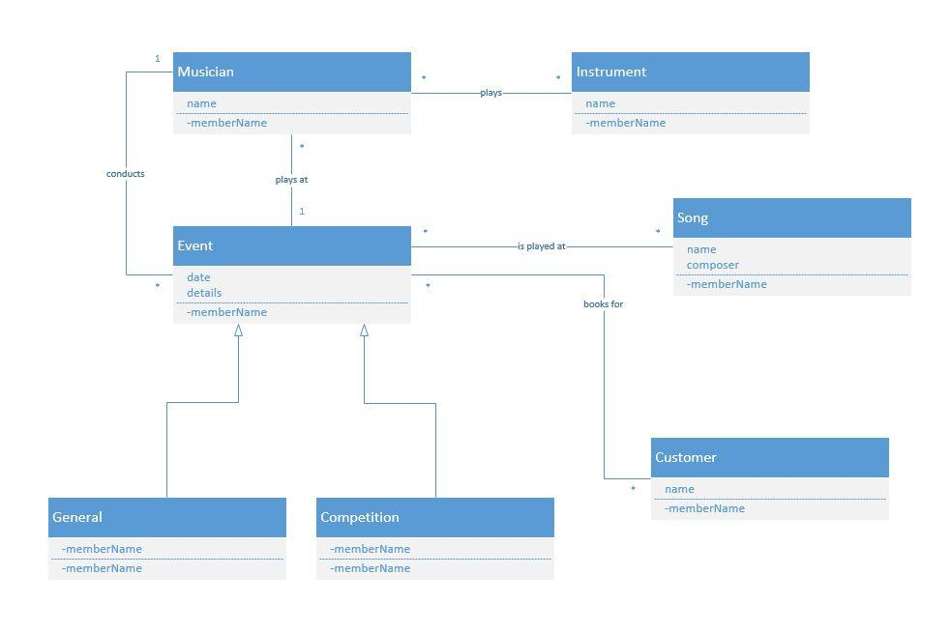

The Customer class is not handled (yet), but without Visio we could not modify the class diagram. The corresponding use cases are therefore not in the use case diagram and in the mock-up.

Use case diagram

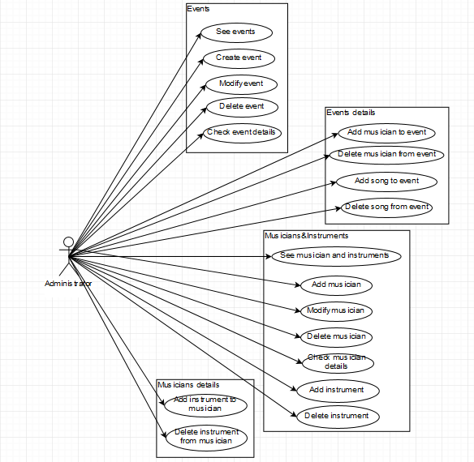

Scenarios and Sequence diagrams

Number | 1
Name | See Events
Summary | Displays the Events page
Preconditions | Being on the homepage
Postconditions | Being on the Events page
Primary actor(s) | User
Secondary actor(s) | Events Class
Main Scenario | Step | Action
 | 1 | System displays the Events page

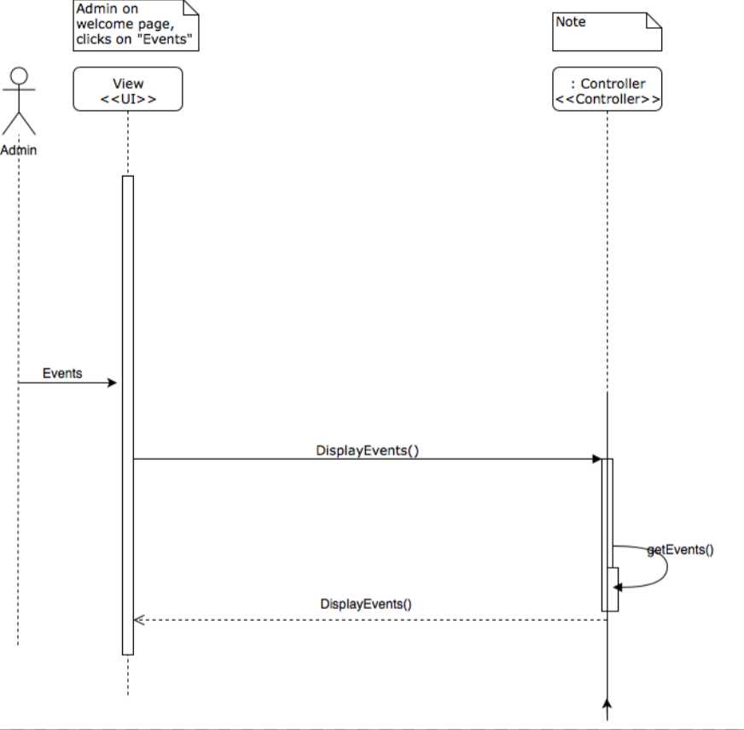

Number | 2
Name | Create Event
Summary | The admin enters the necessary information to add an event
Preconditions | Being on the events page, having logged in as admin
Postconditions | An event has been added
Primary actor(s) | Admin
Secondary actor(s) | Events Class
Main Scenario | Step | Action
 | 1 | System displays form
 | 2 | User fills form
 | 3 | User presses Save button
 | 4 | System saves the event
 | 5 | System displays event page
Extensions | Step | Branching Action
 | 2a | User presses Cancel button
 | 2b | System displays event page
 | 3a | If the form has not been correctly filled, display error

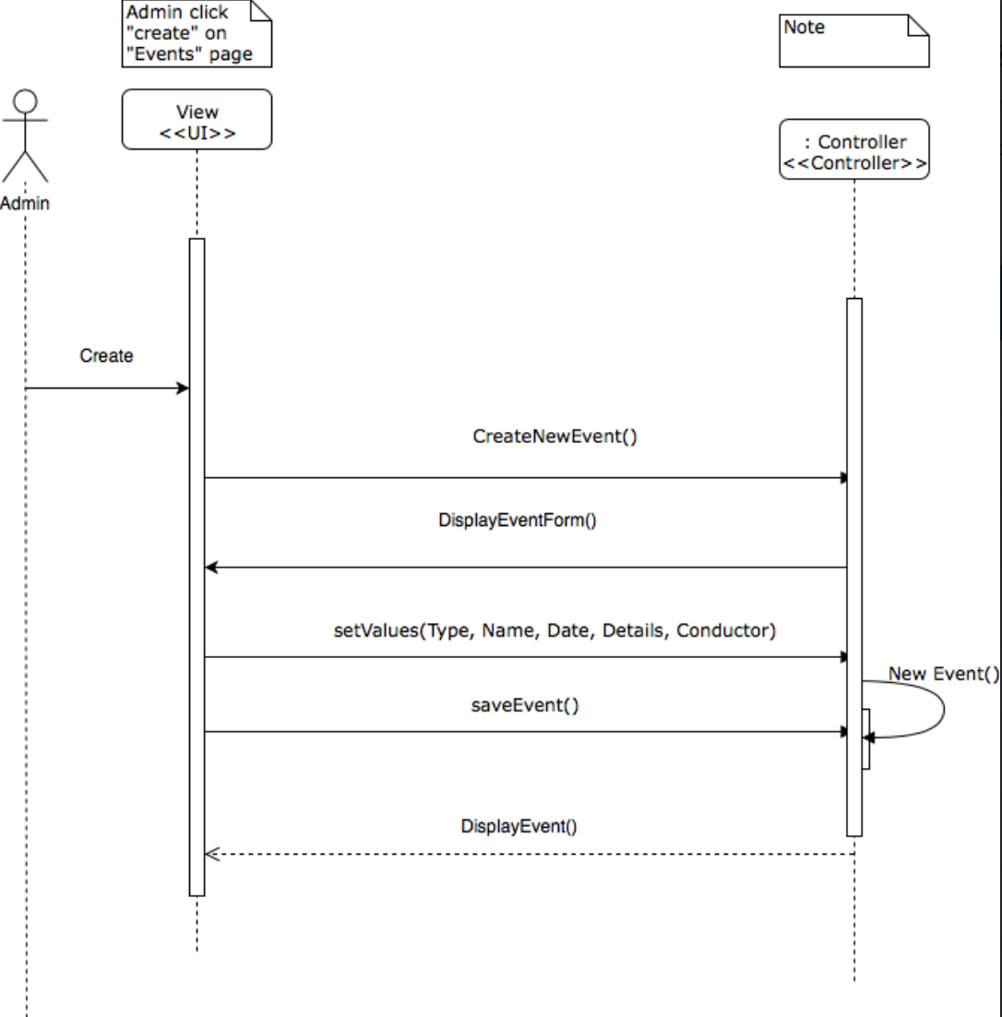

Number | 3
Name | Modify Event
Summary | The admin enters the modified information of an event
Preconditions | Being on the events page, having logged in as admin
Postconditions | The event has been modified
Primary actor(s) | Admin
Secondary actor(s) | Events Class
Main Scenario | Step | Action
 | 1 | System displays form
 | 2 | User fills form
 | 3 | User presses Save button
 | 4 | System saves the event
 | 5 | System displays event page
Extensions | Step | Branching Action
 | 2a | User presses Cancel button
 | 2b | System displays event page
 | 3a | If the form has not been correctly filled, display error

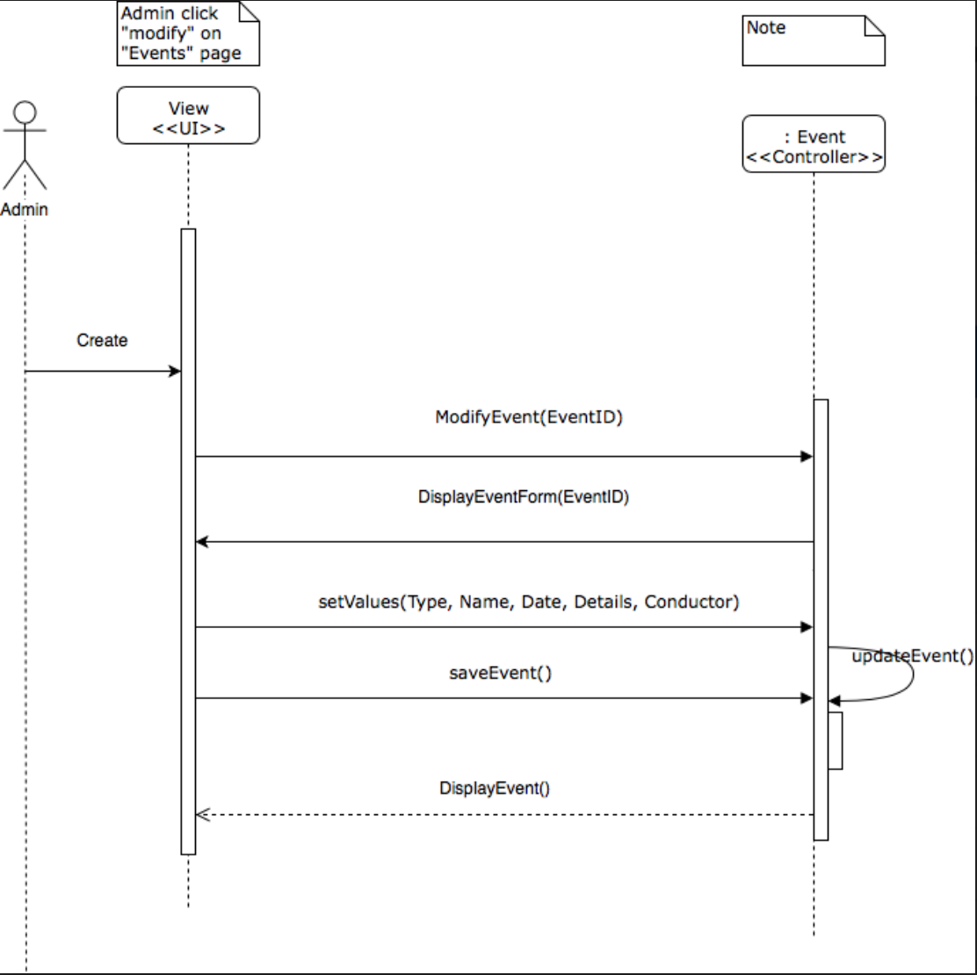

Number | 4
Name | Delete Event
Summary | Remove an event from the events list
Preconditions | Being on the events page, having logged in as admin
Postconditions | The event has been deleted
Primary actor(s) | Admin
Secondary actor(s) | Events Class
Main Scenario | Step | Action
 | 1 | System displays confirmation window
 | 2 | User presses OK button
 | 3 | System deletes the event
 | 4 | System displays event page
Extensions | Step | Branching Action
 | 2a | User presses Cancel button
 | 2b | System displays event page

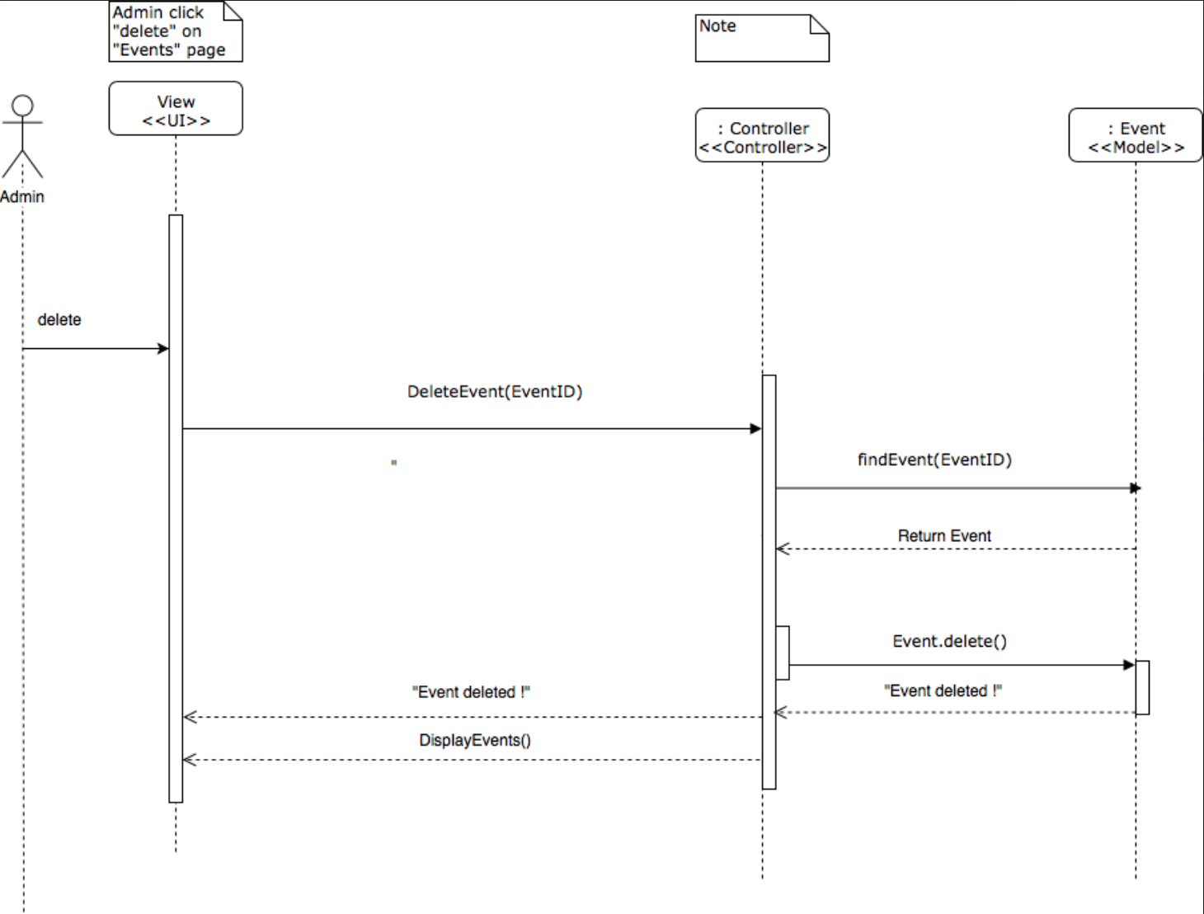

Number | 5
Name | Check Event Details
Summary | Displays the details of an event
Preconditions | Being on the events page
Postconditions | Being on the details page of the event
Primary actor(s) | Admin
Secondary actor(s) | Events Class
Main Scenario | Step | Action
 | 1 | System displays the details page

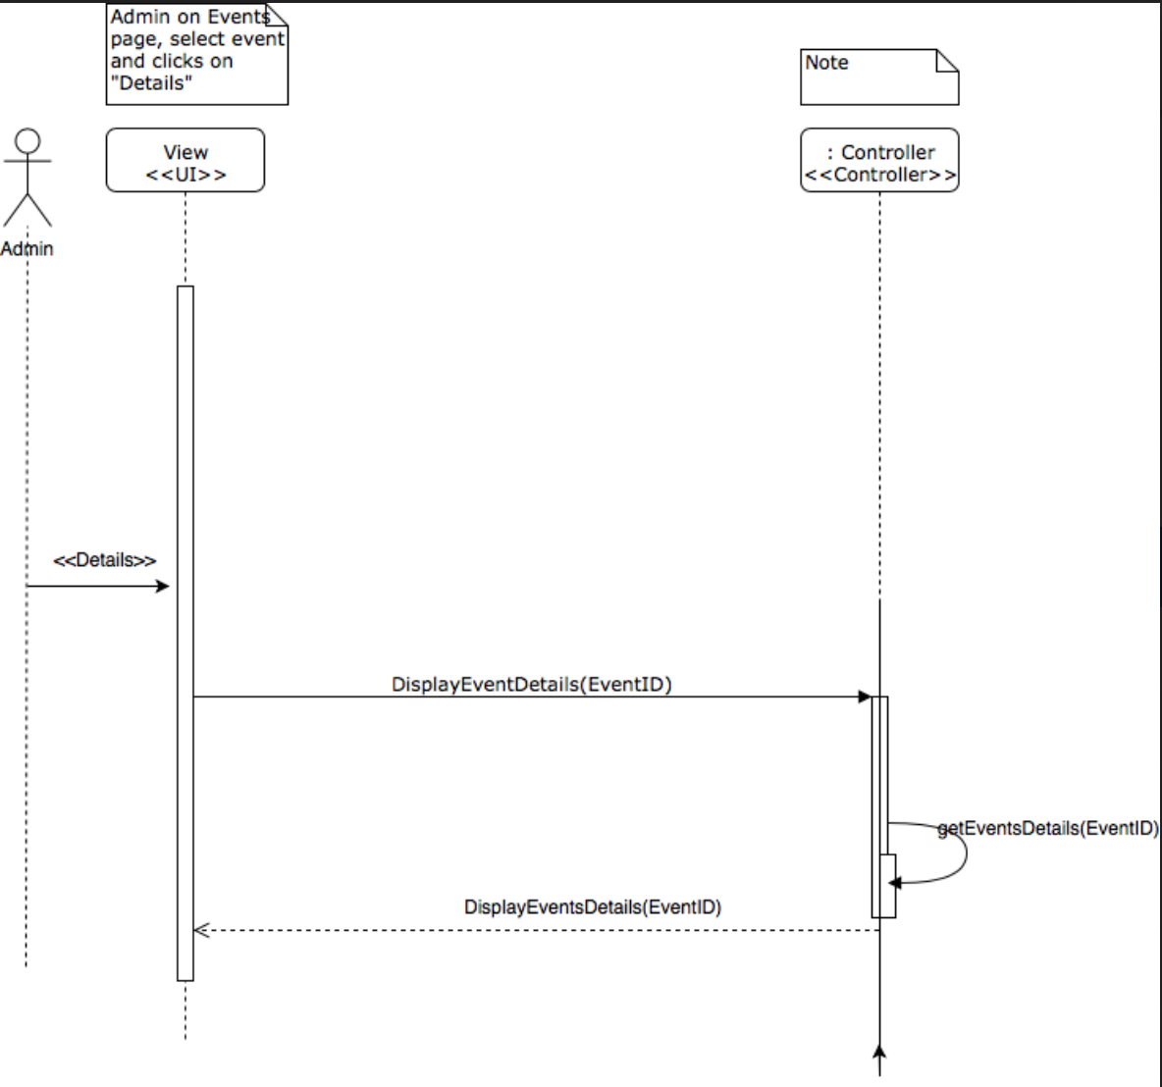

Number | 6
Name | Add Musician To Event
Summary | Adds a musician to an event
Preconditions | Being on the details page of an event, being logged in as an admin
Postconditions | The musician has been added
Primary actor(s) | Admin
Secondary actor(s) | Event Class, Musician Class
Main Scenario | Step | Action
 | 1 | The user chooses an musician in the scrolling menu
 | 2 | The user presses the Add musician button
 | 3 | The system adds the musician to the event
Extensions | Step | Branching Action
 | 2a | The chosen musician is already participating to that event
 | 2b | Display « The chosen musician is already participating to that event»

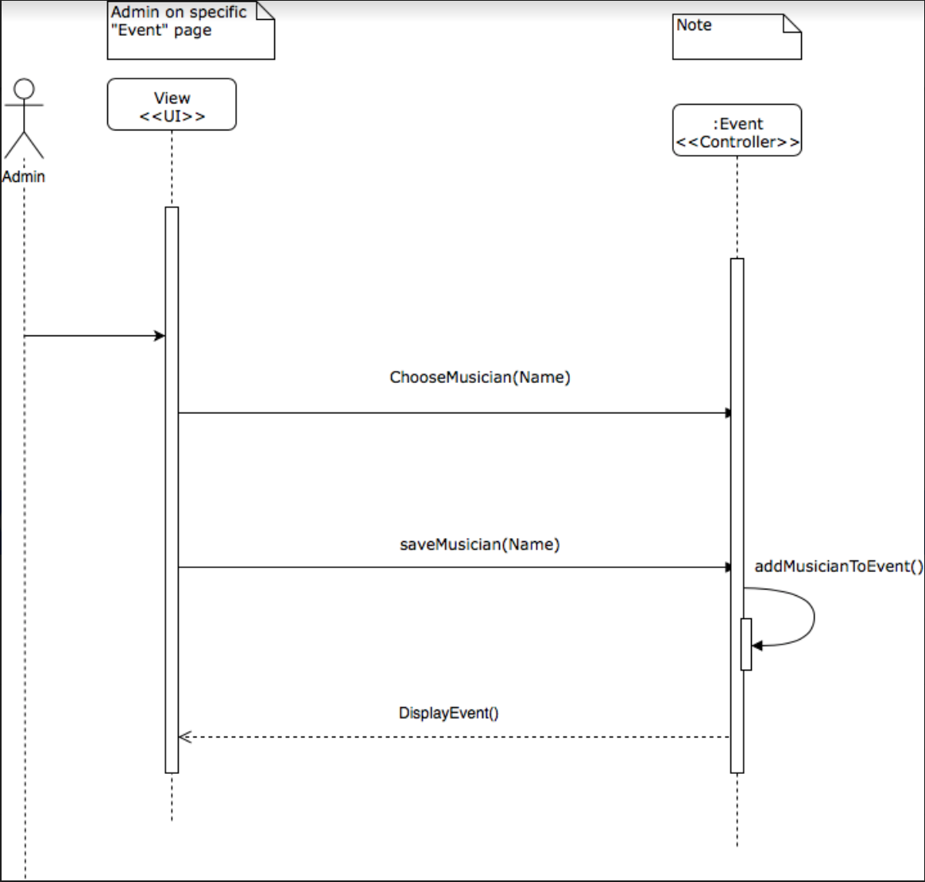

Number | 7
Name | Delete Musician From Event
Summary | Remove a selected musician from an event
Preconditions | Being on the details page of an event, having logged in as admin, having selected a musician in the list
Postconditions | The musician has been removed from the event
Primary actor(s) | Admin
Secondary actor(s) | Events Class
Main Scenario | Step | Action
 | 1 | System displays confirmation window
 | 2 | User presses OK button
 | 3 | System deletes the musician
 | 4 | System displays details page
Extensions | Step | Branching Action
 | 2a | User presses Cancel button
 | 2b | System displays details page
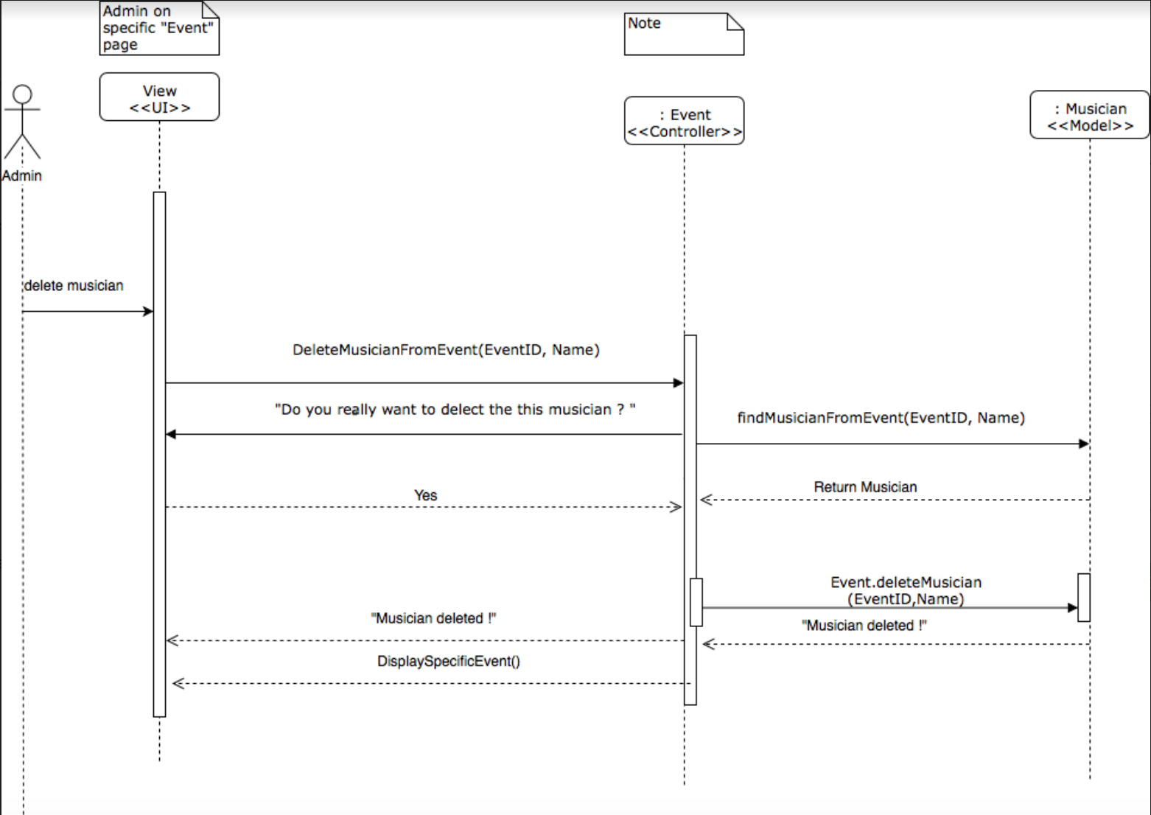

Number | 8
Name | Add Song To Event
Summary | The admin enters the necessary information to add a song to an event
Preconditions | Being on the details page of an event, having logged in as admin
Postconditions | A song has been added
Primary actor(s) | Admin
Secondary actor(s) | Events Class
Main Scenario | Step | Action
 | 1 | System displays form
 | 2 | User fills form
 | 3 | User presses OK button
 | 4 | System saves the song
 | 5 | System displays details page of the event
Extensions | Step | Branching Action
 | 2a | User presses Cancel button
 | 2b | System displays details page of the event
 | 3a | If the form has not been correctly filled, display error
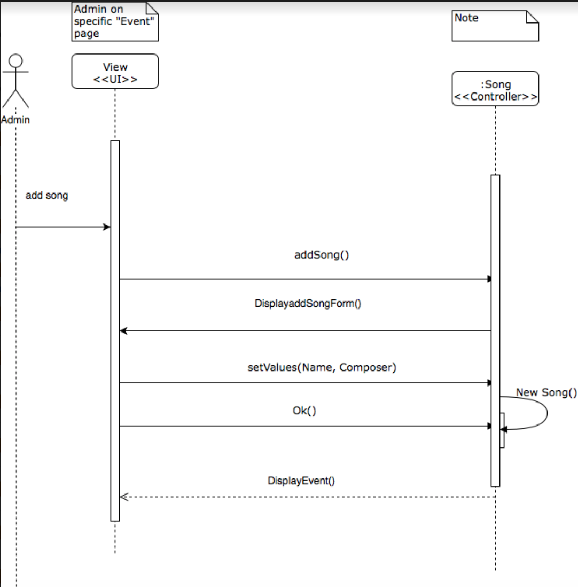

Number | 9
Name | Delete Song From Event
Summary | Remove a selected song from an event
Preconditions | Being on the details page of an event, having logged in as admin, having selected a song in the list
Postconditions | The song has been removed from the event
Primary actor(s) | Admin
Secondary actor(s) | Events Class
Main Scenario | Step | Action
 | 1 | System displays confirmation window
 | 2 | User presses OK button
 | 3 | System deletes the song
 | 4 | System displays details page
Extensions | Step | Branching Action
 | 2a | User presses Cancel button
 | 2b | System displays details page

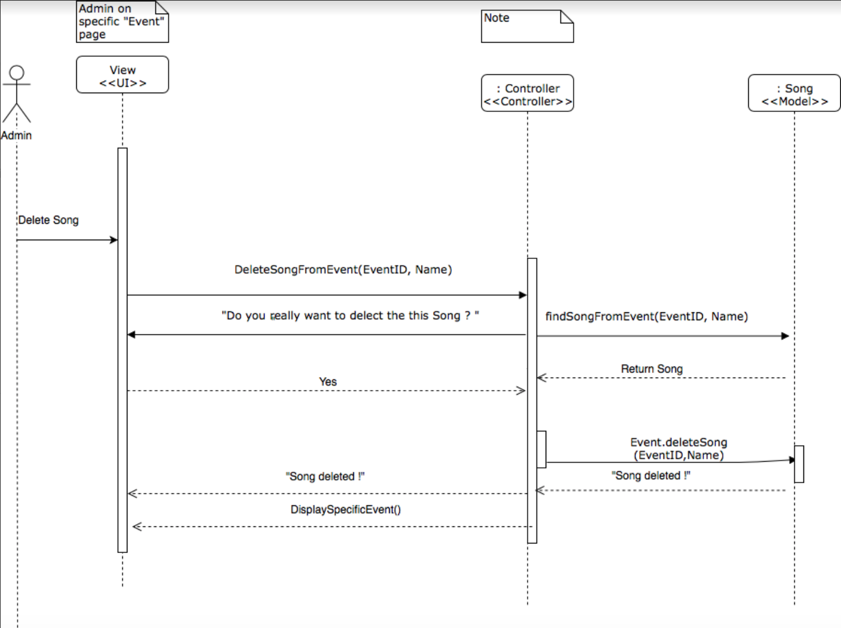

Number | 10
Name | See Musicians And Instruments
Summary | Displays the Musicians&Instruments page
Preconditions | Being on the homepage
Postconditions | Being on the Musicians&Instruments page
Primary actor(s) | User
Secondary actor(s) | Musician Class
Main Scenario | Step | Action
 | 1 | System displays the Musicians&Instruments page

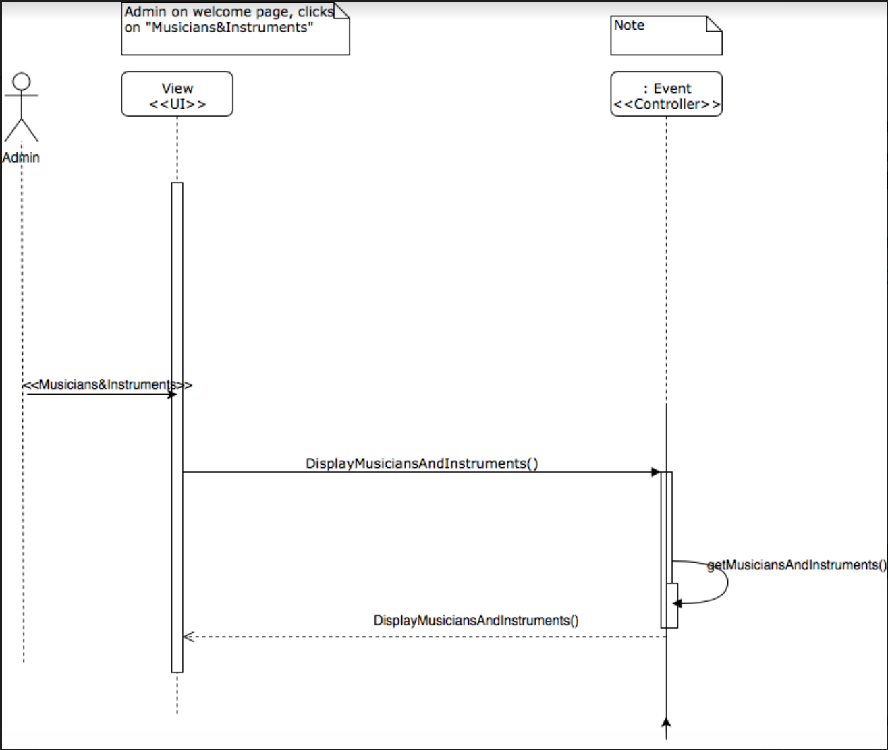

Number | 11
Name | Add Musician
Summary | The admin enters the necessary information to add a musician
Preconditions | Being on the Musicians&Instruments page, having logged in as admin
Postconditions | A musician has been added
Primary actor(s) | Admin
Secondary actor(s) | Musician Class
Main Scenario | Step | Action
 | 1 | System displays form
 | 2 | User fills form
 | 3 | User presses OK button
 | 4 | System saves the musician
 | 5 | System displays Musician&Instruments page
Extensions | Step | Branching Action
 | 2a | User presses Cancel button
 | 2b | System displays Musicians&Instruments page
 | 3a | If the form has not been correctly filled, display error
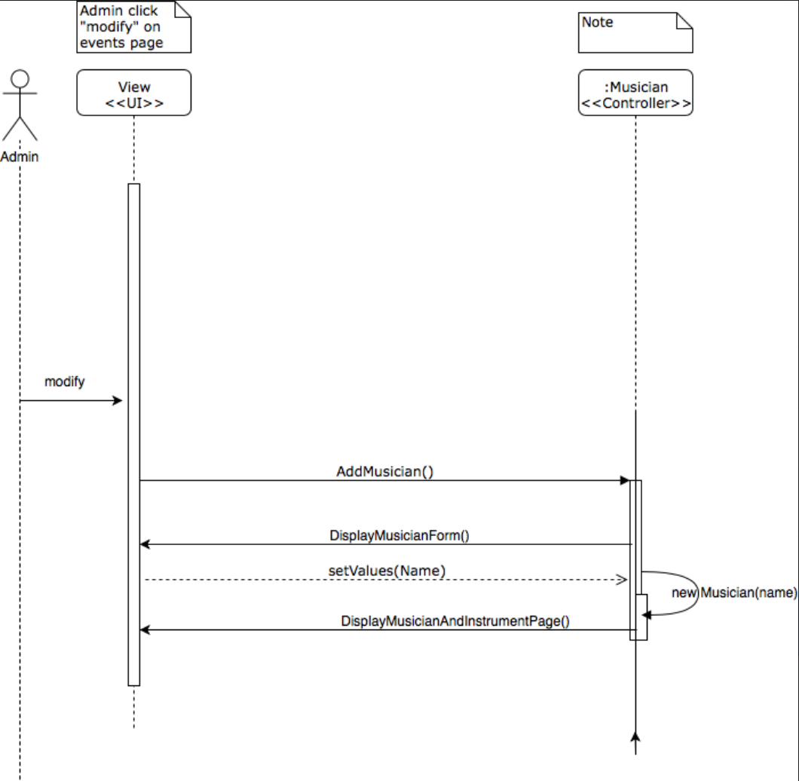

Number | 12
Name | Modify Musician
Summary | The admin enters the modified information of a musician
Preconditions | Being on the Musicians&Instruments page, having logged in as admin
Postconditions | The musician has been modified
Primary actor(s) | Admin
Secondary actor(s) | Musician Class
Main Scenario | Step | Action
 | 1 | System displays form
 | 2 | User fills form
 | 3 | User presses Save button
 | 4 | System saves the musician
 | 5 | System displays Musician&Instruments page
Extensions | Step | Branching Action
 | 2a | User presses Cancel button
 | 2b | System displays Musicians&Instruments page
 | 3a | If the form has not been correctly filled, display error

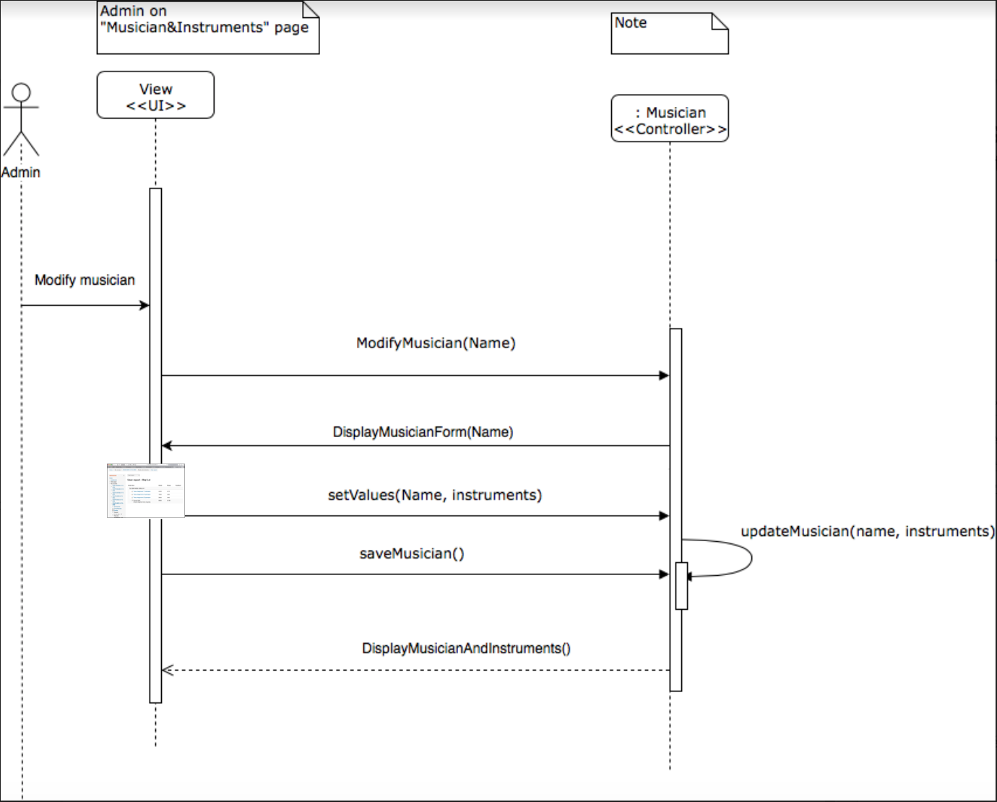

Number | 13
Name | Delete Musician
Summary | Remove a musician from the musicians list
Preconditions | Being on the Musicians&Intruments page, having logged in as admin, having selected a musician
Postconditions | The musician has been deleted
Primary actor(s) | Admin
Secondary actor(s) | Musician Class
Main Scenario | Step | Action
 | 1 | System displays confirmation window
 | 2 | User presses OK button
 | 3 | System deletes the musician
 | 4 | System displays Musicians&Intruments page
Extensions | Step | Branching Action
 | 2a | User presses Cancel button
 | 2b | System displays Musicians&Intruments page

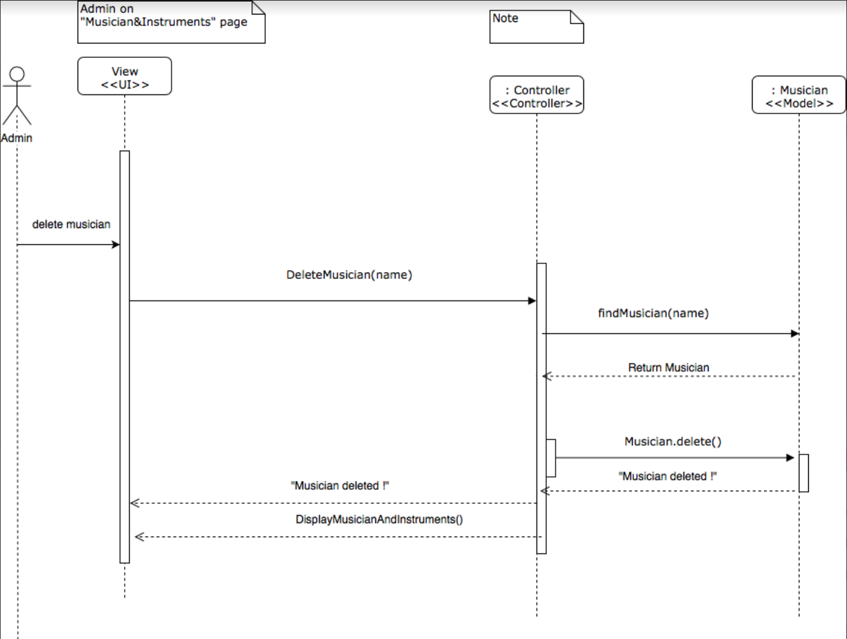

Number | 14
Name | Check Musician Details
Summary | Displays the details page of a musician
Preconditions | Being on the Musicians&Instruments page, having logged in as an admin, having selected a musician
Postconditions | Being on the details page of a musician
Primary actor(s) | Admin
Secondary actor(s) | Musician Class
Main Scenario | Step | Action
 | 1 | System displays the details page of the selected musician

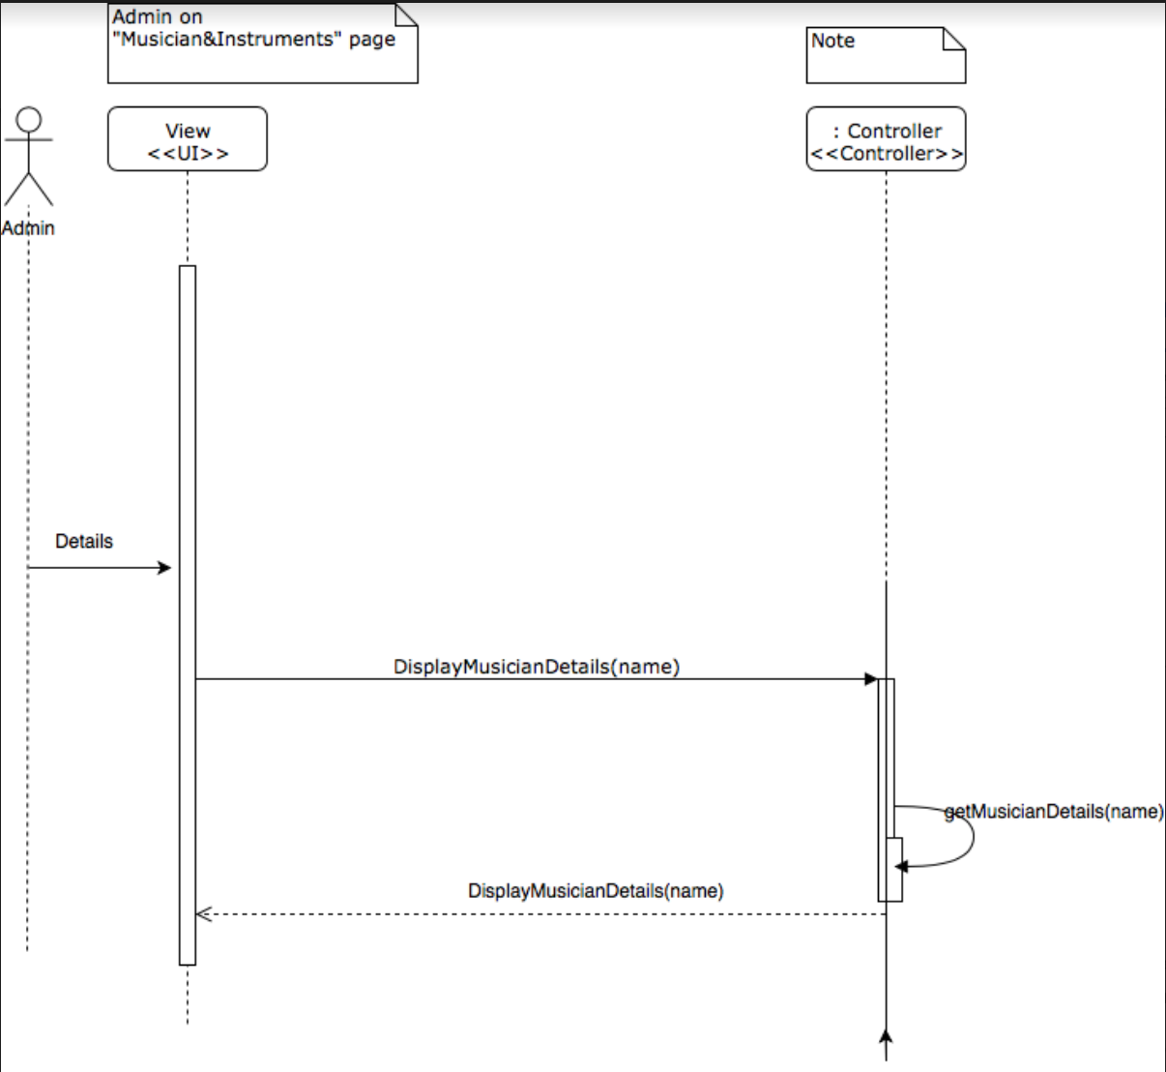

Number | 15
Name | Add Instrument To Musician
Summary | Adds an instrument to a musician
Preconditions | Being on the details page of a musician, being logged in as an admin
Postconditions | The instrument has been added
Primary actor(s) | Admin
Secondary actor(s) | Musician Class, Instrument Class
Main Scenario | Step | Action
 | 1 | The user chooses an instrument in the scrolling menu
 | 2 | The user presses the Add instrument button
 | 3 | The system adds the instrument to the musician
Extensions | Step | Branching Action
 | 2a | The chosen instrument is already in the list of instruments for that musician
 | 2b | Display « The chosen instrument is already in the list of instruments for that musician»

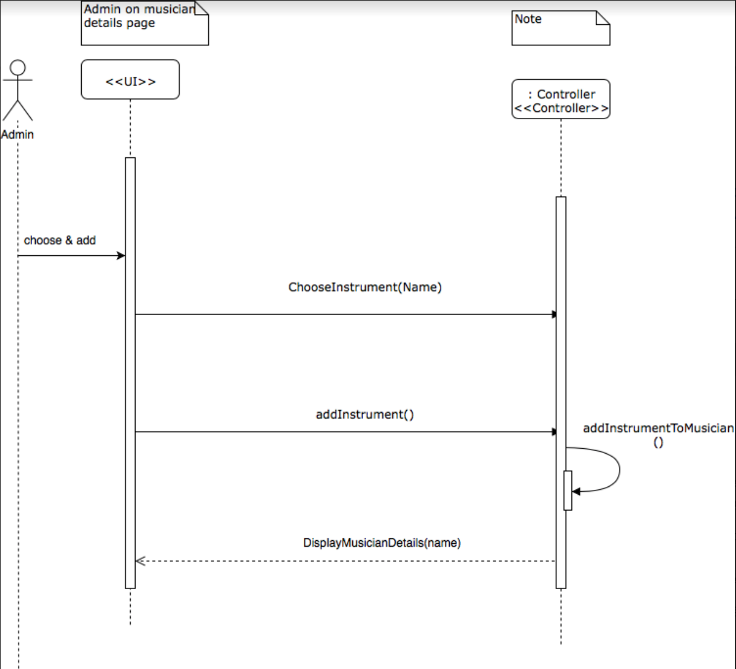

Number | 16
Name | Delete Instrument From Musician
Summary | Remove a selected instrument from a musician
Preconditions | Being on the details page of a musician, having logged in as admin, having selected an instrument in the list
Postconditions | The instrument has been removed from the musician
Primary actor(s) | Admin
Secondary actor(s) | Musician Class
Main Scenario | Step | Action
 | 1 | System displays confirmation window
 | 2 | User presses OK button
 | 3 | System deletes the instrument
 | 4 | System displays details page
Extensions | Step | Branching Action
 | 2a | User presses Cancel button
 | 2b | System displays details page

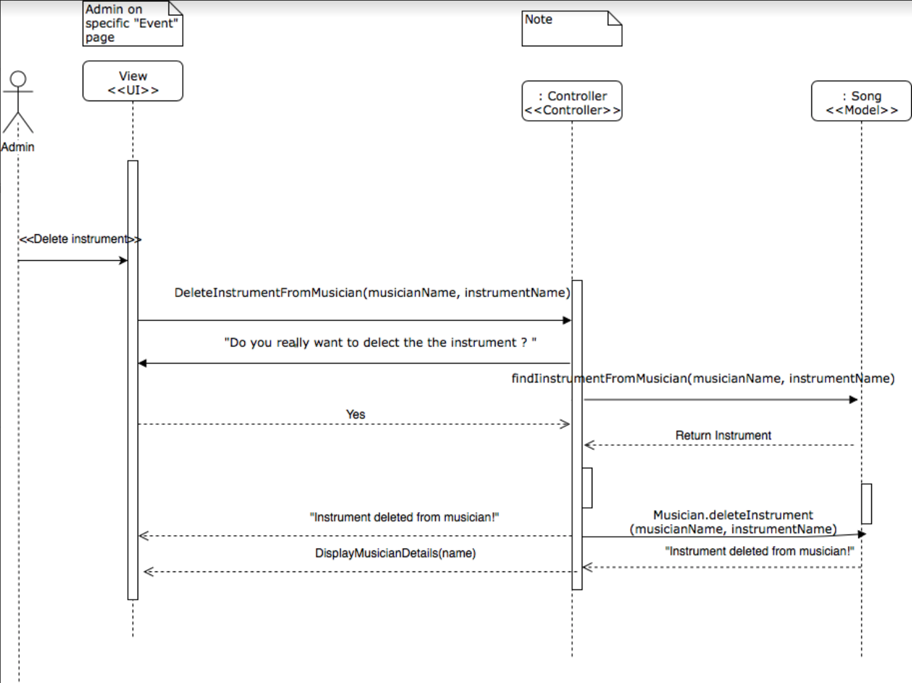

Number | 17
Name | Add Instrument
Summary | The admin enters the necessary information to add an instrument
Preconditions | Being on the Musicians&Instruments page, having logged in as admin
Postconditions | An instrument has been added
Primary actor(s) | Admin
Secondary actor(s) | Instrument Class
Main Scenario | Step | Action
 | 1 | System displays form
 | 2 | User fills form
 | 3 | User presses Save button
 | 4 | System saves the instrument
 | 5 | System displays Musician&Instruments page
Extensions | Step | Branching Action
 | 2a | User presses Cancel button
 | 2b | System displays Musicians&Instruments page
 | 3a | If the form has not been correctly filled, display error

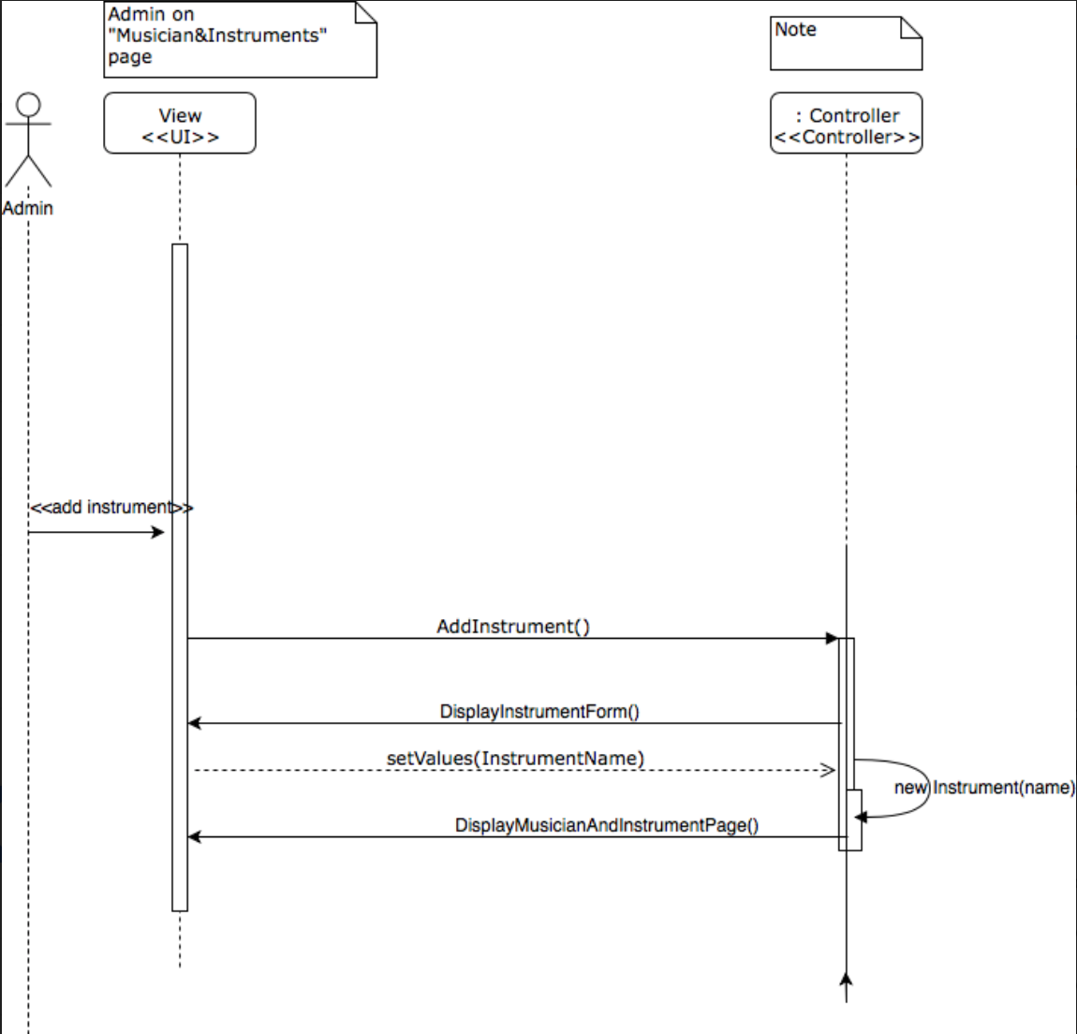

Number | 18
Name | Delete Instrument
Summary | Remove an instrument from the instruments list
Preconditions | Being on the Musicians&Intruments page, having logged in as admin, having selected an instrument
Postconditions | The instrument has been deleted
Primary actor(s) | Admin
Secondary actor(s) | Instrument Class
Main Scenario | Step | Action
 | 1 | System displays confirmation window
 | 2 | User presses OK button
 | 3 | System deletes the instrument
 | 4 | System displays Musicians&Intruments page
Extensions | Step | Branching Action
 | 2a | User presses Cancel button
 | 2b | System displays Musicians&Intruments page

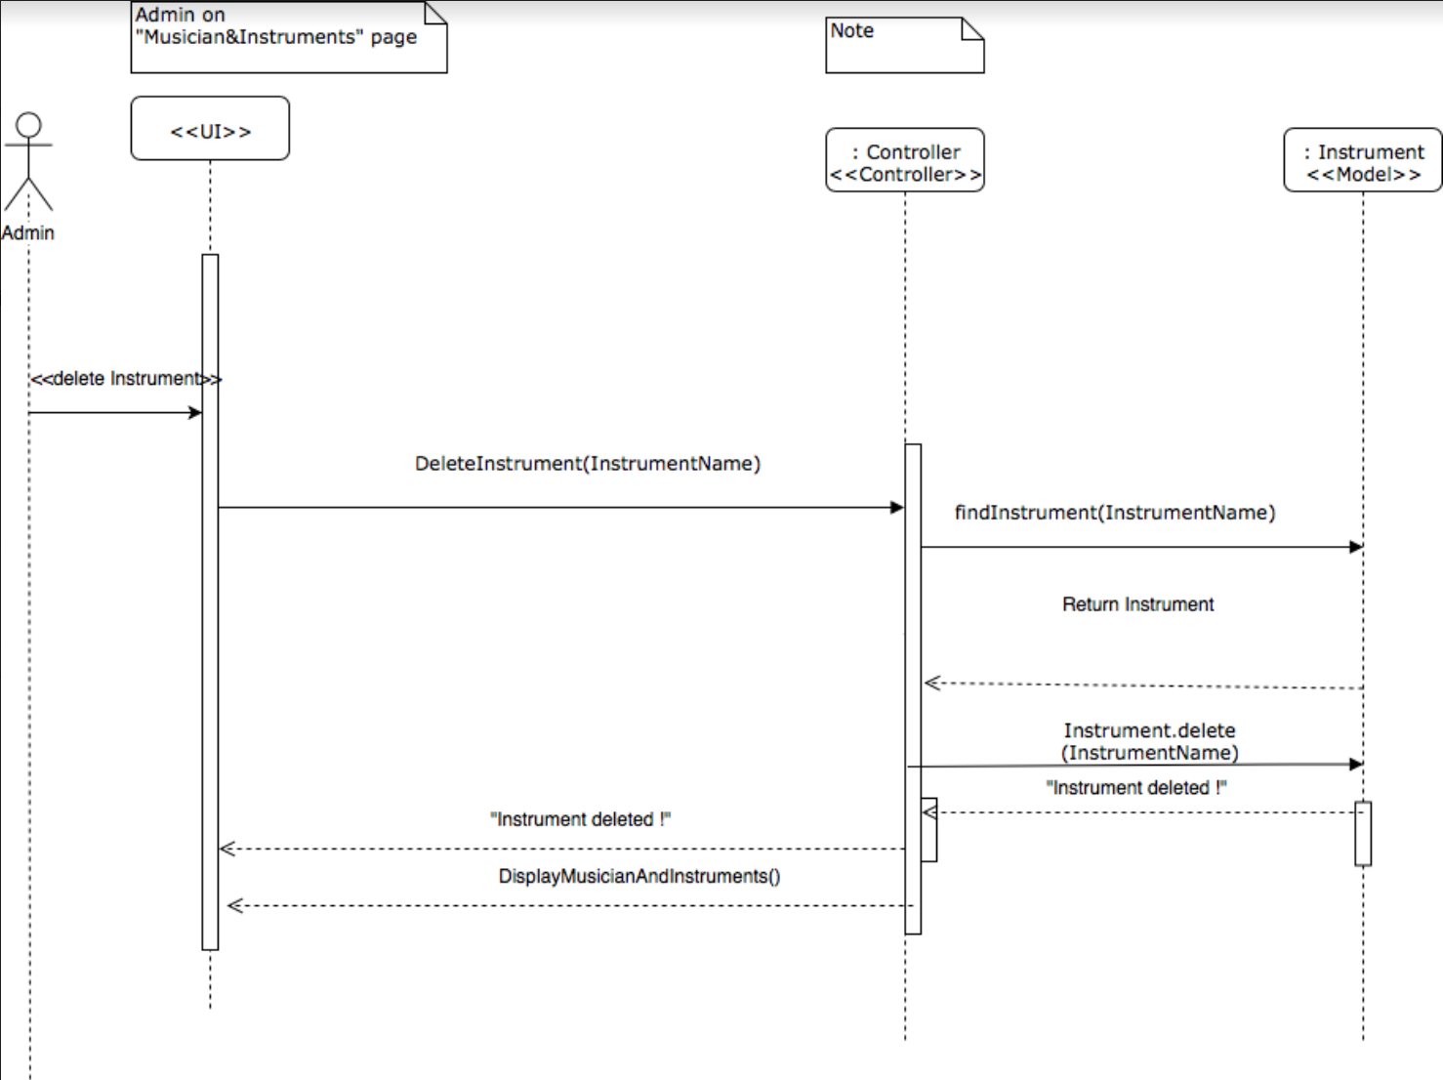

Mock-up

Homepage
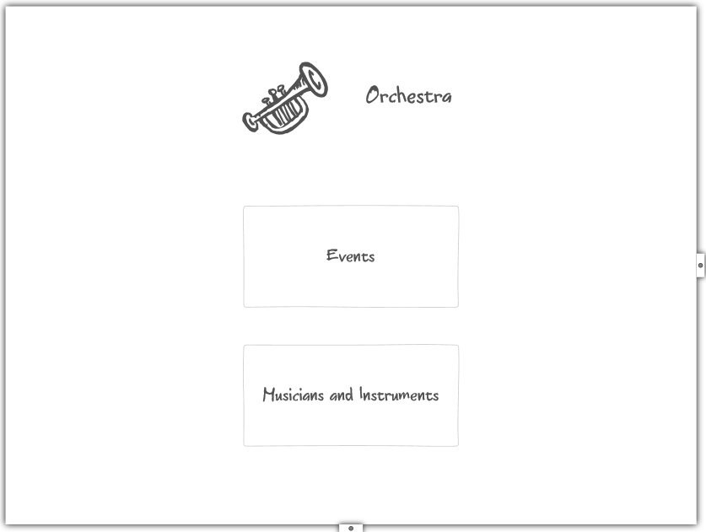

Musicians and Instruments
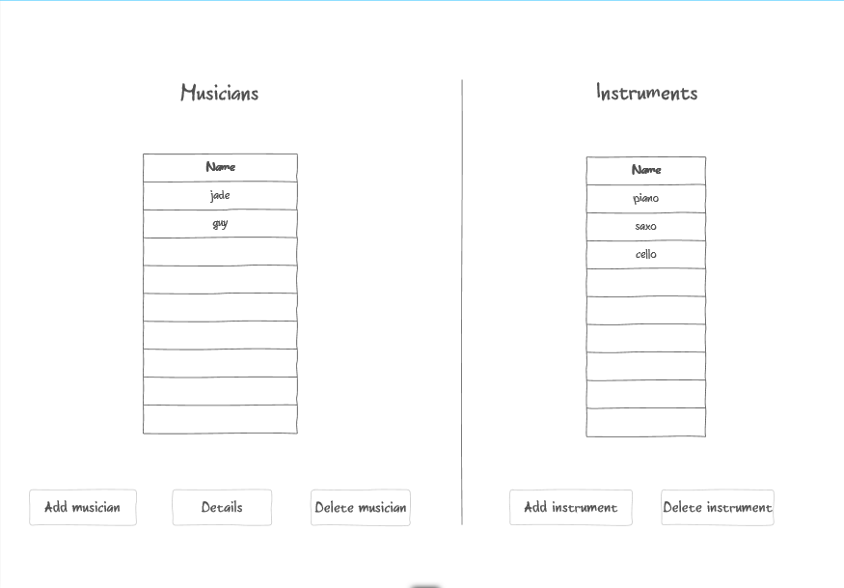

New/modify musician New instrument
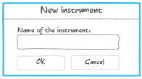
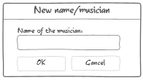

Musician details
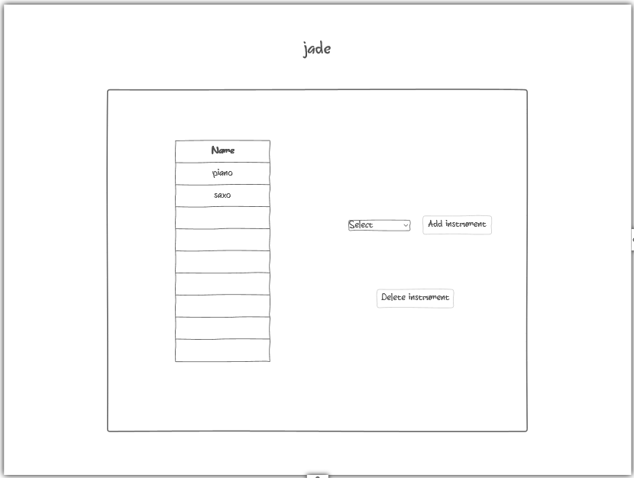

Events
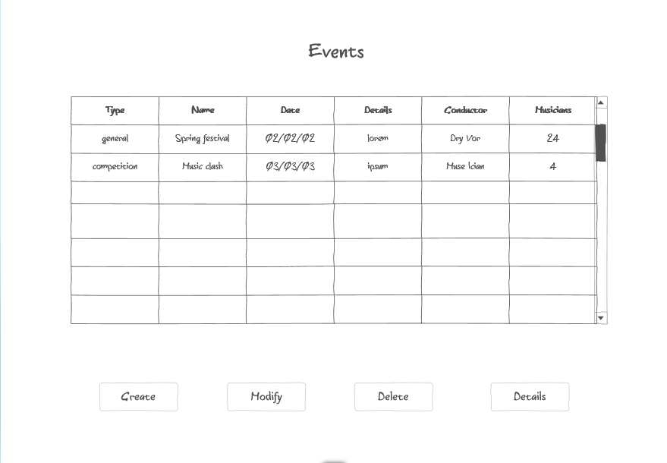

Create/modify event
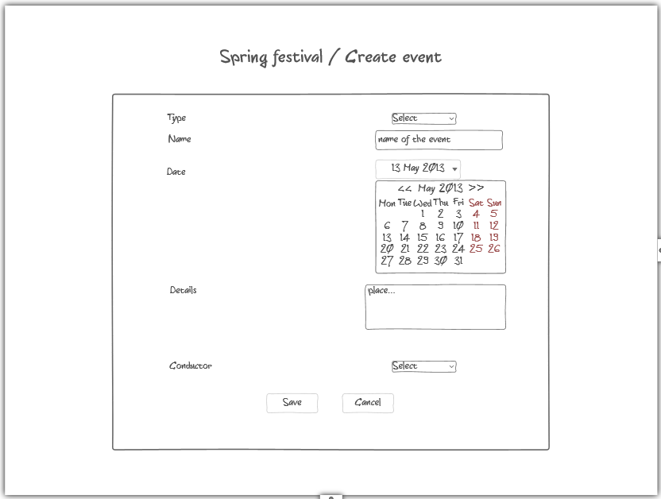

Event details
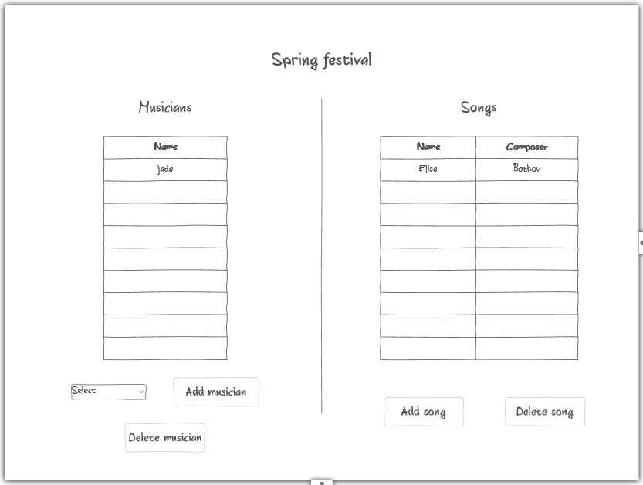

Add song
