Name: NGO TUNG CHUONG
ID: s225586848

YouTube: https://youtu.be/AL-NJk5-9SM?si=Ez_5_I7VazcqRneT
GitHub: https://github.com/NoXxChapter/SIT122---Robotics-Studio.git

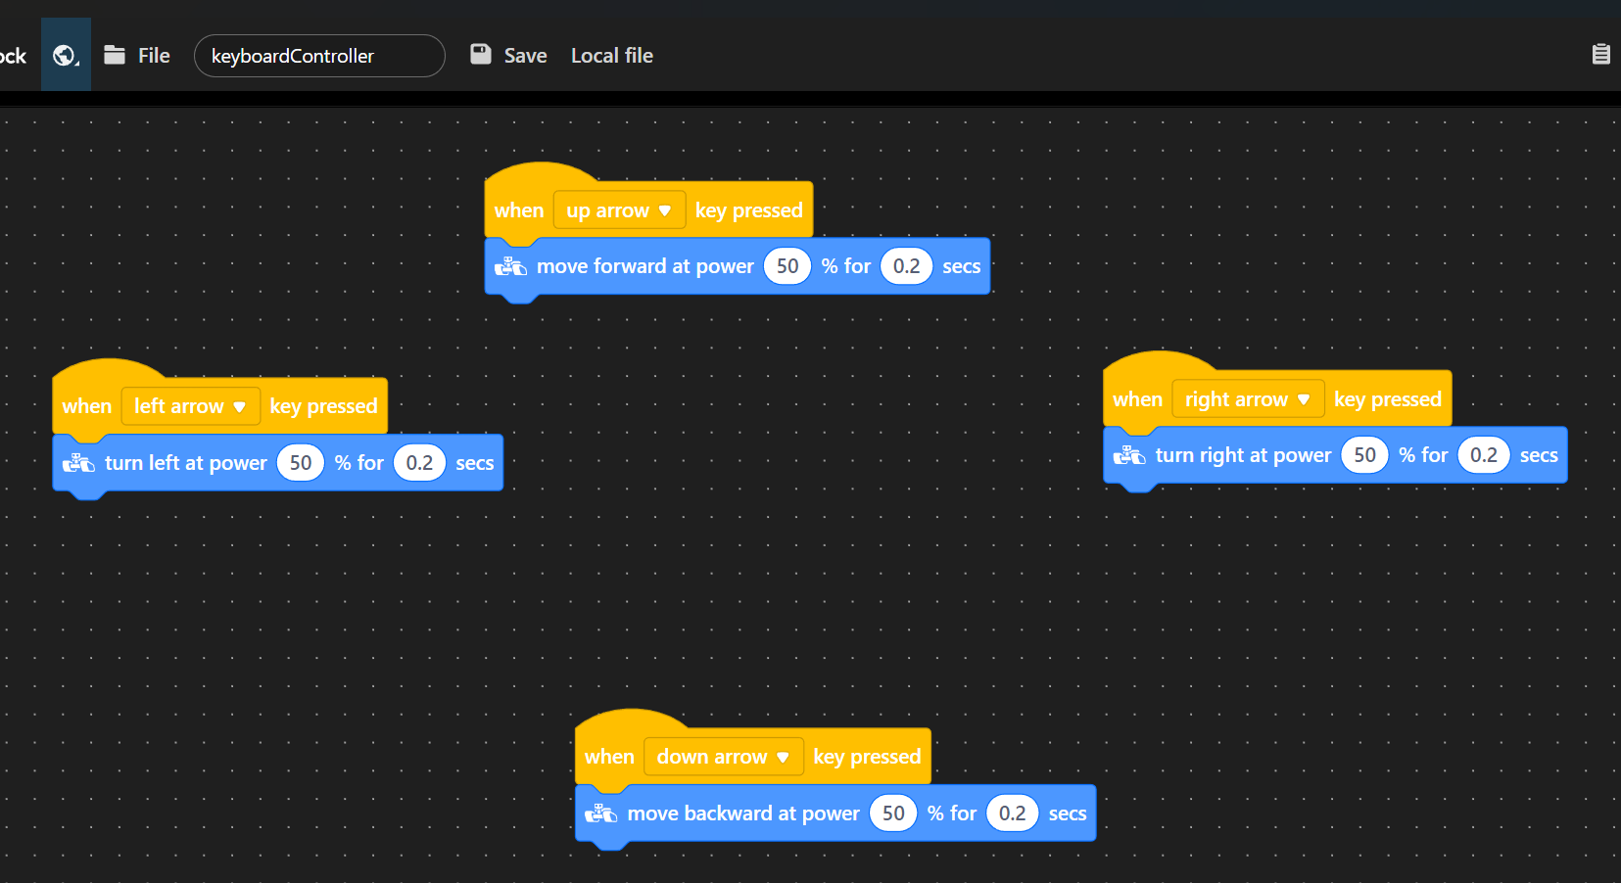
By pressing each respectively key, the RangerRobot move/turn at directed side for 0.2 sec. The reason for that 0.2 interval was to maintain the control on general. If it take too long, then the user cannot make the robot to move/turn at their want. The user have to wait til the interval is over, to make a next input. In case, user press the next key while the interval still active, it will cross on each other. Make the execute’s result not fully acquired.

