Name: NGO TUNG CHUONG
ID: s225586848

YouTube: rotation-100r/min
rotation-500r/min
square_1
square_2
GitHub: https://github.com/NoXxChapter/SIT122---Robotics-Studio.git

Encoder

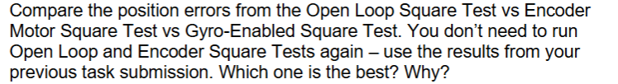
From my observed and experience hands-on. The Gyro-Enable gave a more accurate and smooth turn when compared to other two. I will not talk about Open Loop because it obviously the worst. But with remain two, it a difference story here. Encoder turn based on the calculate of geometric mathematic. By calculate the wheel’s radius, distance between two wheels along with the turning degree’s input. It gives us a general control of how to know when it turns to 90, 180, 360. But with Gyro-Enabled, it utilizes the hardware ability to know the coordinate of the current robot, by that we got a more accurate situation of robot at current to compare and calculate. Which result in far more accurate and impactful measurement.

