Name: NGO TUNG CHUONG
ID: s225586848
Githud : https://github.com/NoXxChapter/SIT210-730.git

Webhooks act as “HTTP callbacks” that allow one system to provide real-world data to another in near real-time. The general mechanism involves around a SOURCE (Adruino in this case) sending an HTTP POST request containing a data package to specific URL (The WEBHOOK endpoint). Different from traditional “polling” method, where a server constantly asks for updates. WEBHOOKs only push data when a specific trigger occurs. In real world, this is apply for instant PayPal payment notifications, syncing GitHud code repositories with server, or sending an alert when a sensor threshold is met,...etc…

In my implementation, the WEBHOOK mechanism is executed by the “ThingSpeak.writeFields(myChannelNumber, myWriteAPIKey)” call within the checkConnection() function. This specific line of code acts as the “upload call” that packages the “temperature” and “lux” variables into a URL-encoded payload. And then transmit it over the network to ThingSpeak’s API endpoint. “myWriteAPIKey” serves as the authentication handshake, ensuring the “Source” has permission to push data.

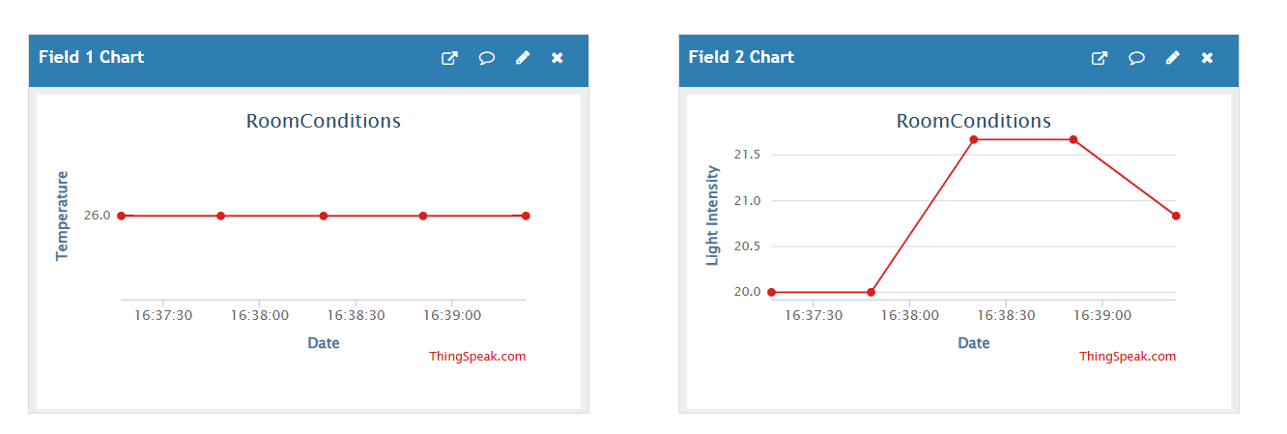
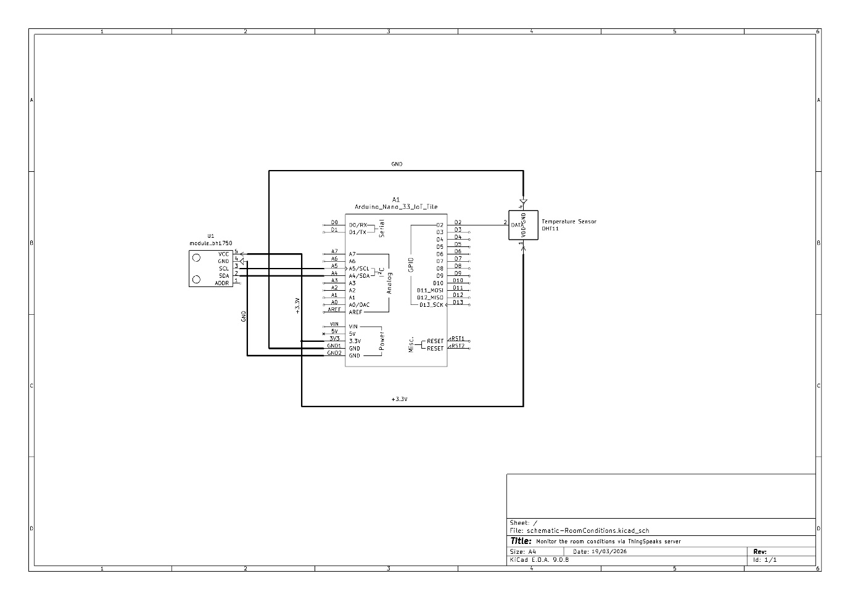
(I already sent this schematic on GitHud. Please check for more convenient.)
