Name: NGO TUNG CHUONG
ID: s225586848
GitHub: https://github.com/NoXxChapter/SIT221-DataStructure.git

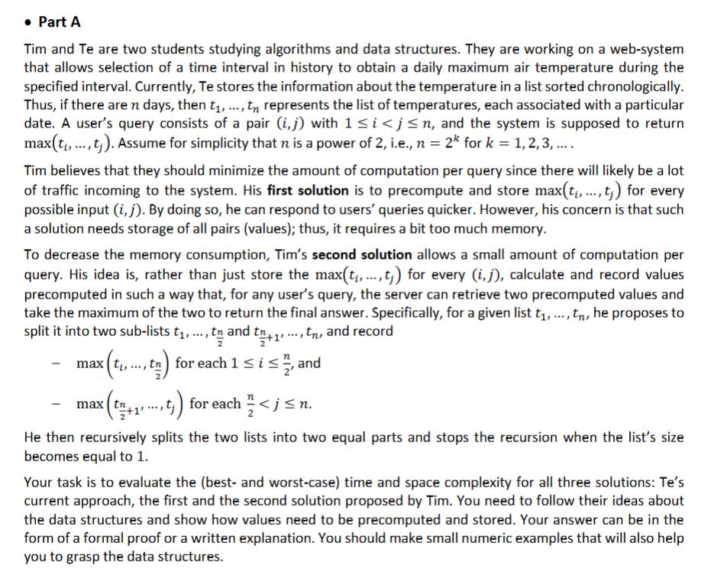
For this answer, I will set a list of temperature for 4 days following: [10, 25, 15 ,20]
1st case – Te’s solution:
This is a like a brute force way; Te keeps the temperature list chronologically. This is Te’s data:
$$\left[10, 25, 15, 20\right]$$
So, for the runtime complexity, when the user wants to ask the maximum temperature between day 1 and day 4. The system must look at each element in the array. From 10, then 25, then 15 and then 20.
In worst case scenario, it could take to $O\left(n\right)$ time. As the bigger the data, the longer it takes for computer to do. The best possible case here is that $i=j$(the range is only one day) then it takes only $O\left(1\right).$ And finally it takes up to $O(n)$ space to store all the data.
2nd case – Tim first’s solution:
Precomputation method – 2D array method. With this Tim can minimize the time it takes to compare when he stores all the answer already for every possible (i, j) pair. And so, this is how Tim stores his data (I will still prefer the data to the prepare example)
 | 1 | 2 | 3 | 4
1 | 10 | 25 | 25 | 25
2 | 25 | 25 | 25 | 25
3 | 25 | 25 | 15 | 20
4 | 25 | 25 | 20 | 20
So, for now, if the user wants the highest temperature from day 1 to day 2. He only needs to access $\left[1,2\right]→25$, it takes only $O\left(1\right).$ Because he simply looks up the answer in the table. But in contrast, since there are roughly $n^{2}$possible pairs of (i, j). The memory required grows very quickly as n increases, up to total $O\left(n^{2}\right).$

3rd case – Tim second’s solution:
The recursive split. Tim split the list into half $\left(1 to\frac{n}{2} and\frac{n}{2}+1 to n\right)$. For the left half, Tim stores the max from every i up to the center. Meanwhile, for the right half, Tim stores the max from the center out to every j. He repeats it recursively until the list size is 1. With this Tim only take $O(1)$ time to look for the answer always take exactly two lookups and one comparison. But because the list is split in half recursively until the size is 1. Since $n=2^{k}$here are $\log{n }$levels of recursion. And at each level, Tim records values for n position. So, it takes up to $O(n∙logn)$ space.
So, for sample, the user wants the data from day 1 till day 3.
 | 1 | 2 | 3 | 4
 | 10 | 25 | 15 | 20
1st split (split between 2 and 3) | 25 | 25 | 15
2nd split (split between 1 and 2, 3 and 4) | 10 | 25 | 15
Final compare (2 and 3) | 10 | 25 | 25

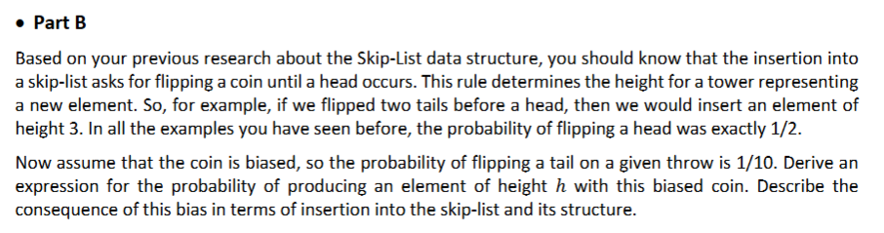
So based on the biased given, we got the probability of TAIL throw if $\frac{1}{10}.$ That mean, HEAD throw = $1-\frac{1}{10}=\frac{9}{10}$. Now we do a math; to reach each height we have to get those following results.
Height | Tail throw | Head throw | Probability
1 | 0 | 1 | $$P(H)$$
2 | 1 | 1 | $$P(T)∙P(H)$$
3 | 2 | 1 | $$P(T)∙P(T)∙P(H)$$
…. | … | … | …
$$n$$ | $$n-1$$ | 1 | $$P({T)}^{n-1}∙P(H)$$

So, the expression for the probability of height is $P\left(h\right)=P({T)}^{n-1}∙P(H)$
So, if the coin has been biased like that it would give some consequences. With the insertion, it would likely cause the short tower effect which the coin will likely result in a Head on the very first flip most of the time. So very few elements will ever reach higher levels. In the end, the skip-list will look "flat” and very few nodes would make in through the upper express lanes.
In the performance, insertion and search most likely searching for an element will require scanning through nearly every node in the bottom layer. Since there are almost no "express lanes" to skip over nodes. Instead of the ideal $O\left(logn\right)$ search time, the performance will drift closer to $O\left(n\right),$similar to a standard linked list. But the insertion process would be must faster cause the act of flipping the coin is faster (we stop sooner).

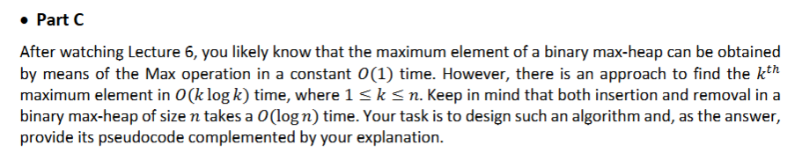
Input: A binary max-heap 'OriginalHeap' of size n, and an integer k
Output: The kth maximum element

Pseudocode FindKthMax(OriginalHeap, k):

If k > n or k <= 0: return Error

// Create a temporary heap to store (value, original_index)
tempHeap = new MaxHeap()

// insert the root of the original heap
tempHeap.insert(OriginalHeap[root].value, OriginalHeap[root].index)

For i from 1 to k-1:
// get the current maximum from the temp list
currentMax = tempHeap.extractMax()

// find the children of this element in the original heap
leftChild = getLeftChild(OriginalHeap, currentMax.index)
rightChild = getRightChild(OriginalHeap, currentMax.index)

// add the children as new candidates for the next largest value
// we pick left first because leftChild > rightChild
If leftChild exists:
tempHeap.insert(leftChild.value, leftChild.index)
If rightChild exists:
tempHeap.insert(rightChild.value, rightChild.index)

// the k-th element extracted is the answer
Return tempHeap.extractMax().value
With this method, by utilize the temporary heap we can explore from the root the the kth node. And how it took $O\left(k∙logk\right)$because first we perform k iterations. And in each iteration, we do 1 extractMax and up to 2 insert operations on the temp heap. The size of the temp heap never exceeds 2k (because we add 2 children but remove 1 parent each time). Since insertion and removal in a heap take $O\left(\log{n}\right)$, with n is size of heap by then each step takes $O(\log{k)}$. So total time is $k∙O\left(logk\right)=O(k∙logk)$. And because we are not modifying or removing elements from the original heap. We only perform lookups O(1) and work within our smaller temp heap, which depends on k, not n. So, it not an $O\left(k∙logn\right)$ this time.

