NAME:
MOAL Noa
SAUNOIS Laura
Installation and User Instructions
Retro Development Station
Raspberry PI 3
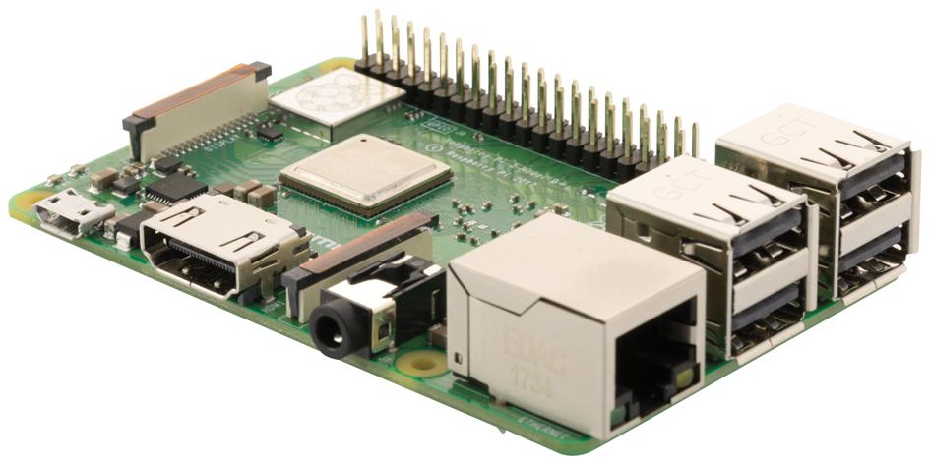


Month 2025
SAE 1.03

Approvals
This document requires following approvals:
Name | Title
Mr. JP. Farrugia
Mr. C. Boullard
Miss A.Daumas

Distribution
This document has been distributed to:
Name | Title
Mr. JP. Farrugia
Mr. C. Boullard
Miss A.Daumas

Table of Contents
1 PREFACE 4
1.1 Description of the User 4
1.2 Conventions Used in This Manual 4
2 DESCRIPTION OF THE PRODUCT 5
2.1 Purpose of the Product 5
2.2 Key features of the product 5
2.3 Accessories 5
2.4 Product elements 5
2.5 Understanding the user interface 5
2.6 Operating Panels 5
3 SAFETY INSTRUCTIONS 6
3.1 How to Use the Product Safely 6
4 INSTALLATION / PACKAGES 7
4.1 STEP 1 7
4.1.1 Procedures for step 1 7
4.2 STEP 2 7
4.2.1 Procedures for step 2 7
5 OPERATION/USE 8
5.1 How to Use the Product 8
5.1.1 Operational environment 8
5.1.2 Manual operating techniques 8
5.1.3 Stopping the product’s operation 8
5.2 What to Do in Emergency and Exceptional Situations 8
6 TROUBLESHOOTING AND REPAIR 9
6.1 How to Identify and Solve Problems 9
7 GLOSSARY 10
8 RELATED DOCUMENTATION 11

PREFACE

Description of the User

User Type
There are 3 unique types of users:
- Installer: Make the initial installation on the RPi3 like: OS flashing, update the system, install development tools (Git, cmake, build-essential…)
- Operator: Execute the configuration commands (./configure, make), handle the development environment (VSCode) and run the final program (retroarch)
- Developer: Make programs in C (and if needed in LUA/C++), test and include the personalized libretro core

Prerequisite and skills needed
This product is designed for skilled users:
Skills needed | Skill level | Project-based Justification
Linux /OS | Intermediate to advanced | Need terminal access, packets management (apt) and understanding of access paths and permissions (sudo)
C programming | Advanced | This product need coding a mini game and create a libretro core, wich implies low-level callbacks management, memory usage and data structures
Compilation/Builds system | Advanced | Need to understand the usage of make, cmake, the meaning of the configuration flags (./configure --disable-vulkan) et the cross-compilation process (implies ARM)
Software Architecture | intermediate | Need to understand the concept of Frontend (RetroArch) and Modular API (libretro) to integrate the code correctly.

Restrictions on Use

- Permitted User: Only the Technician-Developer with the skills and training described above.
- Non-Permitted User: Non-technical end users, inexperienced operators, or anyone without a solid foundation in C programming and Linux administration. Executing system commands (sudo) and compiling code from external sources requires a good understanding of the risks involved.
- Certification or Specific Training: No formal certification is required, but the user must have expertise or equivalent training in Low-Level Software Development or Embedded Systems.

Conventions Used in This Manual
The following style conventions are used in this document:
Bold
Names of product elements, commands, options, programs, processes, services, and utilities Names of interface elements (such windows, dialog boxes, buttons, fields, and menus)
Interface elements the user selects, clicks, presses, or types
Italic
Publication titles referenced in text
Emphasis (for example a new term)
Variables
Courier
System output, such as an error message or script
URLs, complete paths, filenames, prompts, and syntax
User input variables
< > Angle brackets surround user-supplied values
[ ] Square brackets surround optional items
| Vertical bar indicates alternate selections - the bar means “or”

DESCRIPTION OF THE PRODUCT

Purpose of the Product
[Introduce the product and its purpose]

Key features of the product
[Introduce the features of the product]

Accessories
[Introduce the accessories, if any]

Product elements
[Product image with callouts at main elements / captioned schema]
- Element A
- Element B
- Element C
- …

Understanding the user interface
[Provide an explanation of the user interface]

Operating Panels
[Provide an explanation of all operating panels]

SAFETY INSTRUCTIONS
WARNING!

How to Use the Product Safely
[State what the user must pay attention to, if any]

INSTALLATION / PACKAGES

STEP 1
[Provide conceptual information when it is necessary for an adequate understanding and execution of tasks]

Procedures for step 1
[Follow the examples thereafter]
To install SUBELEMENT 1A:
- Do this.
- Complete an action.
- Push the button.
- Select a value.
ILLUSTRATION or SCREEN CAPTURE
- Close the ELEMENT B.
- Do that.

STEP 2
[Provide conceptual information when it is necessary for an adequate understanding and execution of tasks]

Procedures for step 2
[Follow the examples thereafter]
To install SUBELEMENT 1B:
- Do this.
- Complete an action.
- Push the button.

OPERATION/USE

How to Use the Product

Operational environment
[Explain the necessary environment to use the product]

Manual operating techniques
[List the steps to make the product work]
- Do this.
- Complete an action.
- Push the button.

Stopping the product’s operation
[Explain the different steps to stop the operation]
- Do this.
- Complete an action.
- Push the button.

What to Do in Emergency and Exceptional Situations
In case of an emergency:
[Follow the examples thereafter]
- Do this.
- Complete an action.
- Do that.

TROUBLESHOOTING AND REPAIR

How to Identify and Solve Problems
[Complete the following grid]
WARNING:
Error | Cause | Solution
Product does not start | Part A is broken | Replace part A.
… | … | …

GLOSSARY
[Explain the meaning of all terms used in this document]
Term | Meaning

RELATED DOCUMENTATION
[Quote the documentations or papers you used for this product]
# | Document Title | Version # | Location | Author

