Please note: this repository contains only the main entry function of the pipeline. In this overview, I walk through that function and the major components of the full workflow to reflect the process, logic, and tools I worked with. The full proprietary pipeline cannot be shared.

General minion_cluster_search Pipeline Overview

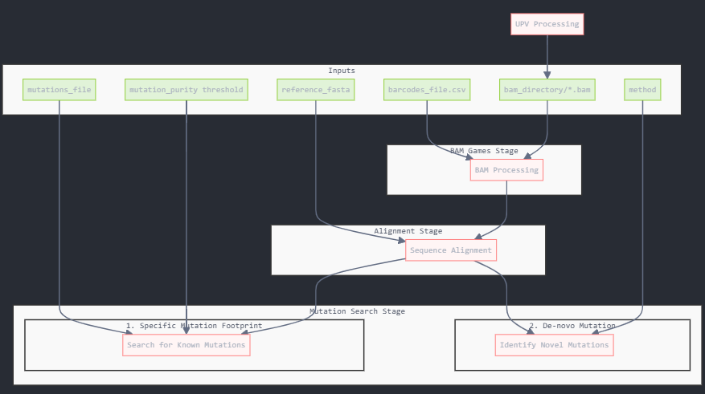
This pipeline takes specific inputs, and splits the minion reads by a common signature. This can either be performed with a pre-known mutation footprint (split_by_signature), or to look for de-novo signatures (split_denovo).
The complete pipeline processes BAM files through three sequential stages: BAM processing, sequence alignment, and mutation search. It handles multiple samples in parallel, creating organized output directories for each processing stage. Each of the pipeline stages can also be run independently.
This is a general overview of the complete pipeline’s main concepts, and of each of its three components.
Environment: mcs.yml
Code location: …/minion_cluster_search.py
Using: minion_cluster_search/scipts/minion_cluster_search.py

Bam games
Using: /minion_cluster_search/scipts/process_bam_data.py
This code processes BAM files and determines which reads map to which references through a tailored, multi-step filtering and decision pipeline. Each stage includes visualizations that document intermediate results and provide transparency into the data (and all is written in a log).

Alignment
Using: minion_cluster_search/scipts/batch_align_augur.py
Performs parallel sequence alignment using Augur. It handles large FASTA files by splitting them into smaller batches, processing them in parallel, and combining the results into a single output (and logged, of course).

Mutation Search

Split_by_signature
Using: minion_cluster_search/scipts/fasta_mutation_selector.py
Filters FASTA sequences based on specified mutations. It analyzes aligned sequences to identify those containing a desired set of mutations at specific positions, with configurable mutation purity threshold. The output includes visualizations (distribution, cumulative, depth), filtered sequences with/out the mutation, and a detailed statistics and analysis results log.
Important! Each of the input parameters for the functions used within this function are also easily adjustable; for example the min_frequency in the consensus function create_consensus_from_fasta.

Split_denovo
Using: minion_cluster_search/scipts/denovo_clustering_pipeline.py
This sub-pipeline analyzes viral quasispecies by converting FASTA sequences into numeric feature matrices, performing quality checks, filtering low-information reads, and computing pairwise genetic distance matrices for downstream clustering. It supports multiple clustering approaches (Spectral, Hierarchical Phylogenetic, and QuasiSeq) and allows running a single method or comparing all methods, with the split_denovo module recommending the most suitable clustering strategy for the input data. The workflow includes feature extraction, entropy and gap analysis, adaptive position filtering, and distance-based modeling followed by PCoA, dendrogram, and heatmap visualizations. All steps are fully logged for reproducibility.

