# Project Title:
Reserve Family Health and Wellbeing Study
# Short Description:
This study focuses on the mental wellbeing of the army reserves families, during the October 7th war by analysing tabular questionnaire data collected through validated psychological and psychiatric scales. The dataset includes participant responses, demographic variables, and composite scores representing constructs such as coping strategies, trauma exposure, and psychological well-being.

**Status:** Active Development (Work in Progress)
Note: in-code paths are demonstrational

# Completed:
- Data collection and integration
- Data cleaning, harmonization, and quality control
- Exploratory data analysis and visualization
- Feature engineering
- Preliminary statistical analysis
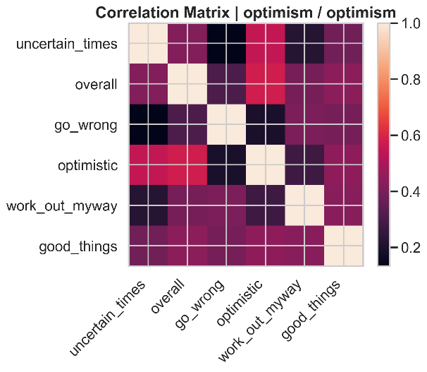
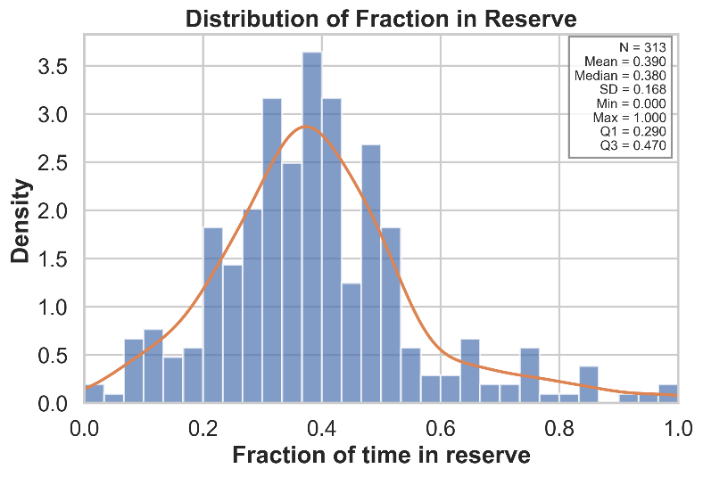

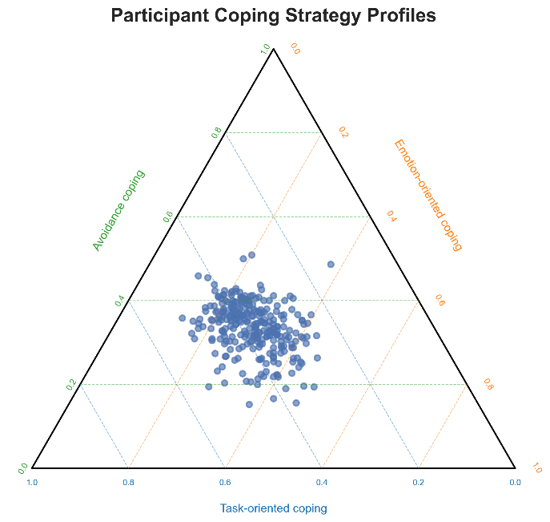
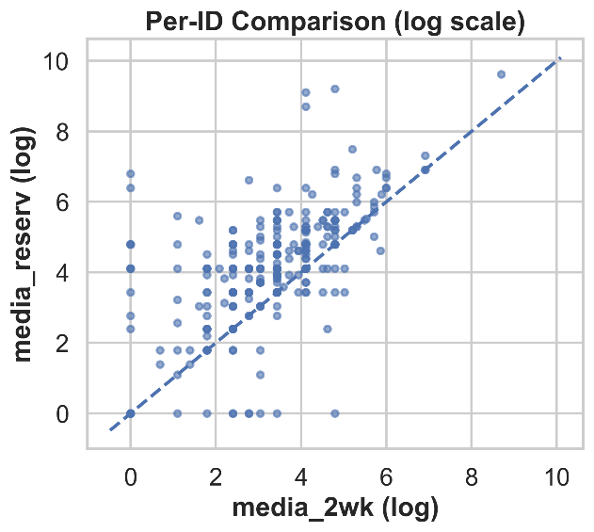

# Currently Working On (and not included here):
- Missing data and imputation
- Model development and benchmarking

# Planned Next Steps:
- Model evaluation
- Error analysis
- Deployment and visualization

Note: these files are not in their

