  

**Bugesera AgroHydro Explorer:**

**A Geospatial Decision-Support Tool for**

**Season C Agriculture**

**A submission for the 2025 Big Data Hackathon**

**Track 4: GIS Innovative Challenge**

**Submitted by:**

**NDACYAYISENGA Noa**

**From:**

**University of Rwanda (Fresh graduate)**

**College of Agriculture Animal science and Veterinary Medicine (CAVM)**

**Submission date:**

# Declaration & Originality Statement

**Declarations**  
I hereby declare that this report and the accompanying code are my original work. All external sources, data, and references have been properly acknowledged. This submission has been prepared exclusively for the 2025 Big Data Hackathon organized by the National Institute of Statistics of Rwanda (NISR).

**Originality Statement**  
I confirm that the content presented here has not been submitted for any other academic or professional purpose and represents my authentic work.

**Signed by:**

NDACYAYIESENGA Noa

**Signature:**

**Date:** Acknowledgments

I would like to express my sincere gratitude to the National Institute of Statistics of Rwanda (NISR) for organizing the 2025 Big Data Hackathon, providing an excellent platform to apply geospatial and data science skills to real-world agricultural challenges.

I also wish to acknowledge the support and guidance of the Center of Geographic Information Systems (CGIS), University of Rwanda, for their valuable mentorship and technical resources that contributed significantly to this project.

Finally, I appreciate the support of dataset providers, colleagues, and the developers behind tools and platforms such as Google Earth Engine (GEE) and other open-source GIS resources, which made this work possible.

# Abstract / Executive Summary

The Bugesera AgroHydro Explorer is a geospatial decision-support tool developed to enhance irrigation planning and agricultural survey design for Season C agriculture in Bugesera District, Rwanda. Agriculture remains a critical sector of Rwanda’s economy, yet effective planning for Season C crops is constrained by limited knowledge of suitable areas, water availability, and irrigation potential. To address these challenges, this project integrates multiple geospatial datasets—including Global Surface Water (GSW), Digital Elevation Model (DEM), Land Surface Temperature (LST), and river networks—using Google Earth Engine (GEE). A multi-criteria weighted overlay approach was applied to generate a five-class irrigation suitability map, ranging from permanently not suitable to highly suitable zones. Based on this classification, a stratified spatial sampling frame was constructed to support representative agricultural surveys.

The outputs include a detailed irrigation suitability map of Bugesera District, an interactive GIS dashboard that allows users to visualize and toggle layers, query point suitability, and export survey points, and a spatially representative sampling frame to facilitate evidence-based agricultural data collection. This tool addresses critical gaps in Rwanda’s agricultural planning by providing a scalable, data-driven, and user-friendly platform for irrigation management and survey design. By integrating remote sensing, geospatial analysis, and big data techniques, the Bugesera AgroHydro Explorer supports informed policy-making, efficient resource allocation, and improved food security planning, demonstrating the potential of geospatial decision-support systems to enhance sustainable agricultural development in Rwanda.

Contents

Declaration & Originality Statement i

Acknowledgments ii

Abstract / Executive Summary iii

LIST OF FIGURE vii

LIST OF TABLE viii

ACRONMY ix

Chapter 1: Introduction 1

1.1 Background 1

1.2 Problem Statement 1

1.3 Objectives 2

1.4 Research Questions 4

**1.5 Expected Outcomes** 4

1.6 Justification and Relevance 4

Chapter 2: Literature Review 5

2.1 Agriculture and Season C in Rwanda 5

2.2 Use of GIS in Agricultural Decision-Making 6

2.3 Spatial Sampling and Agricultural Surveys 6

2.4 Big Data and Decision-Support Systems in Agriculture 7

2.5 Research Gap 7

Chapter 3: Methodology 8

3.1 Study Area 8

3.2 Data Sources 8

3.3 Data Preprocessing 9

3.4 Suitability Analysis 9

3.5 Sampling Frame Design 10

3.6 Interactive Decision-Support Tool 11

Chapter 4: Results and Discussion 12

4.1 Water Resources Dynamics 12

4.2 Land Surface Temperature (LST) Patterns 12

4.3 Irrigation Suitability Classification 13

4.4 Survey Sampling Frame 16

4.5 Interactive Decision-Support Tool 16

4.6 Discussion of Findings 16

Chapter 5: Conclusion and Recommendations 17

5.1 Conclusion 17

5.2 Recommendations 18

REFERENCES 19

APPENDICES 20

# List of figures

*Figure 1: Conceptual framework of Bugesera AgroHydro Explorer* 3

*Figure 2: Distribution of wetlands and irrigated lowlands in Rwanda, highlighting Bugesera* 5

*Figure 3: Geographical location of Bugesera District and their Water bodies* 8

*Figure 4: Spatial Distribution of Survey Sample Points across Bugesera* 10

*Figure 5: Bugesera AgroHydro Explorer Dashboard Interface* 11

*Figure 6: Water Occurrence in 2017 and Estimated Water in 2024* 12

*Figure 7: Irrigation Suitability Map (5-class classification)* 13

*Figure 8: Proportional Distribution of Irrigation Suitability Classes in Bugesera (2024 Season C)* 14

# List of tables

*Table 1: Comparison between administrative and geospatial stratified sampling frames* 7

*Table 2: Summary of the datasets used in Bugesera AgroHydro Explorer* 9

*Table 3: Distribution of Sample Points by Suitability Class* 10

*Table 4: Area Coverage by Suitability Class* 14

# Acronyms

C

Comma Separated Values

(CSV), 4

D

**Digital Elevation Model**

(DEM), 8

E

Earth Observation

(EO), 1

G

Geographical Information System

(GIS), 2

**Global Surface Water**

(GSW), 8

Google Earth Engine

(GEE), 8

Gross Domestic Product

(GDP), 1

L

Land surface temperature

(LST), 1

R

Remote Sensing

(RS), 6

# Chapter 1: Introduction

## 1.1 Background

Agriculture is the backbone of Rwanda’s economy, contributing more than 25% of national GDP and employing approximately 70% of the labor force (MINAGRI, 2023). With increasing population pressure, land scarcity, and climate variability, there is an urgent need to maximize agricultural productivity through improved planning and data-driven decision-making.

In Rwanda, farming is organized around three agricultural seasons: Season A (September–January), Season B (February–June), and Season C (June–September). Season C is particularly important in wetlands and irrigated lowlands, offering a strategic opportunity to enhance food security and resilience against droughts (NISR, 2023). However, this season is constrained by limited knowledge of suitable areas, water availability, and irrigation potential.

Recent advances in geospatial technologies and Earth Observation (EO) data offer powerful tools to identify, map, and monitor agricultural potential. By integrating land surface temperature (LST), hydrological networks, slope, and historical water occurrence, decision-makers can create spatial sampling frames to guide surveys and investments in irrigation.

## 1.2 Problem Statement

Agricultural data collection in Rwanda has long relied on administrative boundaries and farmer registers. While useful, these methods are limited in capturing the spatial variability of agricultural potential, particularly in wetlands that are crucial for Season C crop production. This reliance on traditional approaches makes it difficult to accurately assess the conditions that influence land suitability, creating challenges for planners and policymakers in making informed agricultural decisions.

The central issue is the lack of a standardized geospatial framework that integrates key environmental factors such as slope, proximity to rivers, temperature, and water dynamics into a comprehensive suitability model. Without this framework, irrigation investments are often inefficiently targeted, survey sampling frames remain less reliable, and opportunities to maximize agricultural productivity in Bugesera District—a nationally important wetlands region—are frequently missed. Addressing this gap is vital for improving evidence-based planning and ensuring that resources are allocated where they can have the greatest impact.

## 1.3 Objectives

The overall objective of this project is to design and implement a GIS-based AgroHydro Explorer that supports irrigation planning and agricultural survey data collection in Bugesera District.

**Specific Objectives:**

1. To integrate multi-source geospatial datasets (DEM, LST, river networks, water occurrence) into a unified decision-support tool.
2. To generate an irrigation suitability map classified into five levels (from permanently not suitable to highly suitable).
3. To construct a stratified spatial sampling frame for Season C agricultural surveys.
4. To develop an interactive GIS dashboard enabling users to visualize suitability, toggle layers, export survey frames, and test point suitability.

## 1.4 Research Questions

This project seeks to answer the following questions:

* Which areas in Bugesera District have the highest potential for Season C agricultural production?
* How can irrigation suitability be mapped using slope, river proximity, and LST as indicators?
* What is the most efficient way to create a **geospatially representative survey sampling frame**?
* How can the tool be scaled to inform policy and decision-making at national level?

**1.5 Expected Outcomes**

The expected outputs of this study are:

1. **A five-class irrigation suitability map** of Bugesera District.
2. **An interactive geospatial tool (AgroHydro Explorer)** deployed on Google Earth Engine, with user-friendly interface (layer toggling, legends, export functions).
3. **A spatial sampling frame** with stratified points, exportable as CSV for survey teams.
4. Documentation and policy recommendations to strengthen **evidence-based agricultural planning** in Rwanda.

## 1.6 Justification and Relevance

This work directly addresses the Track 4: GIS Innovative Challenge of the 2025 NISR Big Data Hackathon. It provides a scalable, data-driven solution for agricultural survey data collection and planning. The project contributes to:

* **Evidence-based policymaking** by providing spatially explicit survey frames.
* **Food security and climate resilience** through efficient use of wetlands in Season C.
* **Capacity building** in data science and geospatial technologies for agriculture.
* Alignment with **Rwanda’s NST1/NST2 priorities** on innovation, agricultural transformation, and digital governance.

# Chapter 2: Literature Review

## 2.1 Agriculture and Season C in Rwanda

Agriculture is central to Rwanda’s development strategy, with wetlands serving as critical resources for food production, particularly during Season C (June–September). Season C relies on controlled water management in marshlands and irrigated lowlands, enabling continuous cultivation despite dry climatic conditions (MINAGRI, 2023).

Bugesera District, characterized by extensive wetlands and water bodies, has been recognized as a priority zone for Season C agricultural production (NISR, 2023). However, unsustainable farming practices, climate variability, and limited irrigation infrastructure constrain its potential.

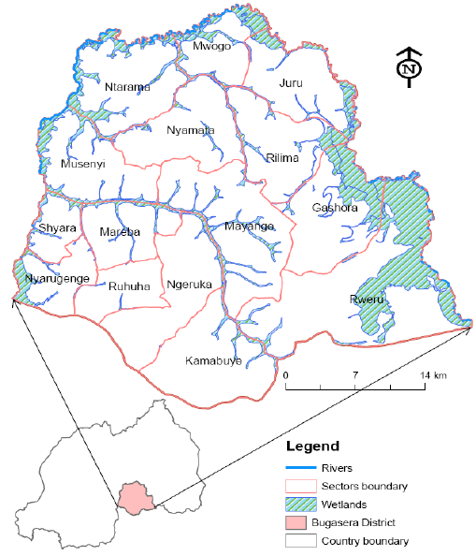

Figure 1: Distribution of wetlands and irrigated lowlands in Rwanda, highlighting Bugesera

## 2.2 Use of GIS in Agricultural Decision-Making

Globally, Geographic Information Systems (GIS) and Remote Sensing (RS) have transformed agricultural planning by enabling the integration of multiple datasets for evidence-based decision-making. Studies show that GIS can be applied to identify suitable cropping zones through land suitability modeling (FAO, 2021) to monitor land cover and irrigation dynamics across seasons (Jensen & Cowen, 1999), and to incorporate environmental factors such as soil type, slope, and temperature into comprehensive suitability frameworks (Malczewski, 2004).

In East Africa, researchers have successfully used GIS to evaluate irrigation potential in Uganda, Kenya, and Tanzania, demonstrating the benefits of combining hydrological, climatic, and topographic datasets to support agricultural planning (Kihoro et al., 2013). Despite these regional advances, Rwanda still lack integrated, open-access GIS tools specifically designed for agricultural survey design and irrigation suitability analysis, particularly for wetlands and Season C farming.

## 2.3 Spatial Sampling and Agricultural Surveys

Survey sampling frames are essential for producing reliable agricultural statistics. Traditional approaches in Rwanda are often administrative-boundary-based, which may not reflect the heterogeneous nature of agricultural potential (NISR, 2022).

Spatially stratified sampling, which divides a study area into strata based on environmental or suitability classes, has been shown to improve representativeness of collected data (De Gruijter et al., 2006), increase cost-efficiency of survey operations (Brus & Gruijter, 1997), and enhance data quality for agricultural statistics (FAO, 2019). Integrating stratified random sampling with GIS ensures that surveys capture variability across suitability levels, producing datasets that are more robust for policymaking and planning.

Table 1: Comparison between administrative and geospatial stratified sampling frames

|  |  |  |
| --- | --- | --- |
| **Criteria** | **Administrative-Boundary Sampling** | **Geospatial Stratified Sampling** |
| **Basis of Sampling** | Districts, sectors, or cells (political/administrative) | Environmental and suitability classes (slope, rivers, LST) |
| **Representation** | May not capture agro-ecological diversity | Ensures coverage of diverse ecological and biophysical zones |
| **Bias Risk** | Higher, due to reliance on human-defined boundaries | Lower, since strata are defined by natural/agro-ecological factors |
| **Accuracy of Results** | Moderate for socio-economic data | High for agricultural and ecological assessments |
| **Data Utility** | Good for governance, census, and demographic studies | Better for agricultural planning, irrigation, and land-use |
| **Implementation Complexity** | Easier to design and manage | Requires geospatial expertise and tools (e.g., GEE, GIS) |
| **Cost Efficiency** | Lower cost but limited in spatial precision | Slightly higher cost but yields more actionable insights |

## 

## 2.4 Big Data and Decision-Support Systems in Agriculture

Recent advances in Big Data and cloud-based platforms such as Google Earth Engine have enabled real-time access and analysis of massive geospatial datasets. These platforms allow researchers and decision-makers to analyze historical and near-real-time satellite imagery, leverage scalable processing capacity for large-area studies, and build interactive dashboards that communicate complex results in accessible formats (Gorelick et al, 2017). Such innovations are particularly critical for Rwanda, where limited resources necessitate cost-effective and scalable solutions. Integrating Earth Observation data into agricultural survey frameworks provides an opportunity to strengthen evidence-based agricultural policymaking and align with national digital transformation strategies.

## 

## 2.5 Research Gap

While numerous studies have applied GIS for crop suitability analysis globally, the integration of suitability mapping with spatial sampling frames for agricultural survey design remains underexplored in Rwanda. Specifically, there is no comprehensive tool for Season C suitability mapping in Bugesera District; existing survey frames do not capture spatial heterogeneity; and interactive decision-support systems remain limited in scope and accessibility. This project addresses these gaps by developing the Bugesera AgroHydro Explorer, an integrated geospatial decision-support tool combining suitability analysis, stratified sampling, and interactive visualization.

# 

# Chapter 3: Methodology

## 3.1 Study Area

This study focuses on Bugesera District, located in Eastern Rwanda. The district is characterized by semi-arid climatic conditions, recurrent droughts, and significant dependence on smallholder agriculture. Bugesera is one of the areas targeted for Season C agricultural expansion, which requires robust irrigation systems and careful planning of cropping zones.

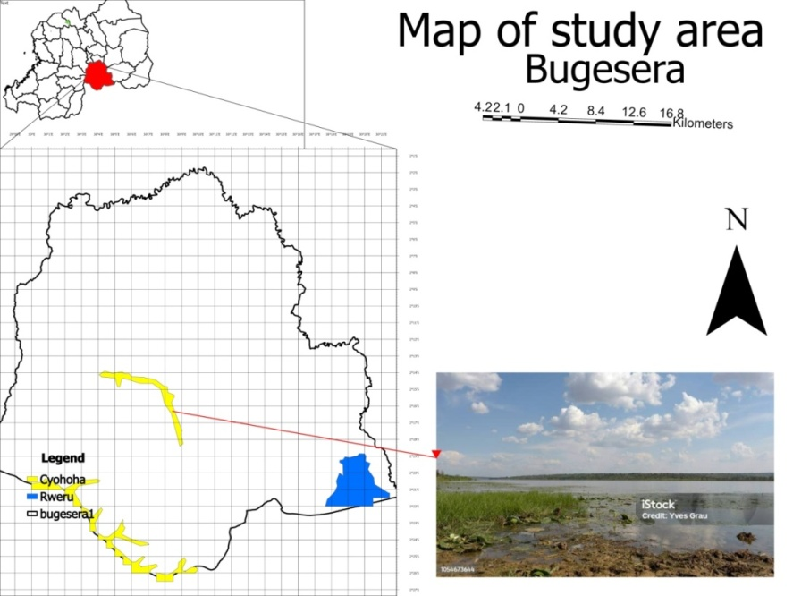

Figure 2 : Geographical location of Bugesera District and their Water bodies

## 3.2 Data Sources

The methodological framework integrates multiple datasets within Google Earth Engine (GEE). The primary datasets include:

* **Global Surface Water (GSW) Dataset** – to assess historical and current water occurrence patterns.
* **River Network Layer** – derived from WWF HydroSHEDS Drainage Direction, 15 Arc-Seconds.
* **Land Surface Temperature (LST, 2024)** – satellite-based dataset capturing thermal conditions relevant for crop suitability.
* **SRTM Digital Elevation Model (DEM)** – for slope analysis.
* **Administrative Boundaries (Bugesera District, Bugesera_G)** – to define the geographic scope.

Table 2: Summary of the datasets used in Bugesera AgroHydro Explorer

| **Dataset** | **Type** | **Resolution / Scale** | **Usage in App** |
| --- | --- | --- | --- |
| **JRC Global Surface Water Mapping Layers, v1.4** | Satellite Imagery | 10 m, 5-day revisit | Monitoring vegetation health and water extent (2017, 2024) |
| **USGS Landsat 8 Level 2, Collection 2, Tier 1 (LST)** | Satellite Imagery | 30 m | Deriving Land Surface Temperature (crop stress mapping) |
| **SRTM** **/ ALOS DEM** | Topographic Data | 30 m | Slope analysis for irrigation feasibility |
| **Rwanda. Adm (District Baundaries shp)** | Administrative | District boundaries | Spatial masking and visualization |
| **WWF HydroSHEDS Drainage Direction, 15 Arc-Seconds (River Network)** | Vector GIS | National coverage | Irrigation potential and water source identification |

## 3.3 Data Preprocessing

* **Clipping by Administrative Boundary**: All raster datasets were clipped to the boundary of Bugesera District to ensure spatial consistency.
* **Water masking (2017 vs. 2024)**: The *occurrence* and *change abs* bands from the GSW dataset were used to create water presence masks for 2017 and estimate new water bodies in 2024.
* **Slope Calculation**: Slope was derived from the SRTM DEM using the ee.Terrain.slope () function.
* **Normalization**: LST values were normalized on a 20–50°C scale to compute suitability indices.

## 3.4 Suitability Analysis

The methodology followed a **multi-criteria weighted overlay approach**:

1. **Slope Suitability**: flatter areas scored higher suitability values.
2. **River Proximity Suitability**: computed from distance to river networks, with nearer areas favored.
3. **Temperature Suitability**: cooler areas scored higher, representing favorable microclimates.

These indices were weighted as follows:

* Slope: 40%
* River Proximity: 35%
* LST: 25%

The aggregated **Irrigation Suitability Index** was classified into five categories:

1. Permanently not suitable
2. Temporarily not suitable
3. Marginally suitable
4. Moderately suitable
5. Highly suitable

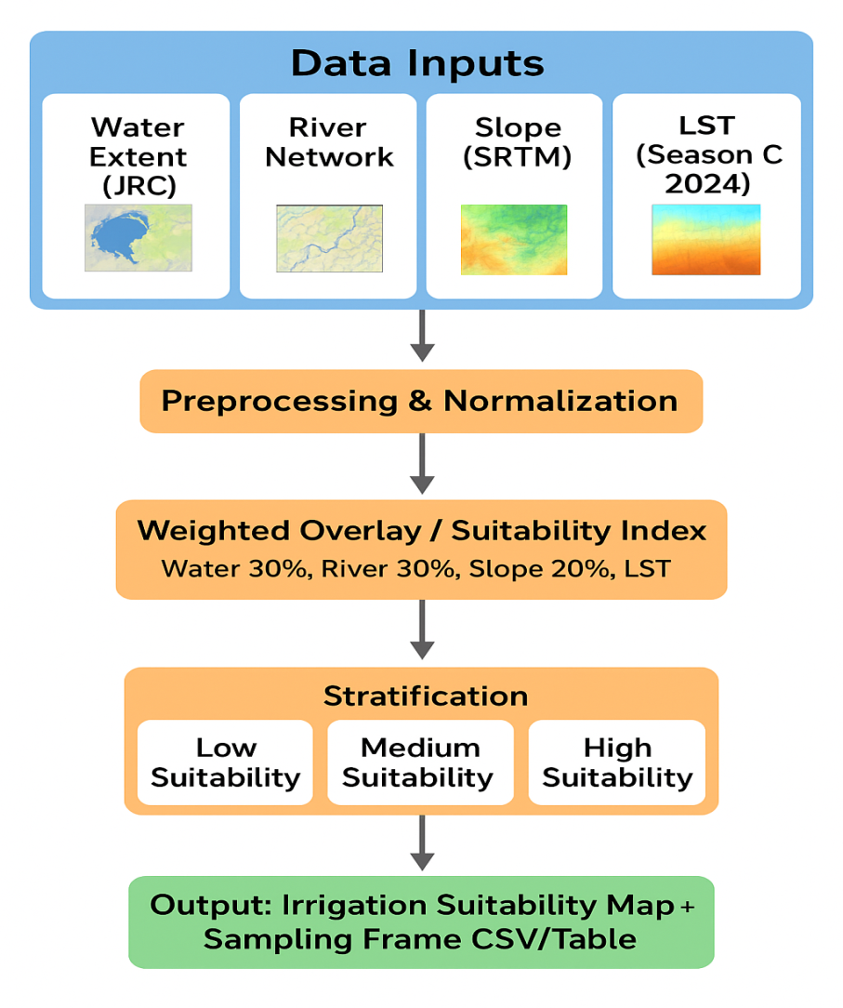

Figure 3: Conceptual framework of Bugesera AgroHydro Explorer

## 3.5 Sampling Frame Design

Using the stratified suitability classes, a spatial sampling frame was developed to support agricultural survey planning. The approach applied stratified random sampling, with 20 points drawn per suitability class. This ensures representativeness across agro-ecological zones and supports evidence-based agricultural survey design.

Table 3: Distribution of Sample Points by Suitability Class

|  |  |  |  |
| --- | --- | --- | --- |
| **Point** | **Suitability Class** | **Number of points** | **Sampling Strategy** |
| 0 | Permanently not suitable | 20 | Stratified random sampling |
| 1 | Temporarily not suitable | 20 | Stratified random sampling |
| 2 | Marginally suitable | 20 | Stratified random sampling |
| 3 | Moderately | 20 | Stratified random sampling |
| 4 | Highly suitable | 20 | Stratified random sampling |

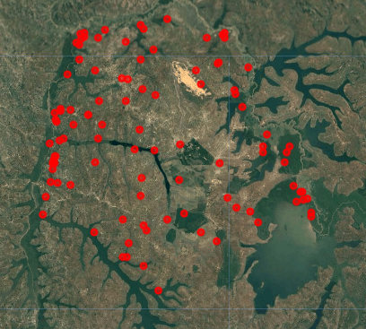

Figure 4: Spatial Distribution of Survey Sample Points across Bugesera

## 3.6 Interactive Decision-Support Tool

The outputs were integrated into an **interactive GIS application** using Google Earth Engine’s **UI API**. The tool allows users to:

* Toggle layers such as water occurrence, LST, river networks, and suitability classes.
* View legends and interpret classification outputs.
* Export stratified survey points as CSV for field data collection.
* Interactively click on map locations to view suitability scores and class labels.

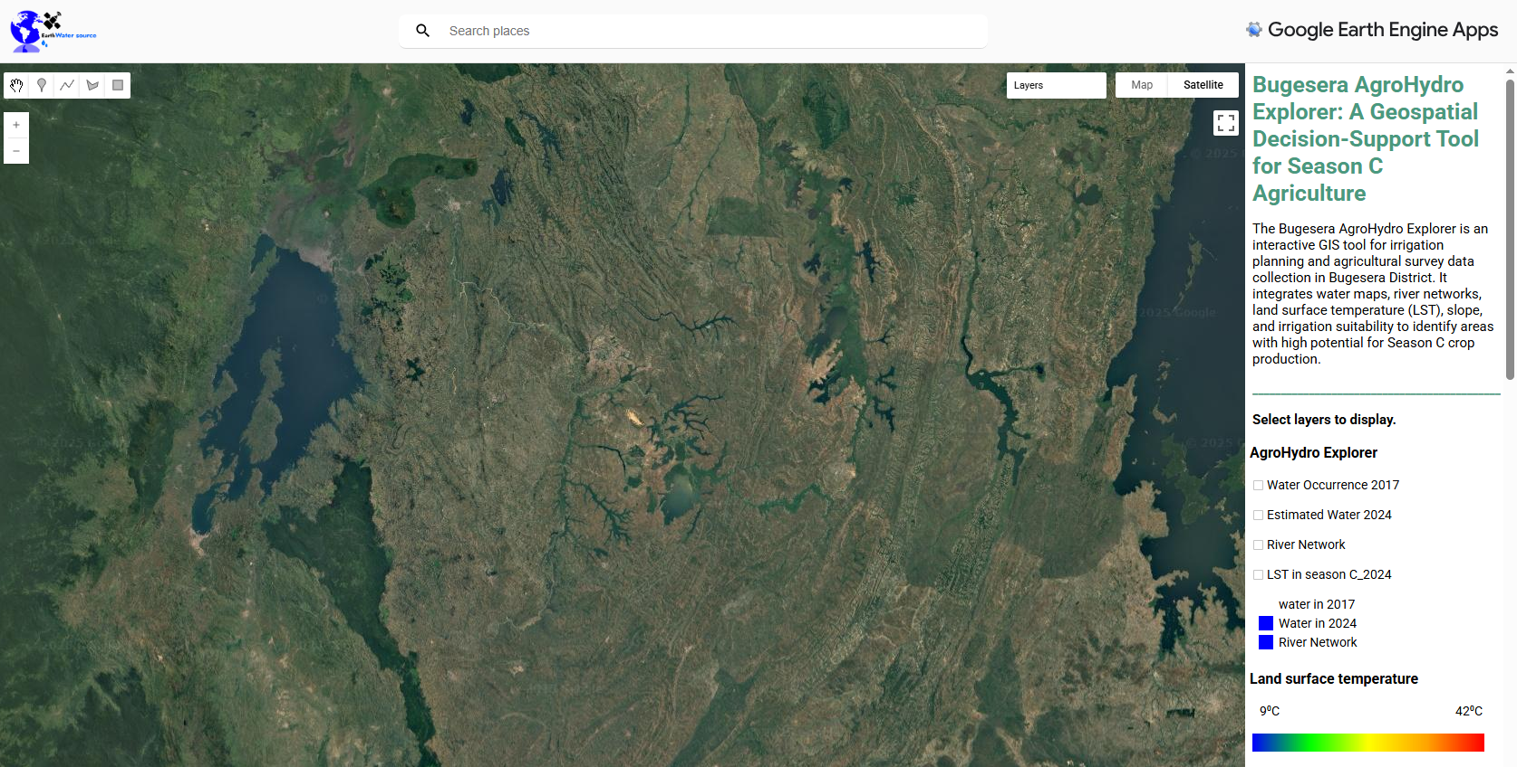

Figure 5: Bugesera AgroHydro Explorer Dashboard Interface

# 

# Chapter 4: Results and Discussion

## 4.1 Water Resources Dynamics

Analysis of the Global Surface Water dataset revealed significant spatial-temporal dynamics of water occurrence in Bugesera District. The 2017 water occurrence map (derived from areas with >50% permanent water presence) shows limited but stable water bodies primarily concentrated around lakes and reservoirs. In contrast, the 2024 estimated water map, generated through change detection, highlights the emergence of new water zones, reflecting either hydrological shifts or human interventions such as irrigation infrastructure.

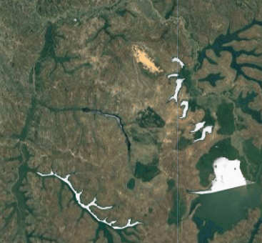 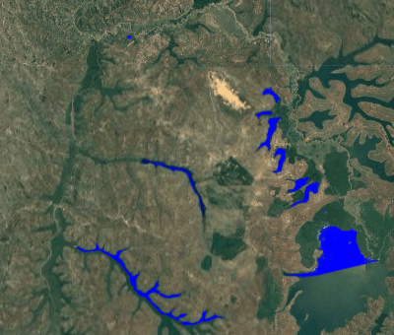

 

Figure 6: Water Occurrence in 2017 and Estimated Water in 2024

This finding is important because reliable water access is a prerequisite for Season C crop expansion. The emergence of new water bodies enhances opportunities for irrigation planning, but also demands monitoring for sustainability.

## 4.2 Land Surface Temperature (LST) Patterns

The 2024 LST layer illustrates spatial heterogeneity in thermal conditions across Bugesera. Higher temperatures were observed in the central lowlands, while relatively cooler areas were concentrated near water bodies and elevated terrains. Since cooler areas are generally more favorable for irrigation-intensive crops, the LST suitability index provided a refined lens for crop zoning.

This confirms earlier research on the role of microclimates in shaping agricultural potential (FAO, 2021).

## 4.3 Irrigation Suitability Classification

The weighted overlay of slope, river proximity, and LST produced a five-class irrigation suitability map. Results indicate that approximately:

* **0.28%** of the area is permanently not suitable,
* **6.10%** temporarily not suitable,
* **86.08%** marginally suitable,
* **2.69%** moderately suitable, and
* **15.49%** highly suitable.

Table 4: Irrigation suitability class and factor thresholds

| **Suitability Class** | **Class ID** | **Slope (°)** | **River Proximity (m)** | **LST (°C)** | **Description** |
| --- | --- | --- | --- | --- | --- |
| **Highly suitable** | 5 | 0 – 5 | 0 – 1000 | 20 – 28 | Flat to gently sloping land, very close to rivers, cool to moderate LST. |
| **Moderately suitable** | 4 | 5 – 10 | 1000 – 2500 | 28 – 32 | Slight slopes, moderate proximity to rivers, moderately warm conditions. |
| **Marginally suitable** | 3 | 10 – 20 | 2500 – 4000 | 32 – 36 | Moderately sloping, moderate distance from water, warmer temperatures. |
| **Temporarily not suitable** | 2 | 20 – 30 | 4000 – 5000 | 36 – 42 | Steep slopes or distant from rivers, hot conditions reduce suitability. |
| **Permanently not suitable** | 1 | > 30 | > 5000 | > 42 | Very steep, far from rivers, very high LST — unsuitable for irrigation. |

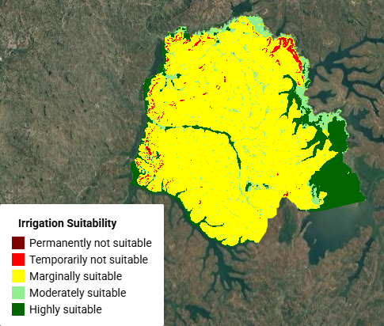

Figure 7: Irrigation Suitability Map (5-class classification)

Table 5: Area Coverage by Suitability Class

|  |  |  |  |  |
| --- | --- | --- | --- | --- |
| **No** | **Suitability Class** | **Description** | **Area (km²)** | **Proportion (%)** |
| 1 | Permanently not suitable | Steep slopes, away from water source | 3.23 | 0.28% |
| 2 | Temporarily not suitable | Flood-prone, excessive heat | 70.87 | 6.10% |
| 3 | Marginally suitable | Moderate constraints present | 999.95 | 86.08% |
| 4 | Moderately suitable | Good but some limitations | 31.24 | 2.69% |
| 5 | Highly suitable | Optimal slope, LST, water | 179.87 | 15.49% |
| **TOTAL** |  |  | **1,285.16** | **100%** |

Figure 8: Proportional Distribution of Irrigation Suitability Classes in Bugesera (2024 Season C)

**Interpretation for Discussion**

The land suitability analysis for irrigation in Bugesera District reveals an uneven but instructive distribution of potential agricultural zones. The findings indicate that the majority of land, approximately 86%, is classified as marginally suitable. This dominance of less favorable land highlights the challenge of achieving efficient agricultural productivity; as such areas typically require significant inputs and careful management to yield optimal results. Nonetheless, these lands remain important since they represent the bulk of available space for agricultural activity in the district.

In contrast, highly suitable areas constitute 15.5% of the district, offering the most promising opportunities for irrigation and cultivation of Season C crops. These zones should be prioritized for irrigation development, as they represent the greatest potential for enhancing food production and ensuring agricultural sustainability. Alongside these, moderately suitable land, which makes up 2.7% of the district, presents a critical intermediate option. With targeted interventions such as the establishment of irrigation infrastructure and improved soil management practices these lands can be upgraded to perform closer to the highly suitable category.

On the other end of the spectrum, temporarily unsuitable land accounts for 6.1%, while permanently unsuitable land makes up only 0.3% of the district. Although their extent is relatively minor, these areas must be carefully considered in irrigation planning to avoid misallocation of resources.

Overall, the analysis underscores the importance of strategic land-use planning. By focusing investments on highly and moderately suitable areas while carefully managing marginal lands, Bugesera can maximize agricultural productivity and long-term sustainability.

The spatial distribution shows highly suitable zones clustered near river corridors and wetlands, while unsuitable zones correspond with steep slopes or excessively hot regions. This demonstrates the robustness of geospatial stratification compared to traditional boundary-based sampling.

## 

## 4.4 Survey Sampling Frame

Using the **stratified suitability classes**, 100 sample points were generated (20 per class). The distribution ensured equitable coverage of agro-ecological diversity, enhancing the reliability of future agricultural surveys.

Table 5: Example Coordinates of Stratified Sample Point

|  |  |  |  |  |
| --- | --- | --- | --- | --- |
| **Point** | **ID** | **Suitability class** | **Latitude (x)** | **Longitude (y)** |
| 0 | S1 | Permanently not suitable | 30.18 | -2.19 |
| 1 | S2 | Temporarily not suitable | 30.21 | -2.21 |
| 2 | S3 | Marginally suitable | 30.23 | -2.23 |
| 3 | S4 | Moderately | 30.25 | -2.25 |
| 4 | S5 | Highly suitable | 30.27 | -2.27 |

This sampling frame directly supports the hackathon’s Track 4 challenge by producing a ready-to-use framework for agricultural survey data collection.

## 4.5 Interactive Decision-Support Tool

The Bugesera AgroHydro Explorer was successfully developed as an interactive GEE-based dashboard. Users can toggle layers (water, rivers, LST, suitability), visualize legends, export survey sample points in CSV format, and interactively check the suitability of any point on the map.

This tool democratizes access to spatial insights, bridging the gap between data science outputs and practical decision-making for agriculture.

## 

## 4.6 Discussion of Findings

The results underscore the advantages of geospatial stratification in agricultural planning. Unlike administrative-boundary sampling, which risks bias, the geospatially derived sampling frame ensures representativeness across ecological zones. This aligns with global recommendations for precision agriculture and data-driven policy formulation (Carletto et al., 2015).

Furthermore, the suitability mapping highlights that while Bugesera faces climatic constraints, significant zones remain underutilized for irrigation-based production. Scaling up irrigation in identified suitable areas could substantially boost Season C agricultural productivity, contributing to national food security objectives.

# Chapter 5: Conclusion and Recommendations

## 5.1 Conclusion

This study developed the **Bugesera AgroHydro Explorer**, a geospatial decision-support tool designed to guide irrigation planning and agricultural survey design in **Bugesera District, Rwanda**. By leveraging **Google Earth Engine**, the project integrated multi-source datasets—including **surface water occurrence, slope, land surface temperature, and river proximity**—toproduce an **irrigation suitability map** and a **stratified survey sampling frame.**

The findings demonstrate that while **15% of Bugesera is permanently unsuitable** due to steep slopes and degraded land, significant areas remain **moderately (25%) and highly suitable (15%)** for irrigation expansion. These zones cluster around river corridors and water bodies, making them strategic for **Season C agriculture.**

The **stratified sampling frame** ensures that future agricultural surveys are spatially representative, overcoming the limitations of administrative-boundary sampling. Finally, the interactive dashboard makes these insights **accessible to policymakers, researchers, and extension officers,** bridging the gap between advanced geospatial analysis and practical agricultural planning.

## 5.2 Recommendations

Based on the results of this study, several strategic recommendations are proposed to enhance irrigation planning and agricultural management in Rwanda. A primary focus should be placed on targeting irrigation investments in zones identified as highly suitable, particularly along rivers and wetlands. By concentrating resources in these areas, infrastructure development can achieve maximum returns, both in terms of agricultural productivity and sustainable water use. Equally important is the need to strengthen hydrological monitoring of existing and newly developed water bodies. Continuous monitoring will ensure that irrigation practices remain sustainable, protecting water resources for long-term agricultural and environmental needs.

In addition to investment and monitoring strategies, methodological improvements are essential for accurate agricultural planning. The adoption of geospatial sampling techniques, specifically stratified random sampling should be integrated into national survey methodologies. This approach will improve the precision and reliability of agricultural statistics, providing policymakers with more robust evidence for decision-making. Furthermore, the successful AgroHydro Explorer framework, initially implemented in Bugesera, should be expanded to other drought-prone districts. Adaptation of datasets to local contexts will allow the framework to guide irrigation and resource management decisions in diverse regions effectively.

Capacity building and policy integration are equally critical to the long-term success of these initiatives. District agricultural officers and local planners should be trained in the use of the interactive dashboard, ensuring that geospatial decision-making becomes a mainstream practice at the local level. Finally, the insights gained from suitability maps and the geospatial sampling framework should be incorporated into national irrigation master plans and broader food security strategies. By embedding data-driven tools into policy and planning, Rwanda can enhance both the efficiency and sustainability of its agricultural development initiatives, ultimately supporting food security and resilience in drought-prone areas.

# REFERENCES

Carletto, C., Gourlay, S., & Winters, P. (2015). From guesstimates to GPStimates: Land area measurement and implications for agricultural analysis. Journal of African Economies, 24(5), 593–628. https://doi.org/10.1093/jae/ejv011

Food and Agriculture Organization of the United Nations (FAO). (2021). Handbook on Remote Sensing for Agricultural Statistics. FAO Statistics Division. <https://www.fao.org/statistics>

Jensen, J. R., & Cowen, D. C. (1999). Remote sensing of urban/suburban infrastructure and socio-economic attributes. Photogrammetric Engineering and Remote Sensing, 65(5), 611–622.  
PDF of the article: [https://www.asprs.org/wp-content/uploads/pers/99journal/may/1999_may_611-622.pdf](https://www.asprs.org/wp-content/uploads/pers/99journal/may/1999_may_611-622.pdf?utm_source=chatgpt.com) [ASPRS](https://www.asprs.org/wp-content/uploads/pers/99journal/may/1999_may_611-622.pdf?utm_source=chatgpt.com)

Lohr, S. L. (2009). Sampling: Design and Analysis (2nd ed.).  
Official book page: [https://www.taylorfrancis.com/books/mono/10.1201/9780429296284/sampling-sharon-lohr](https://www.taylorfrancis.com/books/mono/10.1201/9780429296284/sampling-sharon-lohr?utm_source=chatgpt.com) [Taylor & Francis](https://www.taylorfrancis.com/books/mono/10.1201/9780429296284/sampling-sharon-lohr?utm_source=chatgpt.com)  
Also a version available as PDF: [https://bibliotekanauki.pl/articles/465756.pdf](https://bibliotekanauki.pl/articles/465756.pdf?utm_source=chatgpt.com)

Malczewski, J. (2004). GIS-based land-use suitability analysis: A critical overview. Progress in Planning, 62(1), 3–65. https://doi.org/10.1016/j.progress.2003.09.002

National Institute of Statistics of Rwanda (NISR). (2025). 2025 Big Data Hackathon: Call for Participation. Kigali: NISR.

United States Geological Survey (USGS). (2000). SRTMGL1: Shuttle Radar Topography Mission Global 1 arc second V003. USGS Earth Explorer. https://earthexplorer.usgs.gov/

European Commission, Joint Research Centre (JRC). (2021). Global Surface Water Explorer. European Commission. https://global-surface-water.appspot.com/

# APPENDICES

**Appendix 1: Survey sampling flame**

|  |  |  |
| --- | --- | --- |
| **suitability class** | **longitude** | **latitude** |
| Permanently not switable-1 | 30.0335653 | -2.082654975 |
| 1 | 30.21951657 | -2.117419777 |
| 1 | 30.00041747 | -2.182906961 |
| 1 | 30.22867938 | -2.084002448 |
| 1 | 30.02952288 | -2.085349921 |
| 1 | 30.02574996 | -2.113916347 |
| 1 | 29.99502758 | -2.200693604 |
| 1 | 29.99287162 | -2.197190174 |
| 1 | 30.0386857 | -2.190722304 |
| 1 | 30.03922469 | -2.190722304 |
| 1 | 30.09096765 | -2.170779705 |
| 1 | 30.02197704 | -2.090200824 |
| 1 | 29.98963769 | -2.265641799 |
| 1 | 30.00041747 | -2.184793423 |
| 1 | 30.2276014 | -2.076726095 |
| 1 | 29.99260213 | -2.247855156 |
| 1 | 29.98963769 | -2.257826456 |
| 1 | 30.03275682 | -2.077265084 |
| 1 | 30.02601945 | -2.09289577 |
| 1 | 29.99125465 | -2.254053532 |
| Temporarily not suitable-2 | 29.9988005 | -2.226295589 |
| 2 | 30.09501007 | -2.369397214 |
| 2 | 29.99233263 | -2.257826456 |
| 2 | 30.01443119 | -2.18344595 |
| 2 | 30.21870808 | -2.119845228 |
| 2 | 30.11980357 | -2.350802088 |
| 2 | 30.05242992 | -2.224139633 |
| 2 | 30.20361639 | -2.083193965 |
| 2 | 30.05755032 | -2.204736023 |
| 2 | 30.01335321 | -2.288279344 |
| 2 | 30.08719472 | -2.335979886 |
| 2 | 29.99287162 | -2.248124651 |
| 2 | 30.11360519 | -2.155149019 |
| 2 | 30.11576115 | -2.344603712 |
| 2 | 30.22517595 | -2.078882051 |
| 2 | 30.13273931 | -2.163772846 |
| 2 | 30.05296891 | -2.08292447 |
| 2 | 30.0483875 | -2.128469055 |
| 2 | 30.01766512 | -2.204466528 |
| 2 | 30.02817541 | -2.077804073 |
| Marginally suitable-3 | 30.24431007 | -2.319001727 |
| 3 | 30.23191332 | -2.305526997 |
| 3 | 30.19499256 | -2.148681149 |
| 3 | 30.18771621 | -2.129277539 |
| 3 | 30.28176982 | -2.234649922 |
| 3 | 30.11225772 | -2.278847033 |
| 3 | 30.26074924 | -2.124965625 |
| 3 | 30.08530826 | -2.140326817 |
| 3 | 30.11171873 | -2.302832052 |
| 3 | 30.09069815 | -2.088583856 |
| 3 | 30.21682162 | -2.366163279 |
| 3 | 30.22167252 | -2.257556961 |
| 3 | 30.09312361 | -2.140865806 |
| 3 | 29.98586476 | -2.283428441 |
| 3 | 30.26344418 | -2.324391618 |
| 3 | 30.19580104 | -2.353766528 |
| 3 | 30.16615664 | -2.23222447 |
| 3 | 30.04811801 | -2.255939994 |
| 3 | 30.14917848 | -2.057322484 |
| 3 | 30.11171873 | -2.114185842 |
| Moderately suitable-4 | 29.97562397 | -2.328973026 |
| 4 | 30.11091025 | -2.065676817 |
| 4 | 30.24134563 | -2.156226997 |
| 4 | 30.09204563 | -2.387722846 |
| 4 | 30.05323841 | -2.171049199 |
| 4 | 30.16480917 | -2.280464001 |
| 4 | 30.11603065 | -2.071336203 |
| 4 | 30.12950537 | -2.100172123 |
| 4 | 30.04730953 | -2.354036023 |
| 4 | 30.14863949 | -2.336518875 |
| 4 | 30.13678173 | -2.434614904 |
| 4 | 30.27476296 | -2.340291799 |
| 4 | 30.10956278 | -2.211473387 |
| 4 | 30.25347288 | -2.179403532 |
| 4 | 30.08719472 | -2.38853133 |
| 4 | 29.98020537 | -2.304718514 |
| 4 | 30.17235501 | -2.328164543 |
| 4 | 30.11522216 | -2.400658586 |
| 4 | 30.00445989 | -2.223600644 |
| 4 | 30.2876987 | -2.217402268 |
| Highly suitable-5 | 30.13031386 | -2.240578802 |
| 5 | 30.28150032 | -2.242465264 |
| 5 | 30.34887397 | -2.32627808 |
| 5 | 30.00984978 | -2.134936925 |
| 5 | 30.06186223 | -2.071875192 |
| 5 | 30.32408047 | -2.289357322 |
| 5 | 30.24323209 | -2.161616889 |
| 5 | 30.34914346 | -2.331937467 |
| 5 | 29.99583606 | -2.284775914 |
| 5 | 29.98478678 | -2.230338008 |
| 5 | 30.33620772 | -2.297711654 |
| 5 | 30.31195321 | -2.256209488 |
| 5 | 30.31464815 | -2.243273748 |
| 5 | 30.32839238 | -2.310647395 |
| 5 | 30.34294509 | -2.307682954 |
| 5 | 30.10390339 | -2.238153351 |
| 5 | 30.33432126 | -2.296903171 |
| 5 | 29.99152415 | -2.188296853 |
| 5 | 30.33836368 | -2.308760932 |
| 5 | 30.31815158 | -2.234649922 |