The Influence Indicator Detection System Architecture
Most of the current solutions for identifying discourse waves of influence campaigns rely in great part on human analysts. Influence attackers take advantage of the open system of opinion formation in the Western democracies especially with the reach of social network media platforms, turning free and open debate into desired opinion formation in the target population.
The proposed solution intends to automate the processes of identifying discourse waves of interest, the properties of these waves, the connections between the actors operating behind them, and their target audience quickly and automatically. Two essential requirements must be met for a successful solution – detection of “key” indicators for influence campaigns and a scalable process to identify such campaigns from the massive number of posts flowing through several social media platforms.
The Process Architecture
Many posts from social media messaging platforms and other online data sources continue to feed into the system. Each incoming post will be assigned a unique ID and analyzed by the system (using algorithms to be discussed later) to extract the following information:
- Topic (topic ID – taken from the internal topic dictionary and/or IPTC Subject Codes Media Topics taxonomy)
- Emotion (emotion ID from the dictionary based on the wheel of emotions) and emotion intensity (1-5)
- Entities (entity ID – the unique entity/user who publish the post)
- Linguistic patterns that are relevant to the agenda (pattern ID - taken from the internal linguistic pattern dictionary)
- Timestamp of posting
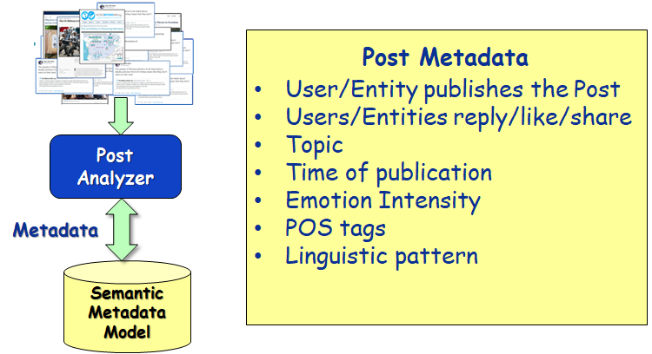
The above information plus those entities who reply, like or share the post constitute the metadata for the post, which will be stored in a semantic graph database. The entities in question can be a human or a BOT (to be determined by its BOT score), each of which will have a unique ID (generated by the system) and may have a name, a description and/or a location. Since all entities have their unique IDs in the semantic graph, it's easy to query the graph for the number of posts an entity publishes, the number of replies, likes and/or share to a post. The timestamps of all such actions will all be recorded in the semantic graph.
All posts connected to an original post constitute a discourse wave with a unique ID. A big discourse wave may split into independent sub-waves over time (organically or through deliberate manipulation) when the topic of discussion evolves and changes to a significantly different one.. The lineage of all discourse waves will be tracked in the semantic graph. When an ongoing discourse wave continues for a significant period of time and has enough volume, it will be tagged as “significant” warranted further analysis.
Periodically, a process will be invoked to extract the following indicators from the metadata of “significant” discourse waves. These indicators are essential for detecting an influence campaign. The algorithms for the extraction will be discussed later.
- AGENDA (agenda ID – taken from the internal agenda dictionary) and discussion topics (topic ID – taken from internal topic dictionary and/or IPTC Subject Codes Media Topics taxonomy)
- Concern (concern ID – taken from the internal concern dictionary) plus Polarization (Polarization level 1-5)
- Emotion (Emotion ID - based on the wheel of emotions) and emotion intensity (1-5)
- BOT score – the percentage of BOTs
- SPREAD – the velocity (number of posts per time interval) and volume (total number of posts in the discourse wave)
- Fakeness – the percentage of fake posts
All these indicators will be recorded in the semantic graph associated with the discourse wave along with the timestamps when the indicators are extracted. The timestamps allow the system to detect changes of the above indicators and the speed of the changes. The spread indicator depends on timing. All other indicators might change over time, some might show up while others diminish. Additionally, all indicators come with a certainty (probability) value from the algorithm, to be associated with each indicator,
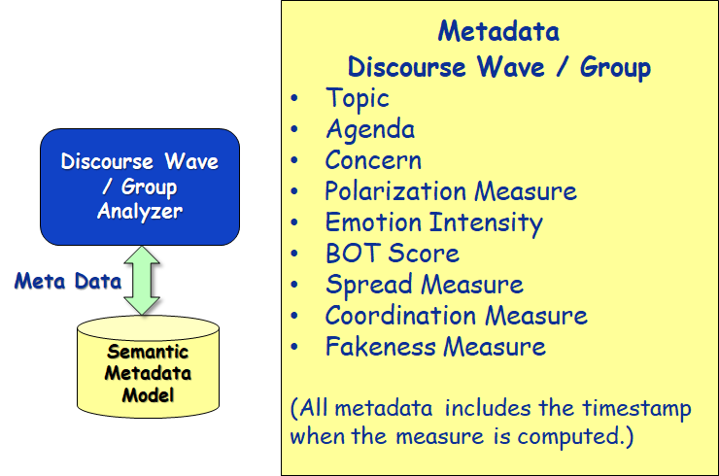
The system also periodically invokes clustering functions to group “similar” discourse waves. From these groupings, we can identify all users (entities) associated with each group. A discourse wave may belong to several groups. Such grouping may change over time as more information becomes available affecting the extracted indicators.
From time to time, all the groups are checked for Coordination (the 7th indicator). The coordination checking process will result in a collection of groups that appears to be coordinated in their influence campaign. The system will assign a coordination level to the collection (1-5). Such collections are not necessarily disjoint. For example, the system may find a collection of 3 groups having a coordination level of 5. However, when included in a collection of 7 groups may result in a coordination level of 3. The coordination measure may evolve over time as more posts and indicators become available.
As groups are formed, the system will try to classify them according to the following statuses.
- Suspected – the system found enough evidence to suspect it is an influence attack. The user will be notified about these groupings. The system continuously analyzes these groupings, tracing changes and finding more evidence to validate whether or not this is an influence attack.
- Maybe – the system continues to monitor (analyze) these groupings, checking if any changes to their indicators.
- Faded – the grouping is too small (too few posts/users) and there has been no activity in the last N days. These groupings will be archived.
- Irrelevant - the discussion topics are not relevant (cooking, parenthood, etc.). The system follows this grouping without checking for indicators. It will change status once a post with a relevant topic is added to it. Irrelevant posts that are M months old will be archived.
The process of identifying the indicators in each of the groupings is an ongoing process. When a particular indicator exceeds the set threshold it is fed into the framing process for this grouping.
The framing process works on each grouping individually and collects the indicators that exceed a set threshold, taking into account their certainty levels.
The framing process uses a set of formulas (patterns) to compute the probability that an influence attack has been detected. Once the probability for a grouping computed from one of the formulas passes a certain threshold, an influence attack is detected. Different formulas may use different combinations of indicators, which together ensures a high enough certainty of discovering an influence attack.
A Scalable Data Model Architecture
Below is a picture of the conceptual ontology for the metadata described above.
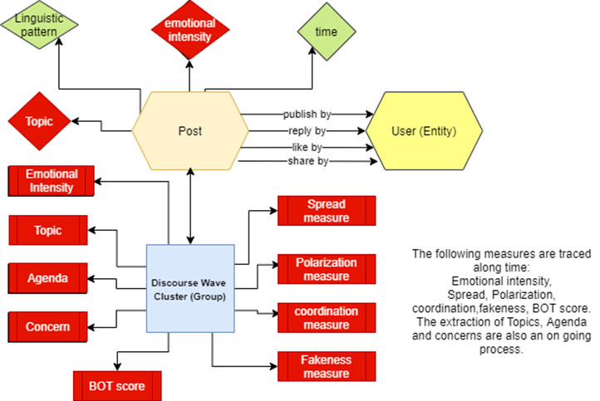
There are a lot of many-to-many associations in this data model. An entity may be involved (publish, reply, like, share) in many posts while a post may involve many entities. A discourse wave may belong to several groups, and a group involves many discourse waves. Similar many-to-many association also exists for all other indicators. Additionally, the data model may evolve as more knowledge is accrued during operation. Such a data model is ideally suited for Semantic graphs.
Perhaps the biggest advantage of a Semantic graph model is its flexibility, when compared to traditional data architecture (e.g., Relational model). Flexibility in many aspects:
- In changing data schemas on the fly and perform real time processing
- In adding new predicates (attributes, relations, the verbs in natural text) and use them in queries the next microsecond
- In writing ad-hoc queries
- In finding complex patterns and working with rules
- In integrating various data sources without complicated master data management
- In dealing with one-to-many and many-to-many relationships
Semantic graph database achieves such flexibility, because it:
- Requires no schema
- Stores whatever you want to store (with URI and RDF), and employs ontologies for inference and to constrain what may be put in the Semantic database
- Needs no link tables because it handles many-to-many relationships directly
- Demands no indexing choices
- Allows new data attributes (predicates, relations) to be added and automatically indexed on-the-fly.
- Accepts any type of data, processing with the same ease rows and columns from RDB, XML, RDF(S), OWL, text and extracted entities alike.
For the Influence Indicator Detection problem, this flexibility is very beneficial, especially when dealing with unforeseen but expected changes in data and attribute types as new media and message platforms are added.
The URI (Uniform Resource Identifier) in the semantic model is a W3C standard way to define globally unique identifiers. The semantic model also comes with standard vocabularies (RDFS and OWL) to organize the information model. It also comes with a powerful and standard query language SPARQL for retrieving information from the graph based on pattern matching.
A Scalable Processing Architecture
As the online discourse explodes in volume and speed, the system must be able to scale up horizontally to detect any and all influence campaigns timely. Keys to this detection process are the indicators for each influence discourse wave that are computed by the system automatically. With the volume and speed, the system must employ as many computing nodes as necessary to share the workload. One key requirement for such a shared architecture to work correctly and effectively is a shared data backend. Metadata such as the context of the message (user id, time, text id responded to, etc.), agenda, worldviews, concerns, and emotions, when extracted or identified from one discourse text, must be made available for subsequent discourse messages. Traditional architecture employs a single source of truth (SSOT), which eventually becomes the bottleneck as the number and frequency of processes accessing this SSOT escalates.
A scalable architecture requires each computing node having its own SSOT, while the system automatically synchronizes all individual SSOTs. In other words, data created or updated by one computing node on its “own” database automatically and immediately propagates to all the other databases owned by other processing nodes. This way, we maintain a SSOT without the data access bottleneck. Such an architecture ensures unlimited horizontal scalability.
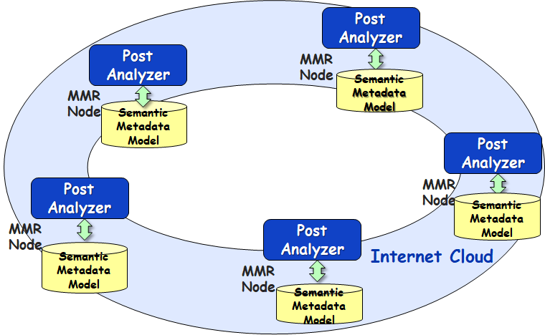
The proposed Semantic Graph database comes with a Multi-Master Replication (MMR) feature that offers exactly such capabilities. It is a real-time transactionally consistent data replication solution. Metadata written to the database at one node automatically propagates to databases at all the other nodes in the cluster. It allows as many computing nodes as necessary to be added and semantic data from individual nodes is automatically synchronized across the network. This also facilitates, besides real-time data sharing, load balancing and disaster recovery.
When a new post arrives or a discourse wave is updated, a load balancer will pick the least busy computing node to compute the necessary influence indicators. As the discourse volume increases, we simply add additional nodes to meet the performance requirements.
The same processing architecture will be employed by the analyzer for discourse waves to extract the 7 target indicators. All processes will access the same data without the database access bottleneck.
The original message data from the massive number of posts plus other NLP information (such as POS tags) must also be stored for possible future references. When the data size is huge (say trillions of facts from all the posts), it's very inefficient to put all the data in one single database. Therefore, we will employ a distributed database for its size scalability, which will be shared by all Post Analyzers. Such “raw” data will not be involved in the extraction process of discourse wave indicators, thus less affected by data access contention.
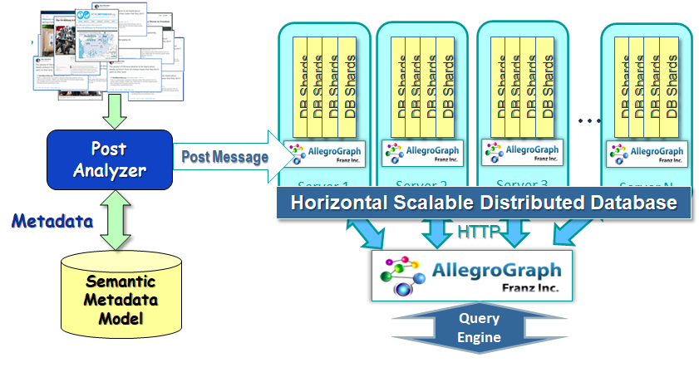
The data is distributed over a cluster of database shards in one or several machines, which is managed by a distributed query engine. The processes make a single query to this distributed query engine, which in turn sends the query to all database shards then collates (or joins) query results returned from all database shards before sending it back to the calling processes. This provides database size scalability, especially suitable for cases where the data is conducive to partition (such as partition by posts or partition by users/entities). As the data size increases, we simply add more server nodes without having to change the applications.

