# Practical: SQL – Insert, Update, Delete, DDL

## Objective

In this practical, you will practice following SQL command.

* DDL – CREATE TABLE, ALTER TABLE, CREATE VIEW, and CREATE INDEX
* DML – INSERT, UPDATE, and DELET

## Tasks

1. **Pre-lab Setup**
   1. Download the script *DBMS_SQL_DDL_setup.sql* from NYP LMS.
   2. Launch MySQL Workbench. Connect as **root**.
   3. Open the script *DBMS_SQL_DDL_setup.sql* and Run it. List the tasks the script does.
   4. Create a new database connection with following details.

|  |  |
| --- | --- |
| Connection Name | DDLstudent_<your AdmNo> |
| Hostname | 127.0.0 (default) |
| Port | 3306 (default) |
| Username | ddlstudent |
| Password (when prompt) | ddlstudPa55 |

**Note: In the following steps, you should keep backup copy of all your scripts so that in case your tables/data are damaged accidentally, you could re-run your scripts to re-build the tables or to populate the data.**

1. **Run Scripts to create tables**
2. Download *CreateHotelBookingTables.sql* from the course web site.
3. Connect MySQL using the *DDLstudent_<your AdmNo>* connection. Select **File > Open** to open the script. Describe the functions of the script.
4. Run the script by press the **Run Script button**.
5. **SQL INSERT Statement**

In this exercise, you are to practice the INSERT statement. You need to insert the following data into the tables that you created in the previous task.

* 1. Insert the data into the Gx_HOTEL

|  |  |  |
| --- | --- | --- |
| **HOTEL_NO** | **HOTEL_NAME** | **CITY** |
| H111 | Grosvenor Hotel | London |

**insert into gx_hotel(Hotel_no , Hotel_name , City )**

**values('H111' , 'Grosvenor Hotel' , 'London');**

* 1. Insert data into Gx_ROOM

|  |  |  |  |
| --- | --- | --- | --- |
| **ROOM_NO** | **HOTEL_NO** | **ROOM_TYPE** | **PRICE** |
| 1001 | H111 | S | 172 |
| 2 1002 | H111 | D | 200 |
| 1003 | H111 | F | 300 |

**insert into gx_room**

**values('1001' , 'H111' , 'S','172');**

**insert into gx_room**

**values('1002' , 'H111' , 'D','200');**

**insert into gx_room**

**values('1003' , 'H111' , 'F','300');**

* 1. Insert data into Gx_GUEST

|  |  |  |
| --- | --- | --- |
| **GUEST_NO** | **GUEST_NAME** | **GUEST_ADDR** |
| G001 | John Smith | London |
| G002 | Michael | London |
| G003 | James | London |

**insert into gx_guest**

**values('G001' , 'John Smith' , 'London');**

**insert into gx_guest**

**values('G002' , 'Michael' , 'London');**

**insert into gx_guest**

**values('G003' , 'James' , 'London');**

* 1. Insert data into Gx_BOOKING

|  |  |  |  |  |
| --- | --- | --- | --- | --- |
| **HOTEL_NO** | **GUEST_NO** | **DATE_FROM** | **DATE_TO** | **ROOM_NO** |
| H111 | G001 | 01-Jan-2003 | 03-Jan-2003 | 1001 |
| H111 | G002 | 05-Feb-2003 | 07-Feb-2003 | 1001 |
| H111 | G003 | 15-Jan-2003 | 17-Jan-2003 | 1003 |

For MySQL, use the date format ‘YYYY-MM-DD’, e.g. ‘2003-01-17’.

**insert into gx_booking**

**values('H111' , 'G001' , '2003-01-01' , '2003-01-03' , '1001');**

**insert into gx_booking**

**values('H111' , 'G002' , '2003-02-05' , '2003-02-07' , '1001');**

**insert into gx_booking**

**values('H111' , 'G003' , '2003-01-15' , '2003-01-17' , '1003')**

1. **Update / Delete SQL**
   1. Guest ‘John Smith’ has called the hotel to inform the change of his address to ‘Manchester’. Perform the update in the guest database.

**SET SQL_SAFE_UPDATES = 0;**

**update gx_guest**

**set Guest_Addr = 'Machester'**

**where Guest_Name = 'John Smith';**

* 1. The ‘Grosvenor Hotel’ has decided to increase all the room rates by 5%. Perform the update in the database table.

**update gx_room**

**set price = price*1.05**

**where Hotel_No = (Select Hotel_No FROM Gx_Hotel where Hotel_name = ‘**Grosvenor Hotel**’**

Note:

If you got this error “Error Code: 1175. You are using safe update mode …”

You can do the following:

**Way 1**. To disable safe mode, toggle the option in Preferences -> SQL Editor as shown below and **reconnect.**

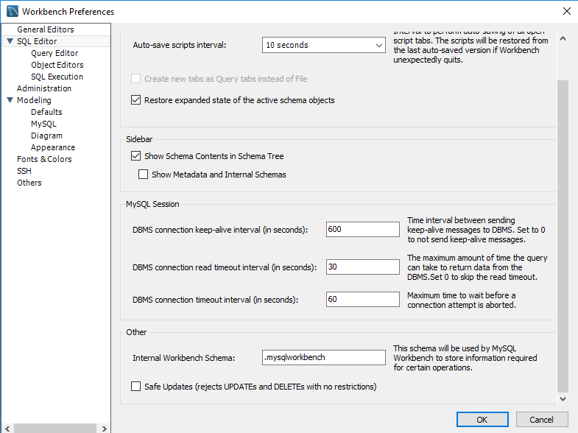

Uncheck this.

**Way 2.** Execute the following statement in the query window.

SET SQL_SAFE_UPDATES = 0;

1. **SQL/DDL: ALTER TABLE Statement**
   1. Add a new column which can contain NULL value

Modify the **Gx_HOTEL** table to add in the following new column which allows NULL value :

Phone : VARCHAR (12)

**alter table gx_hotel**

**add (Phone varchar(12) );**

* 1. Add a new column which is NOT NULL

Suppose the business rules have changed and you need to add in a new column, HOTEL_MANAGER, of type VARCHAR (20) to the table **Gx_HOTEL,** how can this be done? What happen to the existing records?

**alter table gx_hotel**

**add (HOTEL_MANAGER varchar(20) DEFAULT ‘Gary’ Not Null);**

1. **SQL/DDL: CREATE VIEW Statement**
   1. Create a view (**Gx_HOTEL_GUEST**) to list all the guests’ bookings at all the hotels. Include the following information in the view:

* Hotel Name
* Guest Name
* Room Type
* Booking From Date
* Booking Duration
  1. Show the data. What is the SQL statement?
  2. What is the advantage of creating view?

1. **Understand Index** 
   1. Insert some more data in Gx_GUEST table:

use dbms_ddl;

INSERT INTO gx_Guest VALUES ('G111', 'John Smith', 'London');

INSERT INTO gx_Guest VALUES ('G112', 'Mike Tan', 'London');

INSERT INTO gx_Guest VALUES ('G113', 'Alice', 'London');

INSERT INTO gx_Guest VALUES ('G114', 'Ben Wang', 'London');

INSERT INTO gx_Guest VALUES ('G115', 'Thomas', 'London');

INSERT INTO gx_Guest VALUES ('G116', 'Shirly', 'London');

INSERT INTO gx_Guest VALUES ('G117', 'Zoe ', 'London');

* 1. Write a SQL statement that display all detail of guest with name as ‘Shirly’.
  2. With Cursor place at anywhere with in the SELECT statement, Click **Execute EXPLAIN command** button . You will see the visual explain of the SELECT statement as following:

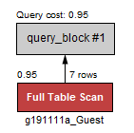

Full table scan indicate in order to find the guest with name ‘Shirly’, database need to scan through the whole table. The cost of the search is 0.95. If the table contains more data, the cost will increase drastically.

* 1. Now create an index on the **guest name** of the **Gx_GUEST** table. Name the index as **Gx_GUEST_NAME_IX**. Write down the SQL statement
  2. With Cursor place at anywhere with in the SELECT statement, Click **Execute EXPLAIN command** button again. The execution explaination changed to following. Instead of full table scan, it changes to Non-Unique Key Lookup. The query cost is also reduced. In a table with a lot of data, the difference in query cost can be tremendous.

