**Static Routing**

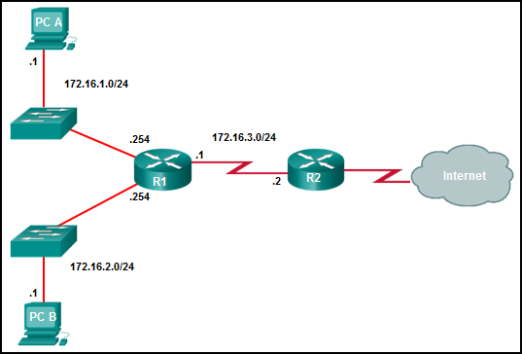



1. Which command will create a static route on R2 which can be used to route packets to the network where PC B resides?
   1. R2(config)# ip route 172.16.2.1 255.255.255.0 172.16.3.1
   2. R2(config)# ip route 172.16.2.0 255.255.255.0 172.16.2.254
   3. R2(config)# ip route 172.16.2.0 255.255.255.0 172.16.3.1
   4. R2(config)# ip route 172.16.3.0 255.255.255.0 172.16.2.254
2. The network administrator configures a router with “ip route 172.16.1.0 255.255.255.0 172.16.2.2”. How will this route appear in the routing table?
   1. C 172.16.1.0 is directly connected, Serial0/0
   2. S 172.16.1.0 is directly connected, Serial0/0
   3. C 172.16.1.0 [1/0] via 172.16.2.2
   4. S 172.16.1.0 [1/0] via 172.16.2.2

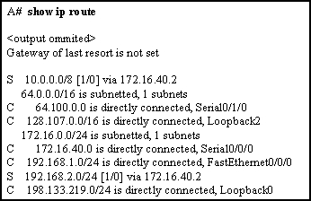

1. The next-hop IP address for static route 10.0.0.0/8 was wrongly configured. What **2 commands** will change the next-hop address from 172.16.40.2 to 192.168.1.2?
   1. A(config)# no network 10.0.0.0 255.0.0.0 172.16.40.2
   2. A(config)# no ip address 10.0.0.1 255.0.0.0 172.16.40.2
   3. A(config)# no ip route 10.0.0.0 255.0.0.0 172.16.40.2
   4. A(config)# ip route 10.0.0.0 255.0.0.0 s0/0/0
   5. A(config)# ip route 10.0.0.0 255.0.0.0 192.168.1.2

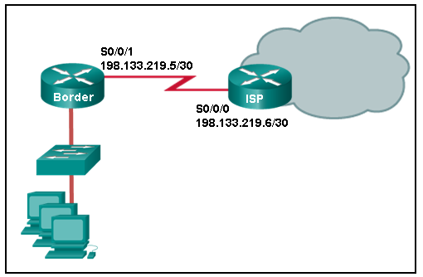

1. Refer to the network topology showing a stub network(one entry and exit point ). Where should the default static route be configured in order for the PCs to reach resources in the Internet?
   1. At the Border router using s0/0/0
   2. At the Border router using s0/0/1
   3. At the ISP router using s0/0/0
   4. At the ISP router using 192.133.219.5

**Short Answer Questions**

1. List the advantages and disadvantages of using static routes for routing?
2. What is a default static route?
3. Refer to below network topology. Configure the network using static routing so that all PCs can reach each other. For simplicity, use only exit interface in your static routes.

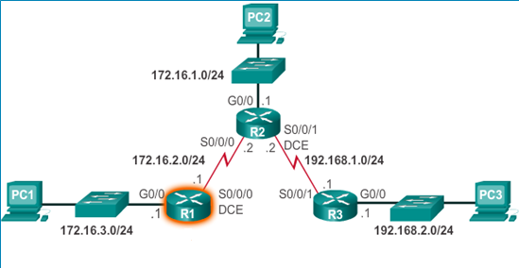

1. Configure router R1 using static routing so that its LANs can reach the remote LAN at router R2. Use the next-hop IP address in your configuration.

