Data Science Project
Main Plan Construction

1. Main idea and project goal
Proposed project title: Kidney Ultrasound Pathology Detection Using Deep Learning and Transfer Learning
Main idea: Develop and evaluate a deep learning model that classifies kidney ultrasound images into two categories: normal and pathological, with the long-term aim of supporting clinicians in primary care.
The project will investigate whether transfer learning can improve classification performance when only a relatively small, specialized medical imaging dataset is available.
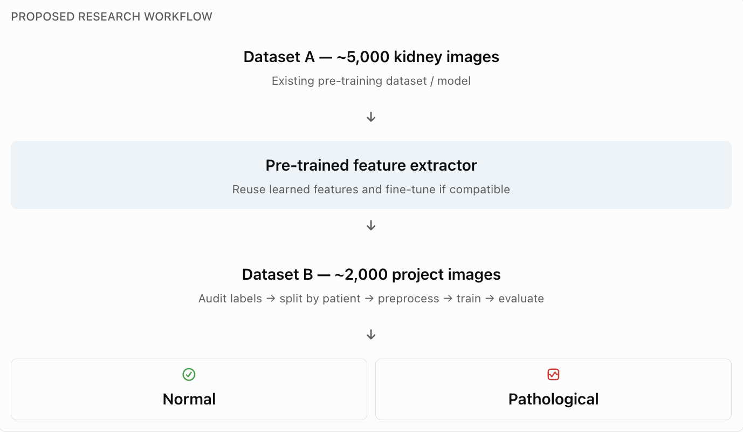
The pre-trained model is the proposed starting point, not an assumption that it will outperform other methods. We should compare it against a simpler baseline and a general image-pretrained model.

2. Key research questions
Research question | How we will answer it
Can deep learning distinguish normal from pathological kidney ultrasound images? | Train a binary classifier and evaluate it on a held-out test set
Does kidney-specific pre-training improve performance? | Compare the available kidney-pretrained model with baseline approaches
Is the dataset sufficient? | Examine class distribution, learning curves, uncertainty, and validation performance
Is segmentation necessary? | Review pathology location and test localization methods before attempting segmentation
Is the model reliable? | Evaluate sensitivity, specificity, ROC-AUC, confusion matrices, and failure cases
Important scope decision: Segmentation should initially be an optional extension, not a required component. The team should first establish a credible classification pipeline and confirm whether lesion masks exist.

3. Proposed division of work - 5 members
Primary responsibility | Main deliverable
Dataset analysis and preprocessing | Dataset audit, cleaning pipeline, patient-level splits
Literature review and existing pretrained model | Research comparison and reproducible transfer-learning setup
Model development and experimentation | Baseline models, fine-tuning, training results
Evaluation, explainability, and documentation | Evaluation report, error analysis, meeting presentations
Everyone should review the central research decisions together, and one other member should review each person's code and results. This avoids creating four disconnected projects.

4. Proposed research timeline
The following is a six-week working plan rather than an instructor-approved schedule.
11-16 Oct: Phase 1 - Define scope and inspect data
Audit both datasets, verify labels and access to pre-trained weights, confirm GPU access and meeting decisions.
17-23 Oct: Phase 2 - Literature and preprocessing
Review related methods, finalize patient-level splits, build preprocessing and augmentation pipelines.
24-30 Oct: Phase 3 - Establish baselines
Run a simple baseline and a general transfer-learning model with reproducible evaluation.
31 Oct-6 Nov: Phase 4 - Kidney-specific transfer learning
Fine-tune the existing kidney-pretrained model and compare against the baselines.
7-13 Nov: Phase 5 - Evaluation and explainability
Analyze sensitivity, specificity, ROC-AUC, errors and image regions influencing predictions.
14-20 Nov: Phase 6 - Consolidate findings
Repeat key experiments, prepare the report and determine whether segmentation is justified.

5. Checklist:
[ ] Which specific kidney pathologies are represented in our datasets?
[ ] Are the labels suitable for binary normal/pathological classification?
[ ] Do we have access to the actual pretrained model weights, or only its training dataset?
[ ] Can we split the images by patient to prevent data leakage?
[ ] Who will own each research workstream?
[ ] What evidence can we realistically present to the instructor on 16 October?
[ ] What GPU resources, software and data permissions are available?
For our Kidney Ultrasound Image Classification project, I would propose testing 3 main deep learning approaches, plus an optional segmentation method.
Since we have approximately 2,000 project images and access to a second dataset of 5,000 kidney ultrasound images, our main strategy should be transfer learning with convolutional neural networks (CNNs).Fernando’s notes mention classification, transfer learning and possible segmentation, but they do not specify architectures. The following are my recommended candidates.

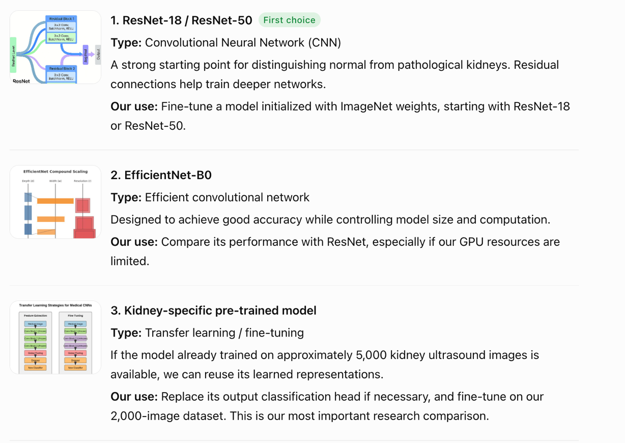

How we should compare the algorithms
Model | Starting weights | Role
Simple CNN | Random initialization | Baseline for comparison
ResNet-18/50 | ImageNet | General transfer-learning baseline
EfficientNet-B0 | ImageNet | Alternative architecture
Existing kidney model | Kidney ultrasound pre-training | Main research experiment
U-Net | Task-dependent | Optional segmentation extension
All classification models should be tested on the same patient-separated test set so their results are directly comparable.

Training and evaluation algorithms
Besides selecting architectures, we need a consistent training procedure.
Component | Proposed method
Loss function | Binary cross-entropy (BCE)
Optimizer | AdamW
Data augmentation | Small rotations, translations, contrast adjustments and clinically appropriate flips
Validation | Patient-level stratified splitting or grouped cross-validation
Class imbalance | Weighted loss or balanced sampling if needed
Explainability | Grad-CAM heatmaps
Evaluation | Sensitivity, specificity, precision, F1, ROC-AUC and confusion matrix
A key requirement is that images from the same patient must not appear in both training and testing. We should also verify that the two datasets contain no overlapping patients or duplicate images.
