Kidney Segmentation: Results Summary
Data Science Project · kidney ultrasound · segmentation part · November 2026
The first step of our system is to find the kidney in an ultrasound image and draw its outline automatically. Everything that follows depends on it: the outline tells the system where to look for lesions, what part of the image to give the classifier, and how large the kidney is. Our goal for this part was simple to state: outline the kidney at least as well as URI-CADS [24], the published system built on the same images, and check that our models still work on images from a different hospital.
To do this, we used the 1,985 images from Hospital Ramón y Cajal and split them into five groups. Each model was trained on part of the data and tested on a group it had never seen, so every image was tested exactly once. We tried three approaches. The first was to train two standard segmentation networks, U-Net and DeepLabV3+, on our own images. The second was to take two ready-made foundation models, MedSAM and UltraSam, which can outline almost any object once you draw a box around it, and use them without any training. The third was a middle way: we kept MedSAM but retrained the small part of it that draws the outline. To score an outline we used the Dice coefficient, which measures how much our outline overlaps the doctors' outline, from 0 (no overlap) to 1 (identical), averaged over all test images. Finally, we ran every model on KidneyUS, 487 images from another hospital and other scanners that were never used for training.
Results
Model | Dataset A Dice % | KidneyUS Dice % | vs URI-CADS (A)
DeepLabV3+ (ResNet-50) | 92.35 | 90.5 | +1.12
U-Net (ResNet-34) | 92.20 | 90.2 | +0.97
MedSAM fine-tuned, automatic box | 91.79 | 89.6 | +0.56
UltraSam, automatic box (no training) | 90.13 | 91.1 | −1.10
URI-CADS baseline [24] | 91.23 | not tested | baseline
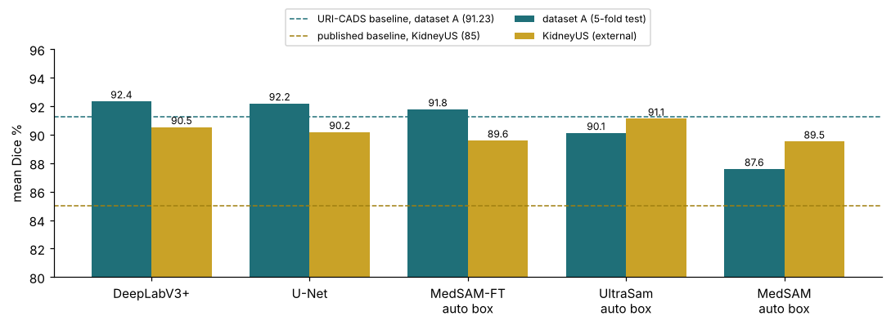
Figure 1. Mean Dice on our images (teal) and on the external KidneyUS images (gold), against both published baselines.
Both networks trained on our data outline the kidney better than URI-CADS: DeepLabV3+ reaches 92.35 % and U-Net 92.20 %, against 91.23 %, and they stay above the baseline in every one of the five test groups. The two networks are practically equal, so either can be used for the rest of the project. More importantly, they keep working in a hospital they have never seen. On KidneyUS they score around 90–91 %, well above the 85 % published for that dataset, which suggests they have learned what a kidney looks like rather than what it looks like on one particular machine.
The foundation models tell a different story. When we give UltraSam the exact box around the kidney, it outlines it better than any of our networks (93.4 %) without ever being trained on our images. But in real use nobody draws that box, and when the box comes from our own model, UltraSam drops to 90.1 %. The outlining is good; finding the kidney is the hard part. Retraining only MedSAM's outline-drawing part fixes much of this, lifting its fully automatic result from 87.6 % to 91.8 %, just above the baseline.
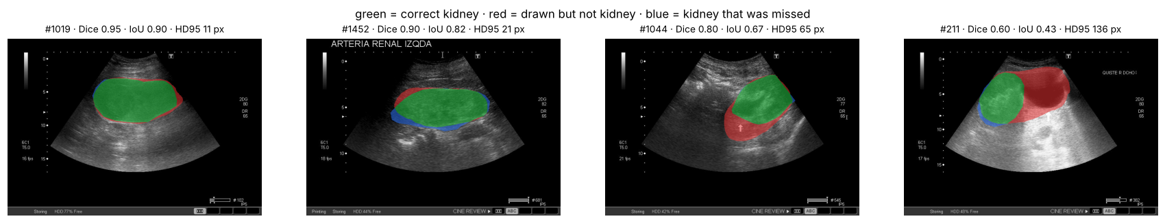
Figure 2. What a score looks like: Dice 0.95, 0.90, 0.80 and 0.60. Green = correct kidney, red = drawn but not kidney, blue = kidney missed.
When the models go wrong, they do so in two ways: they either draw too much and spill into the tissue next to the kidney, or draw too little and cover only part of it (Figure 2). The hardest images are kidneys whose edge is difficult to see, very small kidneys, the less common view and complicated cysts, the same weak spots URI-CADS reports. On KidneyUS, transverse images are weaker, and this is mostly because the model occasionally fails to find the kidney at all.
What comes next
These results come from one hospital and one scanner, and no clinician has yet looked at our outlines, so they should be read with that in mind. Our first task is to retrain the models on the team's corrected data split and hand the predicted outlines to the classification team, who need them for the kidney-focused classifier. After that, we want to make the models more robust to other scanners, give them more practice on the rare view, fine-tune UltraSam in the same way as MedSAM, and understand why transverse kidneys are sometimes missed. Finally, we would like a clinician to review a sample of our outlines, so we know whether the remaining differences matter in practice.

