Project literature review, October 2026
Deep learning classification of kidney ultrasound in primary care
Review
A review of deep learning for kidney ultrasound classification: evidence and lessons for primary care
[Author names]
[Affiliations: university / Nephrology Department]

Abstract
Ultrasound is cheap, portable and radiation-free, which makes it attractive in primary care. Primary-care professionals can often acquire kidney images but may lack the experience to interpret them, so images are sent to specialists such as the Nephrology Department, adding to their workload. Deep learning (DL) could help by classifying images and flagging possible pathology. To understand the state of the art, we reviewed 23 sources found through a structured web search: 15 primary studies applying DL or machine learning (ML) to kidney ultrasound and 8 reviews or context papers on AI and point-of-care ultrasound (POCUS). For each primary study we extracted the task, pathology, population, dataset size, devices, preprocessing, segmentation, algorithms, best result and validation strategy. Transfer learning from ImageNet with ResNet-type networks is the dominant approach, often combined with U-Net segmentation, and reported accuracies range from about 83% to 96%. However, datasets are small and single-centre, patient and device counts are often missing, and no study validates on an external hospital or on images acquired in primary care. We summarise these gaps and propose a pipeline for our project that addresses them.
Keywords kidney ultrasound, deep learning, transfer learning, chronic kidney disease, hydronephrosis, primary care, point-of-care ultrasound

Introduction
Kidney disease is a major and growing health burden, and renal ultrasound is a first-line imaging test because it is real-time, accessible and non-invasive [1]. It can show congenital abnormalities, stones, cysts and tumours, as well as signs of chronic kidney disease (CKD) such as changes in size and echogenicity [1, 3]. Handheld and portable probes have made it increasingly available outside radiology departments, including in primary care [6, 15].
The bottleneck is interpretation. Reading renal ultrasound depends heavily on experience, and interobserver variability is large [2, 9]. Kidney image acquisition and reading are unfamiliar to most clinicians outside specialist services, including primary care [5]. In our setting, images acquired in primary care are therefore sent to the Nephrology Department for interpretation, which increases specialist workload and can delay decisions.
DL has shown strong results in medical image analysis, and convolutional neural networks (CNNs) in particular have improved classification and segmentation of renal ultrasound [1]. Recent reviews describe a shift from experience-dependent reading towards more standardised, automated analysis, but also stress unresolved problems with data quality, interpretability, generalisation and clinical integration [1, 4].
Existing reviews [1–3] summarise the field broadly. Our aim is narrower and practical: to extract, study by study, the technical details that matter for building a model for primary care. Specifically, we examine the following:
- Research tasks and target pathologies, and how they match a primary-care triage use case.
- Dataset size, population, number of patients and ultrasound devices.
- Preprocessing and segmentation steps used before classification.
- Model choices, with emphasis on transfer learning and the best-performing architectures.
- Evaluation metrics, validation strategies and the availability of external validation, data and code.
- Limitations of current work and guidelines for our project.
Figure 1 summarises how the sources were identified and selected.

Methods

Search strategy
We searched the web on 11 October 2026 using seven queries that combined kidney or renal ultrasound with deep learning, CNNs, CKD, hydronephrosis, cysts and stones, public datasets, POCUS in primary care and nephrology, and systematic reviews. Each query returned the top ten results. This was a rapid, structured search rather than a full systematic search of bibliographic databases; a PubMed, Scopus and Web of Science search following PRISMA is planned as the next step (see Guidelines).
Records were screened by title and abstract. The following exclusion criteria were applied:
- Duplicate records of the same study on different websites.
- Other imaging modalities, in particular CT-based kidney studies (for example those using the public Kaggle CT kidney dataset), because results on CT do not transfer to ultrasound.
- Non-human studies, such as veterinary kidney ultrasound.
- Off-topic studies that did not involve the kidney or did not apply an AI-based method.
Twenty-three records were included: 15 primary studies (Table 1) and 8 reviews, letters or methods papers that provide clinical context (Table 1b). Figure 1 shows the selection process.
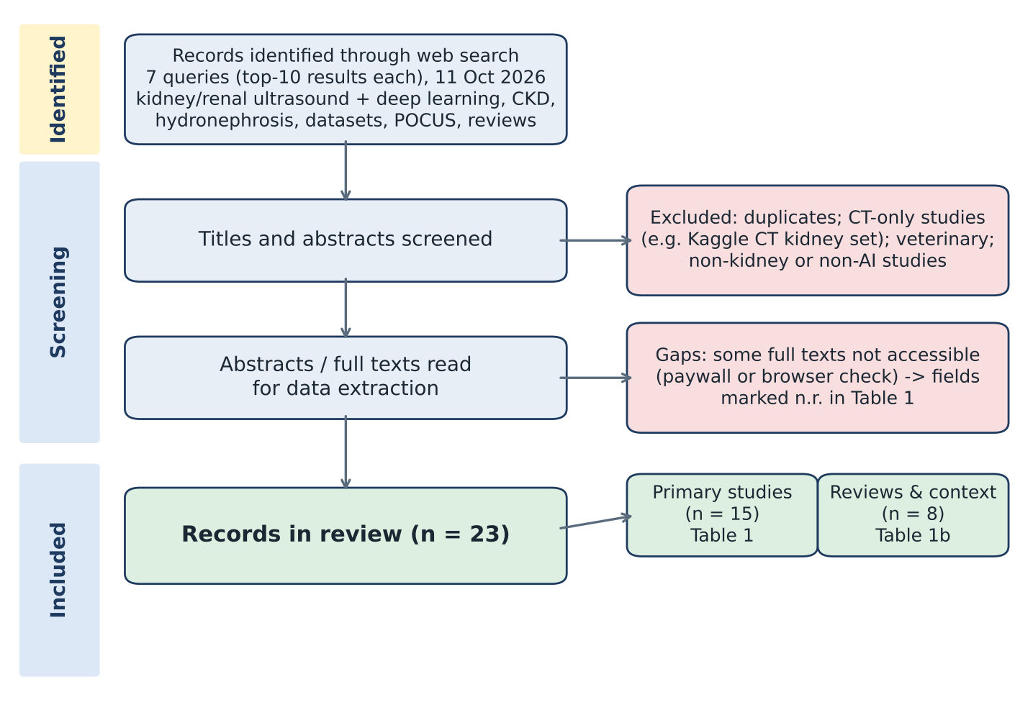
Figure 1 Selection of sources: web search, screening against the exclusion criteria, data extraction from abstracts or full texts, and the final set of 15 primary studies and 8 context papers.

Data extraction
For each primary study we extracted: (i) publication details; (ii) the research task (classification, grading, function prediction, segmentation or quality selection); (iii) the pathology or classes; (iv) the population (adult or pediatric); (v) the dataset size in images and patients; (vi) the number of ultrasound devices; (vii) preprocessing steps; (viii) segmentation methods; (ix) the algorithms compared and the best model; (x) the best reported result; and (xi) the validation strategy. Data were taken from full texts where accessible and from abstracts otherwise. Values that the accessible text did not report are marked n.r. Tables 1, 2 and 3 summarise the extracted data.

Table 1 Overview of included primary studies (2019–2026) on AI for kidney ultrasound, sorted by year. Bold in Algorithm denotes the best-performing model. † Dataset paper. n.r. = not reported in the accessible text. Codes are listed in Table 3.
Year | Paper | Task | Pathology / classes | Population | Images (patients) | Devices | Pre-processing | Segmentation | Algorithm | Best result | Validation
2019 | Kuo [9] | FUN, CLS | eGFR; CKD (eGFR<60) | Adult | 4,505 (n.r.) | n.r. | Cr, Au | - | ResNet (TL, bagging) | Acc 85.6% (CKD) | HO
2020 | Sudharson [10] | CLS | N, Cy, St, Tu | n.r. | n.r. | n.r. | Q | - | ResNet-101, ShuffleNet, MobileNetV2 + SVM; Ensemble | Acc 96.5% (quality); 95.6% (noisy) | HO
 | Hao [11] | CLS | CKD screening | n.r. | 226 (n.r.) | n.r. | n.r. | - | CNN + texture branch (TL) | Acc 96.0%; Sens 99.4% | n.r.
 | Athavale [12] | GRD | IFTA grades 1–4 | Adult | 6,135 (352) | n.r. | R, Dn | U-Net (IoU 0.91) | VGG-19 features + XGB | Acc 86.8%; F1 83.9% (test) | HO
 | Chen [13] | GRD | CKD stages (eGFR) | Adult | n.r. | n.r. | Cr | - | Texture + SVM (classical ML) | n.r. | n.r.
2021 | Kim [14] | GRD | N, mild/moderate CKD, severe CKD | n.r. | 741 (n.r.) | n.r. | Cr (3 ROIs) | - | GLCM + ANN (classical ML) | Acc 95.4% | n.r.
2022 | Tsai [15] | CLS | N vs abnormal (St, Cy, HE, SOL, HN) | Pediatric | 1,599 (n.r.) | n.r. | n.r. | - | ResNet-50 (TL) | Acc 92.9%; AUC 0.959 | HO
 | Priyanka [16] | CLS | St, Cy, HN (likely) | n.r. | n.r. | n.r. | n.r. | - | GAONN, AlexNet (TL) | CNN > GAONN (no value) | n.r.
 | HARP study [17] | SEG, GRD | HN area / parenchyma ratio | Pediatric | 168 (195) | n.r. | n.r. | DeepLabV3+ / UNet++ variants | Ensemble (5 nets) | Dice 0.911 | CV (4-fold)
 | Singla† [18] | DATA, SEG | Kidney anatomy (capsule, cortex, medulla, CEC) | Adult | 514 (514) | 8 | - | nnU-Net | nnU-Net | Dice 0.85 capsule; 0.69 mean | Public set
2023 | Lien [19] | SEG, CLS | Moderate/severe HN vs N | Adult | 5,090 (362) | n.r. | BG, R | U-Net, Res-UNet, UNet++ | Res-UNet | Acc 94.6% | n.r.
2024 | EUO HN study [20] | CLS, SEG | HN vs no HN | Adult | n.r.; 200 test | 3 | Au | DeepLabV3-ResNet50/101 | AlexNet, ResNet50/101/152, GoogLeNet | n.r. | HO (200 new images)
2025 | Seraj [21] | QA | Frame quality (good, bad, null) | n.r. | 1,203 (211) | n.r. | R | - | InceptionV3, EfficientNet, VGG16, ResNet34/50, YOLOv8x, YOLO11x | Acc 90% ± 5.9 (CV) | CV (5-fold)
2026 | Alkhaldi [22] | SEG, CLS | N, CKD, AKI | n.r. | 293 (293) + 9,337 unlabelled | n.r. | R, Nm, Au, Bal | Semi-supervised U-Net (Dice 0.91) | Swin-T, EfficientNetB0, DenseNet121, ResNet50 (dual-input) | Acc 82.9%; AUC 0.913 | HO (3 seeds)
 | Kanchanamala [23] | CLS | St | n.r. | n.r. | n.r. | Dn | DRRN | KSOMFHNet (hybrid) | Acc 92.0%; Sens 90.5%; Spec 92.2% | n.r.
Table 1b Reviews and context papers.
Year | Paper | Type | Scope | Key takeaway for our project
2018 | Nixon [6] | Clinical study | Rural POCUS of kidney and bladder | Kidney POCUS is already used in primary care; supports our clinical setting.
2022 | Sonko [7] | Review | ML in point-of-care ultrasound | Scanners increasingly run on-device ML that gives bedside results instead of remote radiologist reads.
2023 | QIMS review [3] | Systematic review | AI-aided renal ultrasound | CKD and quantitative hydronephrosis are the most promising AI applications.
2024 | Frontiers narrative review [2] | Narrative review | AI in renal ultrasound | AI can reduce the large interobserver variability in renal ultrasound reading.
2025 | Frontiers DL review [1] | Systematic review (98 articles) | Deep learning in renal ultrasound | Open problems: data quality, interpretability, generalisation, clinical integration.
 | JoVE methods [5] | Methods article | Kidney/GU POCUS acquisition | Kidney imaging is unfamiliar to most clinicians, including in primary care.
2026 | Satyagraha [8] | Systematic review | AI for urinary tract stones | Ultrasound AI is a practical, low-cost option for resource-limited settings.
 | Koratala [4] | Letter | AI in nephrology POCUS | Correct image recognition is not correct interpretation; AI should support clinicians.
Table 3 Codes and abbreviations used in Table 1.
Group | Code | Description | Code | Description
Tasks | CLS | Disease classification | GRD | Grading / severity staging
 | FUN | Kidney function prediction (eGFR) | SEG | Segmentation
 | QA | Frame / image quality selection | DATA | Dataset release
Pathology | N | Normal kidney | HN | Hydronephrosis
 | Cy | Cyst | HE | Hyperechogenicity
 | St | Stone (nephrolithiasis) | SOL | Space-occupying lesion
 | Tu | Tumour | CKD | Chronic kidney disease
 | AKI | Acute kidney injury | IFTA | Interstitial fibrosis and tubular atrophy
 | CEC | Central echogenic complex | eGFR | Estimated glomerular filtration rate
Preprocessing | Q | Image quality selection | Cr | Cropping / region of interest
 | Dn | Denoising / speckle reduction | BG | Background removal
 | R | Resizing | Au | Data augmentation
 | Nm | Normalisation | Bal | Class balancing
Models | TL | Transfer learning (ImageNet) | SVM | Support vector machine
 | ANN | Artificial neural network | XGB | Extreme gradient boosting
 | CNN | Convolutional neural network | DRRN | Deep recursive residual network
 | GAONN | Genetic-algorithm-optimised neural network | Swin-T | Swin Transformer (Tiny)
 | GLCM | Grey-level co-occurrence matrix | ViT | Vision transformer
Validation | HO | Hold-out test set | CV | k-fold cross-validation
 | Ext | External (other centre / device) test | n.r. | Not reported

Quality assessment
Following the extraction, each study was assessed on four aspects:
- ML methodology: clear description of architectures, transfer learning and training procedures.
- Model evaluation: adequate metrics and validation, ideally patient-level splits and external testing.
- Data transparency: reporting of patient and device counts, and availability of data or code.
- Clinical relevance: how closely the task and image source match a primary-care triage setting.

Results
This section presents the main findings from the 15 primary studies (Table 1), with context from the 8 supporting papers (Table 1b).

Key research task
Disease classification is the most common task (n=9), followed by severity grading (n=4) and segmentation (n=5, usually as a step before classification). One study predicts kidney function directly from images [9], one selects diagnostically useful frames from ultrasound videos [21], and one releases a public dataset [18]. Most classification studies are multi-class, for example normal, cyst, stone and tumour [10], or normal, CKD and AKI [22]. The design closest to our triage goal is a binary normal-versus-abnormal classifier, which Tsai et al. [15] explicitly framed as a screening aid for general practitioners using portable probes.

Data description
Datasets are small. Among studies that report it, the number of labelled images ranges from 168 [17] to 6,135 [12] (Figure 2), and only five studies report the number of patients. Studies with large image counts usually include many images per patient: for example, 6,135 images came from 352 patients [12], and 5,090 frames from 362 people [19]. Because images from the same patient are highly correlated, image counts overstate the effective sample size, and patient-level splitting becomes essential. Only one primary study describes using more than one ultrasound device [20]; the Open Kidney Ultrasound Data Set is the notable exception, with 514 images from 8 different scanners [18].
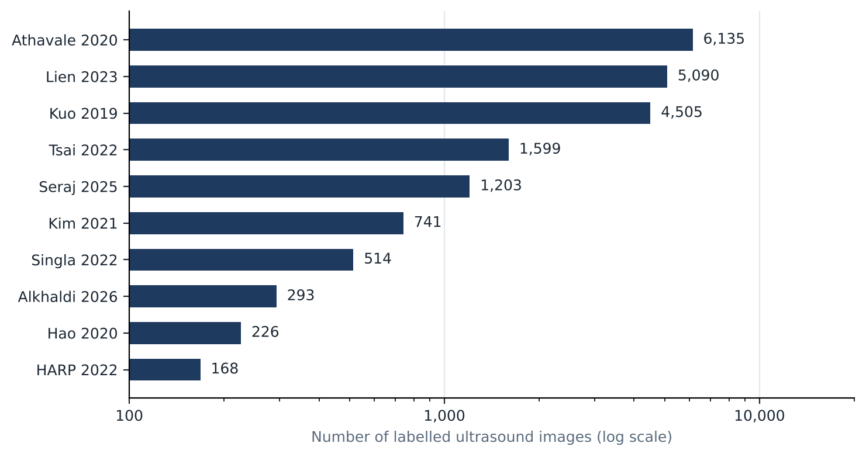
Figure 2 Number of labelled ultrasound images per study, for the ten studies that report it (log scale). Alkhaldi et al. [22] additionally used 9,337 unlabelled images for semi-supervised segmentation.

Pathologies
Hydronephrosis (n=5) and CKD (n=5) are the most studied conditions, followed by stones (n=4) and cysts (n=3). Tumours, AKI and fibrosis (IFTA) each appear in one study. Two studies focus on pediatric patients [15, 17]. These are also the conditions most relevant to primary care, where the clinical question is often whether a kidney looks normal, obstructed or chronically damaged.

Preprocessing
Preprocessing is described in 10 of 14 studies but is rarely standardised. Common steps are resizing to the network input size, cropping to a region of interest, and reducing speckle noise with filters such as the Crimmins filter [12] or a double bilateral filter [23]. Sudharson and Kokil selected images using a perceptual quality score and showed a drop in accuracy on noisy images [10]. Lien et al. removed the image background with a detector before segmentation [19]. Data augmentation [9, 20, 22] and class balancing [22] are used in only a few studies.

Segmentation
Segment-then-classify pipelines are common. U-Net and its variants (Res-UNet, UNet++, nnU-Net) are the standard [12, 18, 19, 22], with DeepLabV3 used in two studies [17, 20]. Reported Dice scores are around 0.91 for the whole kidney [17, 22], but drop for fine internal structures (cortex 0.52, medulla 0.59) on the multi-device Open Kidney dataset [18]. Using a kidney mask, or feeding both the original and the segmented image, generally helped classification [22].

Algorithms
Transfer learning from ImageNet is the dominant strategy. ResNet variants appear in six studies and are the best model in three [9, 15, 22]. Other backbones include VGG [12], AlexNet [16], DenseNet, EfficientNet and Swin Transformer [22], and YOLO classifiers [21]. Several studies use CNNs as feature extractors followed by a classical classifier such as an SVM [10] or XGBoost [12]. Two studies use classical ML on hand-crafted texture features (GLCM with an ANN [14], texture with an SVM [13]). Ensembles gave the best results where they were tested [10, 17]. Transformers have been tried but did not outperform CNNs on small datasets [22].

Evaluation metrics
Accuracy is the most reported metric, sometimes alone. Sensitivity, specificity, F1 and AUC are reported less consistently, although they matter more for triage, where missing pathology is costlier than a false alarm. Reported best results range from 82.9% accuracy (AUC 0.913) for a three-class normal/CKD/AKI problem [22] to 96.5% for a four-class problem with quality-selected images [10]. Results are not directly comparable because tasks, classes and datasets differ.

Evaluation strategy
Most studies use a single hold-out test split; two use k-fold cross-validation [17, 21]. Only a few explicitly split by patient [21, 22]. No study validates on an external hospital or on a different acquisition setting. Several authors acknowledge this, recommending validation across different ultrasound equipment [17] or other datasets [12, 22]. This is the most important limitation for our project, because primary-care images will come from different devices and less experienced operators than the specialist images used in all reviewed studies.

Open-source data and code
Only the Open Kidney Ultrasound Data Set releases images, expert annotations and code, under a non-commercial licence with registration [18]. None of the classification studies we could access report public code or data. Table 2 summarises the reporting and quality findings.
Table 2 Reporting completeness across the 14 primary studies (excluding the dataset paper unless stated).
Item | Studies | Comment
Number of images reported | 9 / 14 | Missing in Sudharson, Chen, Priyanka, Kanchanamala; EUO reports only the test set.
Number of patients reported | 5 / 14 | Image counts are often given without patient counts, so patient-level splits cannot be checked.
Ultrasound devices reported | 1 / 14 | Only the EUO hydronephrosis study (3 devices); the Singla dataset uses 8.
Preprocessing described | 10 / 14 | Usually resizing, cropping or denoising; rarely justified.
Validation strategy stated | 8 / 14 | Mostly a single hold-out split; 2 studies use k-fold CV.
External (other-centre) validation | 0 / 14 | No study tests on a second hospital or on primary-care images.
Public data or code | 1 / 15 | Only the Open Kidney Ultrasound Data Set (Singla) releases data and code.

Challenges and future directions
Small, single-centre data. Most models are trained on a few hundred to a few thousand images from one hospital. Deep networks risk overfitting such data, and performance estimates are likely optimistic. Semi-supervised learning with unlabelled images [22] and pretraining on public data [18] are promising ways to stretch limited labels.
No external validation. Without testing on other centres, devices and operators, it is unknown how these models would behave in primary care. Reviews identify generalisation and clinical integration as the main open problems [1].
Image quality and operator dependence. Primary-care images are likely to be noisier and less standardised. Quality-aware preprocessing [10] and automatic frame selection [21] address this directly and should be part of any primary-care pipeline.
Interpretability and clinical role. Reviews and recent commentary stress that recognising an image pattern is not the same as interpreting it clinically, and that AI should support rather than replace the clinician [1, 4]. Saliency maps such as Grad-CAM, and a triage design that defers uncertain cases to Nephrology, fit this view.
Reporting and reproducibility. Missing patient and device counts, absent code and inconsistent metrics make studies hard to compare or reproduce. The quality assessment in Table 2 shows this clearly.

Guidelines
Based on this review, we propose the following pipeline for our project (Figure 3):
- Task and data. Define the classes together with Nephrology, starting with a binary normal-versus-abnormal triage and, if data allow, the main pathologies (hydronephrosis, CKD changes, cysts, stones). Label at patient level, and record the device and operator for every image.
- Quality and preprocessing. Remove identifying overlays, select diagnostic frames, crop the region of interest and resize consistently. Report every step.
- Segmentation (optional). Consider a U-Net or nnU-Net kidney mask, pretrained on the Open Kidney Ultrasound Data Set [18], and compare models with and without it.
- Model. Start from ImageNet-pretrained CNNs (ResNet-50, EfficientNet) as baselines, then test ensembles or transformers. Prefer simple, well-documented models given the data size.
- Evaluation. Use patient-wise cross-validation, report sensitivity, specificity, AUC and calibration, and reserve an external test set of images acquired in primary care. Publish code and, where ethics allow, data.
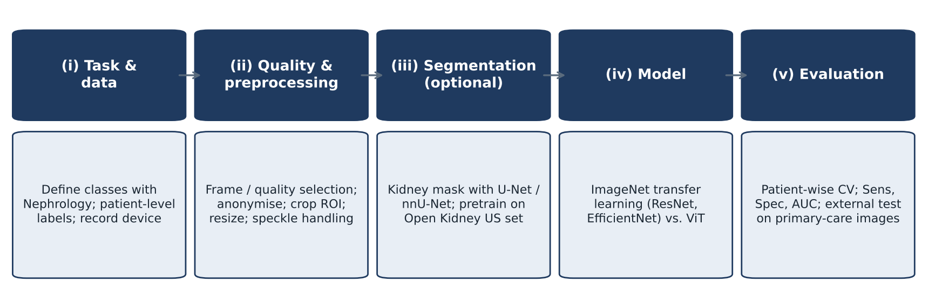
Figure 3 Proposed pipeline for our project, from task definition to external evaluation on primary-care images.
In parallel, the literature search should be extended to PubMed, Scopus and Web of Science with a PRISMA flow, and the n.r. fields in Table 1 completed from the full texts.

Key points
- Deep learning on kidney ultrasound reaches roughly 83–96% accuracy in single-centre studies, mostly using ImageNet transfer learning with ResNet-type CNNs.
- Hydronephrosis and CKD are the most studied conditions, and both are highly relevant to primary-care triage.
- Datasets are small, patient and device counts are often missing, and only one public kidney ultrasound dataset exists.
- No reviewed study validates on an external centre or on images acquired in primary care, which is the main gap our project can address.

Conclusions
The evidence shows that deep learning can classify kidney ultrasound images with promising accuracy, supporting the idea of an AI-assisted triage tool for primary care. However, the current literature is built on small, specialist-acquired, single-centre datasets with limited reporting and no external validation. A project that collects primary-care images from several devices, splits data by patient, reports results transparently and evaluates on an external set would make a clear contribution beyond the existing work and could help reduce the interpretation workload of Nephrology.

Data availability
The extracted data are available in the accompanying spreadsheet (kidney_ultrasound_literature.xlsx), which also tracks reading status and relevance for each source.

References
1. Deep learning in renal ultrasound: applications, challenges, and future outlook. Front Oncol 2025. doi:10.3389/fonc.2025.1730628.
2. A narrative review on the application of artificial intelligence in renal ultrasound. Front Oncol 2024. doi:10.3389/fonc.2023.1252630.
3. Artificial intelligence-aided ultrasound in renal diseases: a systematic review. Quant Imaging Med Surg. PMC10240007.
4. Koratala A, Ferreira F, Diniz H. Letter to the Editor: Artificial intelligence in nephrology point-of-care ultrasonography – opportunities, limitations, and future directions. World J Nephrol 2026;15(3):124607.
5. Point-of-care kidney and genitourinary ultrasound in adults: image acquisition. J Vis Exp (JoVE), article 66802.
6. Nixon G, Blattner K, Muirhead J, Kerse N. Rural point-of-care ultrasound of the kidney and bladder: quality and effect on patient management. J Prim Health Care 2018;10(4):324–330.
7. Sonko ML, Arnold TC, Kuznetsov IA. Machine learning in point of care ultrasound. POCUS J 2022;7(Kidney).
8. Satyagraha P, Budaya TN, Viosandy J. Advancements in artificial intelligence for detecting urinary tract stones: a systematic review of imaging-based approaches. doi:10.1177/20514158261454815.
9. Kuo CC, et al. Automation of the kidney function prediction and classification through ultrasound-based kidney imaging using deep learning. npj Digit Med 2019.
10. Sudharson S, Kokil P. An ensemble of deep neural networks for kidney ultrasound image classification. Comput Methods Programs Biomed 2020.
11. Hao PY, Xu ZY, Tian SY, et al. Texture branch network for chronic kidney disease screening based on ultrasound images. Front Inf Technol Electron Eng 2020;21(8):1161–1170.
12. Athavale AM, et al. Deep learning to predict interstitial fibrosis and tubular atrophy from kidney ultrasound images. medRxiv 2020. doi:10.1101/2020.08.17.20176958.
13. Chen CJ, Pai TW, Hsu HH, et al. Prediction of chronic kidney disease stages by renal ultrasound imaging. Enterp Inf Syst 2020;14(2):178–195.
14. Kim DH, Ye SY. Classification of chronic kidney disease in sonography using the GLCM and artificial neural network. Diagnostics 2021;11(5):864.
15. Tsai MC, Lu HHS, Chang YC, Huang YC, Fu LS. Automatic screening of pediatric renal ultrasound abnormalities: deep learning and transfer learning approach. JMIR Med Inform 2022;10(11):e40878.
16. Priyanka, Kumar D. Kidney image classification using transfer learning with convolutional neural network. Int J Comput Vis Robot 2022;12(6).
17. Deep-learning segmentation of ultrasound images for automated calculation of the hydronephrosis area to renal parenchyma ratio. Investig Clin Urol 2022.
18. Singla R, et al. The Open Kidney Ultrasound Data Set. arXiv 2022;2206.06657.
19. Lien WC, et al. Detecting hydronephrosis through ultrasound images using state-of-the-art deep learning models. Ultrasound Med Biol 2023;49(3).
20. Harnessing artificial intelligence for enhanced renal analysis: automated detection of hydronephrosis and precise kidney segmentation. Eur Urol Open Sci 2024.
21. Seraj A, et al. Deep learning framework for automated frame selection in kidney ultrasound. Sci Rep 2025;15:41940.
22. Alkhaldi N, et al. Automating kidney disease diagnosis: classifying acute and chronic kidney disease from ultrasound images. Eng Technol Appl Sci Res 2026;16(1).
23. Kanchanamala P, et al. Ultrasound-based kidney stone classification using Kronecker self-organizing map forward harmonic network. Ultrason Imaging 2026.

