**OPS345 Midterm (Summer 2023)**

**Weighted 25% of your final grade**

The end state of the configurations is what I will check, video recording is not necessary.

Unless otherwise specified, all tasks should be done with ‘root’ privilege.

Refer to the following diagram for information like Internet facing network/internal network…etc. 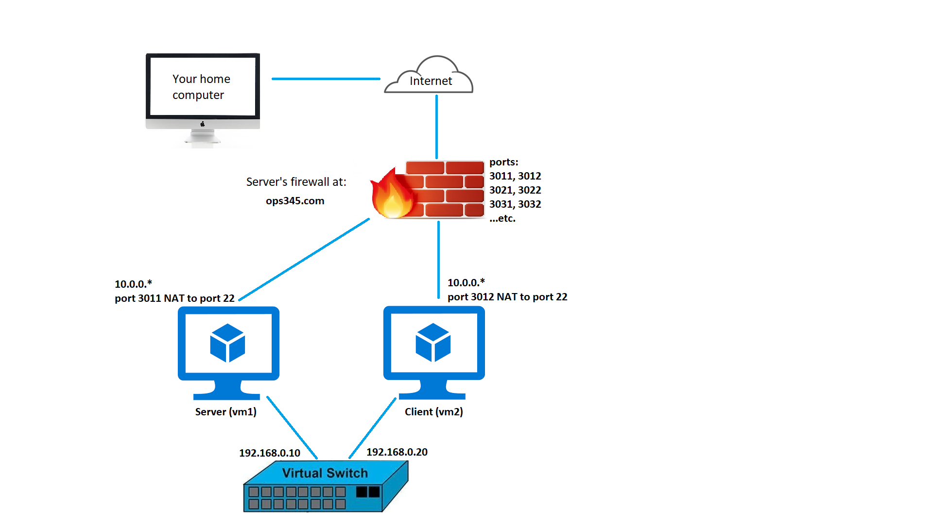

1. SSH to “ops345.com” Server VM (vm1 Port 3**4) and Client VM (vm2 Port 3**5) with pre-determined port number (can be found from Blackboard). Username “ops345” default password “Password1234”

* On Server VM, change the ops345’s password to another password of your choice.

Record the New Password: _________________

* On Client VM, change the ops345’s password to another password of your choice.

Record the New Password: _________________

* **Don’t** use the default “Password1234” as your new password.

1. Create a file in your ops345 home directory with your name and student ID for **both** VMs.
   * The info could be in filename or in the content of a file.
   * I won’t mark your exam if I cannot find this info.
2. Make sure you permanently disabled firewalld service.
3. Install and start iptables service.
4. Create iptables rule(s) on Server VM to the beginning of the chain to allow ssh, http and DNS query from internal network. (You can do it with either multiple iptables rules or single rule to allow all ports altogether).
5. Save the current iptables rules to /etc/sysconfig/iptables

**Build a functional DNS server (master only) with the Server VM.**

1. Install the DNS service and the utilities.
2. Correct syntax of zone declaration (forward lookup).

* All related options to allow localhost and Client VM to query DNS record from 192.168 network **ONLY**.

1. Correct syntax of zone file which must be able to resolve the following record.

server 192.168.0.10

client 192.168.0.20

yoursenecaid 192.168.0.100

1. Correct syntax of zone declaration (reverse lookup).
2. Correct syntax of zone file with the same values in the above steps, but to be used for **reverse lookup**.
3. Add the DNS server 192.168.0.10 to the top of the “resolv.conf” file for **both** VMs.
4. Enable and start your DNS service. (Confirm you can query DNS record from Client VM.)

**Configure mail servers**

1. Configure MUA (mailx) that we have used in the class for Server VM
2. Configure MUA (mailx) that we have used in the class for Client VM
3. Configure MTA (postfix) that we have used in the class for Server VM
4. Configure MTA (postfix) that we have used in the class for Client VM
5. Sent an email from Server VM to [ops345@client.yoursenecaid.ops](mailto:ops335@client.yoursenecaid.ops) with any contents you like.
   1. You **must** change the high lighted part with your Seneca ID.
6. Sent an email from Client VM to [ops345@server.yoursenecaid.ops](mailto:ops335@server.yoursenecaid.ops) with any contents you like.
   1. You **must** change the high lighted part with your Seneca ID.
7. Sent an email from both VMs to [OPS345V1A@GMAIL.COM](mailto:OPS345V1A@GMAIL.COM)

* Subject as “OPS345 Midterm: your_name_initial” (e.g. my name is Jason Pang, my initial is “JP”)
* Any contents you like in the mail body.
* It is okay if your email is rejected, I can give you the mark based on the logs.

Make sure you have filled in your new VM password in this document.

Save this document as “OPS345_2227_Midterm_NameInitial.docx”.

Upload to Blackboard \ MyTasks \ Midterm