ECE 437 Lab 6 Post-Lab

libiano2

October 2023

TA Questions

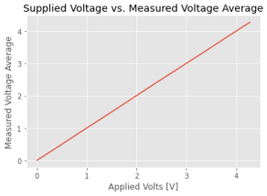Figure 1: Output Voltage vs. Measured Mean Voltage

1. The variations could be given by measurement noise or coupling of our wires. Although, we have a relatively low variation compared to the values of the mean. This matches our expectation of Voltage and Current being linear, since resistors are passive, and power being quadratic, since voltage (linear) time current (linear) outputs something quadratic.

1

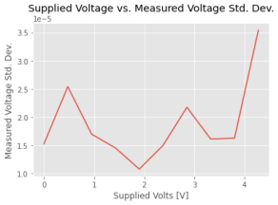Figure 2: Output Voltage vs. Measured Std. Dev. Voltage

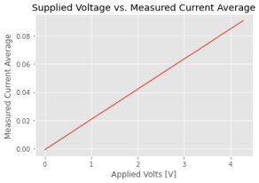Figure 3: Output Voltage vs. Measured Mean Current

2

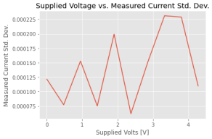Figure 4: Output Voltage vs. Measured Std. Dev Current

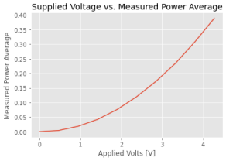Figure 5: Output Voltage vs. Measured Mean Power

3

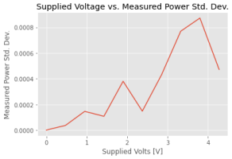Figure 6: Output Voltage vs. Measured Std. Dev Power

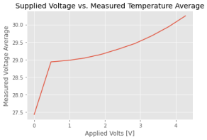Figure 7: Output Voltage vs. Measured Average Temperature

2. The standard deviation of temperature is 0-6 degrees celsius during our low voltage heater measurements. However, we reach a certain point where the standard deviation is 0 (relative to the low voltage heater measurements). This is possibly due to our code taking ample amount of time to take the temperature measurements within the thermal response time of the sensor. We expect to see a low standard deviation since waiting this

4

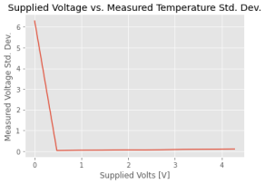Figure 8: Output Voltage vs. Measured Std. Dev Temperature

amount of time to take measurements allows us to read temperature during the settling point of the sensor.

5