* **Post lab question 1:** Why do you see variations in these measurements and what is the theoretical formula that models this behavior? How well do these measurements (i.e. variations in the current and voltage) follow the theoretical model? (20 pts)
  + 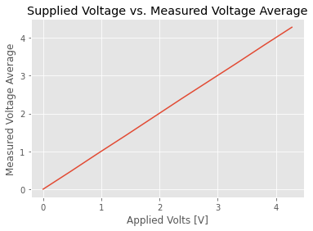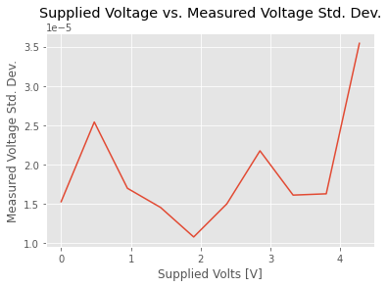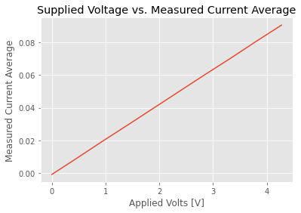
* **Post lab question 2:** Is the standard deviation different for different temperatures (i.e. voltages applied on the power resistor)? Why do you think this is the case? Look over the datasheet and locate a figure with a similar measurement. Include this figure in your report and comment on the differences and similarities between the two results. (20 pts)
  + 