1. Look over the online documentation for the PMOD DHB1 board. What kind of motors can you control with this PMOD? (5 pts)
   1. 
2. What is the maximum number of motors that you can independently control with the PMOD DHB1 board? (5 pts)
   1. 
3. What is the on resistance of the left and right output branch of the H-bridge? (5 pts)
   1. 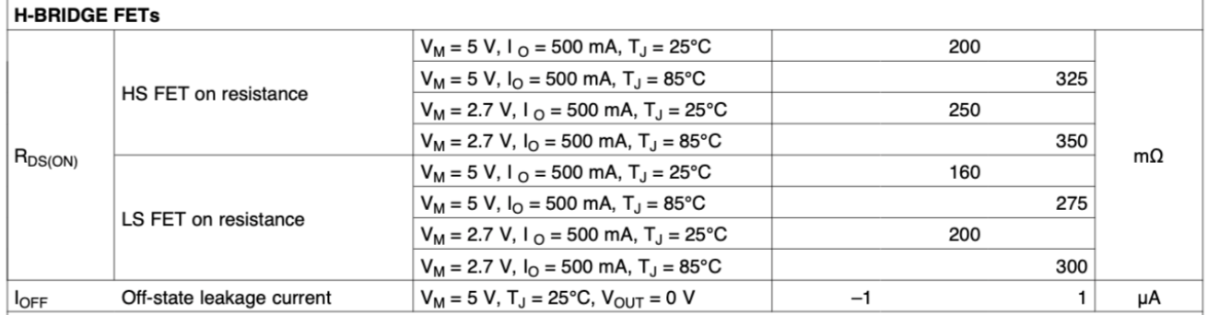
4. The PMOD board will be connected to the sensor board where the OpalKelly FPGA board is connected. What are the pins on the OpalKelly FPGA that you will use to control the motor? (5pts)
   1. Ain1, Ain2, Bin1, Bin2