1. **What is the frequency range for the imager’s master clock signal? (5 pts)**
   1. 
2. **What is the maximum frequency for the SPI clock signal? (5 pts)**
   1. 
3. **Draw the SPI read block diagram and describe how would you use this information to develop the FSM in Verilog? (5pts)**
   1. 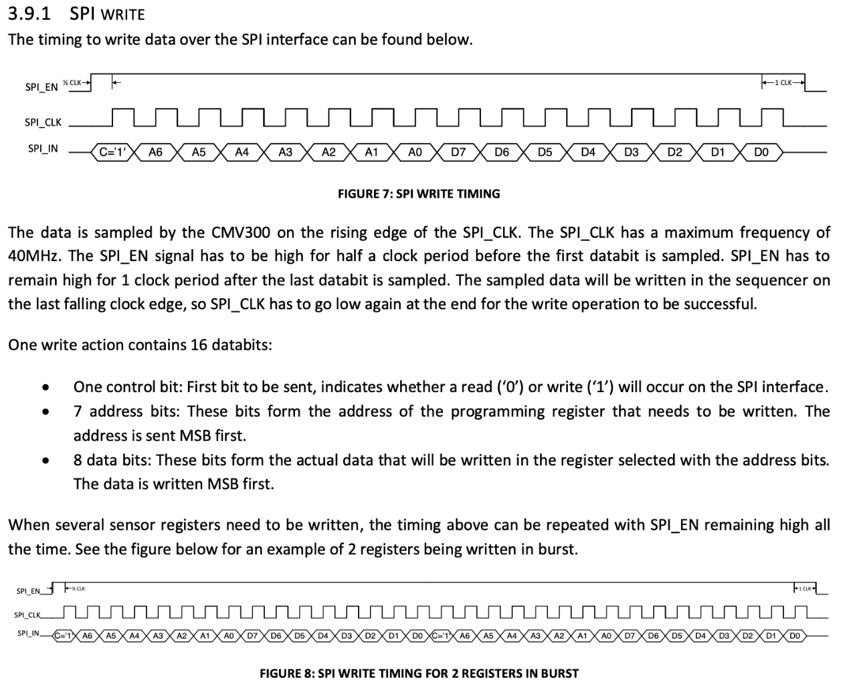
4. **Draw the SPI write block diagram and describe how would you use this information to develop the FSM in Verilog? (5pts)**
   1. 